

**PROJECT**

**Cinema Ticket Sale**

**Group 10**

Names :

1. Muhammad Ryan Cakranigrat

Class : 4 ISA 3

Faculty :

Mhd Idham Khalif, S.Kom

**CEP CCIT**

**FAKULTAS TEKNIK UNIVERSITAS INDONESIA**

**2023**

**PROJECT ON**

Cinema Ticket Sale

**Developed by :**

* **Muhammad Ryan Cakraningrat**



**Cinema Ticket Sale**

Batch Code : 4 ISA 3

Start Date : Sunday, 09 April 2023  
End Date : Saturday, 15 April 2023

Name of Faculty : Mhd Idham Khalif, S.Kom

Names of Developer :

1. Muhammad Ryan Cakraningrat

Date of Submission :



**CERTIFICATE**

This is to certify that this report titled ”**Cinema Ticket Sale**” embodies the original work done by Muhammad Ryan Cakraningrat. Project in partial fulfillment of their course requirement at NIIT.

Coordinator:

Mhd Idham Khalif, S.Kom

\

\

**ACKNOWLEDGEMENT**



Thank you, the writer wishes to God the Almighty for His blessings, we can complete this Project about Object Oriented Programming entitled “Cinema Ticket Sale” for Friendly task both in the form of presentation and paper in a timely manner. Thank you especially for Mhd Idham Khalif, S.Kom and another faculty who always help. Thank you also to fellow students who have supported, and also thank you for being fellow workers in the education at CCIT-FTUI.

The author realizes that in the preparation of this project there are still many shortcomings and far from perfection. Therefore, the authors expect constructive criticism and suggestion to improve this paper and can be a reference in preparing the papers or subsequent tasks.

Depok, April 2023

Author

\

**SYSTEM ANALYSIS**

**System Summary :**

The program is a Cinema Ticket Ordering Application that allows users to buy tickets without having to go to the counter where the ticket is sold. The menus contained in the program include a choice of films, types of tickets, ticket prices, Showtime Options, number of tickets purchased, and total number of tickets to be paid. There are 6 available films, 4 types of tickets, and several Showtime Options.

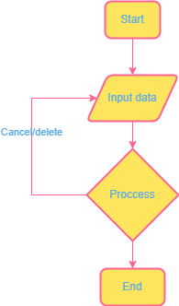

**Flowchart**

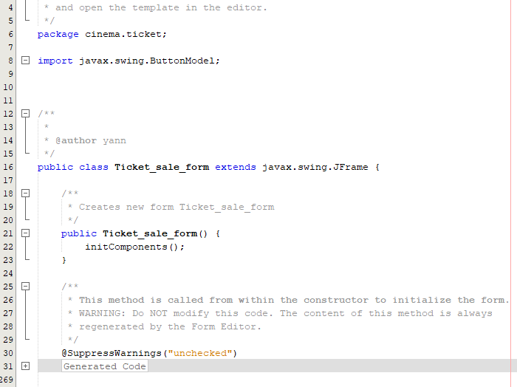

this is the initial declaration for the package name and import class

**CODE**

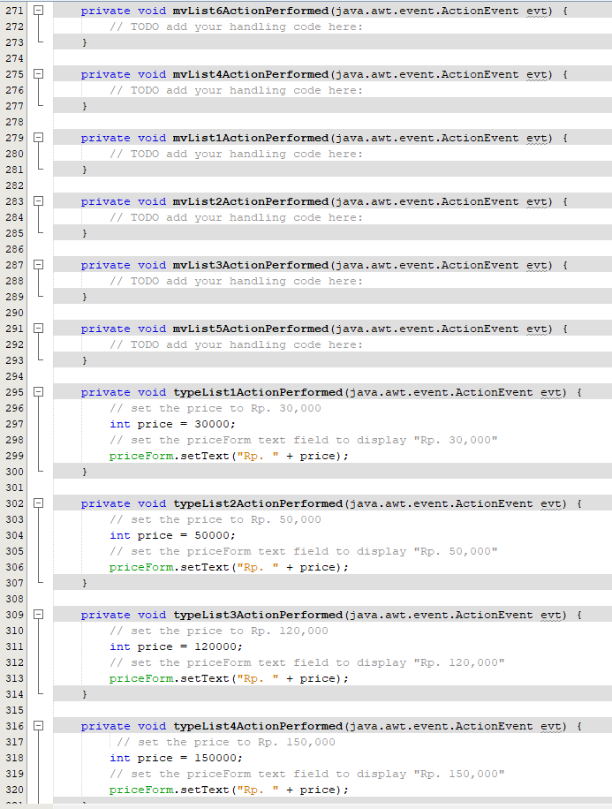

then this is the function creation for actionPerformed each variable

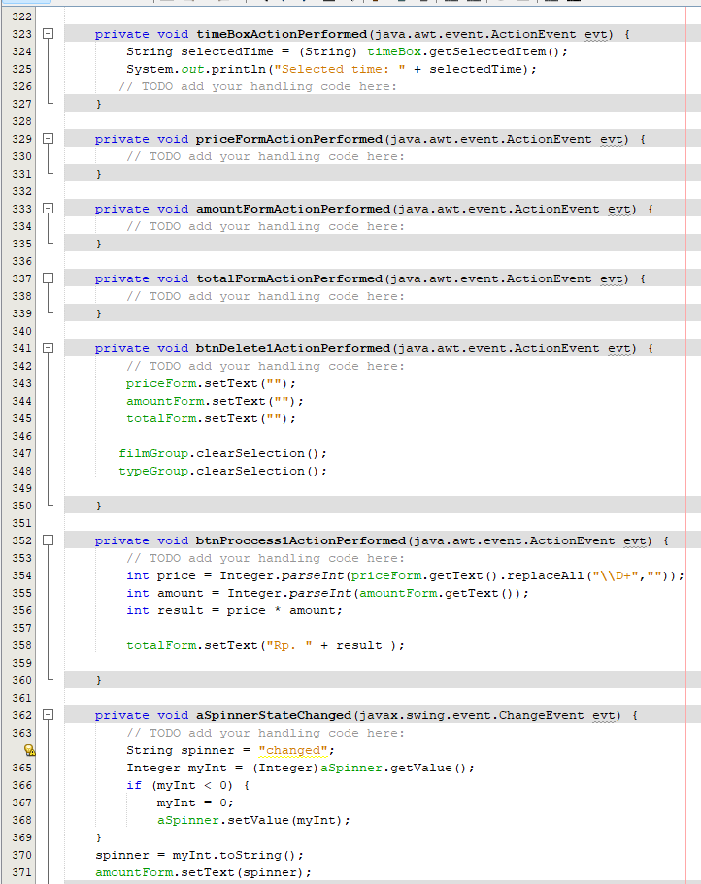

in this code we create a function for the button and also the broadcast time so that it can be selected

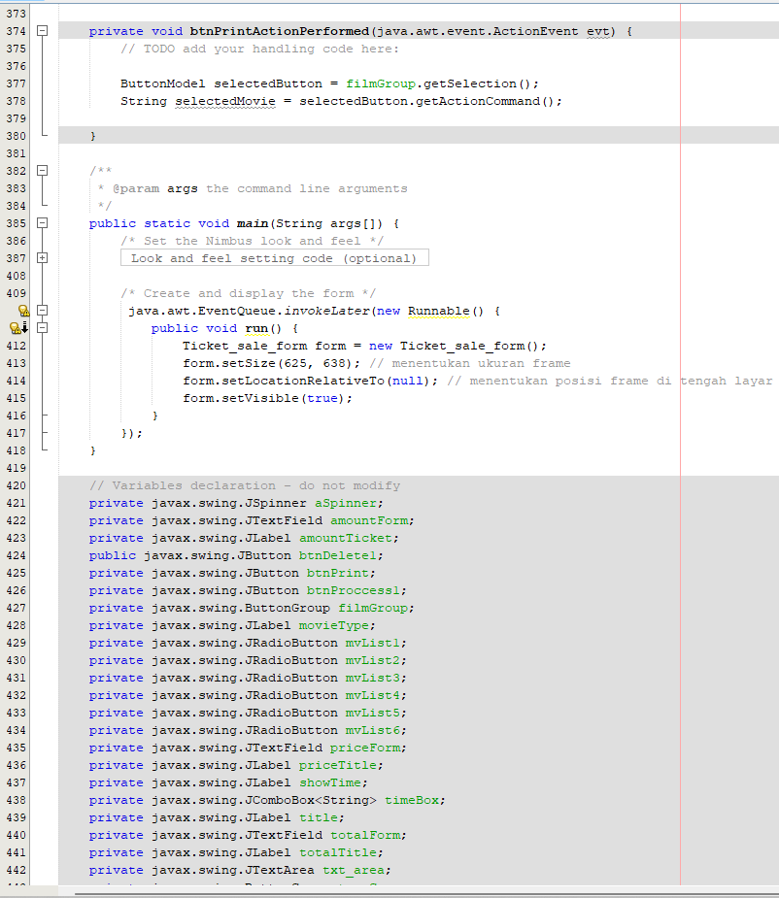

**IDLE**

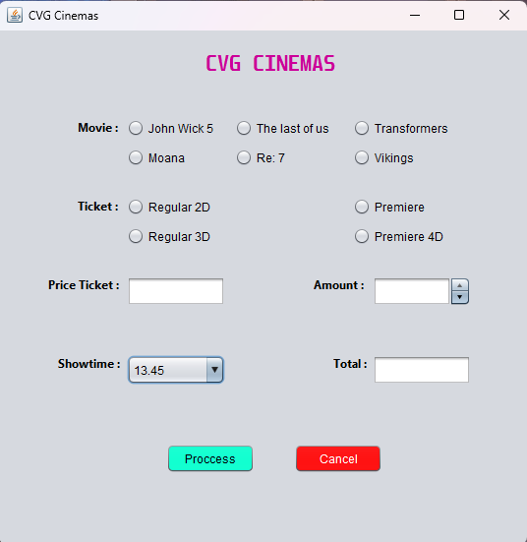

After running the code, this GUI will appear. here we can enter the data listed, such as choosing a film, type of ticket, number and showtime.

**OUTPUT PROGRAM**

**After Inputing Data**

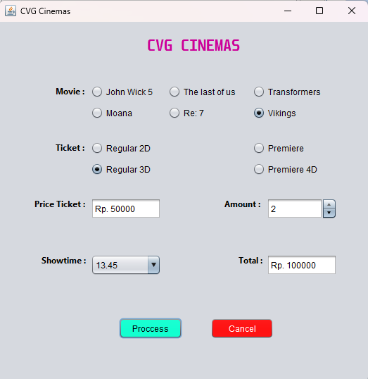

after we try to fill in data such as the type of ticket the program will automatically display the price of the ticket unit in the Price Ticket column. if you fill in the amount then press the process button it will automatically display the total cost

**Hardware : PC**

**Operating System : Windows 11**

**Software : NetBeans 8.2, Draw.io, Microsoft Power Point, Microsoft Word**

|  |  |  |
| --- | --- | --- |
| **PROJECT FILE DETAILS** | | |
| **No** | **File Name** | **Remarks** |
| 1 | CinemaTicket_Group10.rar | Java Program |
| 2 | CinemaTicket_Group10.docx | Word document |
| 3 | CinemaTicket_Group10.pptx | PowerPoint file |
| 4 |  |  |

**CONFIGURATION**

**Hardware :**

**Operating System :**

**Software :**

|  |  |  |
| --- | --- | --- |
| **PROJECT FILE DETAILS** | | |
| **S.No** | **File Name** | **Remarks** |
| 1 | Snake.cpp |  |

**CONFIGURATION**