

**PROJECT**

**Event Organizer Webserver with CI 3**

**Group 13**

Names :

1. Muhammad Ryan Cakranigrat

Class : 4 ISA 3

Faculty :

Listyo Edi Prabowo, S.T., M.T.

**CEP CCIT**

**FAKULTAS TEKNIK UNIVERSITAS INDONESIA**

**2023**

**PROJECT ON**

Event Organizer Webserver with CI3

**Developed by :**

* **Muhammad Ryan Cakraningrat**



**Event Organizer Webserver with CI3**

Batch Code : 4 ISA 3

Start Date : Tuesday, 01 August 2023  
End Date : Thursday, 10 August 2023

Name of Faculty : Listyo Edi Prabowo, S.T., M.T.

Names of Developer :

1. Muhammad Ryan Cakraningrat

Date of Submission :



**CERTIFICATE**

This is to certify that this report titled ” **Event Organizer Webserver with CI3**” embodies the original work done by Muhammad Ryan Cakraningrat. Project in partial fulfillment of their course requirement at NIIT.

Coordinator:

Listyo Edi Prabowo, S.Kom

\

\

**ACKNOWLEDGEMENT**



Thank you, the writer wishes to God the Almighty for His blessings, we can complete this Project about Object Oriented Programming entitled “**Event Organizer Webserver with CI3**” for Friendly task both in the form of presentation and paper in a timely manner. Thank you especially for Listyo Edi Prabowo, S.T., M.T. and another faculty who always help. Thank you also to fellow students who have supported, and also thank you for being fellow workers in the education at CCIT-FTUI.

The author realizes that in the preparation of this project there are still many shortcomings and far from perfection. Therefore, the authors expect constructive criticism and suggestion to improve this paper and can be a reference in preparing the papers or subsequent tasks.

Depok, August 2023

Author

\

**System Summary**

**System Summary :**

This website has two views: the front end for users and the backend for administrators. Essentially, this website is for event organization, and the user can register to enter an existing event by first logging in and then can user register for the event, but if the user has not registered, the user can register first in the column supplied. The admin can oversee event activities, check users, and control anyone who is interested in enrolling in the admin view.

**Front-End User View**

 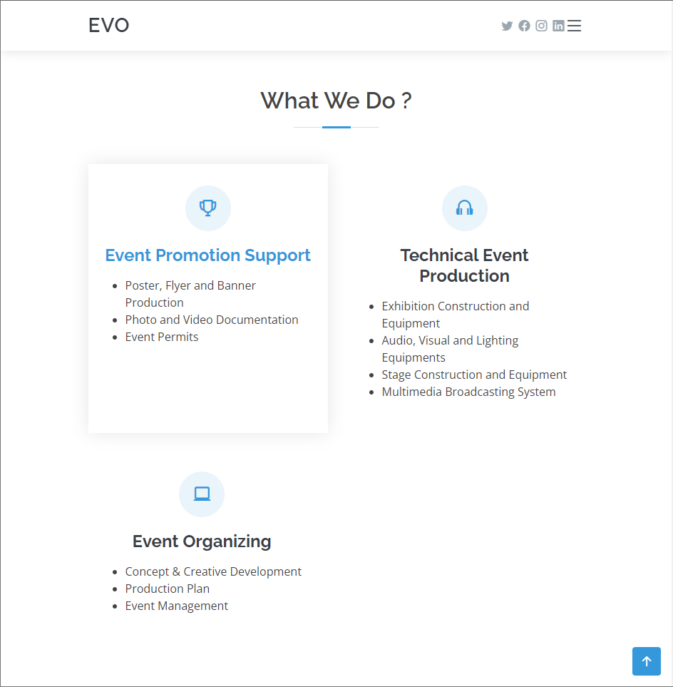

This is the first thing that appears when users open this website, and it also explains a little how to use it.

**OUTPUT PROGRAM**

**About us**

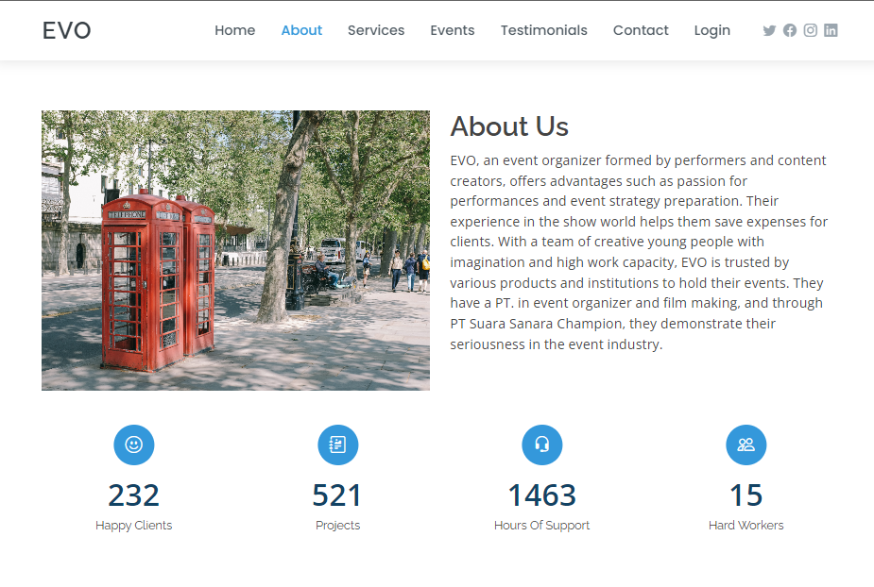

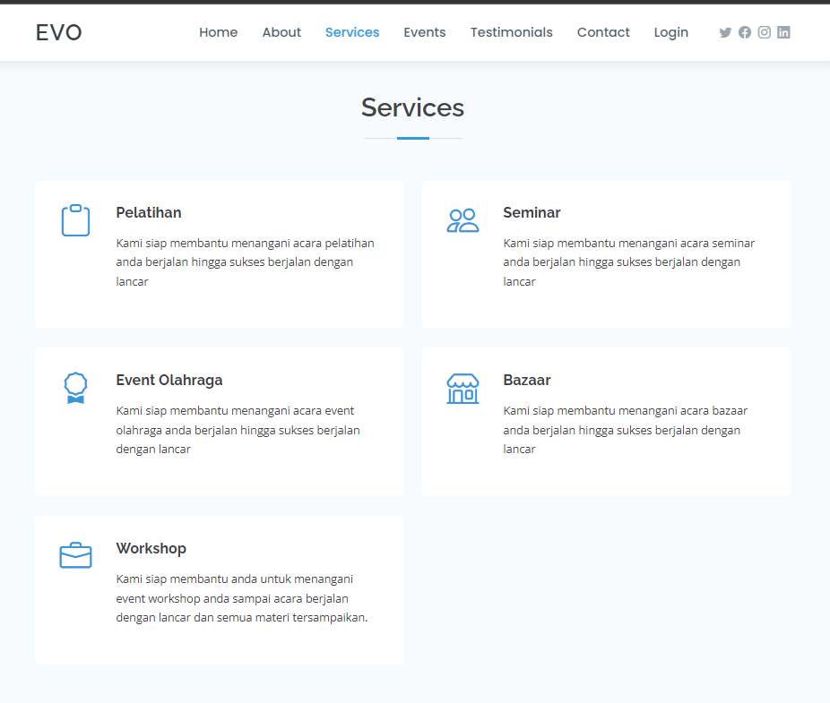

This is a design for a about us page that shows what EVO is like as a website.

**Events**

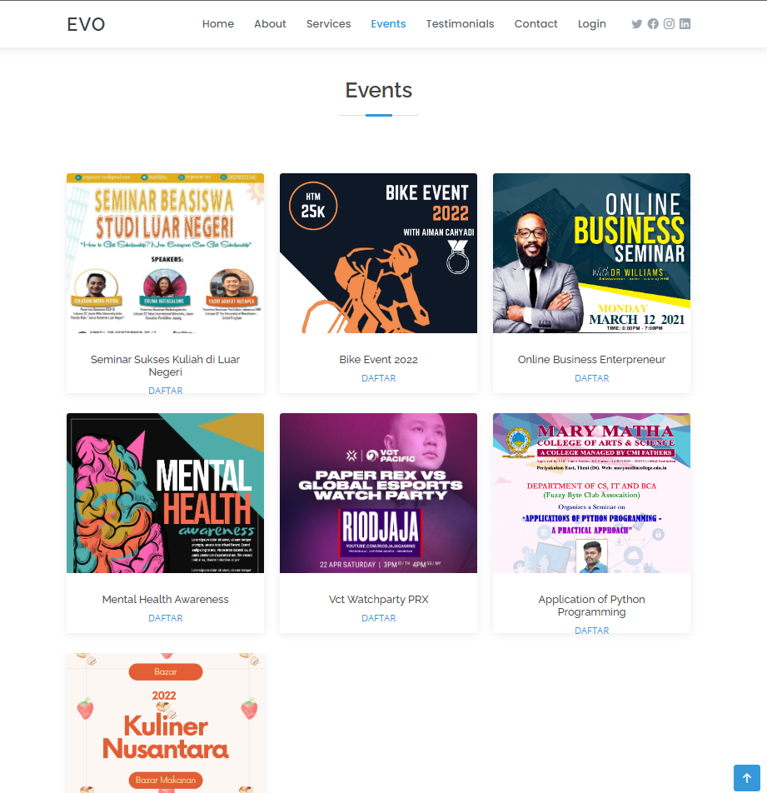 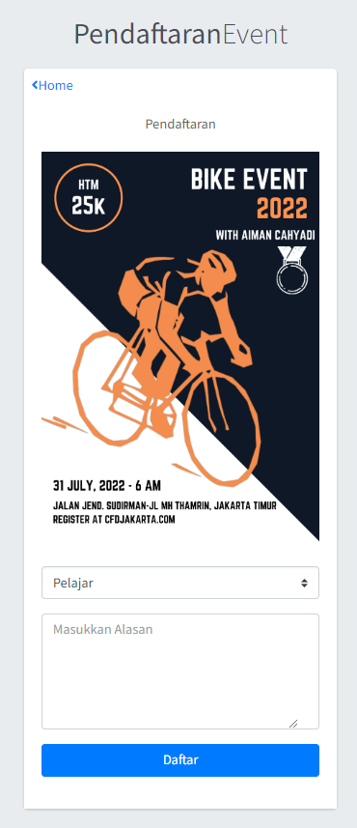

This is a list of events held; if the user wants to register for an event, they can click the register button and be redirected to the login/register page, where they must first log in. After login in, the user can select an event and then click the register button. A display will show based on the event that the user selected, and the user can then register for the event.

**Footer**

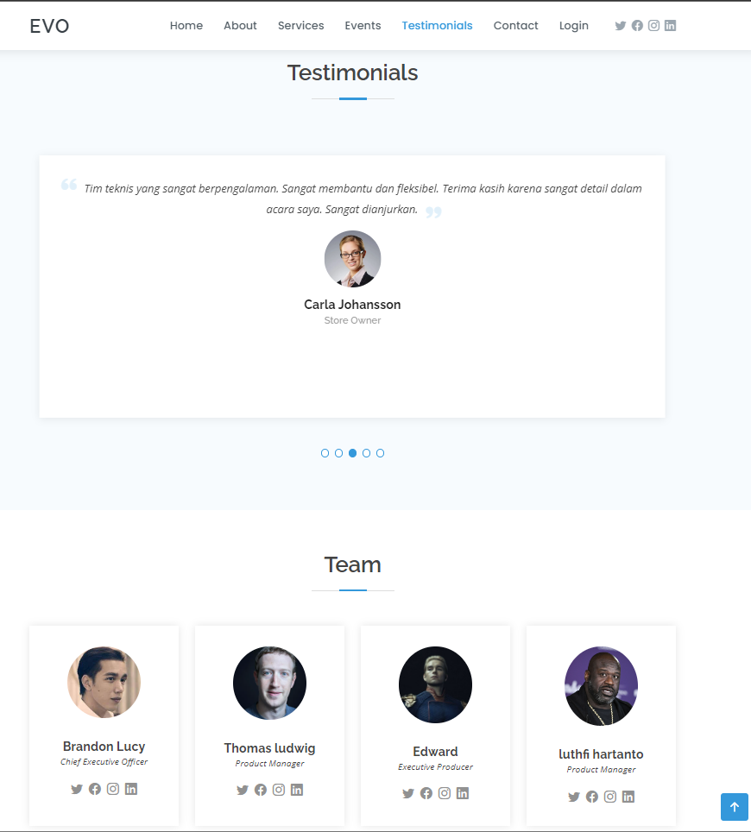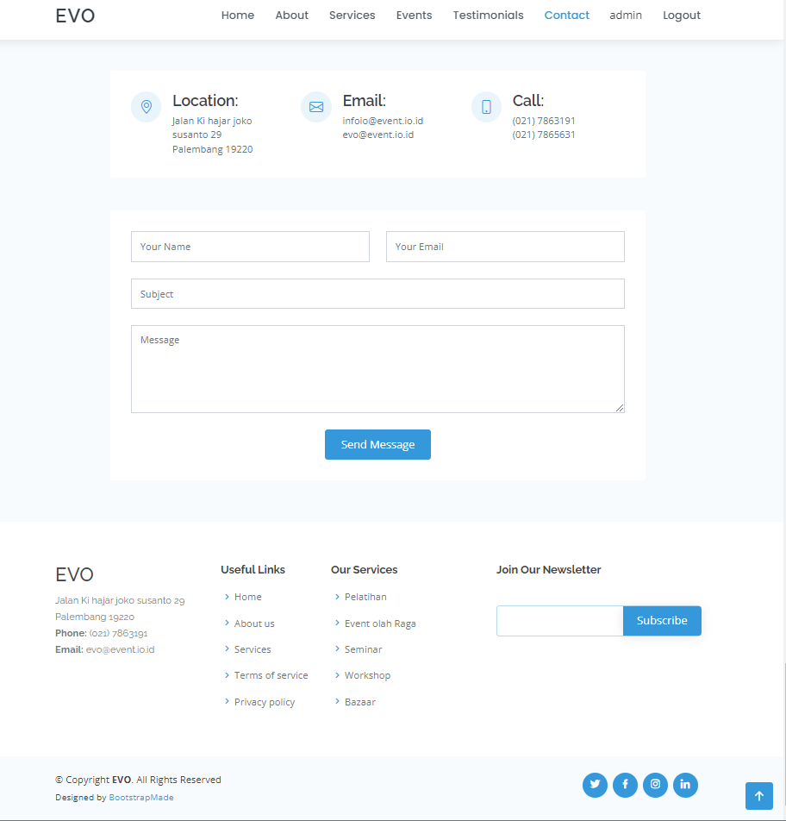

This is a display design for user testimonials, the team, and contacts, all of which are solely utilized to add detailed information to this website.

**Login & Register**

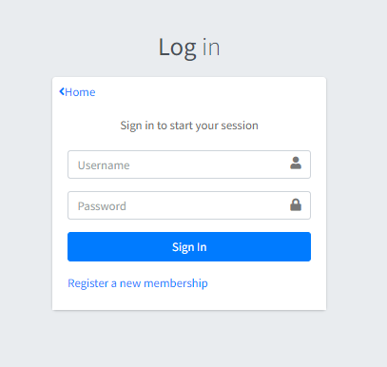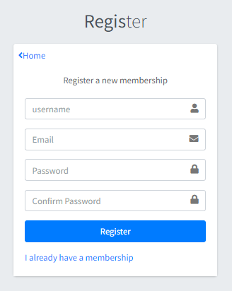

The following is a display for login and registration, which acts to store the user's input in the MySQL database and also to use it on the login method.

**Back-end Admin View**

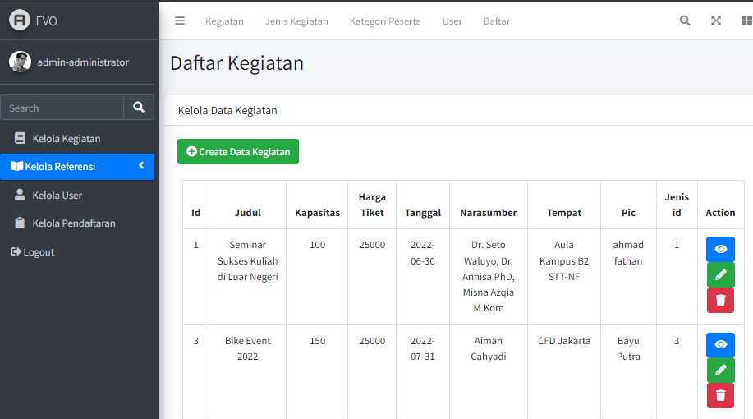

This is the administrator's display; from here, the administrator can navigate to the backend view by clicking the "backend" button. The admin can manage activities or events, manage users, and check who wants to register for an event in this backend mode.

**Hardware : PC**

**Operating System : Windows 11**

**Software : Xampp, Visual Code studio, Microsoft Power Point, Microsoft Word**

|  |  |  |
| --- | --- | --- |
| **PROJECT FILE DETAILS** | | |
| **No** | **File Name** | **Remarks** |
| 1 | evo-ci3_Group13.rar | Codeigniter 3 Program |
| 2 | evo_Group13.docx | Word document |
| 3 | evo_Group13.pptx | PowerPoint file |
| 4 |  |  |

**CONFIGURATION**

**Hardware :**

**Operating System :**

**Software :**

|  |  |  |
| --- | --- | --- |
| **PROJECT FILE DETAILS** | | |
| **S.No** | **File Name** | **Remarks** |
| 1 | Snake.cpp |  |

**CONFIGURATION**