DecideX
Smart Decision Making App
Mobile Application Development (MAD) Lab Project
Built with Kotlin · Android Studio · Firebase · SQLite
· Package: com.example.decidex

RYAN NESHAR
S041
J1 BATCH
MBATECH DATA SCIENCE
8/4/26

1. Introduction
DecideX is an Android app I built to solve a real problem — most people struggle to make decisions, especially when they're tired, stressed, or juggling multiple options. Instead of a random picker, DecideX uses a proper scoring system that considers your mood, urgency, goal, and how you personally rate each option.
The app was built in Kotlin using Android Studio. It has 10 screens (Activities), uses Firebase for login, SQLite to save decision history, and covers everything from Spinners and ListViews to dynamic UI and file reading.

One line summary: DecideX scores your options using a weighted formula based on importance, desire, effort, mood, urgency and goal — then explains why it picked the winner.

Key features at a glance:
- Firebase Authentication — login and register with email/password
- Rate each option on 3 axes: Importance, Desire, Effort (SeekBar sliders)
- Answer 3 context questions: Goal, Mood (Spinner), Urgency
- Weighted scoring formula calculates the best option
- Result screen is 100% built in Kotlin code — no XML layout file
- SQLite database saves all past decisions with timestamps
- File reader lets you import notes from .txt files on your device

2. App Screenshots
Below are screenshots of each screen in the app, showing the complete user journey from login to result.

2.1 Login and Register
The app opens to a login screen. Firebase handles everything — passwords are never stored locally. If you've logged in before, the app skips straight to home.
📷 Login Screen  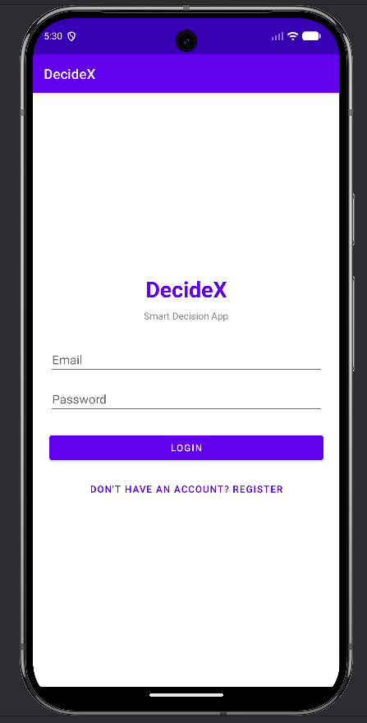 |  | 📷 Register Screen  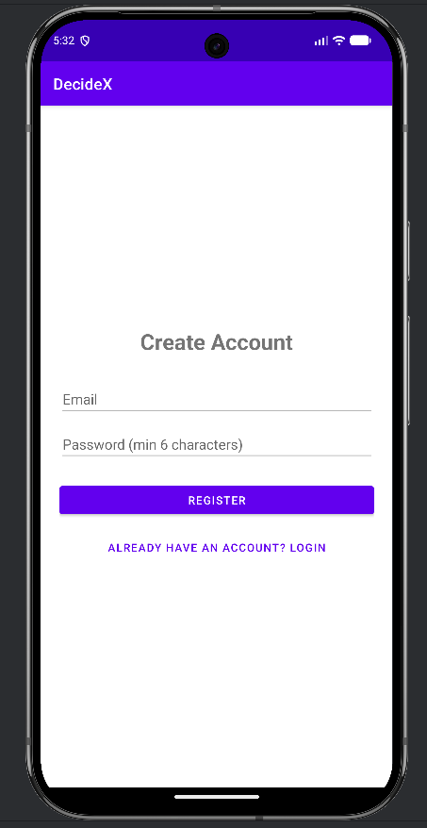

2.2 Home Screen
After login, the home screen shows your email and three options: start a new decision, view history, or import a text file. Tapping Logout shows a confirmation dialog first.
📷 Home Screen — showing user email, Make Decision, View History, Import Notes buttons

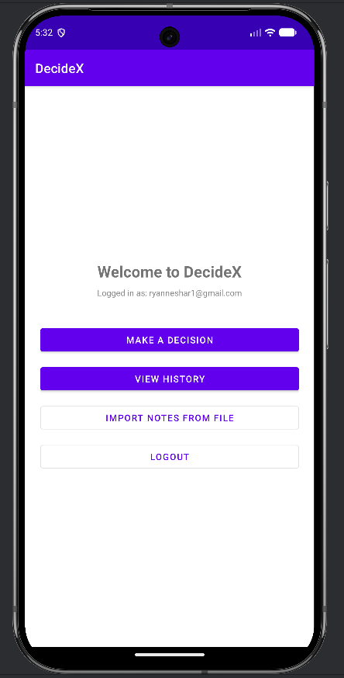

2.3 Add Options
You type each option and tap Add. The app adds it to a live ListView below. Minimum 2, maximum 4 options. It shows a Toast if you try to add more than 4.
📷 Input Screen — options being typed and listed in ListView

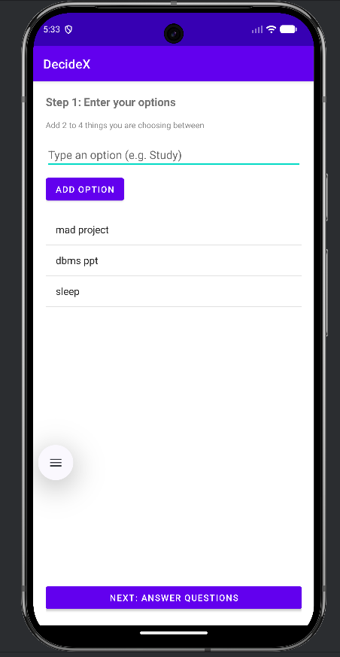

2.4 Rate Each Option
For every option you added, you drag three SeekBar sliders from 0-10. Importance means how much it matters. Desire is how much you actually want to do it. Effort is how hard it will be.
📷 Rating Screen — 3 SeekBars for one option, showing live values

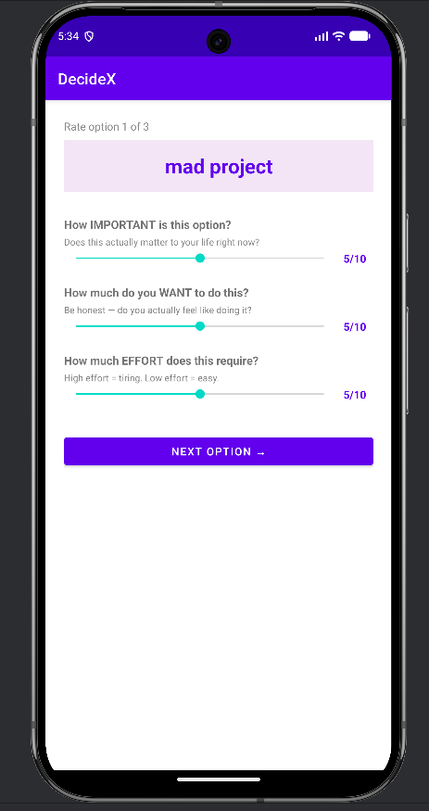

2.5 Questions Screen
This screen has three questions. You pick your Goal using buttons, select your Mood from a Spinner dropdown, and pick Urgency. A progress bar fills up as you answer each one.
📷 Question Screen — Goal buttons, Mood Spinner, Urgency buttons, ProgressBar

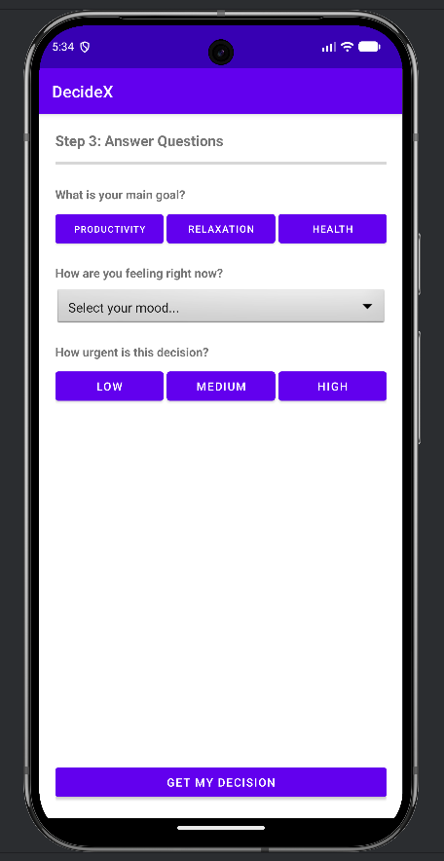

2.6 Result Screen
This entire screen is built in Kotlin code with no XML layout. It shows the winning option in a big box, explains why it won, and shows a GridLayout table comparing all options.
📷 Result Screen — winner box, reason text, GridLayout score table, Save/Retry/Home buttons

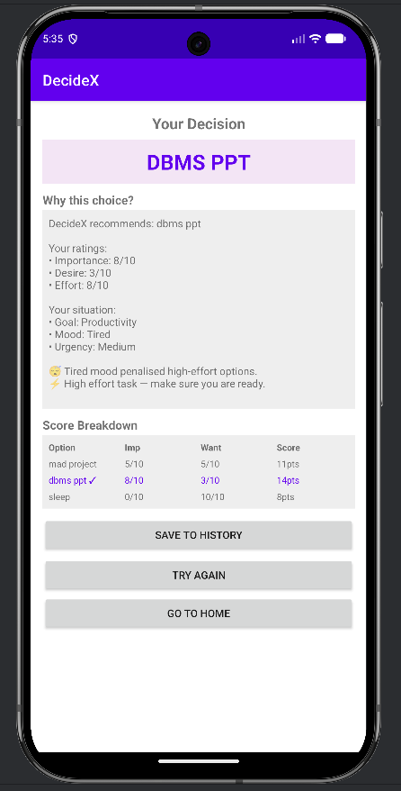

2.7 History Screen
All saved decisions are listed in reverse order with timestamps. Tapping Clear All shows an AlertDialog asking you to confirm before deleting everything.
📷 History Screen — list of past decisions  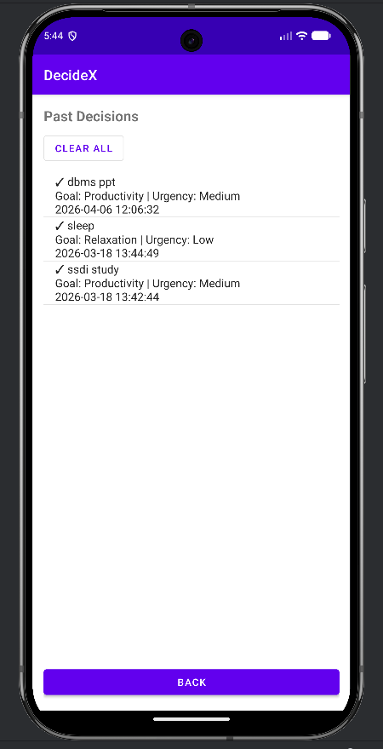 |  | 📷 AlertDialog — confirm clear all  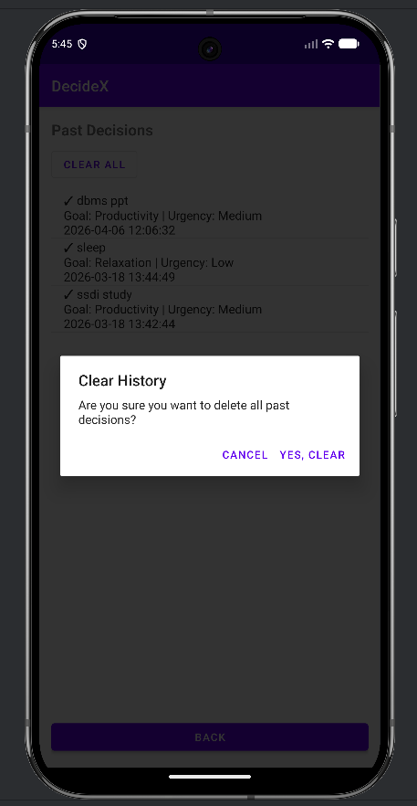

2.8 File Reader
Tapping Choose Text File opens the system file picker. After you select a .txt file, the app reads it and shows the content in a scrollable text area.
📷 File Reader — file picker button, file name, scrollable content

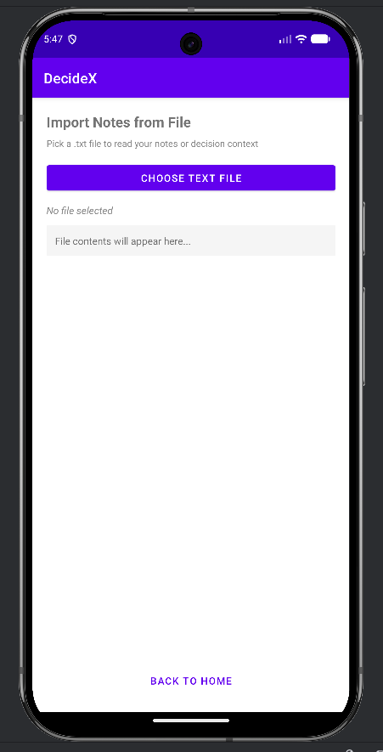

3. Project Structure
The project has 10 Kotlin files. Each file does one specific job — nothing is crammed together.

File | What it does
LoginActivity.kt | Firebase login — checks if already logged in and skips if so
RegisterActivity.kt | Creates new Firebase account with validation
MainActivity.kt | Home screen — shows email, navigation buttons, logout dialog
InputActivity.kt | Add options screen — ListView + ArrayAdapter
RatingActivity.kt | SeekBar sliders — loops through each option
QuestionActivity.kt | Goal + Mood Spinner + Urgency + scoring formula
ResultActivity.kt | Entire UI built in Kotlin — no XML layout file
HistoryActivity.kt | SQLite history list with AlertDialog on clear
FileReaderActivity.kt | File picker + BufferedReader to show .txt content
DecisionDbHelper.kt | SQLiteOpenHelper — creates table, insert, query, delete

The XML layouts folder has 9 files — one for each screen except ResultActivity, which has none.

4. Firebase Authentication
Firebase Authentication handles login and registration. Passwords are never stored in the app — Firebase manages everything securely over HTTPS.

4.1 Auto-login
When the app starts, LoginActivity checks if a session already exists. If it does, it skips the login screen entirely and goes straight to MainActivity:
override fun onStart() {
super.onStart()
// If already logged in, skip to main screen
if (mAuth.currentUser != null) {
startActivity(Intent(this, MainActivity::class.java))
finish()
}
}

4.2 Login
Firebase returns an async result. On success we go to main screen. On failure, Firebase gives a specific error message (like 'wrong password') which we show in a Toast:
mAuth.signInWithEmailAndPassword(email, password)
.addOnCompleteListener { task ->
if (task.isSuccessful) {
startActivity(Intent(this, MainActivity::class.java))
finish()
} else {
// Firebase gives helpful error messages automatically
Toast.makeText(this,
"Login failed: ${task.exception?.message}",
Toast.LENGTH_LONG).show()
}
}

4.3 Registration with validation
Before sending the request to Firebase, we check that the password is at least 6 characters. This gives instant feedback without wasting an API call:
if (password.length < 6) {
Toast.makeText(this, "Password must be at least 6 characters",
Toast.LENGTH_SHORT).show()
return
}
mAuth.createUserWithEmailAndPassword(email, password)
.addOnCompleteListener { task ->
if (task.isSuccessful) {
startActivity(Intent(this, MainActivity::class.java))
finish()
}
}

4.4 Logout with AlertDialog
The logout button shows a confirmation dialog before signing out. This prevents accidental logouts:
AlertDialog.Builder(this)
.setTitle("Logout")
.setMessage("Are you sure you want to logout?")
.setPositiveButton("Logout") { _, _ ->
mAuth.signOut()
startActivity(Intent(this, LoginActivity::class.java))
finish()
}
.setNegativeButton("Cancel", null)
.show()

5. Input and Rating Screens
5.1 Adding options — InputActivity
The user types each option and taps Add. Kotlin's when expression handles all three cases cleanly — empty input, too many options, or valid input:
btnAddOption.setOnClickListener {
val option = etOption.text.toString().trim()
when {
option.isEmpty() ->
Toast.makeText(this, "Please type an option first", Toast.LENGTH_SHORT).show()
optionsList.size >= 4 ->
Toast.makeText(this, "Maximum 4 options allowed", Toast.LENGTH_SHORT).show()
else -> {
optionsList.add(option)
adapter.notifyDataSetChanged() // Updates ListView instantly
etOption.setText("") // Clears field for next option
}
}
}

5.2 SeekBar ratings — RatingActivity
Normally, a SeekBar needs 3 methods implemented (onProgressChanged, onStartTrackingTouch, onStopTrackingTouch). Since we only use one of them, I wrote a helper function to cut the boilerplate:
// Helper: creates a SeekBar listener using just a lambda
private fun simpleListener(onChanged: (Int) -> Unit) =
object : SeekBar.OnSeekBarChangeListener {
override fun onProgressChanged(s: SeekBar?, p: Int, f: Boolean) = onChanged(p)
override fun onStartTrackingTouch(s: SeekBar?) {}
override fun onStopTrackingTouch(s: SeekBar?) {}
}

// Now wiring all 3 SeekBars takes 3 lines instead of 45:
sbImportance.setOnSeekBarChangeListener(simpleListener { tvImportanceVal.text = "$it/10" })
sbDesire.setOnSeekBarChangeListener(simpleListener { tvDesireVal.text = "$it/10" })
sbEffort.setOnSeekBarChangeListener(simpleListener { tvEffortVal.text = "$it/10" })

The screen doesn't start a new Activity for each option. Instead it reuses itself by calling loadOption(index) which resets the sliders and updates the option name:
private fun loadOption(index: Int) {
tvOptionName.text = "Rate option ${index + 1} of ${options.size}"
tvCurrentOption.text = options[index]
sbImportance.progress = 5 // Reset to neutral
sbDesire.progress = 5
sbEffort.progress = 5
// Change button label on the last option
btnNextOption.text = if (index == options.size - 1) "Done" else "Next Option →"
}

6. Questions Screen — Spinner and ProgressBar
QuestionActivity captures three things: Goal (buttons), Mood (Spinner from string-array), and Urgency (buttons). A ProgressBar fills as each is answered.

6.1 Spinner populated from strings.xml
The Mood spinner is populated from a string-array defined in strings.xml. This keeps the text separate from the code:
// strings.xml defines the mood options:
// <string-array name="mood_options">
// <item>Select your mood...</item>
// <item>Motivated</item> <item>Tired</item> <item>Stressed</item> ...
// </string-array>

val moodAdapter = ArrayAdapter.createFromResource(
this, R.array.mood_options, android.R.layout.simple_spinner_item
)
moodAdapter.setDropDownViewResource(android.R.layout.simple_spinner_dropdown_item)
spinnerMood.adapter = moodAdapter

spinnerMood.onItemSelectedListener = object : AdapterView.OnItemSelectedListener {
override fun onItemSelected(parent: AdapterView<*>, view: View?, position: Int, id: Long) {
// Position 0 is 'Select your mood...' — ignore it
selectedMood = if (position == 0) "" else parent.getItemAtPosition(position).toString()
updateProgress()
}
override fun onNothingSelected(parent: AdapterView<*>) {}
}

6.2 ProgressBar that fills as you answer
The progress bar max is 3 (one for each question). It counts how many fields are non-empty:
private fun updateProgress() {
progressBar.progress = listOf(selectedGoal, selectedMood, selectedUrgency)
.count { it.isNotEmpty() } // Count filled fields (0 to 3)
}

7. The Scoring Formula
This is the main innovation in DecideX. Instead of just adding up ratings, the formula applies weights based on what the user told us about their situation.

score = (importance × urgencyWeight) + (desire × moodWeight) − (effort × effortPenalty) + goalBonus

7.1 How the weights work
User Answer | Weight Value | What it does
Urgency = High | urgencyWeight = 3.0 | Triples the importance score
Urgency = Medium | urgencyWeight = 2.0 | Doubles the importance score
Urgency = Low | urgencyWeight = 1.0 | No change to importance
Mood = Tired | effortPenalty = 2.0 | High effort options lose a lot of points
Mood = Motivated | effortPenalty = 0.5 | Effort barely matters when energised
Mood = Stressed | effortPenalty = 1.5 | Medium penalty for effort
Goal = Productivity | goalBonus = importance × 1.5 | Boosts tasks you said were important
Goal = Relaxation | goalBonus = desire × 1.5 | Boosts things you actually want to do
Goal = Health | goalBonus = (imp+desire) × 0.8 | Balanced boost to both

7.2 Code
The full formula in calculateScores() inside QuestionActivity:
private fun calculateScores(): IntArray {
val urgencyWeight = when (selectedUrgency) {
"High" -> 3.0f; "Medium" -> 2.0f; else -> 1.0f
}
val energyWeight = when (selectedMood) {
"Motivated", "Excited" -> 1.5f; "Tired" -> 0.8f; else -> 1.2f
}
val effortPenalty = when (selectedMood) {
"Tired" -> 2.0f; "Stressed" -> 1.5f
"Motivated", "Excited" -> 0.5f; else -> 1.0f
}
return IntArray(options.size) { i ->
val importance = importanceRatings[i].toFloat()
val desire = desireRatings[i].toFloat()
val effort = effortRatings[i].toFloat()
var score = (importance * urgencyWeight) +
(desire * energyWeight) -
(effort * effortPenalty)
score += when (selectedGoal) {
"Productivity" -> importance * 1.5f
"Relaxation" -> desire * 1.5f
"Health" -> (importance + desire) * 0.8f
else -> 0f
}
maxOf(1, score.toInt()) // Minimum score of 1
}
}
This works for ANY option name — the user can type 'Cricket' or 'Assignment' and it scores correctly because we use the user's own ratings, not keywords.

8. Result Screen — Dynamic UI (No XML)
ResultActivity is the most interesting screen technically. There is no XML layout file for it. Every single element — ScrollView, TextView, GridLayout, Buttons — is created in Kotlin code.

8.1 Why build it in code?
The score breakdown table needs to show 2, 3, or 4 rows depending on how many options the user entered. An XML layout can't do that dynamically. Building in code means the UI adapts to any number of options automatically.

8.2 GridLayout score table
The score table uses Android's GridLayout with 4 columns. Each cell gets an equal width using fluid column specs:
val grid = GridLayout(this).apply {
columnCount = 4
setBackgroundColor(Color.parseColor("#EEEEEE"))
setPadding(16, 16, 16, 16)
}

// Local helper to add one cell without repetition
fun addGridCell(text: String, bold: Boolean = false, purple: Boolean = false) {
grid.addView(TextView(this).apply {
this.text = text
if (bold) setTypeface(null, Typeface.BOLD)
if (purple) setTextColor(Color.parseColor("#6200EE"))
layoutParams = GridLayout.LayoutParams().apply {
width = 0
columnSpec = GridLayout.spec(GridLayout.UNDEFINED, 1f) // Equal columns
}
})
}

// Header row
listOf("Option", "Imp", "Want", "Score").forEach { addGridCell(it, bold = true) }

// Data rows — winner highlighted in purple
options.forEachIndexed { i, opt ->
val isWinner = (i == bestIndex)
addGridCell(if (isWinner) "$opt ✓" else opt, purple = isWinner)
addGridCell("${importanceRatings[i]}/10", purple = isWinner)
addGridCell("${desireRatings[i]}/10", purple = isWinner)
addGridCell("${scores[i]}pts", purple = isWinner)
}

8.3 Linkify
One line of code makes any URLs in the reason text automatically clickable as hyperlinks:
// Linkify scans the text and auto-converts URLs to tappable links
Linkify.addLinks(tvReason, Linkify.WEB_URLS)

9. SQLite Database — DecisionDbHelper
DecisionDbHelper extends SQLiteOpenHelper to manage a local database. It creates the table, inserts records, queries them, and deletes them all.

9.1 Table schema
CREATE TABLE decisions (
id INTEGER PRIMARY KEY AUTOINCREMENT,
options TEXT, -- all options comma-separated
result TEXT, -- the winning option
goal TEXT, -- Productivity / Relaxation / Health
energy TEXT, -- mood at time of decision
urgency TEXT, -- Low / Medium / High
date_time DATETIME DEFAULT CURRENT_TIMESTAMP
)

9.2 Insert and query
Insert uses ContentValues so there's no risk of SQL injection. The query returns results newest-first:
fun insertDecision(options: String, result: String,
goal: String, energy: String, urgency: String) {
val values = ContentValues().apply {
put(COL_OPTIONS, options)
put(COL_RESULT, result)
put(COL_GOAL, goal)
put(COL_ENERGY, energy)
put(COL_URGENCY, urgency)
}
writableDatabase.insert(TABLE, null, values)
}

fun getAllDecisions(): ArrayList<String> {
val cursor = readableDatabase.rawQuery(
"SELECT * FROM $TABLE ORDER BY $COL_ID DESC", null
)
// ... read cursor and return list
}

9.3 Clear with AlertDialog
Clearing history shows a confirmation dialog. Without this, one wrong tap would delete everything:
btnClearHistory.setOnClickListener {
AlertDialog.Builder(this)
.setTitle("Clear History")
.setMessage("Are you sure? This deletes all past decisions.")
.setPositiveButton("Yes, Clear") { _, _ ->
db.clearAll()
loadHistory() // Refresh the list
}
.setNegativeButton("Cancel", null)
.show()
}

10. File Reader — Reading Text Files
FileReaderActivity lets you pick any .txt file from your device and read it in the app. This uses Android's Storage Access Framework (SAF) which works without needing storage permissions.

10.1 Opening the file picker
btnPickFile.setOnClickListener {
val intent = Intent(Intent.ACTION_GET_CONTENT).apply {
type = "text/plain" // Show only text files
addCategory(Intent.CATEGORY_OPENABLE)
}
startActivityForResult(
Intent.createChooser(intent, "Select a text file"),
FILE_PICK_CODE
)
}

10.2 Reading the file content
Once a file is selected, we use ContentResolver to get the name and BufferedReader to read the content:
private fun readTextFile(uri: Uri) {
// Get the file name
contentResolver.query(uri, null, null, null, null)?.use { cursor ->
if (cursor.moveToFirst()) {
val nameIdx = cursor.getColumnIndex(OpenableColumns.DISPLAY_NAME)
if (nameIdx >= 0) tvFileName.text = "File: ${cursor.getString(nameIdx)}"
}
}
// Read the full file content
val content = contentResolver.openInputStream(uri)?.use { stream ->
BufferedReader(InputStreamReader(stream)).readText()
}
tvFileContent.text = content ?: "File is empty"
}

11. Practicals Coverage
This table maps every practical from the syllabus to where it appears in DecideX:

P# | Feature | Where | Detail
P1 | LinearLayout + RelativeLayout | All screens | Question screen uses RelativeLayout
P1 | onClick listeners on Activity | Every Activity | All buttons registered to Activity class
P2 | Spinner + string-array | QuestionActivity | Mood dropdown from strings.xml array
P2 | Spinner listener | QuestionActivity | onItemSelectedListener skips position 0
P3 | Multiple Activities + Intents | All 10 screens | Data passed via putExtra / getExtra
P3 | ListView + ArrayAdapter | Input + History | notifyDataSetChanged on add
P3 | Linkify | ResultActivity | Linkify.addLinks() on reason text
P4 | File picker + read text file | FileReaderActivity | SAF + BufferedReader
P5 | Dynamic Activity (no XML) | ResultActivity | 100% Kotlin View API
P5 | Passing data between screens | All Activities | Intents with String + IntArray extras
P8 | GridLayout | ResultActivity | 4-column score table built in code
P8 | SQLite | DecisionDbHelper | Insert, SELECT, DELETE operations
P8 | Dialog Boxes | Main + History | AlertDialog on logout and clear
P9 | Firebase Authentication | Login + Register | Email/Password, session persistence

12. Challenges and How I Fixed Them

Challenge 1 — Passing data across 4 screens
Problem: After the user enters options, rates them, and answers questions — all that data needs to reach the Result screen. That's 3 string arrays and 3 int arrays passing through 4 Activities.
Solution: Everything is passed via Intent extras. putExtra / getIntArrayExtra handles int arrays. Each Activity receives exactly what it needs and passes everything forward.

Challenge 2 — Making the scoring formula fair
Problem: If you just add up ratings, a tired person and a motivated person get the same result for the same option. That's not realistic.
Solution: The weights change based on mood and urgency. When you're tired, effort is penalised twice as much. When urgency is high, importance is multiplied by 3. The same ratings produce different results depending on your situation — which is the point.

Challenge 3 — Dynamic result screen
Problem: The score table needs 2, 3, or 4 rows depending on how many options were entered. A fixed XML layout can't do this without messy visibility toggling.
Solution: The whole screen is built in Kotlin. GridLayout.spec(UNDEFINED, 1f) distributes columns equally no matter how many options there are.

Challenge 4 — SeekBar boilerplate
Problem: Each SeekBar needs a listener with 3 methods. For 3 SeekBars that's 9 methods and about 45 lines for what is basically just 'update this label when slider moves'.
Solution: A simpleListener helper function takes a lambda and returns the full listener object. Three SeekBars wired in three lines.

13. Conclusion
DecideX covers all the major Android topics from the MAD syllabus — Firebase, SQLite, Spinner, ListView, dynamic UI, file reading, dialogs, Linkify — but they're all connected into one app that actually does something useful.
The weighted scoring formula is what makes it different from a basic lab submission. It works for any option name because it uses the user's own ratings rather than keyword matching. The result explanation tells you exactly why the app picked what it picked.

DecideX — built in Kotlin, 10 Activities, Firebase Auth, SQLite, dynamic Result screen, custom scoring formula.

