How to Play

Characters
A character refers to an enemy, player, or boss.

Battle Index
The battle index is a measure of how powerful a character is. It is calculated by adding all of the character's armored stats (stats gained from armor plus basic stats).
The battle index for a level 1 warrior is 283.

Point Gain
When an enemy is slain, points get added to a counter in the current level. When the amount of points is greater than or equal to the user-defined max points, the boss fight for that level will start
The amount of points gained from killing an enemy is equal to 1/10th the enemy's battle index.

Stats
A character’s stats refers to the statistics of various aspects of that character. Stats include the following.

Health
When a character's health reaches 0, the character dies. Health is also referred to as HP.
For reference, a warrior's base health is 200, the mage's base health is 150, and the scout's health is 100.

Mana
Mana determines what attacks a character can use. When using an attack that uses mana, the attack's mana is subtracted from the player's mana pool.
A character may choose to recover their mana. When they do, 30% of their max mana is restored and their turn is ended.
For reference, a warrior has a base mana of 20, a mage has a base mana of 100, and a scout has a base mana of 55.

Defense
Defense is subtracted from oncoming damage. It does not negate damage received from buffs or any attacks with the tag Ignores Armor.
For reference, a warrior has a base defense of 20, a mage has a base defense of 2, and a scout has a base defense of 2.

Damage
A character’s damage is added to every attack they use. Damage does not affect the damage of buffs.
For reference, a warrior has a base damage of 13, a mage has a base damage of 5, and a scout has a base damage of 17.

Speed
Speed determines how fast a character can attack. Each active character has a timer assigned to it, and the speed of which the timer increases is proportional to the speed of the character. When the timer reaches its maximum value, the character that it is assigned to is able to make a turn.
In case of a tie, the characters each have a turn in order of spawn (characters near the front get to go first) with preference given to the players.
For reference, a warrior has a base speed of 10, a mage has a base speed of 14, and a scout has a base speed of 35.

Intelligence
Intelligence currently has no function.
For reference, a warrior has a base intelligence of 20, a mage has a base intelligence of 100, and a scout has a base intelligence of 55.

Turns and Rounds
A turn is a unit of time where a character can perform one attack, movement, mama replenishment, or consumption/equipping of an item.
A round is a unit of time equal to two turns. After a character's round is up, control is passed to the next character.
Each active character has a timer assigned to it, and the speed of which the timer increases is proportional to the speed of the character. When the timer reaches its maximum value, the character that it is assigned to is able to make a turn.
In case of a tie, the characters each have a turn in order of spawn (characters near the front get to go first) with preference given to the players.

Common Problems

Why Are There Two Save Files?
One save file (map.xml) is used to track player progress in the game. The other (map-static.xml) is used for editing the map. Whenever a change is made in the Map Editor, the change is reflected in map-static.xml when the edited map is saved. When reseting/exporting the map, map.xml is overwritten by map-static.xml.

Error: Save File Cannot Be Read!
This error can be caused by the manual editing of the save files or by corruption of the save files. If this error is caused after editing map.xml, reseting/exporting the map should fix the error. Otherwise, use the save file for the campaign as a template for rebuilding your save file.

Creating Your First Map

Creating A Map
To create a map, click on the Create New Custom Map button located on the homepage. After you select a location to create the map, you will be redirected to the Map Creator where you can create your map. Remember to save the map before closing the editor. </Paragraph>

Playing A Custom Map
To play a custom map, you must first reset/export your map by clicking on the Reset/Export button and selecting the map save file if necessary. This will reset the map to ensure any progress you make from testing the map does not make it into the final product.
If you do want to play-test your map, edit the map.xml file to give your character items, buffs, ect.

Sprites And Icons
Select templates for sprites (map images) and icons can be found within the Art folder.

Sprites And Map Images
What would normally be referred to as a sprite will now be referred to as a map image. Anything that can be seen on a battle field is assigned a map image. This includes enemies, players, bosses, and even the background of maps.
Most character map images are 48 pixels by 48 pixels in size. An exception is the map’s and level’s map images, which can be as big as desired.

Icons
Icons are used in this game as they are used in any other game. Icons typically are 48 by 48 pixels in size.

Active Regions
An active region defines a region that, if adhered to, will insure that armor and weapons will be displayed properly on the character. Also see Sprites And Icons.
Note that active regions only apply to characters marked as humanoid or slime.

Active Regions For Armor
When creating armor, you must adhere to the following active regions. You can find specifications to each region below. The location is measured from the top left of the player and is measured in pixels. The size is also measured in pixels.
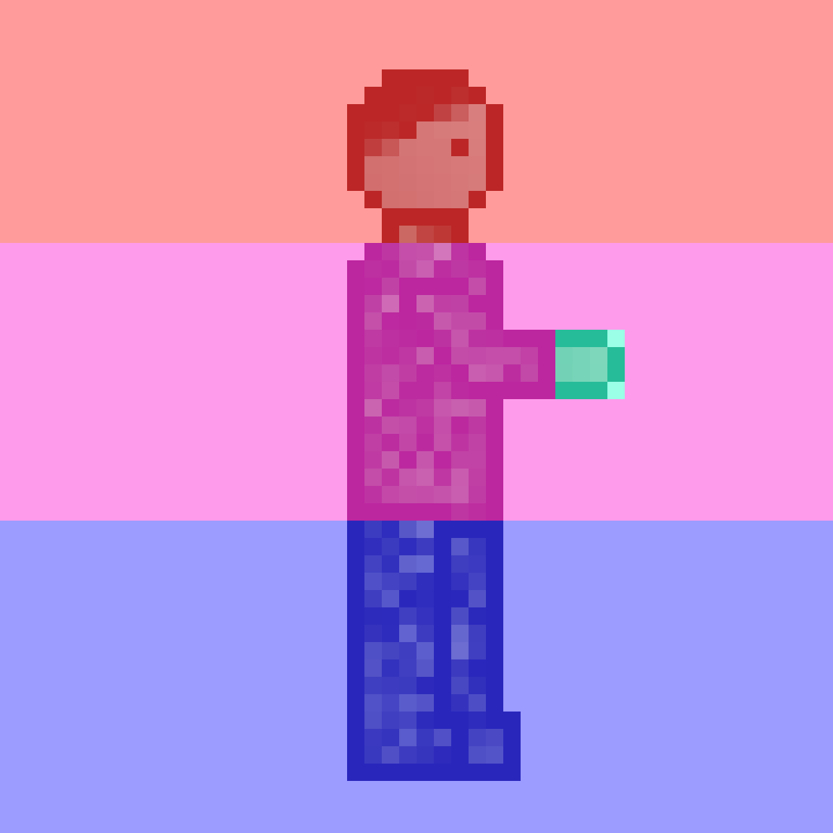

Helmet
On humanoids, the helmet is drawn in the red region as shown above.
- Location: 0, 0
- Size: 48, 14
When creating the map image for the helmet, first create a PNG that is 48 pixels wide and 14 pixels tall to ensure compliance with the active regions. That image will be overlaid on top of the red region as shown above.

Torso
On humanoids, the torso is drawn in the pink region as shown above.
- Location: 0, 14
- Size: 48, 16
When creating the map image for the torso, first create a PNG that is 48 pixels wide and 16 pixels tall to ensure compliance with the active regions. That image will be overlaid on top of the pink region as shown above.

Legs
On humanoids, the legs are drawn in the blue region as shown above.
- Location: 0, 14
- Size: 48, 16
When creating the map image for the legs, first create a PNG that is 48 pixels wide and 18 pixels tall to ensure compliance with the active regions. That image will be overlaid on top of the blue region as shown above.

Weapon Connection Point
The weapon connection point specifies the point where the handle is for the weapon. That region of the humanoid, excluding transparent pixels, will be copied over the image of the weapon to give the weapon the appearance of being held.
The weapon connection point for humanoids is fixed and cannot be moved.

Active Regions For Weapons

Weapon Connection Point
The weapon connection point specifies the point where the handle is for the weapon. That region of the humanoid, excluding transparent pixels, will be copied over the image of the weapon to give the weapon the appearance of being held.
To select the weapon connection point, enter in the top left most pixel you want the weapon connection point to be drawn.

