We ran the standard Bubble sort with the following code

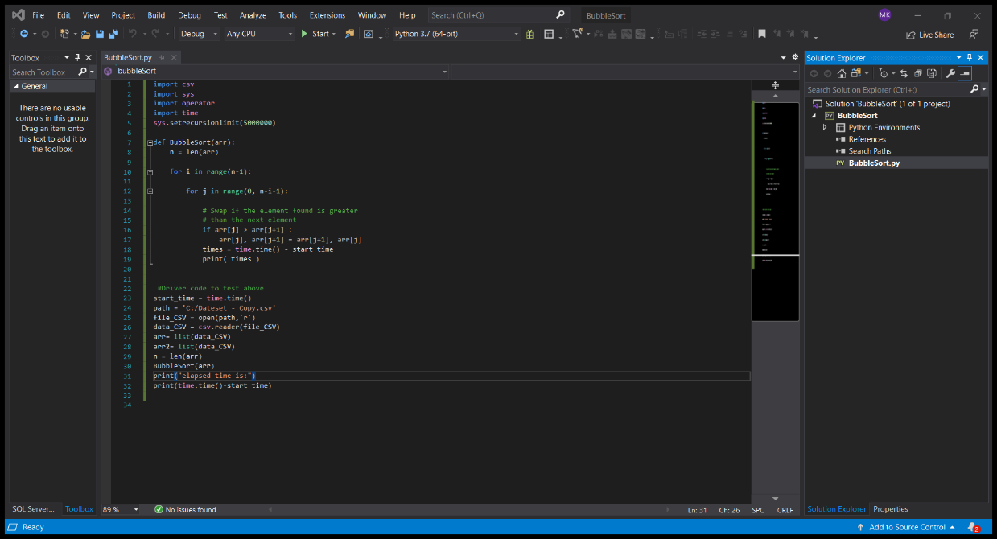

Time per run through of code is 0.004129171371459961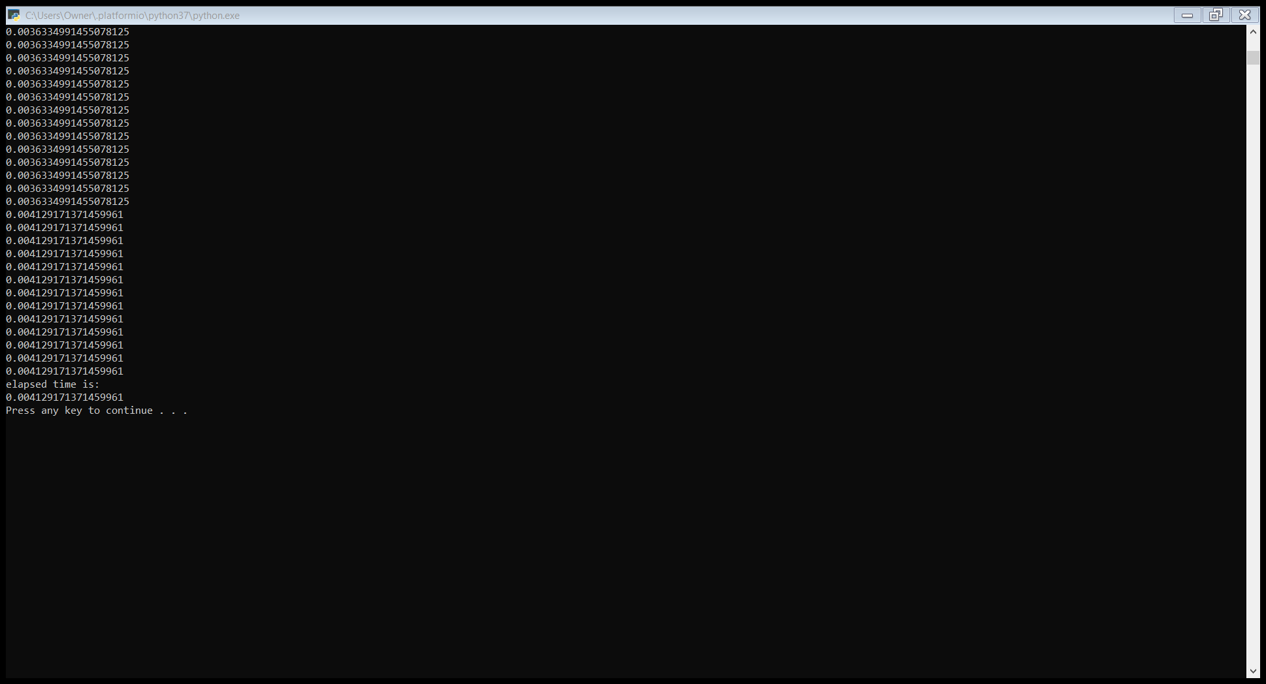

With 318,439 entries to sort, this equates to being about 1314 seconds