CS2430 OOPSI Spring 2019
Program #2 (20 points + 10 points + 5 bonus points)

Due Dates
Due date: Wednesday, March 13 @ 11:59pm

Grace date: Friday, March 15 @ 11:59pm

Program Description and Requirements

For this program, new features are going to be added to the Department Management System you implemented for program1.

- In addition to DepartmentManagement.java, Department.java, and Professor.java, design three more classes: Person.java, Student.java, and Course.java. Make class Person abstract and make class Professor and class Student the subclasses of Person. Prog2.java will be provided.

- Class Course maintains a course id (e.g., cs2430 or se3430), a course title (e.g., oops1 or software engineering), a list of students registered in this course, and a professor who teaches the course. Let’s assume a course can only be taught by one professor. Please override toString() that may be called in several different places.

- In class Department, you can only have one array of type Person holding all Professor and Student references. It will be very difficult to match the desired output if you maintain a Professor array and a Student array respectively. It is designed this way to give you an opportunity to better understand how polymorphism works.

- Class Person is an abstract class that contains an abstract method: public abstract void register(Course crs); Class Professor and Student have to provide implementation for the method. Registration in a course means differently for a student and for a professor, so the method in class Professor and Student has to be implemented differently. The client code calling the method doesn’t need to differentiate whether a person is a professor or a student. It is the place where polymorphism works.

- In class Department, you also need to maintain a list of courses. The user should be able to list all courses and add a new course. You don’t need to support deleting a course.

- No duplicate ids are allowed for both professors and students, which means there are no two people having the same id on campus. Unlike program1, this time you need to check duplicates for people in all departments.

- The id of a student or a professor has to contain 5 digits. No other type of characters is allowed.

- Please refer to figure1 and Sample Input and Output for the menu design. In the main menu, the user will firstly be asked to enter a department name (or quit), which leads to the second level menu: 1) manage people, 2) manage course, 3) register a course for a person, 4) return to upper menu.

  - The first item manage people is selected by entering MP which leads to 1) list all people (show a list of all professors and students in the department), 2) add a person (ask the user to provide name, id, and select a role of either a student or a professor), 3) delete a person (ask the user to enter the id), and 4) return to upper menu.

  - The second item manage course is selected by entering MC which leads to 1) list all courses (show a list of all courses in the department), 2) add a course (ask the user to provide a course id and a course title), 3) return to upper menu.

  - The third item register a course for a person is selected by entering RC. The user needs to provide the id of either a professor or a student and the course id. This is where the overriding method register (Course crs) is called to register a student or a professor.

- If the user enters a department name, you should first check if the department has already existed in the department list. If not, add the new department into the list, otherwise pull out all data associated with the department.

- Design test cases to perform both system testing and module testing for your program. (10 points) Please refer to the attached template to create a test specification of your own. It is required that you put a testbed main into class Department and Course and run the test cases you created for methods in the two classes. The test specification should be submitted to D2L before the due date.

- Please submit your program to prog2bonus to get the 5 points for bonus. The extra work needs to deal with invalid input with exceptions and add another abstract method into class Person: public abstract void unRegister(Course crs); Note that after deleting a student or professor, you need to unregister her from all courses she has already registered. Please refer to the last dataset.
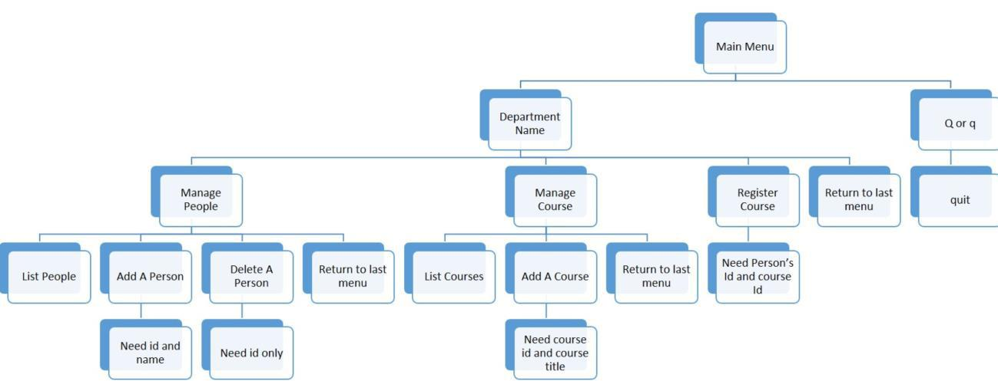

Figure 1. Menu design for the Department Management System
Notes:
- You MUST follow the software development ground rules that is available in D2L. Points off if not.

- Fully test your program before submission.

- All programs should be submitted to Grader before due date and the test specification should be submitted to D2L. If you submit after due date and before grace date you will get 20% off the grade; Programs submitted after the grace date will get 0!

- You MUST use SE tools to keep an up-to-date log of the time spent working on this program. You must use the automatic punch in and punch out when possible. Select the activities and provide specific comments about what you worked on during that period. Up to -5 points if this is not done or you do not log all your time or you do not provide specific comments as to what you were working on.

Sample Input and Output:
Department Management System is running...!
Mainmenu: please enter a department name or enter Q to quit:

EE

Please enter

MP to manage people,
MC to manage course
RC to register a course for a person
RM to return to upper menu
mp

Please enter

LP to list all people,
AP to add a person,
DP to delete a person

RM to return to upper menu
lp

No people in the list. Add a student or professor first.

Please enter

LP to list all people,
AP to add a person,
DP to delete a person
RM to return to super menu
dp

The people list is empty.

Please enter
LP to list all people,
AP to add a person,

DP to delete a person
RM to return to upper menu

ap
Please enter name:
Joe

Please enter id:
11111
Please select the role of the person by entering 1 or 2: 1.Student,
2.Professor
2

The person you just added: Professor: name=Joe and id=11111

Please enter

LP to list all people,
AP to add a person,
DP to delete a person
RM to return to upper menu
ap

Please enter name:
Luke
Please enter id:
22222

Please select the role of the person by entering 1 or 2: 1.Student,

2.Professor
1
The person you just added: Student: name=Luke and id=22222

Please enter

LP to list all people,
AP to add a person,
DP to delete a person
RM to return to upper menu
ap

Please enter name:
Tom
Please enter id:
33333

Please select the role of the person by entering 1 or 2: 1.Student,

2.Professor
1
The person you just added: Student: name=Tom and id=33333

Please enter

LP to list all people,
AP to add a person,
DP to delete a person
RM to return to upper menu
dp

Please enter the person's id:
33333
The person with id = 33333 was deleted.

Please enter

LP to list all people,
AP to add a person,
DP to delete a person
RM to return to upper menu
lp

Professor: name=Joe and id=11111
Student: name=Luke and id=22222

Please enter
LP to list all people,
AP to add a person,
DP to delete a person
RM to return to upper menu
rm
Please enter
MP to manage people,

MC to manage course
RC to register a course for a person
RM to return to upper menu
mc

Please enter
LC to list all courses,
AC to add a course,
RM to return to upper menu
lc

No course in the list. Add a course first.

Please enter
LC to list all courses,
AC to add a course,

RM to return to upper menu
ac
Please enter course id:
cs2430
Please enter course title:

oops1
The course was added: cs2430, oops1

Please enter
LC to list all courses,
AC to add a course,
RM to return to upper menu
lc
Course information: cs2430, oops1

Please enter
LC to list all courses,
AC to add a course,
RM to return to upper menu
rm

Please enter

MP to manage people,
MC to manage course
RC to register a course for a person

RM to return to upper menu
rc

Please enter an id of a student or a professor:
11111
Please enter course id:

cs2430
Registration was successfully.
Course information: cs2430, oops1
Professor: name=Joe and id=11111

Please enter
MP to manage people,
MC to manage course
RC to register a course for a person
RM to return to upper menu
rc
Please enter an id of a student or a professor:

22222
Please enter course id:
cs2430
Registration was successfully.
Course information: cs2430, oops1

Professor: name=Joe and id=11111
Student: name=Luke and id=22222

Please enter
MP to manage people,
MC to manage course
RC to register a course for a person
RM to return to upper menu
mc

Please enter
LC to list all courses,
AC to add a course,
RM to return to upper menu
lc

Course information: cs2430, oops1
Professor: name=Joe and id=11111
Student: name=Luke and id=22222

Please enter

LC to list all courses,
AC to add a course,
RM to return to upper menu
rm

Please enter
MP to manage people,
MC to manage course
RC to register a course for a person
RM to return to upper menu

rm

Mainmenu: please enter a department name or enter Q to quit:

q
Thanks for using Department Management System!

