Documentation

Dungeons and Dragons Team

By Peter Hiesel and Ryan Costello

**Original Design and Flow Diagrams**

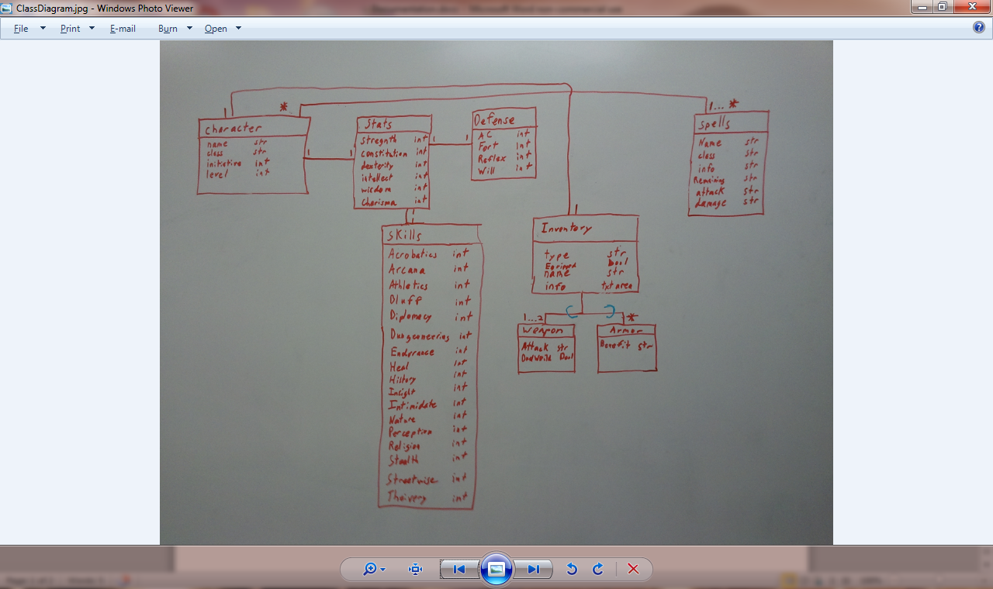

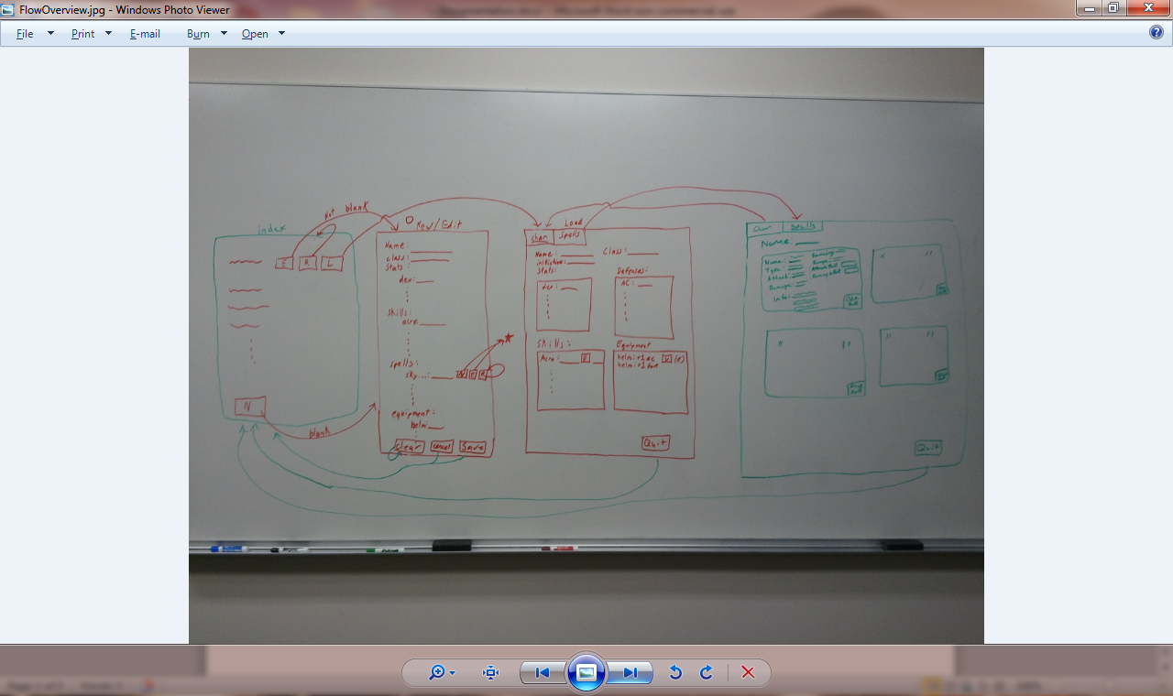

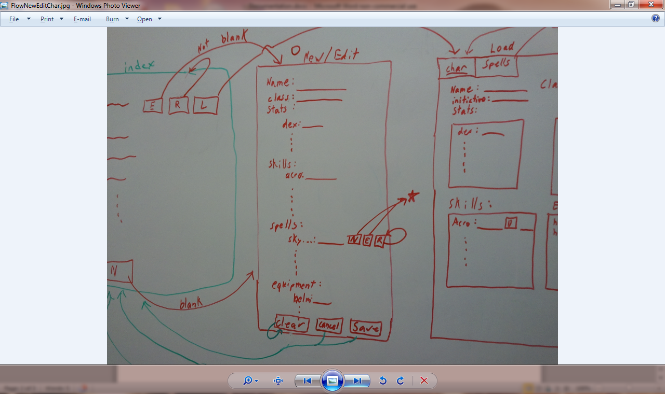

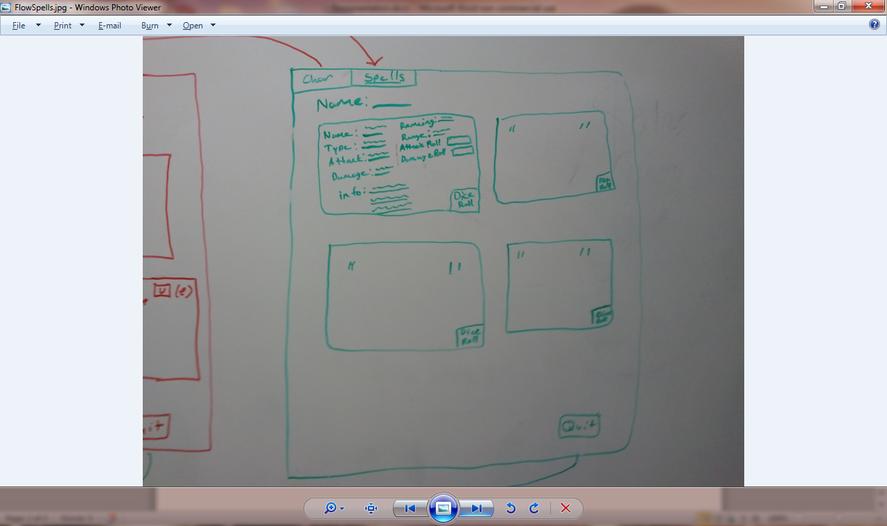

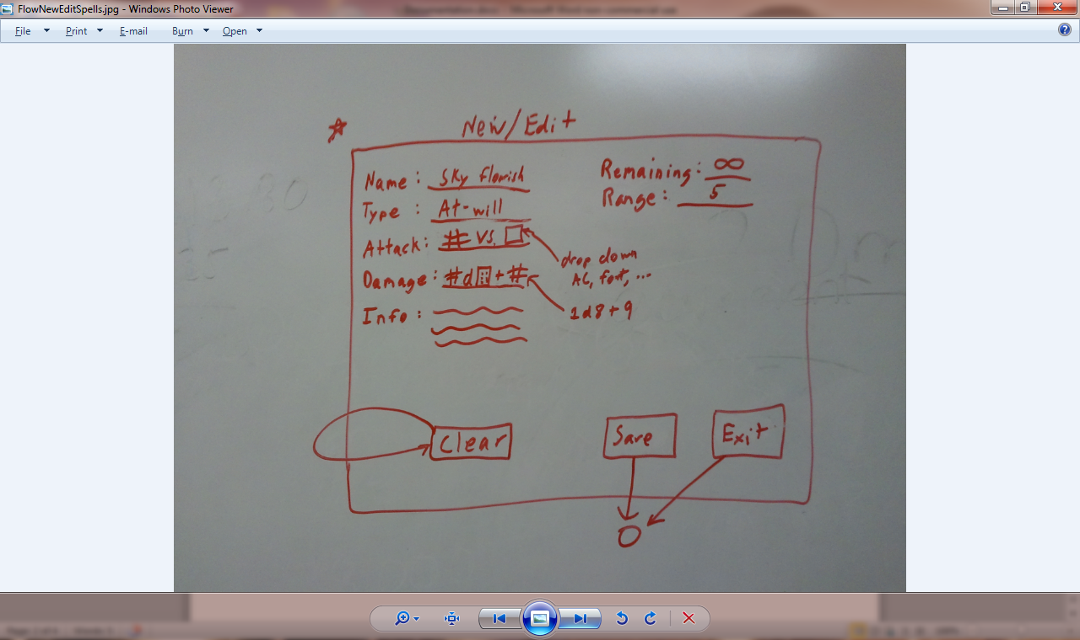

**Design Changes:**

Changes for the entire program –

Added: CSS/HTML was coded to everything in the View directory.

Added: Custom buttons replaced links in the View directory.

Merging: Defense and Stats table were combined into the Players table.

Added: Two tables called Player_Spells and Player_Inventories. (Helped combine data from two different tables)

Added: A master list of Spells and Inventories were added to hold data for all players to use.

Added: A list of the player’s current equipment and interchangeable.

Removed: Ruby on rails links to show or edit pages were removed. (Not all of them)

Added: Session variable was added to prevent users from accessing URLs without being logged into a player.

Views/Player/Form.erb.html –

Added: Additional classes added are: Mage, Warrior, Rogue, Ranger, Paladin, Cleric, Warlord, and Warlock.

Added: Drop boxes to all stats and defenses

Fixed: Used Stats array once for all stats’ drop down box (strength, constitution, dexterity, intellect, wisdom, and charisma)

Fixed: The Stats starting value will no longer start at 1. But will start at 8 instead.

View/Player/Show.erb.html –

Added: Health tracker was added to the Show page.

Fixed: Health tracker was crashing when user entered a Letter instead of number.

Fixed: Re-aligned tables and redesigned how the page looked.

Fixed: Calculations were corrected.

View/Player_Inventories/Index.erb.html –

Fixed: Table was not removing extra items to the equipment list.

Fixed: Items were not replacing correctly

Fixed: The show page was showing weapon when item was an armor type.

View/Player_Spells/Index.erb.html –

Fixed: Removed the show link to prevent users from adding a spell that was not their class.

Fixed: Spell was not removing from the list correctly.

**Bugs:**

Currently, there are no bugs to fix.

**Q and A Team:**

User Acceptance Test: Selenium program was used. The team found a bug with Health Tracker.

Load Testing: QA Team used Jmeter program to test the loading of our program. Everything loaded good without crashing.

Bottleneck Profiling: QA Team didn’t report findings on Bottleneck. We went ahead and used the Jmeter file they used for testing to find the longest load times for our pages. The View/Player/Show.erb.html or <http://dnd.heroku.com/players/12> was the longest load time. We cleaned up our code and made the times faster.

**Deployment:**

We used Heroku.com to deploy our program on the web. Our link is: http://dnd.heroku.com

**Special Thanks to:**

Thanks to our professor Preston Lee, whom helped guide us to make our product a success.