retinotopic_cerebellum.Rmd
Ryan Marshall
2023-05-10
library(dplyr)
##
## Attaching package: 'dplyr'
## The following objects are masked from 'package:stats':
##
## filter, lag
## The following objects are masked from 'package:base':
##
## intersect, setdiff, setequal, union
library(ggplot2)
library(gridExtra)
##
## Attaching package: 'gridExtra'
## The following object is masked from 'package:dplyr':
##
## combine
work_dir <- "/projectnb/somerslab/ryanmars/projects/CrossTaskAnalysis/proj_allrest/results/group/HCP_SUIT"
setwd(work_dir)
# define streams
streams <- list(
dorsal = c("V1d", "V2d", "V3d", "V3A", "V3B", "IPS0", "IPS1", "IPS2", "IPS3", "IPS4", "IPS5", "SPL1", "FEF"),
ventral = c("V1v", "V2v", "V3v", "hV4", "VO1", "VO2", "PHC1", "PHC2"),
lateral = c("LO1", "LO2", "TO1", "TO2")
)
streams_big <- list(
early_dorsal = c("V1d","V2d","V3d"),
mid_dorsal = c("V3A","V3B","IPS0","IPS1","IPS2"),
late_dorsal = c("IPS3","IPS4","FEF"),
early_lateral = c("LO1","LO2"),
late_lateral = c("TO1","TO2"),
early_ventral = c("V1v", "V2v", "V3v"),
mid_ventral = c("hV4","VO1","VO2"),
late_ventral = c("PHC1","PHC2")
)
# Define the color palette
dorsal_palette <- c("#00BFC4", "#00939C", "#007377")
ventral_palette <- c("#F8766D", "#C43C35", "#7F0000")
lateral_palette <- c("#FFB85F", "#D46F00")
color_palette_full <- c(dorsal_palette, ventral_palette, lateral_palette)
color_palette_small <- c("#00BFC4", "#F8766D", "#FFB85F")
color_palette_by_roi <- c("#00CED1", "#00BFC4", "#00A5AA", "#00939C", "#00878B", "#007377", "#006E72", "#005A5F", "#005A5F", "#004749", "#003535", "#FF7258", "#F8766D", "#E64C46", "#C43C35", "#BF1D19", "#8F0000", "#7F0000", "#5F0000", "#FFB85F", "#FF944C", "#D46F00", "#D46F00")
## Load data
df <- as.data.frame(read.csv("retinotopic_tstats_full.csv"))
rois <- as.list(unique(df$roi))
nsub = 166; dof = nsub - 2;
rois_reorder <- c("V1d", "V2d", "V3d", "V3A", "V3B",
"IPS0", "IPS1", "IPS2", "IPS3",
"IPS4", "IPS5", "SPL1", "FEF",
"V1v", "V2v", "V3v", "hV4",
"VO1", "VO2", "PHC1", "PHC2",
"LO1", "LO2", "TO1", "TO2")
rois_reorder <- rois_reorder[rois_reorder!=c("IPS5", "SPL1")]
## Warning in rois_reorder != c("IPS5", "SPL1"): longer object length is not a
## multiple of shorter object length
df <- df %>% filter(cb_idx != 0 & roi %in% rois_reorder) %>%
mutate(stream = case_when(
roi %in% streams$dorsal ~ "dorsal",
roi %in% streams$ventral ~ "ventral",
roi %in% streams$lateral ~ "lateral"
)) %>%
mutate(stream = factor(stream, levels = c("dorsal", "ventral", "lateral"))) %>%
mutate(stream_depth = case_when(
roi %in% streams_big$early_dorsal ~ "early_dorsal",
roi %in% streams_big$mid_dorsal ~ "mid_dorsal",
roi %in% streams_big$late_dorsal ~ "late_dorsal",
roi %in% streams_big$early_lateral ~ "early_lateral",
roi %in% streams_big$late_lateral ~ "late_lateral",
roi %in% streams_big$early_ventral ~ "early_ventral",
roi %in% streams_big$mid_ventral ~ "mid_ventral",
roi %in% streams_big$late_ventral ~ "late_ventral"
)) %>%
mutate(stream_depth = factor(stream_depth, levels = c("early_dorsal", "mid_dorsal", "late_dorsal", "early_ventral", "mid_ventral", "late_ventral","early_lateral","late_lateral")))
cb_roi_full_map <- list("R_lat_VIIIb/IX","R_med_VIIIb/IX","L_med_VIIIb/IX","L_lat_VIIIb/IX","L_VIIb/VIIIa","R_VIIb/VIIIa","L_med_OMV","L_lat_OMV","R_med_OMV","R_lat_OMV" )
cb_roi_full_reorder <- list("L_lat_VIIIb/IX","L_med_VIIIb/IX","L_VIIb/VIIIa","L_lat_OMV","L_med_OMV","R_med_OMV","R_lat_OMV","R_VIIb/VIIIa","R_med_VIIIb/IX","R_lat_VIIIb/IX" )
cb_roi_full_reorder_RL <- list("L_med_OMV","R_med_OMV","L_lat_OMV","R_lat_OMV","L_VIIb/VIIIa","R_VIIb/VIIIa","L_med_VIIIb/IX","R_med_VIIIb/IX","L_lat_VIIIb/IX","R_lat_VIIIb/IX" )
cb_roi_full_reorder_bh <- list("med_OMV","lat_OMV","VIIb/VIIIa","med_VIIIb/IX","lat_VIIIb/IX")
# define mapping for cb_roi and cb_hemi
cb_roi_map <- c("lat_VIIIb/IX","med_VIIIb/IX","med_VIIIb/IX","lat_VIIIb/IX","VIIb/VIIIa","VIIb/VIIIa","med_OMV","lat_OMV","med_OMV","lat_OMV")
cb_hemi_map <- c("R","R","L", "L", "L", "R", "L", "L", "R", "R")
df$cb_roi_full <- cb_roi_full_map[df$cb_idx]
df$cb_roi <- cb_roi_map[df$cb_idx]
df$cb_hemi <- cb_hemi_map[df$cb_idx]
bh_pear_df <- df %>% filter(hemi == "bilat" & corrtype == "pearson")
lh_pear_df <- df %>% filter(hemi == "lh" & corrtype == "pearson")
rh_pear_df <- df %>% filter(hemi == "rh" & corrtype == "pearson")
lh_part_df <- df %>% filter(hemi == "lh" & corrtype == "partial")
rh_part_df <- df %>% filter(hemi == "rh" & corrtype == "partial")

Create t boxplots for each ROI averaged across cb_roi and grouped by stream_depth
bh_pear_df %>%
group_by(roi, stream_depth) %>%
# Plot data
ggplot(aes(x = factor(roi, levels = rois_reorder), y = t, fill= stream_depth), fill = stream_depth) +
geom_boxplot() +
facet_grid(scales = "fixed") +
scale_x_discrete(guide = guide_axis(n.dodge = 2)) +
labs(title = paste0("bilat pearson t values across retinotopic cerebellar seeds"),
x = "ROI",
y = "T value") +
scale_fill_manual(values=color_palette_full)
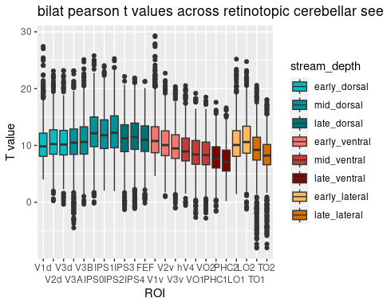
# Create t boxplots for each bilateral cerebellar retinotopic seeds, also grouped by stream_depth
bh_pear_df %>%
group_by(roi, stream_depth) %>%
# Plot data
ggplot(aes(x = factor(cb_roi, levels = cb_roi_full_reorder_bh), y = t, fill = stream_depth)) +
geom_boxplot() +
facet_grid(scales = "fixed") +
scale_x_discrete(guide = guide_axis(n.dodge = 2)) +
labs(title = paste0("bilat pearson t values across retinotopic cerebellar seeds"),
x = "ROI",
y = "T value") +
scale_fill_manual(values=color_palette_full)
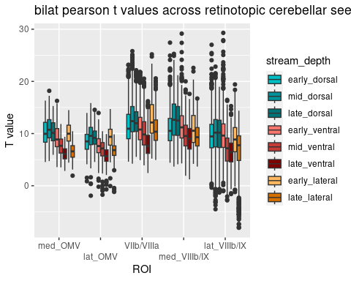
# Create same boxplots but converted to correlation values from t statistic
bh_pear_df %>%
mutate(r = sqrt(t^2 / (t^2 + dof))) %>%
group_by(roi, stream_depth) %>%
# Plot data
ggplot(aes(x = factor(roi, levels = rois_reorder), y = r, fill= stream_depth), fill = stream_depth) +
geom_boxplot() +
facet_grid(scales = "fixed") +
scale_x_discrete(guide = guide_axis(n.dodge = 2)) +
scale_y_continuous(limits = c(0,1), breaks = seq(0,1,.1)) +
labs(title = paste0("bilat pearson r values across retinotopic cerebellum by cortical ROI"),
x = "ROI",
y = "Effect size r") +
scale_fill_manual(values=color_palette_full)
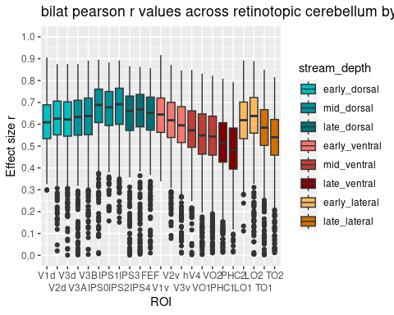
# Filter and group data
bh_pear_df %>%
mutate(r = sqrt(t^2 / (t^2 + dof))) %>%
group_by(roi, stream_depth) %>%
# Plot data
ggplot(aes(x = factor(cb_roi, levels = cb_roi_full_reorder_bh), y = r, fill = stream_depth)) +
geom_boxplot() +
facet_grid(scales = "fixed") +
scale_x_discrete(guide = guide_axis(n.dodge = 2)) +
scale_y_continuous(limits = c(0,1), breaks = seq(0,1,.1)) +
labs(title = paste0("bilat pearson r values by retinotopic cerebellar ROI"),
x = "ROI",
y = "Effect size (r)") +
scale_fill_manual(values=color_palette_full)
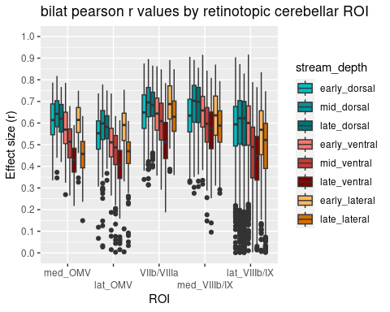
df_cb_lh <- df %>% filter(corrtype=="partial",cb_hemi=="L") %>% group_by(roi,cb_roi) %>% mutate(roi = factor(roi, levels = rois_reorder))
df_cb_rh <- df %>% filter(corrtype=="partial",cb_hemi=="R") %>% group_by(roi,cb_roi) %>% mutate(roi = factor(roi, levels = rois_reorder))
df_ctx_lh <- df %>% filter(corrtype=="partial",hemi=="lh") %>% group_by(roi) %>% mutate(roi = factor(roi, levels = rois_reorder))
df_ctx_rh <- df %>% filter(corrtype=="partial",hemi=="rh") %>% group_by(roi) %>% mutate(roi = factor(roi, levels = rois_reorder))
df_cb_lh_ipsi <- df_cb_lh %>% filter(hemi == "lh")
df_cb_rh_ipsi <- df_cb_rh %>% filter(hemi == "rh")
df_cb_lh_contra <- df_cb_lh %>% filter(hemi == "rh")
df_cb_rh_contra <- df_cb_rh %>% filter(hemi == "lh")
df_ctx_lh_ipsi <- df_ctx_lh %>% filter(cb_hemi=="L")
df_ctx_rh_ipsi <- df_ctx_rh %>% filter(cb_hemi=="R")
df_ctx_lh_contra <- df_ctx_lh %>% filter(cb_hemi=="R")
df_ctx_rh_contra <- df_ctx_rh %>% filter(cb_hemi=="L")
df_ctx_lh_ipsi_sum <- df_ctx_lh_ipsi %>% group_by(stream,roi) %>% summarize(ctx_lh_ipsi_t = mean(t), ctx_lh_ipsi_r = sqrt(mean(t)^2 / (mean(t)^2 + dof)))
## `summarise()` has grouped output by 'stream'. You can override using the
## `.groups` argument.
df_ctx_rh_ipsi_sum <- df_ctx_rh_ipsi %>% group_by(stream,roi) %>% summarize(ctx_rh_ipsi_t = mean(t), ctx_rh_ipsi_r = sqrt(mean(t)^2 / (mean(t)^2 + dof)))
## `summarise()` has grouped output by 'stream'. You can override using the
## `.groups` argument.
df_ctx_lh_contra_sum <- df_ctx_lh_contra %>% group_by(stream,roi) %>% summarize(ctx_lh_contra_t = mean(t), ctx_lh_contra_r = sqrt(mean(t)^2 / (mean(t)^2 + dof)))
## `summarise()` has grouped output by 'stream'. You can override using the
## `.groups` argument.
df_ctx_rh_contra_sum <- df_ctx_rh_contra %>% group_by(stream,roi) %>% summarize(ctx_rh_contra_t = mean(t), ctx_rh_contra_r = sqrt(mean(t)^2 / (mean(t)^2 + dof)))
## `summarise()` has grouped output by 'stream'. You can override using the
## `.groups` argument.
df_cb_lh_ipsi_sum <- df_cb_lh_ipsi %>% group_by(roi,cb_roi) %>% summarize(cb_lh_ipsi_t = mean(t), cb_lh_ipsi_r = sqrt(mean(t)^2 / (mean(t)^2 + dof)))
## `summarise()` has grouped output by 'roi'. You can override using the `.groups`
## argument.
df_cb_rh_ipsi_sum <- df_cb_rh_ipsi %>% group_by(roi,cb_roi) %>% summarize(cb_rh_ipsi_t = mean(t), cb_rh_ipsi_r = sqrt(mean(t)^2 / (mean(t)^2 + dof)))
## `summarise()` has grouped output by 'roi'. You can override using the `.groups`
## argument.
df_cb_lh_contra_sum <- df_cb_lh_contra %>% group_by(roi,cb_roi) %>% summarize(cb_lh_contra_t = mean(t), cb_lh_contra_r = sqrt(mean(t)^2 / (mean(t)^2 + dof)))
## `summarise()` has grouped output by 'roi'. You can override using the `.groups`
## argument.
df_cb_rh_contra_sum <- df_cb_rh_contra %>% group_by(roi,cb_roi) %>% summarize(cb_rh_contra_t = mean(t), cb_rh_contra_r = sqrt(mean(t)^2 / (mean(t)^2 + dof)))
## `summarise()` has grouped output by 'roi'. You can override using the `.groups`
## argument.
ctx_df <- full_join(full_join(df_ctx_lh_ipsi_sum,df_ctx_rh_ipsi_sum),full_join(df_ctx_lh_contra_sum,df_ctx_rh_contra_sum))
## Joining with `by = join_by(stream, roi)`
## Joining with `by = join_by(stream, roi)`
## Joining with `by = join_by(stream, roi)`
cb_df <- full_join(full_join(df_cb_lh_ipsi_sum,df_cb_rh_ipsi_sum),full_join(df_cb_lh_contra_sum,df_cb_rh_contra_sum))
## Joining with `by = join_by(roi, cb_roi)`
## Joining with `by = join_by(roi, cb_roi)`
## Joining with `by = join_by(roi, cb_roi)`
ctx_df %>% ggplot() +
geom_point(aes(x = ((ctx_lh_ipsi_r+ctx_rh_ipsi_r)/2), y = ((ctx_lh_contra_r+ctx_rh_contra_r)/2), color = roi), size = 3, stroke = 1) +
scale_color_manual(values = color_palette_by_roi) +
xlim(.25,.65) + ylim(.25,.65) +
labs(x = "partial r with ipsilateral retinotopic cerebellum",
y = "partial r with contrateral retinotopic cerebellum",
title = "Functional asymmetries from visual cortex") +
geom_abline(intercept = 0, slope = 1, linetype = "dotted")
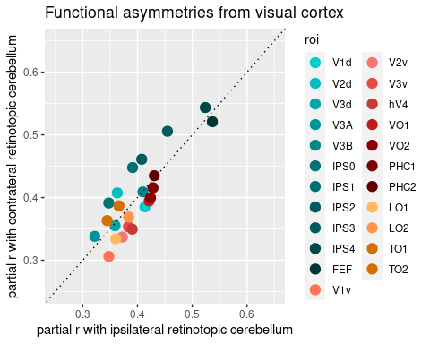
ctx_df %>% ggplot() +
geom_point(aes(x = ctx_lh_ipsi_r, y = ctx_lh_contra_r, color = roi), size = 3, stroke = 1) +
scale_color_manual(values = color_palette_by_roi) +
xlim(.25,.65) + ylim(.25,.65) +
labs(x = "partial r with ipsilateral retinotopic cerebellum",
y = "partial r with contrateral retinotopic cerebellum",
title = "Functional asymmetries from left visual cortex") +
geom_abline(intercept = 0, slope = 1, linetype = "dotted")
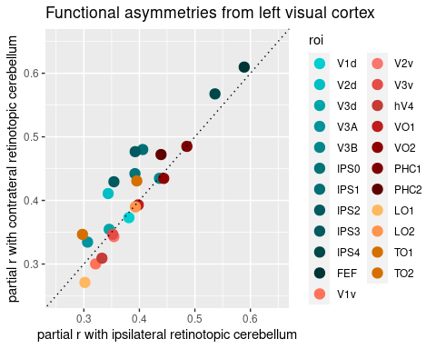
ctx_df %>% ggplot() +
geom_point(aes(x = ctx_rh_ipsi_r, y = ctx_rh_contra_r, color = roi), size = 3, stroke = 1) +
scale_color_manual(values = color_palette_by_roi) +
xlim(.25,.65) + ylim(.25,.65) +
labs(x = "partial r with ipsilateral retinotopic cerebellum",
y = "partial r with contrateral retinotopic cerebellum",
title = "Functional asymmetries from right visual cortex") +
geom_abline(intercept = 0, slope = 1, linetype = "dotted")
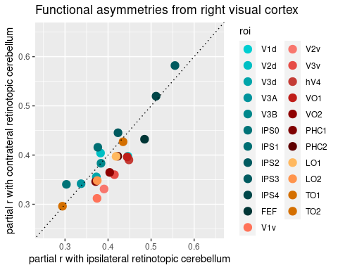
cb_df %>% filter(cb_roi == "med_OMV") %>% ggplot() +
geom_point(aes(x = ((cb_lh_ipsi_r+cb_rh_ipsi_r)/2), y = ((cb_lh_contra_r+cb_rh_contra_r)/2), color = roi), size = 3, stroke = 1) +
scale_color_manual(values = color_palette_by_roi) +
xlim(.25,.65) + ylim(.25,.65) +
labs(x = "average partial r with ipsilateral visual cortex",
y = "average partial r with contrateral visual cortex",
title = "Asymmetry of cerebellar medial OMV") +
geom_abline(intercept = 0, slope = 1, linetype = "dotted")
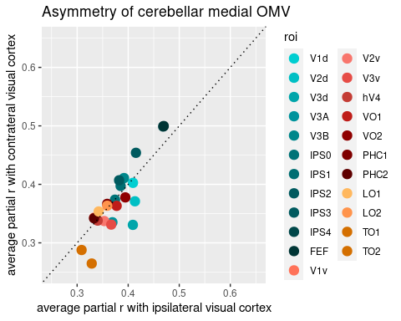
cb_df %>% filter(cb_roi == "lat_OMV") %>% ggplot() +
geom_point(aes(x = ((cb_lh_ipsi_r+cb_rh_ipsi_r)/2), y = ((cb_lh_contra_r+cb_rh_contra_r)/2), color = roi), size = 3, stroke = 1) +
scale_color_manual(values = color_palette_by_roi) +
xlim(.25,.65) + ylim(.25,.65) +
labs(x = "average partial r with ipsilateral visual cortex",
y = "average partial r with contrateral visual cortex",
title = "Asymmetry of cerebellar lateral OMV") +
geom_abline(intercept = 0, slope = 1, linetype = "dotted")
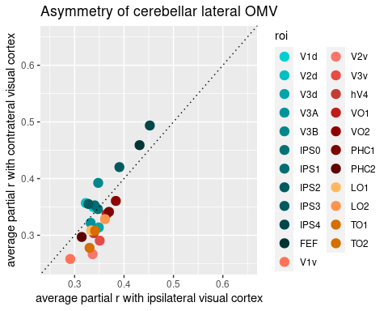
cb_df %>% filter(cb_roi == "VIIb/VIIIa") %>% ggplot() +
geom_point(aes(x = ((cb_lh_ipsi_r+cb_rh_ipsi_r)/2), y = ((cb_lh_contra_r+cb_rh_contra_r)/2), color = roi), size = 3, stroke = 1) +
scale_color_manual(values = color_palette_by_roi) +
xlim(.25,.65) + ylim(.25,.65) +
labs(x = "average partial r with ipsilateral visual cortex",
y = "average partial r with contrateral visual cortex",
title = "Asymmetry of cerebellar VIIb/VIIIa") +
geom_abline(intercept = 0, slope = 1, linetype = "dotted")
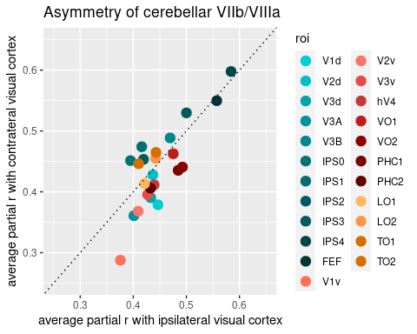
cb_df %>% filter(cb_roi == "med_VIIIb/IX") %>% ggplot() +
geom_point(aes(x = ((cb_lh_ipsi_r+cb_rh_ipsi_r)/2), y = ((cb_lh_contra_r+cb_rh_contra_r)/2), color = roi), size = 3, stroke = 1) +
scale_color_manual(values = color_palette_by_roi) +
xlim(.25,.65) + ylim(.25,.65) +
labs(x = "average partial r with ipsilateral visual cortex",
y = "average partial r with contrateral visual cortex",
title = "Asymmetry of cerebellar medial VIIIb/IX") +
geom_abline(intercept = 0, slope = 1, linetype = "dotted")
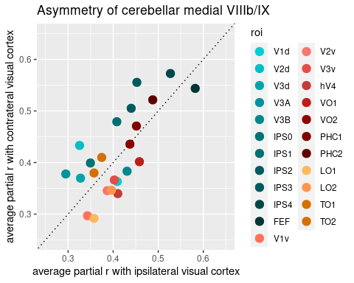
cb_df %>% filter(cb_roi == "lat_VIIIb/IX") %>% ggplot() +
geom_point(aes(x = ((cb_lh_ipsi_r+cb_rh_ipsi_r)/2), y = ((cb_lh_contra_r+cb_rh_contra_r)/2), color = roi), size = 3, stroke = 1) +
scale_color_manual(values = color_palette_by_roi) +
xlim(.25,.65) + ylim(.25,.65) +
labs(x = "average partial r with ipsilateral visual cortex",
y = "average partial r with contrateral visual cortex",
title = "Asymmetry of retinotopic cerebellar lateral VIIIb/IX") +
geom_abline(intercept = 0, slope = 1, linetype = "dotted")
## Warning: Removed 2 rows containing missing values (`geom_point()`).
