61CSE111 - IoT and Smart Devices - SS2025

Re-exam with solutions
Full name : .................................................................
Student ID : .................................................................
Intake : .................................................................
Notes: Duration 90 minutes. Closed book. Questions are based on the curriculum aka.ms/iot-beginners.

Part 1: Multiple choice questions (8 points)

There are 40 multiple choice questions, choose the most appropriate answer for each question and write it to the answer sheet (A, B, C, D).

Answer sheet:

1 | 2 | 3 | 4 | 5 | 6 | 7 | 8 | 9 | 10
11 | 12 | 13 | 14 | 15 | 16 | 17 | 18 | 19 | 20
21 | 22 | 23 | 24 | 25 | 26 | 27 | 28 | 29 | 30
31 | 32 | 33 | 34 | 35 | 36 | 37 | 38 | 39 | 40

1. Where are IoT edge devices typically deployed for optimal performance?
- On cloud servers to handle global data
- On public internet for open access
- Near the data source, within local networks
- In completely offline environments only

2. Which of the following is a key feature of IoT devices?
- Virtual simulation
- Sensor integration and connectivity
- High-definition graphics
- Data encryption for web apps

3. Digital sensors send data as:
- A sequence of digits
- Voltage ranges
- High and low voltage only

4. The execution of embedded software in an IoT device is handled by
- Sensor module
- Microcontroller unit
- Communication module
- Digital to analog converter

5. Where is the most AI model of IoT trained?
- In the sensor
- In the edge
- In the cloud
- In other computer

6. What role does the broker play in Message Queuing Telemetry Transport (MQTT)?
- It routes messages between publishers and subscribers
- It generates messages and sends them to sensors
- It stores all data permanently
- It encrypts data between servers

7. Containers are used in software deployment because they:
- Are dependent on the host operating system
- Require dedicated hardware
- Only work with cloud-native services
- Allow applications to run in isolated environments

8. Which of the following best describes the foundation of IoT systems?
- Software components
- Hardware components
- A combination of hardware and software
- None of these components

9. In an IoT setup, actuators are responsible for:
- Sensing changes in the environment
- Processing data in the cloud
- Executing physical actions like movement or light activation
- Connecting edge devices to the networks

10. Which mechanism allows an app to send a command and receive a response from an IoT device?
- Device twin
- Direct method request
- Device to cloud message
- Sensor polling

11. In the sentence 'set a 3 minute timer':
- The intent is 3 minutes and the entity is a timer
- The intent is set a timer and the entity is 3 minutes

12. Language understanding involves:
- Looking at the individual words in a sentence and trying to get the meaning
- Finding pre-defined sentences and using those to get the meaning
- Looking at the whole sentence and trying to get the meaning using the context of the words

13. The three parts of speech generation are:
- Text analysis, understanding analysis, sound generation
- Text analysis, linguistic analysis, waveform generation
- Word analysis, audio production

14. When deploying a Functions App to the cloud, you need to create and deploy:
- A Functions App, a Storage Account, and Application Settings
- A Functions App only
- A Functions App and a Storage Account only

15. Which of the following statements best summarizes the differences between Single-Board Computers and microcontrollers?
- Single-Board Computers prioritize low power consumption and real-time responsiveness for single-task applications, while microcontrollers offer general-purpose computing capabilities with OS support for multi-purpose tasks.
- Single-Board Computers offer support for various operating systems, making them ideal for multi-purpose tasks, whereas microcontrollers are designed for low power consumption and real-time responsiveness in single-task applications.

16. Points inside the geofence have a distance:
- Less than 0 (a negative value)
- Greater than 0 (a positive value)

17. IoT data is stored by IoT Hub?
- True
- False

18. The three components of architecting an IoT application are
- Things, Insights, Actions
- Things, Internet, Databases
- AI, Blockchain, FizzBuzzers

19. You can use Serverless code to respond to IoT events
- True
- False

20. When you send IoT events to IoT Hub:
- Only one service can read events off the IoT Hub
- Any number of services can read events off the IoT Hub
- Services cannot read events from IoT Hub

21. When reading events off IoT hub, you can only do so using code that runs in the cloud
- True
- False

22. Serverless code can be used to write IoT data to a database
- True
- False

23. The SPI (Serial Peripheral Interface) protocol supports:
- Only one controller and only one peripheral
- Only one controller and multiple peripherals
- Multiple controllers and multiple peripherals

24. Which levels of Quality of Service (QoS) that MQTT provides?
- At most once - the message is sent only once and the client and broker take no additional steps to acknowledge delivery (fire and forget).
- At least once - the message is re-tried by the sender multiple times until acknowledgement is received (acknowledged delivery).
- Exactly once - the sender and receiver engage in a two-level handshake to ensure only one copy of the message is received (assured delivery).
- All of them

25. Processing of data from analog sensors in IoT devices
- IoT devices require conversion of analog values to digital values using an Analog-Digital converter (ADC)
- IoT devices can work with analog values without requiring conversion

26. Symmetric key encryption compares to asymmetric key encryption in which ways:
- Symmetric key encryption is slower than asymmetric
- Symmetric key encryption is slower than asymmetric, but more secure
- Symmetric key encryption is faster than asymmetric, but less secure
- Symmetric key encryption is more secure than asymmetric

27. The technique uses to train a model with only a few images from a pretrained model is called:
- Supervised learning
- Few-shot learning
- Transfer learning

28. Edge devices always need an Internet connection.
- True
- False

29. AI models would convert 1234 into which spoken phrase:
- One two three four
- One thousand two hundred and thirty four
- It can be ‘one two three four’ or ‘one thousand two hundred and thirty four’ depending on the context

30. Can detected objects from an image overlap?
- True
- False

31. Serverless code can only be written in JavaScript and COBOL:
- True
- False

32. Edge computing can be more secure than cloud computing.
- True
- False

33. Running an ML model on an edge device is less accurate than running an ML model in the cloud.
- True
- False

34. What is the full form of IIoT?
- Intelligent IoT
- Infrastructure IoT
- Industrial IoT
- Integrated IoT

35. The I2C (Inter-Integrated Circuit) protocol supports:
- Only one controller and only one peripheral
- Only one controller and multiple peripherals
- Multiple controllers and multiple peripherals

36. How large is 1 second of 16-bit audio sampled at 16 KHz?
- 1KB
- 16KB
- 32KB

37. Pulse width modulation (PWM) is commonly used for controlling what type of device?
- Soft blinking LEDs
- Mechanical actuators
- Audio amplifiers
- All the above

38. Data gathered from sensors and sent to the cloud is called:
- Commands
- Telemetry
- Measurements

39. IoT devices gather information from the world around them using:
- Actuators
- Controllers
- Sensors
- Collectors

40. What is the standard method for digitizing analog audio signals?
- Pulse Code Modulation
- Pulse Width Modulation
- Frequency Modulation
- Analog-to-Analog Modulation

Part 2: Written questions (2 points)

Question 1: (1 point)

Fill in the two missing parts in the diagram

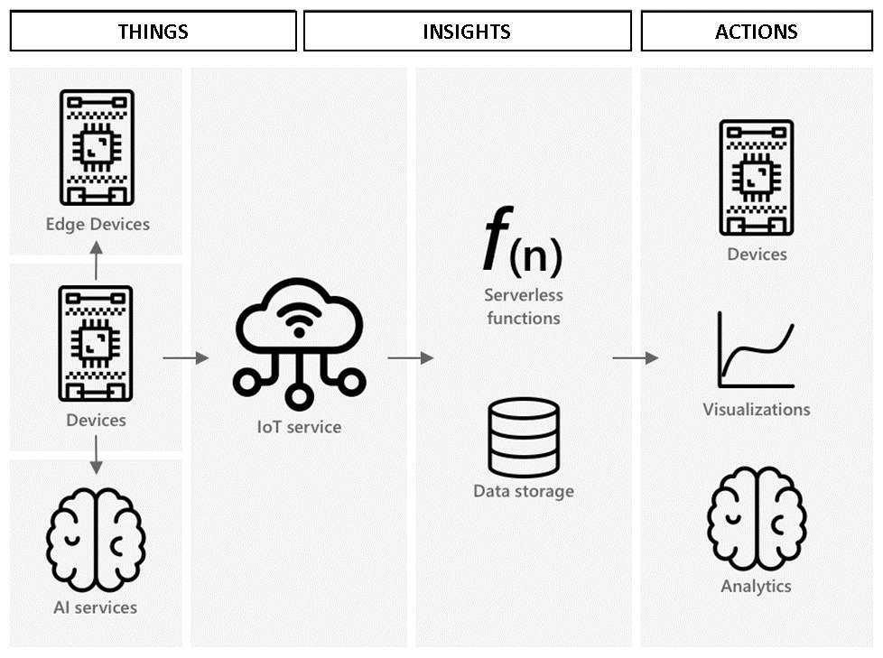

Question 2: (1 point)
An IoT application is to be designed that uses a GPS sensor to determine whether a user is located inside a predefined geographic area (geofence). Based on the user’s location:
- If the user is within the geofenced area, an LED on the IoT device turns ON.
- If the user is outside the area, the LED remains OFF.
The IoT device is equipped with a GPS sensor to capture real-time location data. This data is transmitted to the cloud for further processing. The system includes two serverless cloud functions:
- Function 1: Receives GPS data from the IoT device and stores it in cloud storage.
- Function 2: Retrieves the latest GPS data, checks whether the location is within the geofence, and sends a command to the IoT device to control the LED accordingly.
Your task:
- Draw a diagram illustrating the components of the IoT system and how they interact, including the GPS sensor, cloud storage, serverless functions, and LED.
- Describe the data flow within the system, from GPS data acquisition to the final control of the LED based on geofence evaluation.

Diagram:

Explanation:

