I. INTRODUCTION
[Red italic text is a note. Replace it with your own words, then delete the note. Write as the restaurant owner who orders this software: what does the restaurant need?]
In this project, we investigate the business functions of a restaurant, and provide a desktop application supporting customers, staff and the admin. [Continue: how orders are taken today, what goes wrong, and how the app helps.]
This project provides the basic functions for the users as follows:
- Register a customer account and log in.
- View the menu, filter it by category and search it by name.
- Add dishes to a cart and place an order for a table.
- Track the status of an order and save a receipt.
- View the queue of open orders, move an order to its next status, or cancel it.
- Mark a dish as sold out.
- Add, change and remove dishes (admin).
- Add and remove staff accounts (admin).
Table 1: User roles
No | Role | Description | Functions
1 | Customer | A guest who orders food at a table. | Register, log in, view and search the menu, place an order, track the order, save a receipt.
2 | Staff | A restaurant worker who prepares and serves the orders. | Log in, view the order queue, update the order status, cancel an order, mark a dish sold out.
3 | Admin | The manager. An admin is a kind of staff. | All staff functions, plus manage the menu and manage staff accounts.

[One paragraph about Table 1. Example points: why there are three roles, and why the admin has all staff rights.]
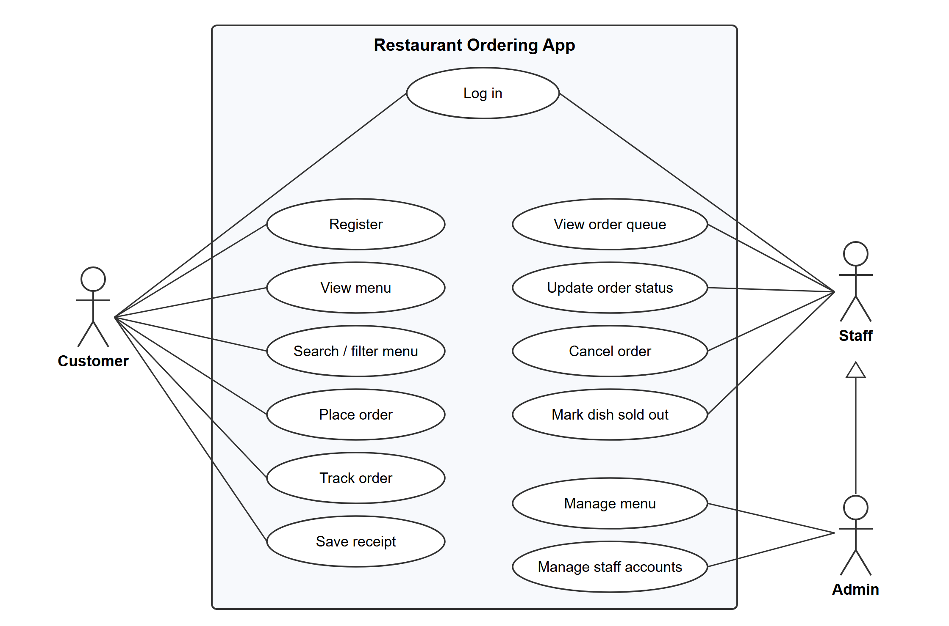
Figure 1: Use case diagram of the Restaurant Ordering App
[One paragraph that walks through Figure 1: the three actors, what each one can do, and what the hollow arrow from Admin to Staff means.]
In this project, we use Java OOP for designing classes and applying the OOP features such as encapsulation, inheritance, abstraction and polymorphism. [Add one sentence on how the data is saved: a SQLite database through JDBC.]

