TagSeq library preparation   
(version June 2019)

Galina Aglyamova, Jessica Podnar, Mikhail Matz

University of Texas at Austin, [matz@utexas.edu](mailto:matz@utexas.edu)

**Materials**

|  |  |
| --- | --- |
| **Reagent** | **Vendor/Cat #** |
| dNTPs | NEB/N0447S |
| 0.1M DTT (aliquots) | ThermoFisher/707265ML |
| 5X First Strand (FS) Buffer | Takara(Clontech)/ 639537 |
| SMARTScribe™ Reverse Transcriptase | Takara(Clontech)/ 639537 |
| Klentaq DNA polymerase | Klentaq/SKU: 100 |
| 3ILL-30TV primer * | IDTDNA |
| 3 switch primers *# | IDTDNA |
| Agencourt AMPure Beads XP | Beckman Coulter A63881 |
| 80% ETOH | Prepared Fresh from 100% EtOH |
| Eppendorf twin-tec 96-well PCR plate | Eppendorf  (VWR:95041-440): |
| Adhesive PCR plate Foil Seal | Fisher/UT Mkt:  AB-0626 |
| Magnet plate | Alpaqua A001219 |
| Barcode (index) primers* & | IDTDNA |

* see **tagseq_oligo_order_200samples.xlsx** file; it lists oligos sufficient for a 200-sample experiment. If you have more samples per project, order more TruSeq_Un oligos with additional indices (substitute GCCAAT, CAGATC, GATCAG, or CTTGTA for the sequence written in red font). Each additional TruSeq_Un oligo adds capacity for 24 additional samples.

# Prepare switch-oligo mix by mixing the three switch oligos. First, dilute each oligo to 10 µM in RNAse-free 10 mM Tris-HCl pH 8.0 (can use elution buffer from RNAqueous kit). Then, mix them in the proportion switchTG : switchGC : switchMW = 1 : 1 : 1.5. Aliquot the mix by 100 µl, store in -80oC.

& Barcoding primers should be pre-mixed as “index plates” prior to the library prep. Dilute ILL-BC and Truseq_UN oligos to 2 µM in 10mM Tris-HCl pH 8.0 and mix them in equal volumes in a 96-well plate according to the layout shown in a separate sheet in **tagseq_oligo_order_200samples.xlsx**. Each sample takes 6 ul of barcode mix. Premade index plates can be stored for a few months at -20oC.

The procedure works with as little as 10 ng total RNA per sample at the start (1 ng also works but results are substantially less consistent across replicates). The RNA does not have to be perfectly intact but should show reasonably high-MW smear on gel or Bioanalyzer. DNA contamination is OK although we recommend DNAse treatment when the amount of material is not limiting.

**Extract total RNA** with the kit/method of your choice. When using RNAqueous micro, elute by passing the same 12 µl through the column twice. DNAse treatment is not strictly necessary although we recommend DNAse treatment when the amount of material is not limiting.

1. **RNA fragmentation**
2. Pipet **10 µl of total RNA** (containing at least 10 ng, and preferably 100 ng) into wells in a 96-well PCR plate.
3. Prepare a master mix: (all volumes are in µl)

Number of samples x 1.1 =

|  |  |  |
| --- | --- | --- |
| **Reagent** | **Volume** | **Volume in master mix** |
| dNTPs (10 mM ea) | 1 |  |
| DTT (0.1 M) | 2 |  |
| 5x First-Strand buffer | 4 |  |
| 3ILL-30TV, 10 µM | 1 |  |

1. Aliquot master mix into strip tubes to aid pipetting (105 µl per tube). Using a multi-channel pipet, add **8µl of master mix** to each RNA sample and pipet to mix.
2. Cover plate with foil seal, creating a secure seal around each well using a kimwipe and plate cover paddle/roller.
3. Place samples in the preheated thermocycler and incubate at 70°C (with the heated lid on) for 10 minutes.
4. Move samples to ice and incubate for 2 minutes.

**2. First-strand cDNA synthesis**

1. Preheat the thermocycler to 42°C .
2. Spin down the plate and carefully remove the foil seal. Return the plate to ice.
3. Aliquot 1.1X µl (per # samples in each row) of switch-oligo mix (see Materials above), and the same volume of SmartScribe RT, into separate 8-strip tubes.
4. To each sample, using a multi-channel pipet, add **1µl switch-oligo mix and 1µl of SmartScribe RT**. Set pipet to 15µl and mix. Cover with a foil seal.
5. Place the samples in the preheated thermocycler and run at 42°C for 1hr, then 65°C for 15 min.

**3. AMPure cleanup of cDNA**

1. Bring AMPure beads to room temperature for 30 minutes.
2. Centrifuge sample plate and remove the foil seal. Use multi-channel pipet and reagent reservoir to add **30µl of H2O** to each sample to bring the volume to 50ul.
3. Perform a 0.9x AMPure bead purification of the cDNA by adding **45µl of AMPure beads** to each sample.
4. Mix by pipetting sample 10 times until the beads are uniformly mixed with the reaction.
5. Incubate at room temperature for 15 minutes. Prepare 80% EtOH during this incubation step (200µl 80% EtOH needed/sample). Can use Liquidator or multi-channel pipet for remaining wash steps depending on samples number.
6. Place plate on the magnet plate for 5 minutes to collect the beads. Carefully remove the seal. Then, remove the supernatant without disturbing the beads (approx. 90ul/sample).
7. Wash the beads 2X with 100µl 80% EtOH. Incubate for 30s. Discard the ethanol washes
8. Using a 20µl tips, remove any remaining EtOH from the bottom of the wells and air dry the samples for 3 minutes. Do Not Overdry!
9. Resuspend the samples in **12µl of water** by uniformly mixing by pipetting up and down 10 times. Incubate 2 min at room temperature. (beads may not fully resuspend at this step)
10. Place the plate on the magnet for approx. 5 min. to collect the beads.
11. **Transfer 10µl** of AMPure purified cDNA to a new 96-well plate.

**3. cDNA amplification**

1. Prepare the master mix (all volumes are in µl):

Number of samples x 1.1=

|  |  |  |
| --- | --- | --- |
| **Reagent** | **per sample** | **Volume in Master Mix** |
| H2O | 4.5 |  |
| dNTPs (2.5uM each) | 2 |  |
| 10x PCR buffer | 2 |  |
| 10uM 5ILL oligo | 0.5 |  |
| 10uM 3ILL-30TV oligo | 0.5 |  |
| Klentaq DNA polymerase | 0.5 |  |

1. Mix by gentle inversion or pipetting and briefly spin master mix.
2. Aliquot master mix into 8-strip tubes (130 µl per tube). Using a multi-channel pipet, add **10µl of master mix** to each well with cDNA. Pipet to mix. Cover with a foil seal.
3. Run the PCR program: 94°C 5 min, (94°C 1 min, 63°C 2 min, 72°C 2 min) X 18 cycles

*(this reaction can be left overnight at room temperature in the thermocycler)*

1. *(optional)* For a random selection of 6-8 samples, run 2 µl on a 2% agarose gel to verify that the reaction worked.

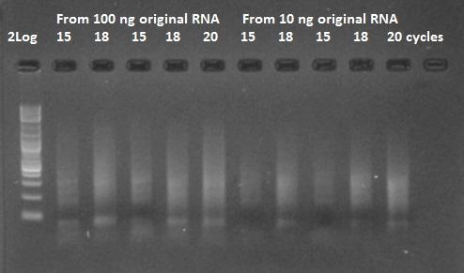

*NOTES:   
- If you started with large amount (~1 µg) of total RNA you might see a carry-over degraded RNA smear on the gel, which can be confused with the PCR product. One way to make sure is to set up a couple of negative control reactions, lacking the 5ILL primer. If doubts remain, add one more PCR cycle to all reactions to confirm that the product actually accumulates.*

*- Different samples might require slightly different number of cycles, this is OK since all the potential biases due to PCR amplification will be removed at the data analysis stage by discarding PCR duplicates. Do not worry about adding more PCR cycles – the fraction of duplicates does not change after the first 3-4 cycles, see Appendix III.*

**4. AMPure cleanup of amplified cDNA**

* 1. Centrifuge plate and remove the foil seal. Use multi-channel pipet and reagent reservoir to add **30µl of H2O** to each sample to bring the volume to 50ul.
  2. Perform a 0.9x AMPure bead purification of the cDNA by adding **45µl of AMPure beads** to each sample.
  3. Mix by pipetting sample 10 times until the beads are uniformly mixed with the reaction.
  4. Cover plate with a foil seal and incubate at room temperature for 15 minutes. Prepare 80% EtOH during this incubation step (200µl 80% EtOH needed/sample). Can use Liquidator or multi-channel pipet for remaining wash steps depending on samples number.
  5. Place plate on the Alpaqua magnet for 5 minutes to collect the beads. Carefully remove the supernatant without disturbing the beads (approx. 90ul/sample). Wash the beads 2X with 100µl 80% EtOH. Incubate for 30s. Discard the ethanol washes.
  6. Using 20µl tips, remove any remaining EtOH from the bottom of the wells and air dry the samples for 5 minutes. Do Not Overdry!
  7. Resuspend the samples in **22µl of water** by uniformly mixing by pipetting up and down 10 times.
  8. Place the plate on the magnet for approximately 5 min. to collect the beads.
  9. Transfer **20µl** of the amplified cDNA into a new 96-well plate..

1. Quantify the purified products by Quant_IT Picogreen DS DNA Kit (Life Technologies P7589). See Appendix I for details.

*- expected yield is about 10 ng/ul*

1. Prepare 20 µl of the purified PCR products **diluted to exactly 5 ng µl-1** in water. It’s extremely important to put the same amount of template into the barcoding PCR.

**5. Barcoding and size selection**

1. Add **6 µl of mixed barcode primers** from the index plate (see Materials above) to each sample well. Have another lab member watch you add the barcodes and sign off once transferred.
2. Prepare the following master mix:

Number of samples x 1.1=

|  |  |  |
| --- | --- | --- |
| **Reagent** | **per sample** | **Volume in master mix** |
| H2O | 7.4 |  |
| dNTPs (2.5mM) | 3 |  |
| 10x PCR buffer | 3 |  |
| Klentaq DNA polymerase | 0.6 |  |

1. Mix by gentle inversion or pipetting and briefly spin master mix.
2. Add **14µl of master mix** to each sample well. Pipet to mix.
3. Cover the plate with a foil seal and quick spin.
4. Place the plate in the thermocycler and run the following profile:   
   95°C 5 min, (95°C 40 sec, 63°C 2 min, 72°C 2 min) X 4 cycles
5. Run 5 µl of product form 6-8 randomly chosen samples on 2% agarose gel to **confirm that amplification across all samples was successfµl and uniform** (as it should be if quantification and dilutions at the previous stage were precise).
6. Pool 3 µl from each sample. Concentrate the pool into 60 µl using AMPure beads, as described above.
7. Prepare a gel for size selection. This preparative gel should be 2% agarose in 1X TBE buffer, with SYBR Green I nucleic acid gel staining dye (Invitrogen # S7563) added according to the manufacturers’ instructions (1:10,000 dilution). Be sure to use very wide and large volume combs to allow loading of the 30 µl mix +5 µl loading dye into a single well.

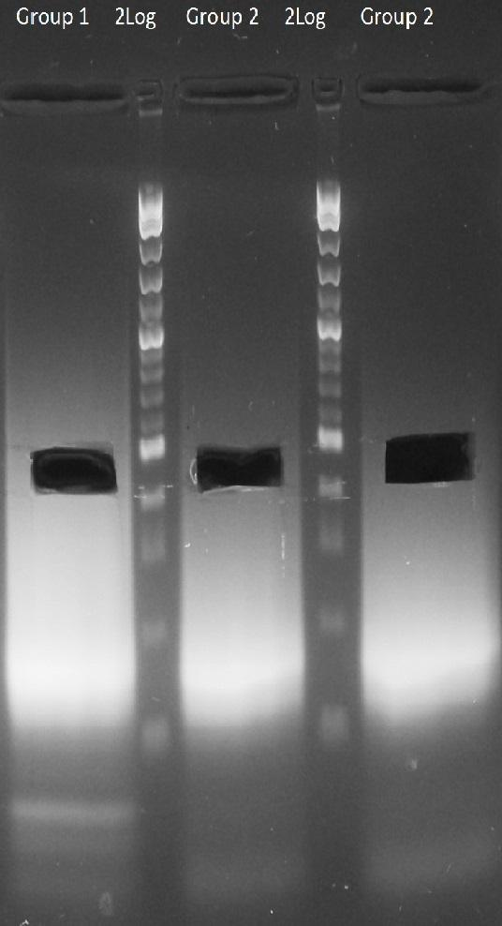

1. Load samples and run the gel slowly, at 5 volts cm-1 (i.e., at 100V if the distance between electrodes is 20cm), for 70 -90 minutes until marker bands in the 100 - 500bp size range are well separated. Use blue-light gel illuminator to safely cut out the required size range (400-500bp). Cut only the middle of the lane, leave the edges (see picture above). Slice each cut-out piece into 4-5 fragments and put them into a new 0.5 ml tube.
2. Use QIAquick Gel Extraction Kit (QIAGEN 28704) to extract DNA.

*NOTE: Sze selection can be most conveniently done on* ***BluePippin****, with higher yields. Set the* ***size selection window to 350-550 bases****.*

**HiSeq notes:**

* Put two-fold higher amount of TagSeq libraries on Illumina runs then suggested by P5-P7 quantitative PCR.
* Add 15% of phiX to the lane.
* The optimal sequencing depth is 2-3 million raw reads per sample.
* 50xSE reads are optimal; there is no advantage in doing longer reads (unless TagSeq is used for genotyping) or PE reads.

**Appendix I: PicoGreen assay Protocol**

1. Place 100µl 1X TE into all first columnwells except B1.
2. Add 150µl of DNA standard (@ 2ug/ml, which is the same as 2ng/ul) into B1.
3. Serially dilute standards by taking 50µl of B1, mixing into C1, taking 50µl of C1, mixing into D1, and so on until taking 50µl from H1 and throwing it out.
4. To all sample wells, add 98µl of 1X TE.
5. Add 2µl sample DNA to sample wells.
6. Mix Pico Green Master mix: 99.5µl 1XTE + 0.5µl PicoGreen for one sample. Multiply accordingly (plus 8 wells for DNA standard).
7. Add 100µl of master mix to all standard and sample wells, bringing up final volumes in each well to 200.
8. Read the fluorescence (excitation 480nm, emission 520nm). We use SpectraMax M2 plate reader and Costar assay plates 96 well, no lid, flat bottom, non-treated black with black bottom (Corning 3650) or clear bottom (Corning 3631).
9. Save the data into txt file, assemble the results in Excel in two-column form – well, reading - save it as comma-delimited (.csv) file. The file must contain all A1-H1 wells (blank and calibrators) plus an arbitrary number of sample wells, in any order. See file picogreen.csv as an example.
10. Use picogreen.R script to calculate sample concentrations (ng/µl in the original sample).

**Appendix II: PCR duplicates**

Perhaps counter-intuitively, the fraction of PCR duplicates among reads depends predominantly on the ratio between number of reads (*n*) and the number of original unique molecules (*N*) and does not increase with additional PCR cycles beyond the first 3-4:

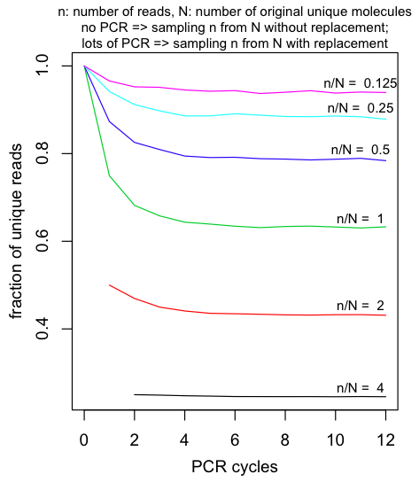

This is because with lots of PCR cycles the fraction of duplicates approaches the value expected in a sample of *n* from *N* with replacement.