Midterm

Bicycle Light

# Specifications

The bicycle light controller [BLC] has one output and one input.

An “LED” output leads to an LED controller which drives/powers an LED from a logical pulse-width modulated [PWM] signal. When the BLC outputs a logical high, the LED will be on at 100% of its brightness. When the BLC outputs a logical low, the LED will be off (0% brightness). The LED controller is an external component which uses the BLC “LED” output to deliver the proper voltage across and current through the LED.

A push button provides a one-bit input. The button is spring-loaded so it is naturally open (logical 0). When the switch is depressed, the button is closed and outputs a high signal (logical 1). When the button is released, the BLC should change operational modes.

The BLC has four operational modes. The first mode is “OFF”, in which the LED is off. The second mode is “BLINK”, in which the LED alternates sequentially between being fully on and fully off at 2Hz. The “off” and “on” sub-states of this blinking mode have equivalent durations (i.e. the LED is on for a quarter of a second and then off for a quarter of a second, etc.). The third mode is “ON”, during which the LED is fully on. The fourth and final mode is “DIM”, during which the LED is lit at 50% brightness. The states proceed sequentially—when the button is released, OFF transitions to BLINK, BLINK transitions to ON, ON transitions to DIM, or DIM transitions to OFF. The states and associated system controls are managed by a finite state machine [FSM] whose general architecture is shown in Figure 1.

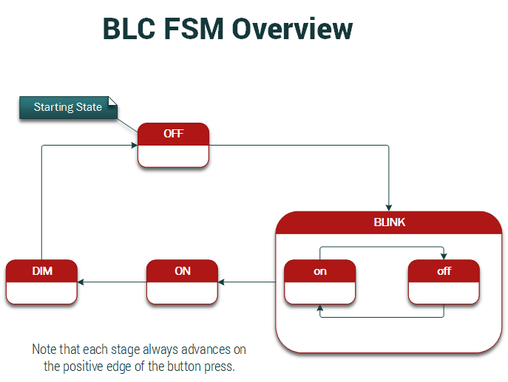

Figure 1: An overview of the modes/states of operation of the BLC.