Web1 Design Document

Group: Vasilis Beloglou Ryan Meijs

Web application topic:
A site to search for information, reviews and to discuss video games. Articles about new releases and news related to gaming events and trends.

Target audience:
Anybody who plays video games. Users who’d like to find information or reviews of a certain game, and users who wants to discuss a game with others.

Sitemap:
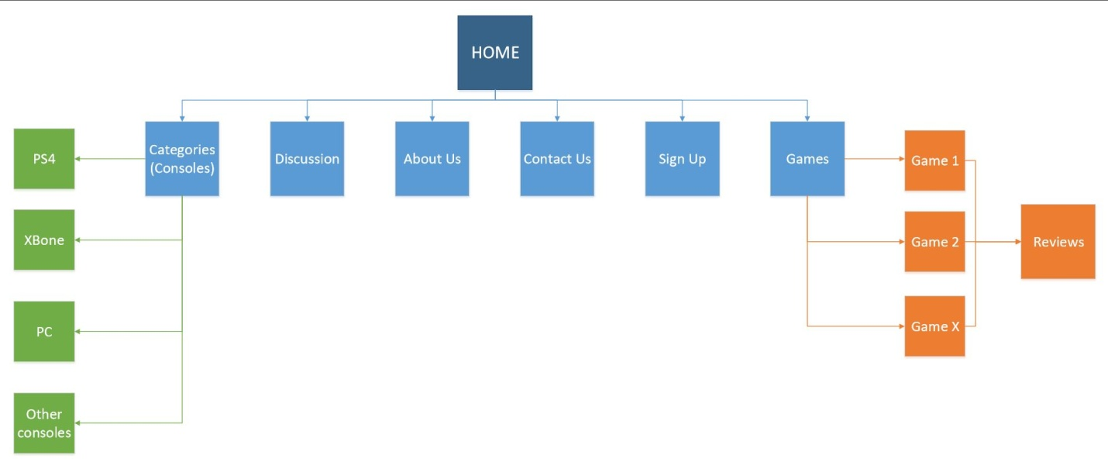

Wireframe:
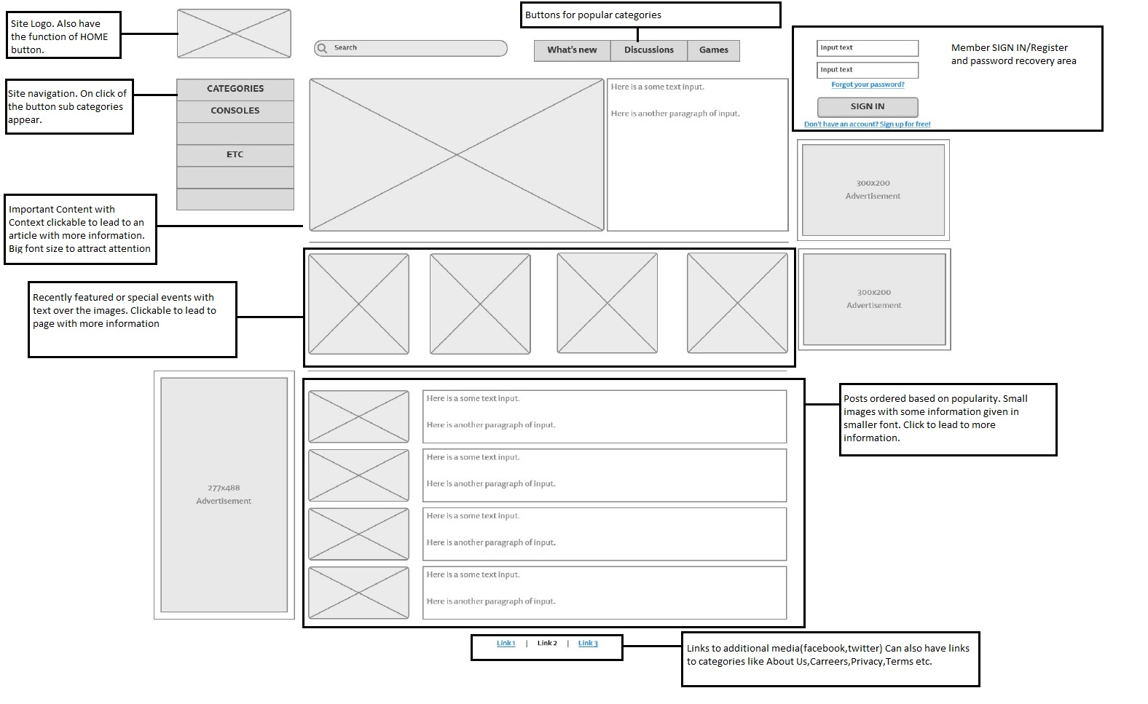
Visual Design:

