**Technical Specification**

**for**

**Vesta Trash Bin**

**Prepared by**

**GAO Mingyuan Tony 1155107738**

**LI Yuxin Ryan 1155107874**

**LIU Zhenyuan Desmond 1155107659**

**YAO Chaorui Claire 1155107717**

**March 12, 2019**

**Table of Content (Every section is revised by all of the members.)**

1.Introduction (Desmond) ….………...……………………………………………..3  
 1.1 Purpose……………………………………………………....…………..3  
 1.2 Scope………………………………………………………....………….3  
 1.3 Definition/ Abbreviation/ Terminology……………………...………….3  
 2.Overview (Claire)……………...………………………………………...………..4  
 2.1 General Description……………………………………………………..4 2.2 Product Functions……………………………………………………….5  
 2.3 User Characteristics……………………………………………………..6  
 2.4 General Constraints………………………………………….…...……...6  
 2.5 Assumption and Dependencies………………………………………….6  
 3. Specific Requirement……………………………………………………………..6  
 3.1 Overall System (Ryan)…………………………………………………..6  
 3.2 Functional Requirements (All members)……...…………………....…...7  
 3.3 External Interface Requirements………………………………………..12  
 3.3.1 User Interface (Tony)………………………….……....………12  
 3.3.2 Hardware Interface (Desmond).....……………………………15  
 3.3.3 Hardware Components (Ryan)……….……………………….16  
 3.4 Performance Requirement (Ryan, Tony)..………………………………17  
 3.5 Design Constraints (Ryan).……………………………………………...18  
 3.6 Maintainability (Tony).…….……………………………………………18  
 4. Reference..………………………….………………………………………….....20

1. Introduction

The product is named after Vesta, the goddess of the hearth in Roman religion. In this document, ‘trash bin’ and ‘Vesta’ refer to the ‘Vesta Trash Bin’.

1.1 Purpose

The purpose of this document is to provide a description of ‘Vesta Trash Bin’ including the dimension, constraints, functionality, and components. Moreover, users can also get clear instructions on how to use this product properly and the solutions to some commonplace failures. In this document, we will explain the usage of the main features of the product and how users interact with the product via its external interface.

1.2 Scope

The “Vesta Trash Bin” is a smart domestic appliance with many innovative new features including automatic trash bag sealing and replacing, trash compressing, lid controlling and sweeping robot support. It aims to allow users to do house cleaning in a much more convenient and elegant way. In addition, the product is also intend to be environmentally friendly by adding PETase into the rubbish insideto speed up the degradation process.

With all the innovative features provided, the “Vesta Trash Bin” help users get away from the annoying routines such as sealing and replacing the bags. Everything users need to do is to throw their the daily trash into the bin, and to move the packed and sealed trash bag out of their house.

1.3 Definition/ Abbreviation/ Terminology

|  |  |
| --- | --- |
| **Term** | **Definition/ Abbreviation/ Terminology** |
| User | The people who user our product. |
| Auto-Open State | The state that trash bin lid can open automatically. |
| Control system | A control system manages, commands, directs, or regulates the behavior of other devices or systems using control loops[1]. |
| Closed State | The state that trash bin lid is closed. |
| Open-Lock State | The state that trash bin lid keeps open. |
| PE | In the document, PE is an abbreviation of polyethylene which is the most common plastic. |
| HDPE | In the document, HDPE is an abbreviation of high density polyethylene which is a kind of common recyclable plastic. |
| PETases | In the document, an esterase class of enzymes that catalyze the hydrolysis of poly (ethylene terephthalate) PET plastic to monomeric mono-2-hydroxyethyl terephthalate (MHET). [2] |
| PSM | In the document, PSM is an abbreviation of Plastarch Material. PSM is a biodegradable, thermoplastic resin. It is composed of starch combined with several other biodegradable materials. PSM is stable in the atmosphere, but biodegradable in compost, wet soil, fresh water, seawater, and activated sludge where microorganisms exist.[3] |
| Switch | In the document, switch refers to the power button. |
| Function Button | In the document, function button refers to the button to achieve three functions by different pressing methods. (see section 3.3.1.2) |

2. Overview

This section will give an overview of the whole system. It will introduce the functions and elaborate on how the systems cooperate with each other. Meanwhile, the assumptions and dependencies will be given clearly. At last, the general constraints will be presented.

2.1 General Description

Vesta Trash Bin is an autonomous waste collection device. The mechanical body is the trash bin, which provides the charging interface to sweeping robot. The integration makes Vesta intellectual enough to collect and preprocess the trash.

The trash bin consists of four systems. The lid controlling, auto-sealing and auto-packing systems simplify people’s life and prevent the breeding of germs. The auto-compressing system helps to reduce the usage of plastic bags significantly. The features expressed in this document are intended to be fully implemented. The enhanced products may be developed in subsequent versions.

2.2 Product Functions

The Vesta Trash Bin mainly integrates five functions. Each one relates to automatic control and sensor technology closely.

(a)Automatic Lid Control

The infrared sensors on the lid can detect users’ gesture within 0-35 centimeters. When detecting the trash, the sensor will send electric signals to the control system and then the lid will open automatically.

(b)Automatic Sealing

When the user keeps pressing the function button for 3 seconds, the control system will command the mechanical structure under the changeable bag box to seal the bag using heat sealing technique.

(c) Automatic Bag Replacing

The subtle design of the trash bags and the heat sealing bar frees users from changing bags manually.

(d) Automatic Compressing

When the user double clicks the function button or the sensors detects that the trash reaches the threshold set by the developer, the control system will command the mechanical structure under the cover to stretch and compress the trash. The extent of compressing is measured by the piezoresistive pressure sensors. When the pressure reaches the threshold, the control center receives signals and terminates the compressing process.

(e) Sweeping Robot Support

Vesta Trash Bin also supports charging and dust moving for certain kinds of sweeping robots that comply with the interface mentioned in Section 3.3.

2.3 User Characteristics

The product is mainly used in household or office by the general public. The education level or qualifications are not constrained since the product is designed to be usable by general users. Using the product does not intensively depend on text reading. The attached documents have English, French, Chinese(Simplified), Chinese(Traditional), Japanese, Korean and Arabic versions.

|  |
| --- |
| WARNING: Please do not let children under 8 operate the product unattendedly. |

2.4 General Constraints

The trash must be powered by 12V AC to operate normally.

The sensitivity of detecting is constrained due to the hardware constraints of sensors.

The enzyme can only catalytic the degradation process while degrading the trash fast and completely is not necessarily guaranteed.

|  |
| --- |
| WARNING:  DO NOT throw any sharp-pointed, flammable, acid, alkali, explosive or pour a large amount of liquid into Vesta. |

2.5 Assumptions and Dependencies

The electric signals are transmitted and received correctly and stably;

The chips and circuits function properly;

Vesta Trash Bin must be placed in a moderate enviornment. The range of operating temperature is -25~40℃.

3. Specific Requirements

This section contains all description of the functional and quality requirements of the Vesta Trash Bin. It aims to offer specific requirements of Vesta Trash Bin in detail.

3.1 Overall System

The whole product consists of 4 major subsystems, respectively lid control system, sealing and bag replacement system, compression system, and sweeping robot support system.

3.1.1 Activity Diagram For Major Subsystems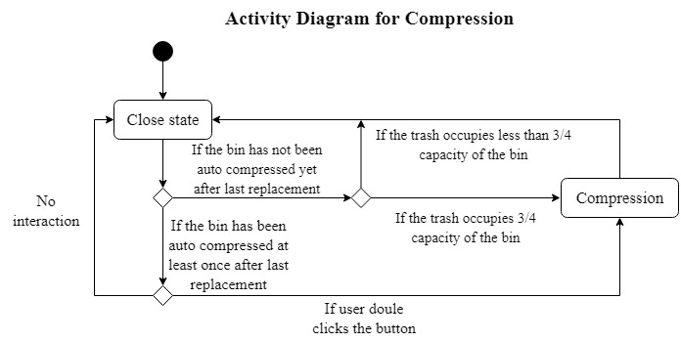

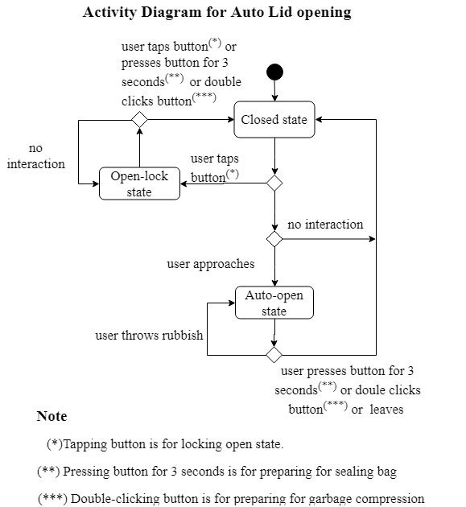 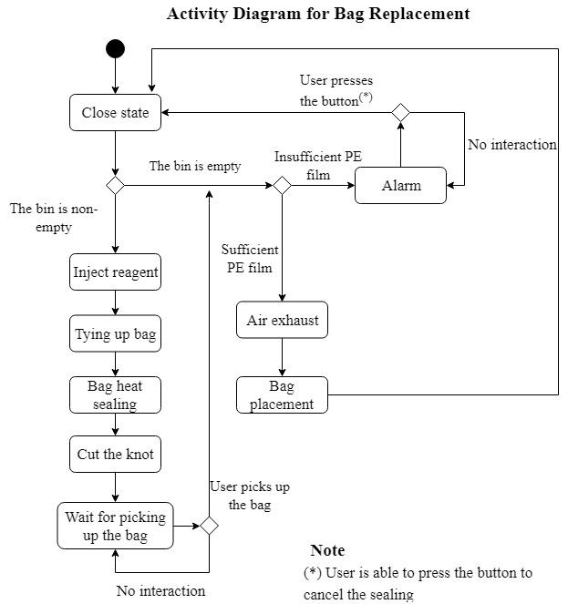[4]

3.2 Functional Requirements

3.2.1 Lid Control System

3.2.1.1 Functional Requirement 1.1

Feature: Gesture Detector

To detect the approaching of the users or the hands moving gesture of the users.

Description:

Mode 1: Approaching Detection

Detecting whether a user is in the distance from the trash bin of 35 centimeters.

Mode 2: Quick Gesture Detection

Detecting the quick hand movement of the user above the trash bin.

The lid will open for 6 seconds (see section 3.4.2) for this kind of gesture.

Mode 3: Normal Gesture Detection

Detecting the slow hand movement of the user above the trash bin.

The lid will open for 3 seconds (see section 3.4.2) for this kind of gesture.

3.2.1.2 Functional Requirement 1.2

Feature: Automatic Lid Opening and Closing

The lid will automatically switch between the auto-open state and closed state according to the signal sent from the gesture detector. This function is to keep the awful smell and nasty scene in a trash bin away from the users.

Description:

If the lid is in Closed state, then it will be open to the vertical position to enter the auto-open state.

If the lid is in Auto-open state, it will enter the closed state and be closed at the speed of 2 rad/s for 0.2s.

Then become slowly to avoid the noise and smell when it is closed to the body.

3.2.1.3 Functional Requirement 1.3

Feature: Manual lid opening and closing

User taps the function button to make the lid enter or quit Open-lock state.

Description:

After the user presses the function button, if the lid is not in the Open-lock state, it will enter this state, in which it will open to the vertical position and keep open until the function button is tapped again. If the lid is already in the Open-lock state, it will quit this state and return to the closed position.

3.2.2 Sealing and Bag Replacement System

3.2.2.1 Functional Requirement 2.1  
Feature: Detecting whether there is a bag in the bin  
Purpose: To detect if the trash bin is ready to place with a new bag.

Description:  
 When the user starts to change bag, the trash bin will check whether this request is valid or not by detecting bags using an infrared sensor. If there is no garbage bag, a sensor responds with an invalid request.  
 When the bag is sealed but not taken out, the LED light will turn into the constant light mode to notify the user.  
3.2.2.2 Functional Requirement 2.2  
Feature: Air exhausting  
Purpose: To make PSM film reach the bottom of the bin to form a garbage bag and refresh the air within the bin.  
Description:(two scenarios in total)  
Scenario 1: At the time of placing a new bag.

The fan on the back side of the bin will keep exhausting the air to decrease the pressure under the PSM film until the PSM film is pushed down and contacts the wall of bin closely.

Scenario 2: At the time of heat sealing.

The fan exhausts the smelly odor and refreshes the air in the bin.   
3.2.2.3 Functional Requirement 2.3  
Feature: Placing a new bag  
Purpose: To place the garbage bag automatically.  
Description:  
 After the packed and sealed bag is removed, if there is sufficient PSM film in a storage box, with the help of the fan, the PSM film will be pushed down automatically by atmospheric pressure and it will contact with the wall of bin closely to form a garbage bag.   
3.2.2.4 Functional Requirement 2.4  
Feature: PSM film tying up  
Purpose: To shrink and tie the opening of the rubbish bags.  
Description:

Two movable bars will tie up four sides of PSM film in the corner of the upper square frame and press them with sealing bars. The tied up PSM film is tight enough to be sealed sufficiently.

3.2.2.5 Functional Requirement 2.5

Feature: Dripping reagent

Purpose: To speed up the degradation process of the rubbish. This will make the rubbish easier to be degraded if it is buried in the landfill.

Description:

Before heat sealing, 5ml of PETases enzyme will be dripped into the bag. The enzyme will degrade the rubbish partially but it won’t degrade garbage bag at all.

3.2.2.6 Functional Requirement 2.6  
Feature: Heat sealing  
Purpose: To seal the bag automatically and keep users away from dirty trash.  
Description:  
 The sealing bars press the PSM film and smear a certain amount of adhesive. Then PSM film is heated up by sealing bars and form a knot. All dirty rubbish is packed so that the user is able to pick up the bag. [5]  
3.2.2.7 Functional Requirement 2.7  
Feature: Cutter  
Purpose: To cut the PSM film placed inside the bin and separate the new bag from the remaining PSM film.  
Description:  
 A cutter cuts the knot of the sealed bag to separate new bag and old bag. Both the top of the old bag and the bottom of the new bag are sealed off at the same time.

3.2.3 Compression System

3.2.3.1 Functional Requirement 3.1

Feature: Detecting the volume of the rubbish inside the bag.

Purpose: To detect whether the bag is to be full and invoke compression function.

Description:

A set of infrared sensors is able to detect the current top surface of rubbish. When the rubbish is over the ¾ capacity of the bin more than one minute, the sensors will send an electric signal to control system to invoke compression function if the bin has not been compressed after last replacement.

3.2.3.2 Functional Requirement 3.2

Feature: Compressing rubbish.

Purpose: To save capacity and preprocess the rubbish.

Description:

A compression board under the lid will be pushed down by mechanical scratcher driven by the control system to compress the rubbish but won’t damage the bag. The pressure is able to compress something that is easy to be compressed, such as paper, plastic bottle and package so on and so forth. And if pressure sensor responds that it will terminate compressing, the board will return to the initial position.

3.2.3.3 Functional Requirement 3.3

Feature: Measuring the pressure.

Purpose: Compress the rubbish as compact as possible but not damage the bin.

Description:

A pressure sensor is able to measure the current pressure collected from the compression board. If the pressure is larger than the threshold (50 Newton), the sensor will send feedback to the control system to terminate compressing.

3.2.3.4 Functional requirement 3.4

Feature: Automatically dust moving for sweeping robot

|  |
| --- |
| NOTICE:  To use the function, the sweeping robot model must comply with Robot dust moving interface (see section 3.3.3.2). Currently, only a few of model produced by Vesta supports this interface. |

Description:

After the sweeping robot moves back into the depot, the trash bin will connect to the dust bag of the sweeping robot. Then, the trash bin will use vacuum to suck the dust out of the dust bag of the robot, into the bag of the trash bin, until the dust bag is empty.

3.2.4 Sweeping Robot Support System

3.2.4.1 Functional Requirement 4.1

Feature: Automatically charging for sweeping robot

Purpose: To charge the sweeping robot when it is in the sweeping robot depot.

Description:

When the sweeping robot is in the depot. The robot will make use of the charging site within the back of the depot to charge itself. The charging indicator (if any) on the sweeping robot will be lit.

|  |
| --- |
| WARNING:  The sweeping robot must comply with the sweeping robot charging interface (see section 3.3.3.1). If it is not compatible with the interface, the charging function may not operate. Even, unpredictable failure may occur to both the trash bin and your sweeping robot. |

3.3 External Interface Requirements

3.3.1 User Interface

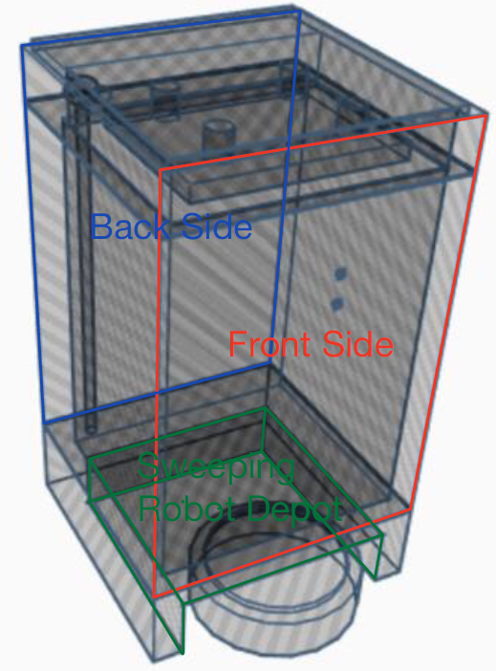[4] 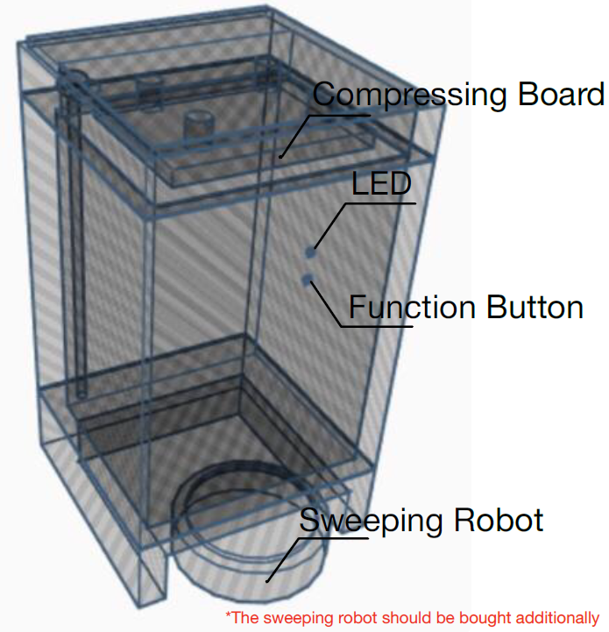 [4]

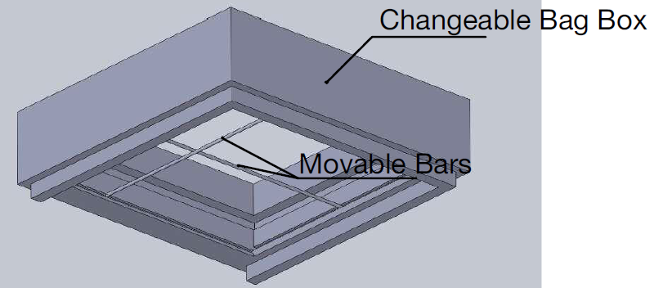[4]

3.3.1.1 Exterior Design

A round funtion button on the front side closed to the lid.

-Different functions with different pressing time

A round-shaped LED around the edge of the round function button

-Different modes of light are for different kinds of notification

A power switch and a charging port located at the mid-lower part of the back side

A charging interface for the sweeping robot under the bin body

A circular rubber ring at the edge of the lid

0.3s to open the lid and 0.5s to close

|  |  |  |  |
| --- | --- | --- | --- |
| Size | Length | Width | Height |
| SI / cm | 57 | 25 | 25 |
| Imperial Units/inch | 22.5 | 10 | 10 |

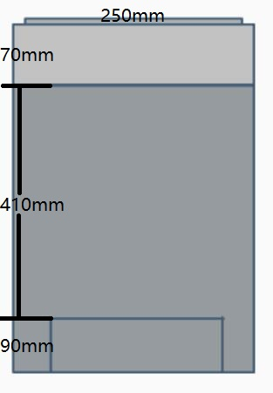[4] 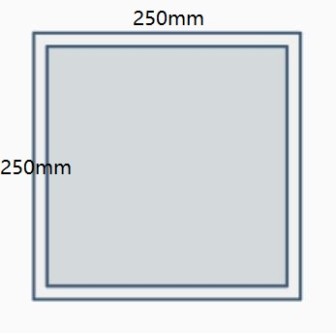[4]

|  |  |
| --- | --- |
| Net Weight | 3.0kg |
| Volume | 15L |
| Color | White and Black |
| Material | PSM (Plastarch Material) for bags, ABS (Acrylonitrile Butadiene Styrene) for trash bin [6]  [7] |
| Sensors Detection Distance | 3-7cm for the front side  10-50cm above the bin |
| Package Contents | 1 x Vesta Trash Bin  1 x Changeable Bag Box  1 x Instruction Manual  1 x Warranty Card |

3.3.1.2 Types of Pressing Function Button

|  |  |
| --- | --- |
| Tap | If not in Open-lock state and keep the lid open  If in Open-lock state, the lid will close and enter the Auto-Open state |
| Double Click | Invoke compression function |
| Press for 3 seconds | Invoke Auto-sealing and bag replacement functions |

3.3.1.3 Meaning for Different Modes of LED Light

|  |  |
| --- | --- |
| Constant Red Light | The plastic bag is full but not sealed or sealed but not taken out |
| Constant Red Light | The number of bags is less than 5 |
| Blink with Withe Light | The lid is in the Open-lock state |
| Blink with Beeping | The trash bin is fell down or there is liquid leaked |
| Blink with Red Light | Low battery |
| Blink with Red Light | The trash bin is in charge (the light will go out when full electricity in this case) |

3.3.2 Hardware Components3.3.2.1 Built-in Battery The Vesta has a built-in rechargeable Li-ion battery [8]. Its nominal voltage is 12V and its capacity is 11Ah, which allows charging at a steady current of 2.2 amperes for an hour.

3.3.2.2 Movable Bars and Guide Rail Two bars driven by two motors will be placed in the two guide rails under the changeable plastic box respectively. They will move freely when the motors drive them. These two bars are able to offer sufficient pressure to press PSM film.

3.3.2.3 Changeable Plastic Box

A changeable plastic box, also called ‘PSM film storage box’, is placed between the body of the bin and the lid. Each box stores 150ml PETases enzyme and 12-meter-long rolled up PSM film that can be degraded. A glass tube storing PETases is connected with the interface on the body of the bin. And the PSM film and the glass tube are able to be replaced.

3.3.2.4 Auto Reagent Injector

A 10-centimeter-long metal injector is inserted in the wall of the bin. The injector is able to extract the PETases enzyme from the glass tube in the changeable plastic box and drips it into the bag before heat sealing.  
3.3.2.5 Heat sealing bars A 2-centimeter bar is inserted into a certain edge of the corner of the bottom of the changeable plastic box in the lid of the bin. It is made from Nickel-chromium alloy designed to directly contact a metal wire. And the sealing bar is able to support up to 13V voltage.

3.3.2.6 Cutter  
 A 1.5-centimeter-long metal cutter is inserted into another edge, which nears the heat sealing bar, of the corner of the bottom of changeable plastic box. It is hidden in the edge unless it needs to cut the knot. Cutter slot is inserted into the opposite movable bar.

3.3.3 Hardware Interface

3.3.3.1 Sweeping Robot Charging Interface

A charging site for the sweeping robot is integrated into the bottom of our product. To use the charging site, the sweeping robot must satisfy the following constraints:

|  |  |
| --- | --- |
| Height | less than 9cm |
| Width | less than 20cm |
| Charging Voltage | 220V, 50Hz |
| Charging Power | less than 440W |
| Remarks | Support Bluetooth 1.0 Protocol  Support Infrared Positioning |

3.3.3.2 Sweeping Robot Dust Moving Interface

To facilitate robot dust moving function of the trash bin. The sweeping robot must comply with

(a) Sweeping Robot Charging Interface (see section 3.3.3.1), and;

(b) Vesta Reusable Dust Bag Design

3.4 Performance Requirements

This section gives technical requirements that Vesta Trash Bin is reached.

3.4.1 Operating Noise

Replacing Bag: Less than 50dB

Lid Opening and Closing: Less than 40 dB

3.4.2 Gesture Detection and Lid Control

|  |  |  |  |
| --- | --- | --- | --- |
| Modes  Parameter | Approaching Detection  (Quick, Short Distance) | Quick Gesture Detection  (Quick, Short Distance) | Normal Gesture Detection  (Slow, Long Distance) |
| Distance | 3-7cm | 10-30cm | 30-50cm |
| Response Time | 0.5s | 0.3s | 0.5s |
| Opening Time | 3s | 6s | 3s |

3.4.3 Battery Performance

|  |  |
| --- | --- |
| 100% charging time | 10 hours |
| Battery lifetime (*) | 30 days |
| Estimated battery lifespan (**) | 60 months |

(*) Battery lifetime: the maximum time the trash bin will run before it must be recharged.

(**) Battery lifespan: The total amount of time the battery will last before it must be replaced.  
3.4.4 Heat Sealing Performance  
The procedure of heat sealing will be completed within 5 seconds.   
The knot of sealing is strong enough to hold pressure of 6000 Pascal, which is a general upper bound of the weight of rubbish a household can produce per day. [9]   
The metal wire allows at most 2.2A AC to heat up the PSM film.  
The temperature of heat sealing must be reached from indoor temperature in one second.

3.4.5 Bag Replacement  
The whole procedure of bag replacement will be completed within 10 seconds  
The cutter is able to cut off the knot whose strength is at most 80 Newtons.  
The cutter is safely hidden in the frame when it is idle.

3.5 Designed Constraints

3.5.1 PSM Film Storage Box

Users must use the boxes we designed for Vesta Trash Bin.

The box is made from HDPE.

The box stores 12m rolled up PSM film.

The box stores 150ml reagent.

PE film and reagent are replaceble.

3.5.2 BagUsers must use the bag we designed for Vesta Trash Bin.

The garbage bag is made from PSM film (polyethylene).

The melting point of PSM falls in the range from 110°C to 140°C  
The size of the PSM film is XL (extra-large) and XT (extra-thick).  
The length of PSM film is at least 12 meters so that the period of use can be at least 30 days.

3.6 Maintainability

When you encounter these failures mentioned below, please check the solutions provided. If you still cannot resolve the problem or encounter any failures that are not listed, please contact our technical stuff for professional support.

|  |
| --- |
| WARNING:  For your safety, DO NOT take apart the trash bin on your own under any circumstances. |

3.6.1 Automatic Opening Failure

Description: The lid of the trash bin does not open automatically.

Possible Cause: When the lid is in open-lock mode, the user pushes the lid to close directly without tapping the function button.

Solution: Tap the function button to enter the lock-open state, the sensors will be restored automatically, then press again to quit.

3.6.2 Function Button Failure

Description: The trash bin does not respond after user taps or presses the function button.

Possible Cause: User presses the function button and turns the switch on the power at the same time.

Solution: Turn the switch off and wait for at least 5 seconds. Then restart the power.

3.6.3 Automatic Sealing Failure

Description: The movable bars get stuck and cannot return to the initial position.

Possible Cause 1: Movable bars dysfunction.

Solution: First, check if there is any garbage prevent the movable bars from moving. Press the function button for 3 seconds to reset it, then press the function button again for 3 seconds to continue the sealing.

Possible Cause 2: The volume of trash exceeds the capacity of the trash bin body.

Solution: Compress the trash or take out some trash. Then try pressing the function button for 3 seconds to invoke the sealing function again.

3.6.4 Bags Replacement Failure

Description: After the bag is sealed and taken away, the trash bin does not place the bag.

Possible Cause: Some garbages or liquids cover the IR sensors on the lower part of the inner wall of the bin.

Solution: Remove the garbages or liquids and make sure the trash bin completely empty. Then press the function button for 3 seconds to reset it.

4. Reference

[1] “Control system,” Wikipedia, 27-Feb-2019. [Online]. Available: https://en.wikipedia.org/wiki/Control_system. [Accessed: 11-Mar-2019].

[2] H. P. Austin, M. D. Allen, B. S. Donohoe, N. A. Rorrer, F. L. Kearns, R. L. Silveira, B. C. Pollard, G. Dominick, R. Duman, K. E. Omari, V. Mykhaylyk, A. Wagner, W. E. Michener, A. Amore, M. S. Skaf, M. F. Crowley, A. W. Thorne, C. W. Johnson, H. L. Woodcock, J. E. McGeehan, and G. T. Beckham, “Characterization and engineering of a plastic-degrading aromatic polyesterase,” PNAS, 08-May-2018. [Online]. Available: https://www.pnas.org/content/115/19/E4350. [Accessed: 4-Mar-2019].

[3] “Plastarch material,” Wikipedia, 27-Feb-2019. [Online]. Available: https://en.wikipedia.org/wiki/Plastarch_material. [Accessed: 7-Mar-2019].

[4] Liu Zhenyuan. “Desmond_Work: Pictures for ELTU Informative Presentation”.github.com Feb. 13, 2019. [Online]. Available: https://github.com/DesmondZhenyuanLIU/Desmond_Work. [Accessed: 13-Feb-2019]

[5] “Heat Sealing Fundamentals, Testing, and Numerical Modeling.” [Online]. Available: https://web.wpi.edu/Pubs/E-project/Available/E-project-042915-173630/unrestricted/Heat_Sealing.pdf. [Accessed: 9-Mar-2019].

[6] A. Patel, R. Brahmbhatt and S. Devi, "Mechanical properties and morphology of PP/ABS blends compatibilized with PP-g-2-HEMA", Journal of Applied Polymer Science, vol. 88, no. 1, pp. 72-78, 2003. Available: 10.1002/app.11554.

[7] “SPI Resin Identification Code - Guide to Correct Use,” razor tie artery foundation announce new joint venture recordings | Razor & Tie. [Online]. Available: https://web.archive.org/web/20160126213345/http://www.plasticsindustry.org/AboutPlastics/content.cfm?ItemNumber=823&navItemNumber=1125. [Accessed: 4-Mar-2019].

[8] “The Li-Ion Rechargeable Battery: A Perspective,” ACS Publications. [Online]. Available: https://pubs.acs.org/doi/abs/10.1021/ja3091438. [Accessed: 4-Mar-2019].

[9] “Monitoring of Solid Waste in Hong Kong 2017” Waste Data & Statistics | Waste Reduction Website, 27-Apr-2018. [Online]. Available: https://www.wastereduction.gov.hk/sites/default/files/msw2017.pdf [Accessed: 5-Mar-2019].