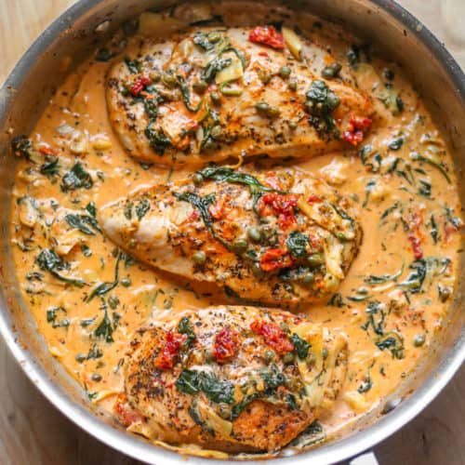
Creamy Tuscan Chicken

Ingredients
8 (6-ounce) boneless skinless chicken breasts
2 tsp Italian seasoning
2 tsp kosher salt
1 tsp black pepper
6 tbsp extra virgin olive oil
8 garlic cloves, minced
½ cup finely chopped yellow onion
1 cup sun-dried tomatoes, thinly sliced
4 cups baby spinach
3 cups heavy cream
½ cup freshly grated parmesan

Instructions
- Season chicken with Italian seasoning, salt, and pepper.
- Heat 2 tbsp of olive oil in a large skillet over medium heat. Add the chicken and sear for 3-4 minutes on each side until golden.
- Add +1 tbsp of oil to the same skillet and add the onion. Sauté for 2-3 minutes until soft.
- Add the tomatoes and garlic, sauté another minute until fragrant.
- Add the spinach, sauté another minute until just starting to wilt
- Add heavy cream and parmesan cheese. Stir together and bring to a simmer.
- Put chicken back and cook until cooked through (165F), about 5 minutes.

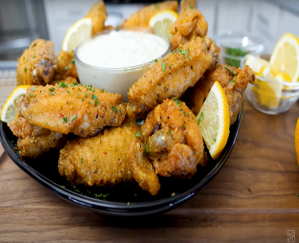
Lemon Pepper Wings

Ingredients
2 lbs Chicken Wings, split into drumettes and flats
1 cup All-Purpose Flour
1/4 cup Cornstarch
Lemon pepper seasoning
MSG (To season flour)
Garlic Powder ~ Any other seasonings
Non-Stick Cooking Spray

Instructions
- Preheat air fryer to 380F for 3-5 minutes
- In a large bowl, mix together the all-purpose flour, and cornstarch.
- Pat the chicken wings dry with paper towels to remove any excess moisture.
- In another bowl, mix the seasonings and chicken.
- Dredge the seasoned chicken wings in the flour mixture, shaking off any excess flour.
- Lightly spry the air fryer basket with cooking-spay to prevent sticking.
- Place the coated chicken wings in the air fryer basked in a single layer, making sure they are not overcrowded. Cook in batches if needed.
- Air fry wings at 380F for 14-18 minutes, flipping them halfway through the cooking time, until they are golden brown and crispy.
- Once cooked, remove from the air fryer and add additional seasonings.

Ingredients
1 ¼ lbs. Boneless skinless chicken breasts, diced into 1-inch pieces
2 tbsp all-purpose flower
2 tsp Italian seasoning
? tsp salt
? tsp pepper
8 tbsp unsalted butter, diced into 1-tbsp pieces
1 tbsp olive oil
2 tbsp minced garlic (6 cloves)
12 oz. thin or standard spaghetti
1 cup dry white wine (Sauvignon Blanc)
1/8-1/4 tsp red pepper flakes
1 tbsp fresh lemon juice
1/3 cup chopped parsley
2/3 cup shredded parmesan cheese

