COMP2147 – Sprint 2

Entecott, Nicholas – 101090483

Haberle, Ryan – 101094993

Murphy, Patrick – 101103097

Shaikh, Nehaal - 101095479

User Stories

1. As a User I want to be able to Enroll in a course
2. As an Administrator I want to be able to add/delete courses

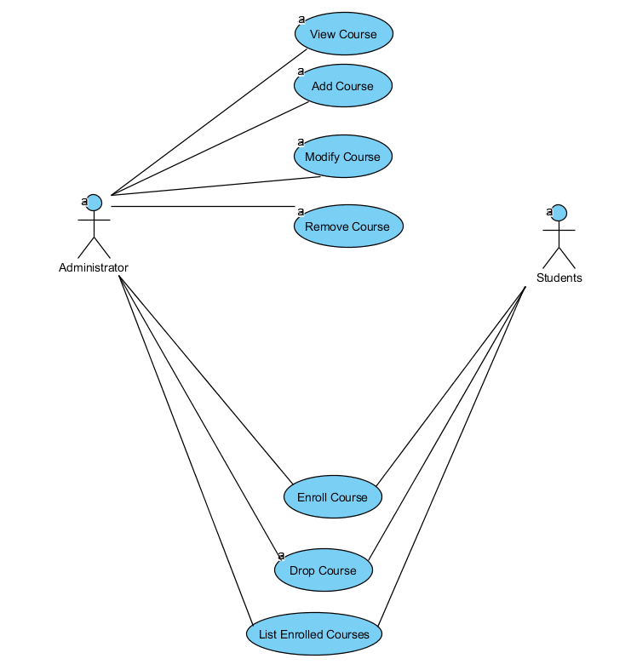

Class Diagram

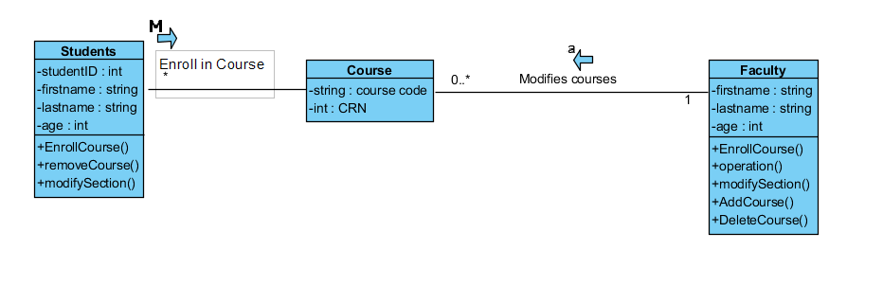

**Method Contract 1**

|  |  |  |
| --- | --- | --- |
| Method name: EnrollInCourse() | Class Name:Student | ID:1 |

|  |
| --- |
| Clients: Students |

|  |
| --- |
| Associated use cases: Helps students enroll in class |
| Description of responsibilities:  Students request to be enrolled in classes |
| Arguments received: CRN number, Student number, course name |
| Type of value returned: Boolean value |
| Pre – condition:  Student number not null  Class limit must not be full |
| Post conditions: none |
|  |

**Method Contract 2**

|  |  |  |
| --- | --- | --- |
| Method name: deleteCourse() | Class Name:Teacher | ID:2 |

|  |
| --- |
| Clients: Teachers |

|  |
| --- |
| Associated use cases: Helps teachers delete a course |
| Description of responsibilities:  Teachers can remove a course from the registry |
| Arguments received: CRN number , course name |
| Type of value returned: Boolean value – if deleted or not |
| Pre – condition:  Crn must not be null  Students cannot be enrolled in calss |
| Post conditions: none |
|  |

**Method Contract 3**

|  |  |  |
| --- | --- | --- |
| Method name: addCourse() | Class Name:Teacher | ID:3 |

|  |
| --- |
| Clients: Teachers |

|  |
| --- |
| Associated use cases: Helps teachers add a course |
| Description of responsibilities:  Teachers can add a course to the registry |
| Arguments received: CRN number , course name |
| Type of value returned: Boolean value – if created or not |
| Pre – condition:  Crn must not be null  Cannot have same crn as other course |
| Post conditions: none |
|  |

**Method Specification**

|  |  |  |
| --- | --- | --- |
| Triggers\Events: Student enrolled in class if conditions are met | | |
| **Arguments received: Data type** | **NOTES:** | |
| Student number: int | Student number | |
| CRN number: int | Course number | |
| course name: string | Student’s name | |
|  |  | |
|  |  | |
|  |  |  |
| **Messages sent & arguments passed:** | **DataType** | **Notes** |
| Student.EnrollInCourse(int,int, string) | Student enrolled:boolean | If true student is enrolled |
| Student.classInProgram(int) | boolean | If true student can enroll in class |
|  | |
|  |  | |
| **Algorithm specifications:**  If class not full && student number != null  Enroll student.  Else  Don’t Enroll student. | | |

User Interface Design

Student Registration

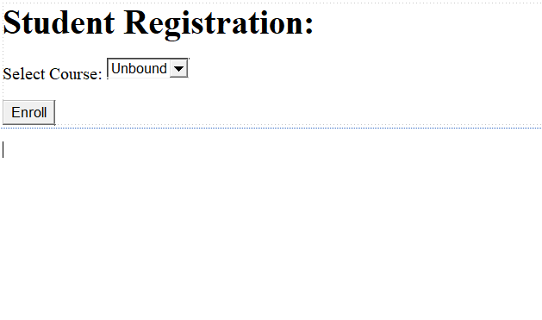

Administrator

