COMP2147 – Sprint 3

Entecott, Nicholas – 101090483

Haberle, Ryan – 101094993

Murphy, Patrick – 101103097

Shaikh, Nehaal – 101095479

Entity Relationship Diagram

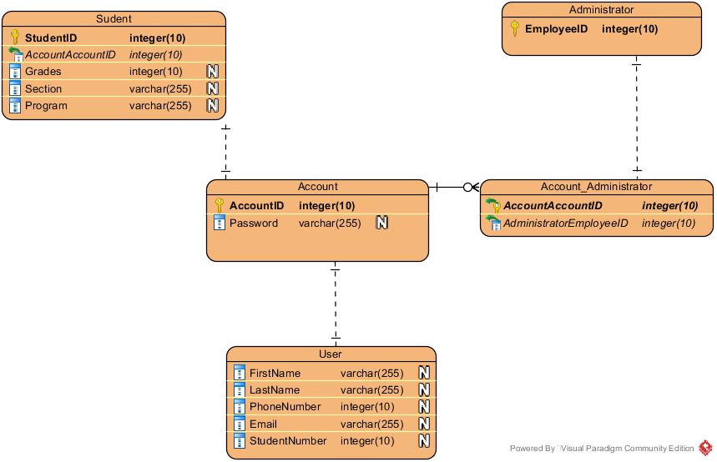

Interface Design

TimeON Student Portal

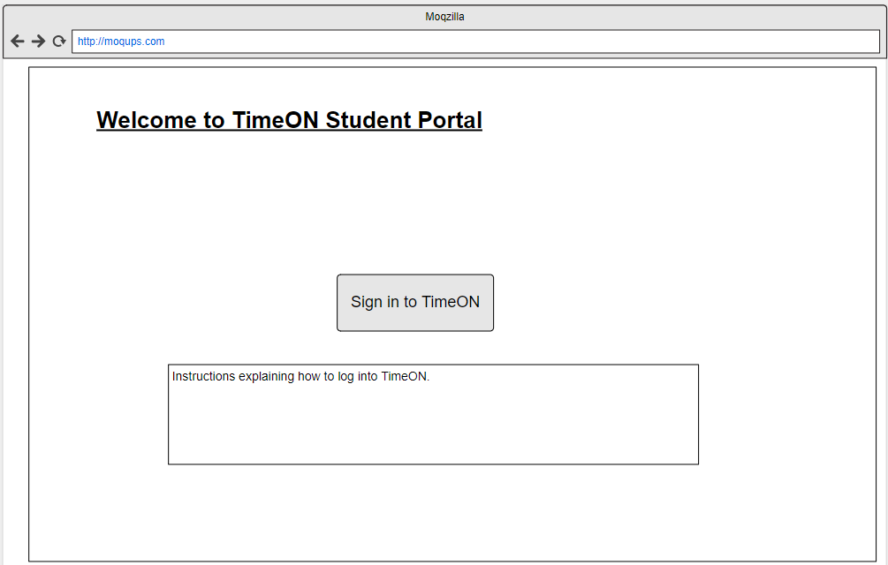

Admin Grade Change Form

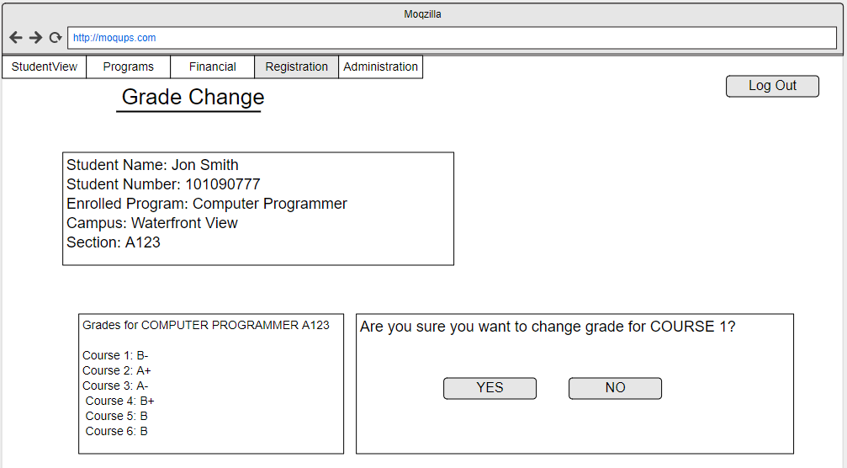

Student Grade Appeal Form (Grade Request)

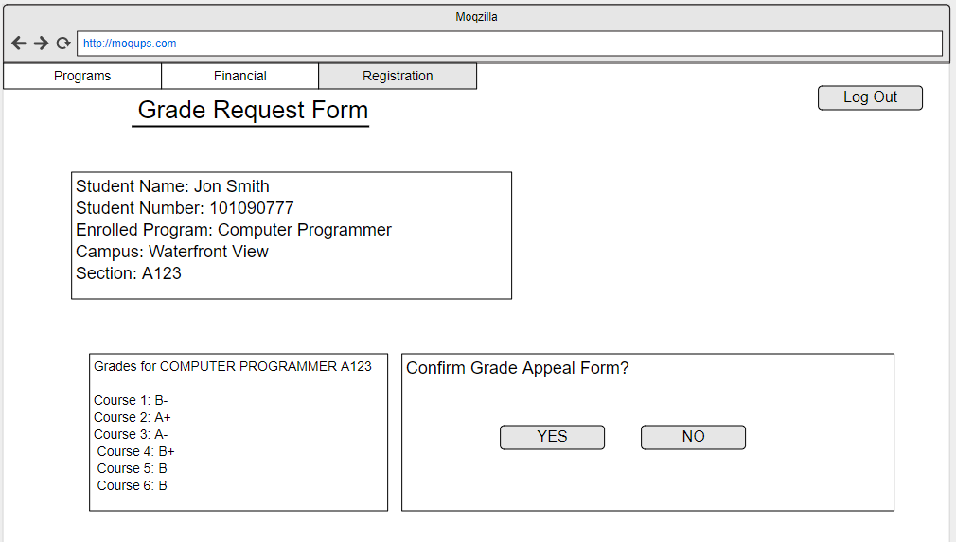

Network Model Deployment Diagram

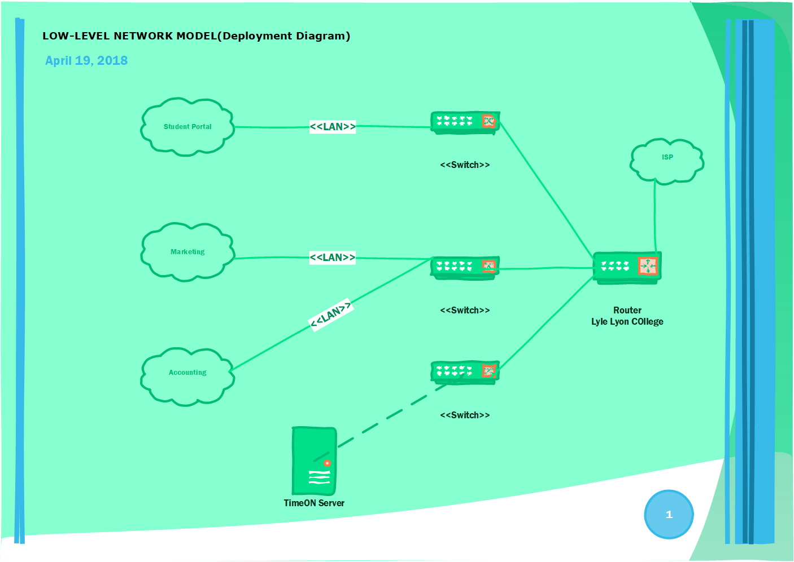

Hardware and Software Deployment Diagrams

Hardware:

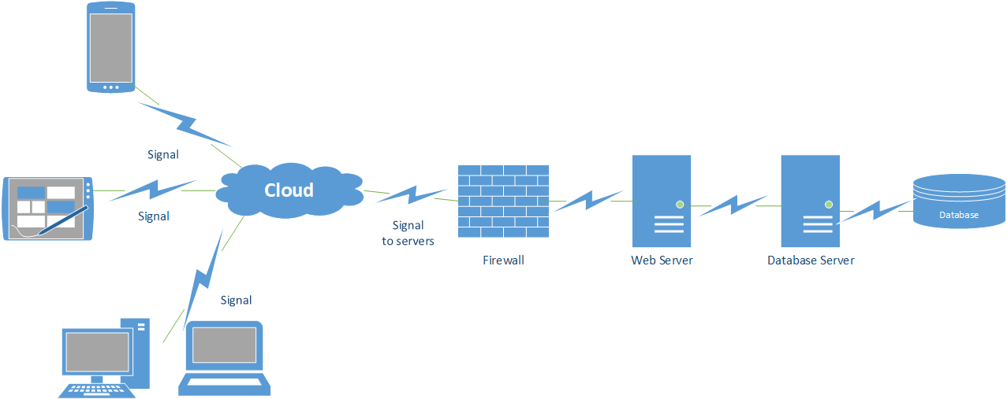

Software:

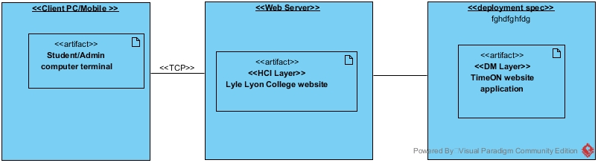

Additional User Stories and Class Diagrams

