GROUP 1

Tony Eardley 14417434

Josh Challand 14414449

Julius Prakelis 16430034

Ryan Haskins 16442673

Contents

Schema Design 2

Skeleton Tables Design 2

Proposed Automation Strategy 5

Evidence of Additional Research 5

Screenshots 6

PROCEDURES 6

Procedures Functionality: 6

FUNCTIONS 9

Functions Functionality: 9

TRIGGERS 11

Triggers Functionality: 11

Test Plan 12

References 17

Appendix 17

# Schema Design

One of the initial stage of creating the database is the creation of a schema, detailed below is the schema of which the database system is derived from. Built from the initial ERM, the schema builds on top of the already established entities and their relationship by adding objects to be used by the database and enhance its functionality, efficiency and design.

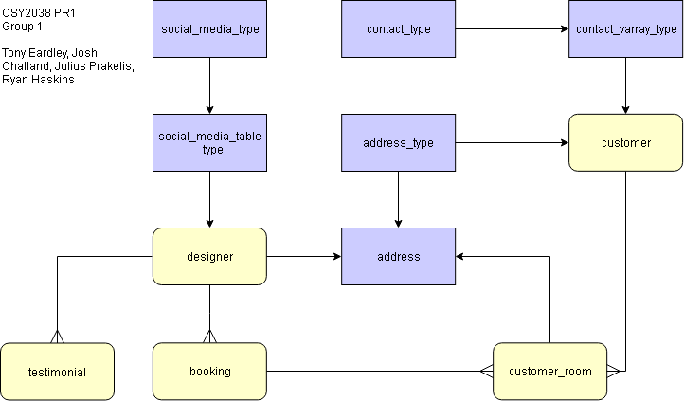

# Skeleton Tables Design

The following table details the design of the database objects and tables, there attributes, datatypes, and constraints providing the initial groundwork to build the database from scratch. Effectively being a blueprint for the entire project.

|  |  |  |  |  |
| --- | --- | --- | --- | --- |
| Table | Attribute | Key | Datatype | Constraints/Defaults |
| DESIGNERS | designer_id | PK | NUMBER(8) |  |
|  | firstname |  | VARCHAR2(25) | NOT NULL |
|  | lastname |  | VARCHAR2(25) | NOT NULL |
|  | address |  | ref of address_type |  |
|  | social_media |  | social_media_table_type |  |
|  | pay_rate |  | NUMBER(4,2) | DEFAULT 7.50 |
|  | hire_date |  | DATE | DEFAULT SYSDATE |
|  | dob |  | DATE | NOT NULL |
|  | | | | |
| BOOKINGS | booking_id | PK | NUMBER(8) |  |
|  | designer_id | FK | NUMBER(8) | NOT NULL |
|  | cost |  | NUMBER(10,2) |  |
|  | completed |  | CHAR(1) | NOT NULL  CHECK (‘Y‘ || ‘N’’)  DEFAULT ‘N’ |
|  | order_date |  | DATE | DEFAULT SYSDATE |
|  | arrival_date |  | DATE |  |
|  | | | | |
| CUSTOMERS | customer_id | PK | NUMBER(8) |  |
|  | title |  | VARCHAR2(10) |  |
|  | firstname |  | VARCHAR2(25) | NOT NULL |
|  | lastname |  | VARCHAR2(25) | NOT NULL |
|  | username |  | VARCHAR2(25) |  |
|  | address |  | address_type |  |
|  | contact |  | contact_varray_type |  |
|  | | | | |
| CUSTOMER_ROOMS | customer_id | PK FK | NUMBER(8) | NOT NULL |
|  | booking_id | PK  FK | NUMBER(8) | NOT NULL |
|  | room_width |  | NUMBER(6) | NOT NULL |
|  | room_length |  | NUMBER(6) | NOT NULL |
|  | address |  | ref of address_type |  |
|  | | | | |
| TESTIMONIALS | testimonial_id | PK | NUMBER(8) |  |
|  | designer_id |  | NUMBER(10) | NOT NULL |
|  | review |  | VARCHAR2(125) |  |
|  | rating |  | NUMBER(2) | NOT NULL  CHECK( rating < 11) |
|  | date_created |  | DATE | DEFAULT SYSDATE |
|  | | | | |
| ADDRESSES | address_type: | | | |
|  | house_number |  | VARCHAR2(25) |  |
|  | street |  | VARCHAR2(25) |  |
|  | city |  | VARCHAR2(25) |  |
|  | postcode |  | VARCHAR2(25) |  |
|  | country |  | VARCHAR2(15) |  |
|  | | | | |
| SOCIAL_MEDIA_TABLE_TYPE | social_media_type: | | | |
|  | media_name |  | VARCHAR2(25) |  |
|  | contact |  | VARCHAR2(50) |  |
|  | | | | |
| CONTACT_VARRAY_TYPE | contact_type: | | | |
|  | contact_type |  | VARCHAR2(15) |  |
|  | contact_method |  | VARCHAR2(15) |  |
|  | contact_info |  | VARCHAR2(50) |  |

The following table details the sequences, functions, procedures, triggers, and Queries that were identified to be useful when implementing the design of the system. They offer key functionality, that enhances the databases maintainability and efficiency whilst providing the means to extract useful information.

|  |  |
| --- | --- |
| **Sequences, Functions, Procedures, Triggers, and Queries** | |
| **Name** | **Description** |
| **Sequences** | |
| designers_seq | Starts with 10000000 and increments by 1 |
| bookings_seq | Starts with 40000000 and increments by 1 |
| testimonials_seq | Starts with 30000000 and increments by 1 |
| customers_seq | Starts with 20000000 and increments by 1 |
| customer_rooms_seq | Starts with 50000000 and increments by 1 |
| **Functions** | |
| func_retire_age  (in_dob designers.dob%TYPE, in_retire_age NUMBER)  RETURN NUMBER | Function determines the months left until retirement based upon the dob and retirement age passed in its parameters. |
| func_booking_cost  (in_total_area NUMBER, in_pay_rate designers.pay_rate%TYPE, in_avg_rate testimonials.rating%TYPE)  RETURN NUMBER | Function takes in the total area of a room, a pay rate of a designer, and average rating of said designer. The function then uses the three arguments to generate a total cost which is return to the calling routine. |
| func_total_area  (in_length customer_rooms.room_length%TYPE, in_width customer_rooms.room_width%TYPE)  RETURN NUMBER | Function takes in the total area of a room, a pay rate of a designer, and average rating of said designer. The function then uses the three arguments to generate a total cost which is return to the calling routine. |
| **Procedures** | |
| proc_retire_param  (in_designer_id designers.designer_id%TYPE, in_retire_age NUMBER) | Procedure takes in a designers id and the age at which they plan to retire, it then stores the designers date of birth using a query. the  dob and age they plan to retire is send to a function which returns the number of months they have left until retirement. |
| proc_higher_rate  (in_rating testimonials.rating%Type) | Procedure takes in a rating and creates a cursor which queries all ratings in testimonials which are greater than the input rating. The procedure then opens the cursors and checks if a row was found, displaying  and appropriate message. If a row was found it loops through the results displaying the relevant information from the results found. |
| proc_booking_cost  (in_total_area NUMBER, in_booking_id bookings.booking_id%TYPE) | Procedure takes in a total area and booking id. The booking id is then used in a cursors to find all customer rooms under the same booking, each customer rooms area is then added to the total area of the booking. It is also used in two queries that extracted the designers pay rate and average rating via joins and the AVG function into two variables. The total area, pay rate, and average rating are then passed to a function which returns a total cost which is used to update the booking associated with the booking id with a new cost. |
| **Triggers** | |
| trig_designer | Trigger runs before insert, update or delete on the designers table taking appropriate action dependant on the action that triggered the trigger. If inserting it displays the name of who is being inserts. If updating it sends the dob of the record being updated to a function which returns the remaining months until retirements base on a hardcoded age of 67. If deleting it displays the name of who is being deleted. |
| trig_booking_cost | Trigger runs when a customer room is inserted. It takes the width and length and works out the total area and passes it into the procedure to update the bookings cost. |
| **Queries** | |
| Highest booking cost using functions. | |
| Customer rooms in which a designer is located. | |
| Find designers and their average ratings. | |
| List designer’s bookings and whether they are completed or not. | |
| Designer’s information and social media. | |
| Designer’s information and address. | |
| Customers address. | |
| Customer emergency contact details. | |
| Customers who have customer rooms and bookings. | |

# Proposed Automation Strategy

As the part of the database build some of the processes were automated to ease the process of the data query and format outputs. As for the complete database build SQL PROCEDURES, FUNCTIONS and TRIGGERS were implemented.

In the below paragraph all procedures, triggers and functions used in the database build will be introduced and briefly explained. Purpose is to comply with the aims and objectives which were set for the successful completion of the database build.

# Evidence of Additional Research

Some of the parts of the project build required additional research which helped to improve database functionality and comply with the up to date conventions.

One of the most informal and reader friendly documents was - **“Oracle SQL & PL/SQL Optimization for Developers Documentation Release 2.1.1”** written by: Ian Hellstrom released: Dec 29, 2017.

Document introducing starting level developer with the best practices and conventions from the very beginning and then going in depth to the structure of the complex queries, procedures etc. Documentation is easy to read and understand due to its nature explaining everything what's happening behind the scenes while running the code.

# Screenshots

## PROCEDURES

Table below will show procedure which is implemented in the database and brief description.

|  |  |  |
| --- | --- | --- |
| **ID.** | **Name** | **description** |
| **1** | proc_retire_param | Procedure takes in a designer’s id and the age at which they plan to retire, it then stores the designer’s date of birth using a query. The dob and age they plan to retire is send to a function which returns the number of months they have left until retirement. |
| **2.** | proc_higher_rate | Procedure takes in a rating and creates a cursor which queries all  ratings in testimonials which are greater than the input rating. The  procedure then opens the cursors and checks if a row was found, displaying and appropriate message. If a row was found it loops through the results displaying the relevant information from the results found. |
| **3.** | proc_booking_cost | Procedure takes in a total area and booking id. The booking id is then used in two queries that extracted the designers pay rate and average rating via joins and the AVG function into two variables. The total area, pay rate, and average rating are then passed to a function which returns a total cost which is used to update the booking associated with the booking id with a new cost |

With the help of the procedures we can easy query multiple parameters and use functions to ease data retrieval from the database.

### Procedures Functionality:

1. proc_retire_param

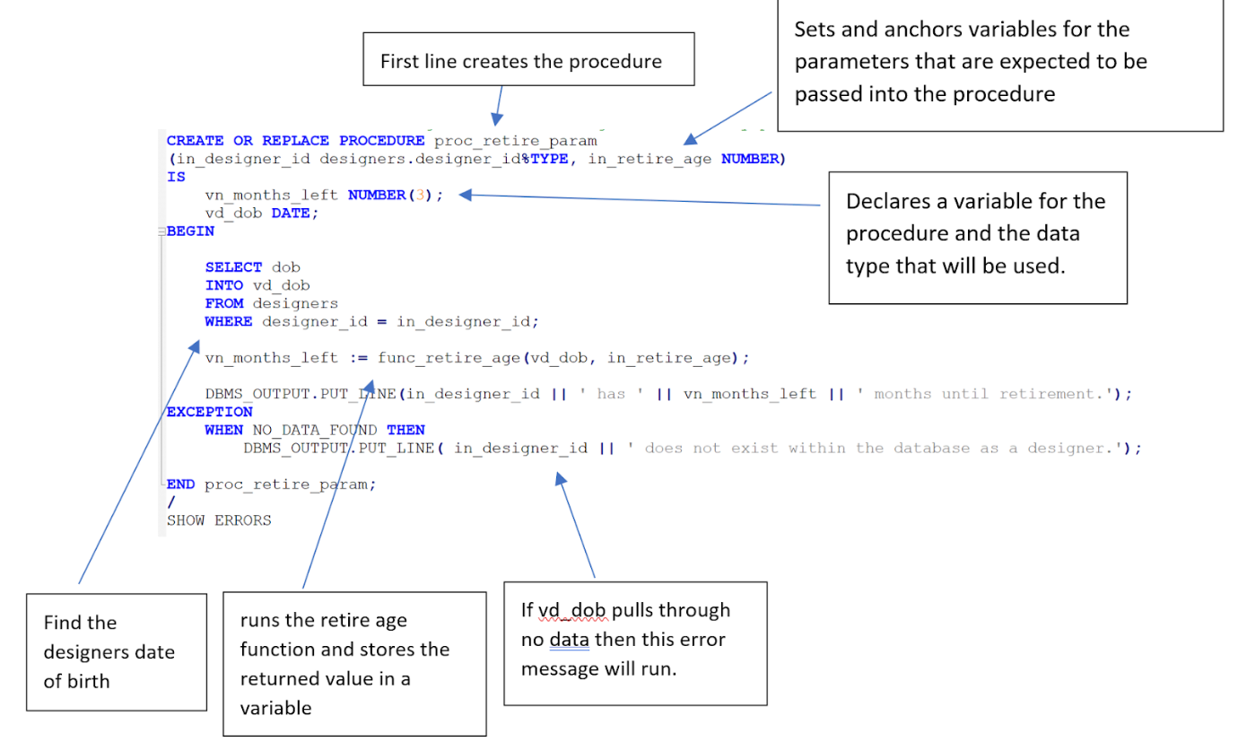  
  
2. proc_higher_rate  
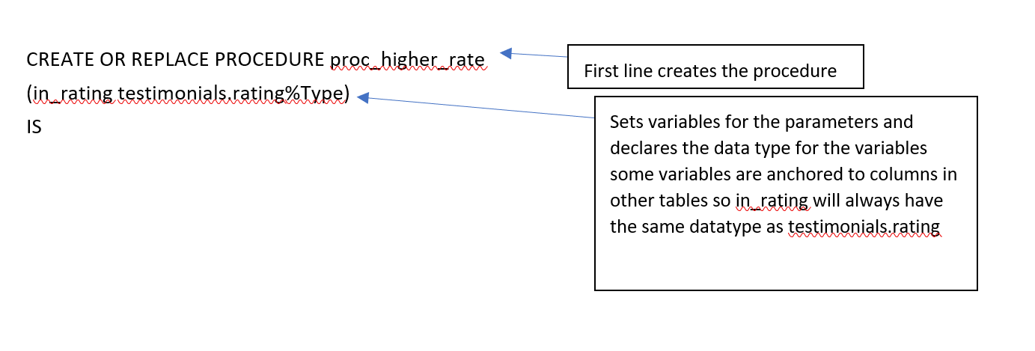

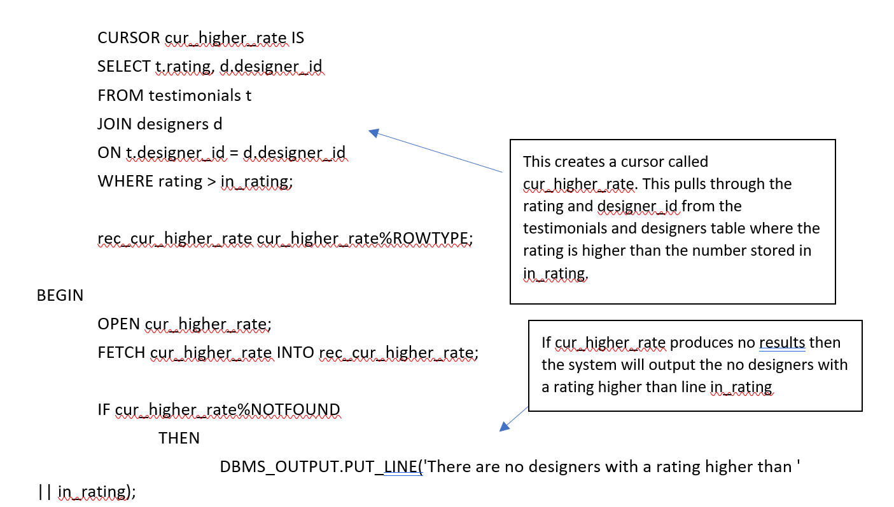

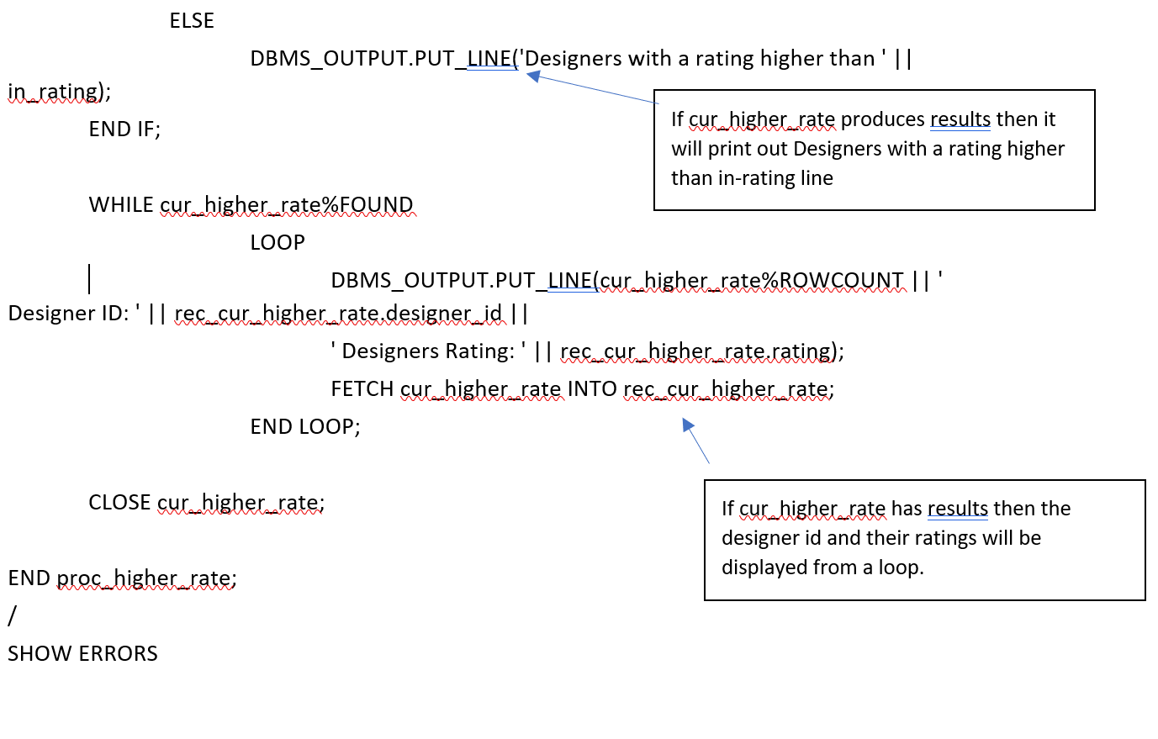

3. proc_booking_cost

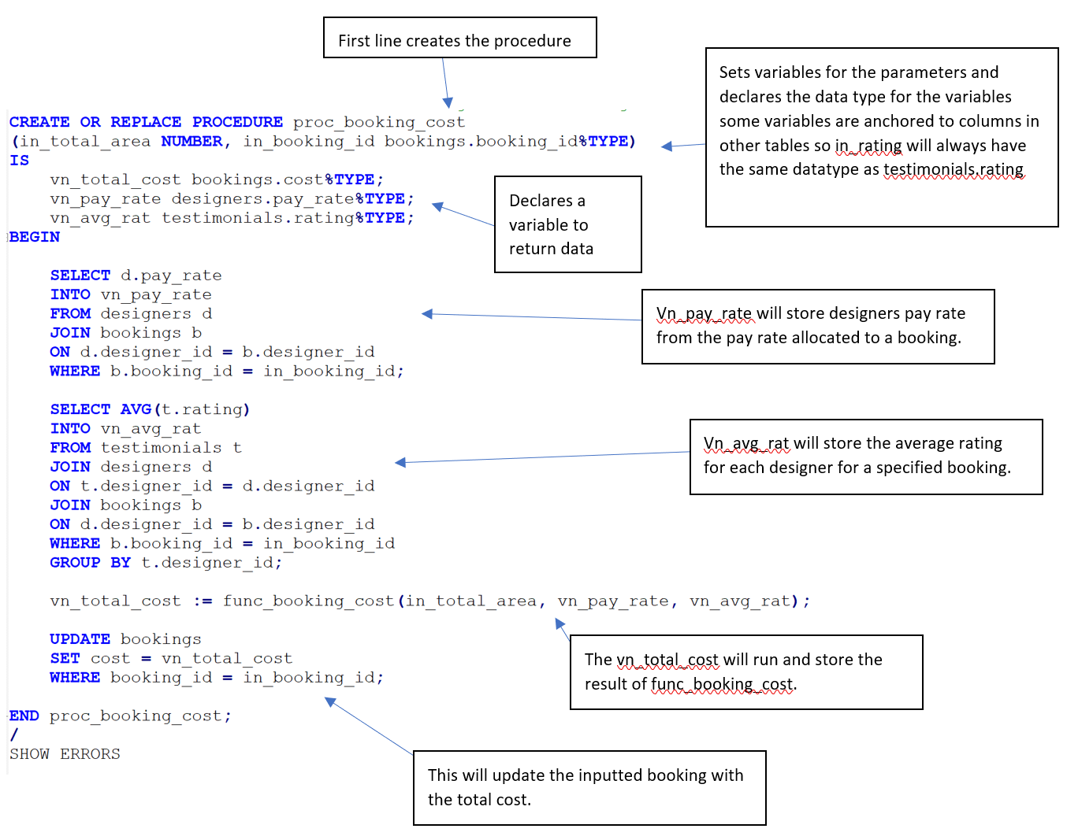

## FUNCTIONS

Table below will contain named functions and descriptions on what the functions are doing.

|  |  |  |
| --- | --- | --- |
| **ID.** | **Name** | **description** |
| **1.** | func_retire_age | Function determines the months left until retirement based upon the dob and retirement age passed in its parameters. |
| **2.** | func_booking_cost | Function takes in the total area of a room, a pay rate of a designer, and average rating of said designer. The function then uses the three arguements to generate a total cost which is return to the calling routine. |
| **3.** | func_total_area | Function calculates and returns the total area based upon two parameters passed if which are assumed to be measurements. |

All of the functions explained above is designed to cover 3 different database areas. With the help of these functions it easier and faster to do calculations for the provided criteria.

### **Functions Functionality:**

1. func_retire_age:

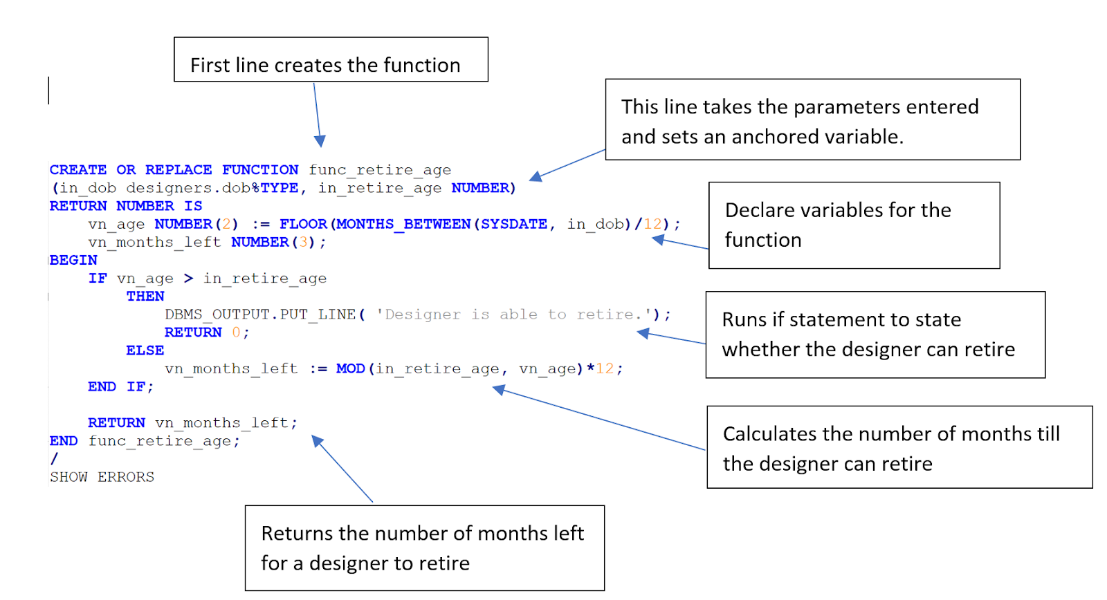

2. func_booking_Cost

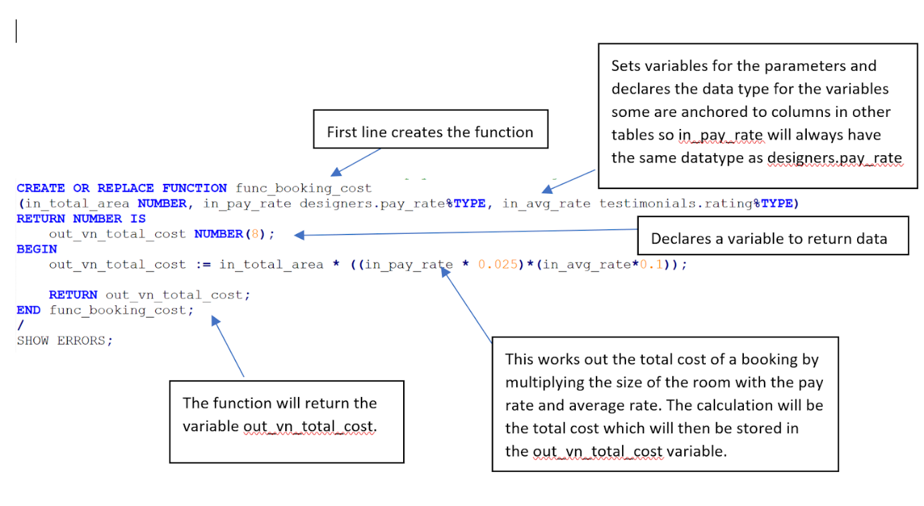

.3. func_total_area

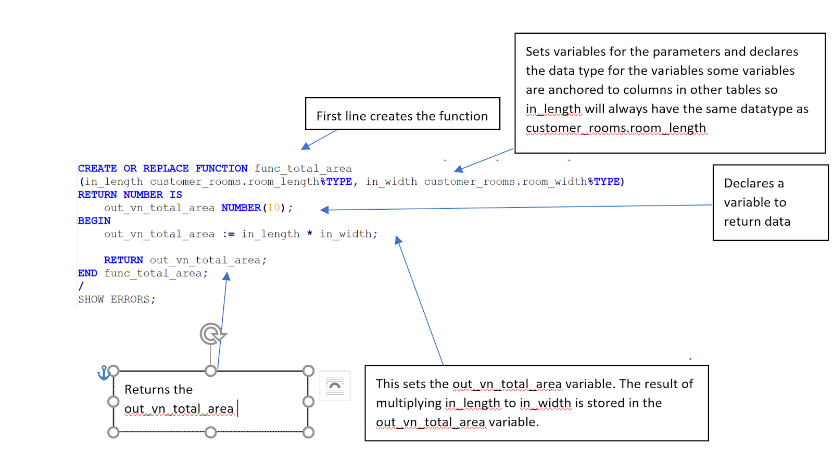

## TRIGGERS

Table below will identify and describe triggers which are going to run if certain parameter is met.

|  |  |  |
| --- | --- | --- |
| **ID.** | **Name** | **description** |
| **1.** | trig_designer | Trigger runs before insert, update or delete on the designers table  taking appropriate action dependant on the action that triggered the trigger. If inserting it displays the name of who is being inserts. If updating it sends the dob of the record being updated to a function which returns the remaining months until retirement’s base on a hardcoded age of 67. If deleting it displays the name of who is being deleted. |
| **2.** | trig_booking_cost | Trigger runs when a customer room is inserted. It takes the width and length and works out the total area and passes it into the procedure to update the bookings cost |

### Triggers Functionality:

1. trig_designer

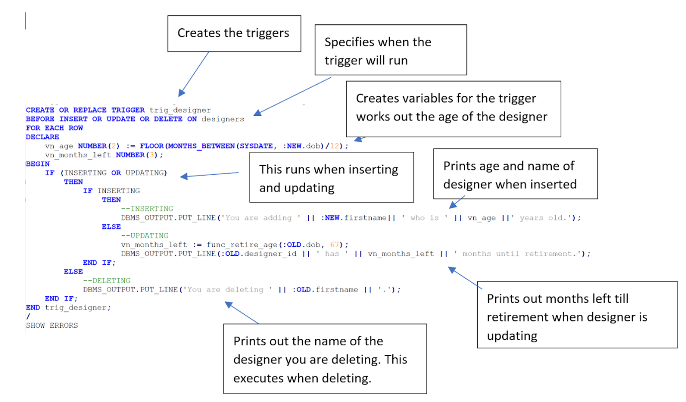

2. trig_booking_cost

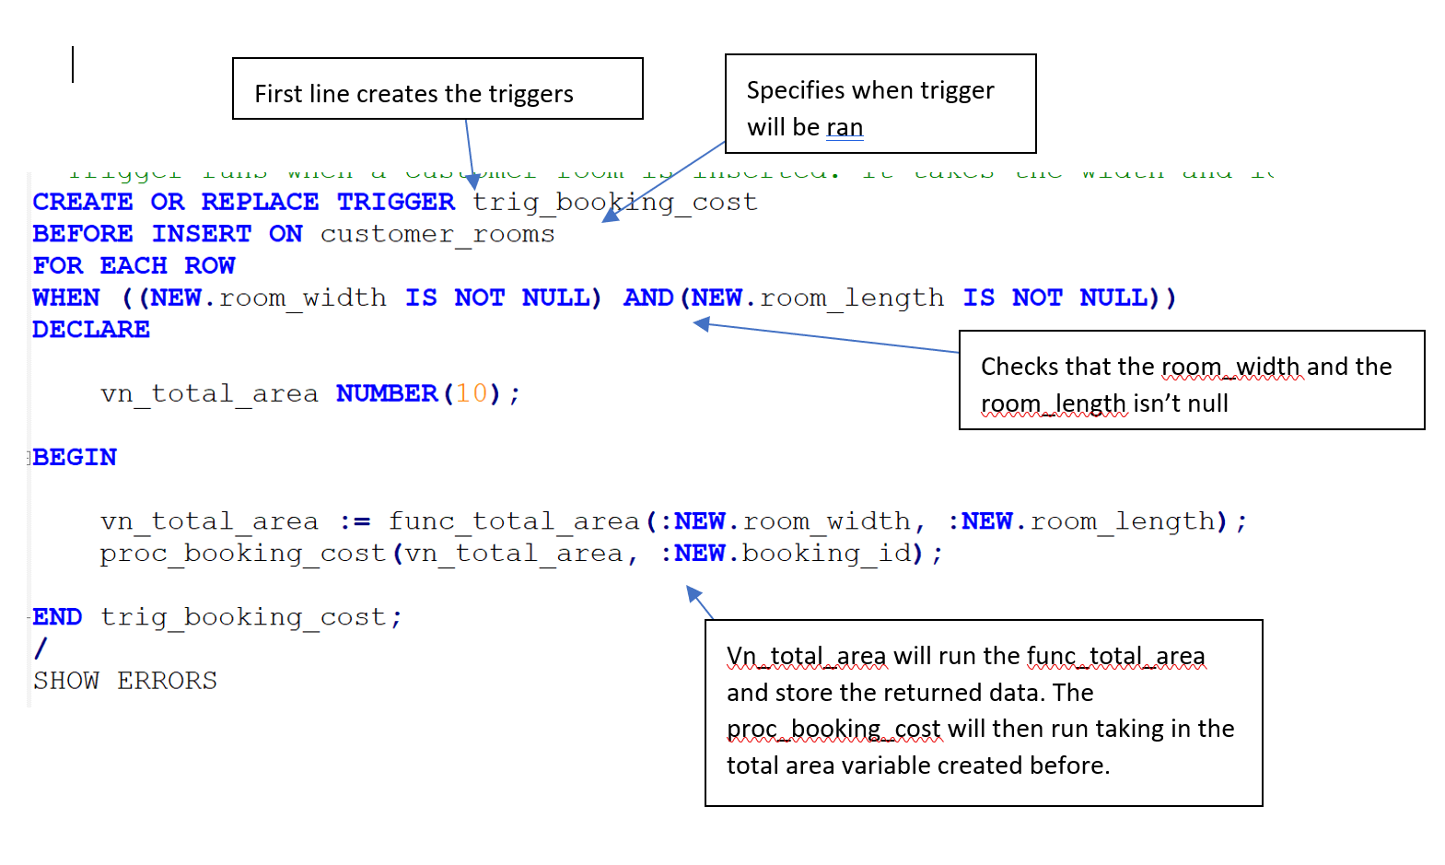

# Test Plan

Testing is fundamental in establishing a program works as intended, as such a test plan was constructed to ensure the queries, functions, procedures, and triggers created in task 1 work as intended and produce accurate/expected results.

The test plan works by assigning ids to individual tests, providing a test description which is the test itself (the query being tested or action required to trigger the action within the system), details the expected results of the action taking place, provides an actual result which either confirms the expected result was correct or details what was output instead, and finally action column details the actions taken to fix the error which caused the result to be different than the expected results.

|  |  |  |  |  |
| --- | --- | --- | --- | --- |
| ID | Test Description | Expected Results | Actual Results | Action |
| 1 | SELECT booking_id,  CEIL(cost), FLOOR(cost),  ROUND(cost),  TRUNC(cost), cost  FROM bookings  WHERE cost = (  SELECT MAX(cost)  FROM bookings  ); | 2880000 | ✓ | - |
| 2 | SELECT cr.customer_id,  cr.booking_id,  cr.address.street,  cr.address.city,  cr.address.country  FROM customer_rooms  cr  WHERE cr.address.city  IN (  SELECT d.address.city  FROM designers d  WHERE  d.address.country = 'UK'  ); | 20000003   40000003  KETTERING ROAD  NORTHAMPTON UK   20000002   40000003  KETTERING ROAD  NORTHAMPTON UK  20000001   40000001  MATCHLESS CLOSE  NORTHAMPTON UK | ✓ | - |
| 3 | SELECT d.designer_id,  AVG(t.rating)  FROM designers d  LEFT JOIN  testimonials t  ON d.designer_id =  t.designer_id  GROUP BY  d.designer_id; | 10000003     6    10000002     3    10000000    10000001     8    10000004 | ✓ |  |
| 4 | SELECT d.designer_id,  d.firstname, d.lastname,  b.booking_id,  b.completed  FROM designers d  LEFT JOIN bookings b  ON b.designer_id =  d.designer_id; | 6 rows selected. | ✓ |  |
| 5 | SELECT d.designer_id,  d.firstname, d.lastname,  s.contact  FROM designers d,  TABLE(d.social_media) s; | 9 rows selected. | ✓ | - |
| 6 | SELECT d.designer_id,  d.firstname, d.lastname,  d.address.house_number,  d.address.street,  d.address.city,  d.address.postcode  FROM designers d  ORDER BY designer_id; | shows the designers  name, id and  address details. | ✓ | - |
| 7 | SELECT customer_id,  DEREF(address)  FROM customer_rooms  WHERE customer_id IN (  SELECT customer_id  FROM customers  WHERE  customer_id = '20000001'  ); | 20000001  ADDRESS_TYPE  ('2A', 'MATCHLESS CLOSE',  'NORTHAMPTON', 'UK',  'NN5 6YE') | ✓ | - |
| 8 | SELECT c.customer_id,  c.firstname, c.lastname,  co.contact_type,  co.contact_info  FROM customers c,  TABLE(c.contact) co  WHERE co.contact_type =  'EMERGENCY'; | 5 rows selected. | ✓ | - |
| 9 | SELECT customer_id FROM  customers  INTERSECT  SELECT customer_id FROM  customer_rooms  MINUS  SELECT booking_id FROM  customer_rooms; | 20000001    20000002    20000003    20000004 | ✓ | - |
| 10 | **Test proc_retire_param**  EXEC proc_retire_param  (10000000, 67); | 300 months until  retirement. | ✓ | - |
| 11 | **Test proc_retire_param**  EXEC proc_retire_param  (10000000, 60); | 216 months until  retirement. | ✓ | - |
| 12 | **Test proc_retire_param**  EXEC proc_retire_param  (40000000, 57); | 40000000 does not exist within the database as a designer. | ✓ | - |
| 13 | **Test proc_retire_param**  EXEC proc_retire_param  (10000000, 0); | Designer is able to retire. | ✓ | - |
| 14 | **Test proc_higher_rate**  EXEC proc_higher_rate(5); | Designers with a rating  higher than 5  1 Designer ID: 10000001  Designers Rating: 10  2 Designer ID: 10000003  Designers Rating: 6 | Designers with a rating  higher than 5  1 Designer ID: 10000001  Designers Rating: 7  2 Designer ID: 10000001  Designers Rating: 7  3 Designer ID: 10000001  Designers Rating: 10  4 Designer ID: 10000003  Designers Rating: 6 | Need to account for cartesian product by limiting results to singular designer and then using a function such as average or max to give a rating value. |
| 15 | **Test proc_higher_rate**  proc_higher_rate(0); | Designers with a rating  higher than 5  1 Designer ID: 10000001  Designers Rating: 10  2 Designer ID: 10000002  Designers Rating: 3  3 Designer ID: 10000003  Designers Rating: 6 | Designers with a rating  higher than 5  1 Designer ID: 10000001  Designers Rating: 7  2 Designer ID: 10000002  Designers Rating: 3  3 Designer ID: 10000001  Designers Rating: 7  4 Designer ID: 10000001  Designers Rating: 10  5 Designer ID: 10000003  Designers Rating: 6 | Need to account for cartesian product by limiting results to singular designer and then using a function such as average or max to give a rating value. |
| 16 | **Test proc_higher_rate**  proc_higher_rate(10); | There are no designers  with a rating higher than 10 | ✓ | - |
| 17 | **Test trig_designer**  INSERT INTO designers (designer_id, firstname, lastname, dob)  VALUES (designers_seq.NEXTVAL, 'JOSH', 'LAND', '26-JAN-1995'); | You are adding JOSH who is 23 years old. | ✓ | - |
| 18 | **Test trig_designer**  UPDATE designers SET lastname = 'CHALLAND'  WHERE designer_id = 10000005; | 252 months until retirement. | ✓ | - |
| 19 | **Test trig_designer**  DELETE FROM designers WHERE designer_id = 10000005; | You are deleting JOSH. | ✓ | - |
| 20 | **Test trig_booking_cost**  INSERT INTO testimonials (testimonial_id, designer_id, rating)  VALUES (testimonials_seq.NEXTVAL, 10000000, 5);  INSERT INTO customer_rooms (customer_room_id, customer_id, booking_id, room_width, room_length)  VALUES (customer_rooms_seq.NEXTVAL, 20000000, 40000000, 50, 50);  select booking_id, cost from bookings where booking_id = 40000000; | --BOOKING_ID       COST  -------- ----------  --  40000000        281 | ✓ | - |

# References

Media.readthedocs.org. (2018). *Oracle SQL & PL/SQL Optimization for Developers Documentation*. [online] Available at: https://media.readthedocs.org/pdf/oracle/latest/oracle.pdf [Accessed 14 Jan. 2018].

# Appendix

--CSY2038 PR1 Assignment - CSY2038PR1

/*

Group 1

Josh Challand - 14414449

Julius Prakelis - 16430034

Ryan Haskins - 16442673

Tony Eardley - 14417434

*/

--Tony Login CSY2038_296@student/CSY2038_296

--Josh Login CSY2038_249@student/CSY2038_249

--Ryan Login CSY2038_286@student/16442673

--Julius Login - CSY2038_251@student/CSY2038_251

--@K:\scripts\CSY2028PR1.sql

/* Useful Commands

COLUMN object_name FORMAT A20;

COLUMN object_type FORMAT A20;

SELECT object_name, object_type FROM user_objects;

*/

/* ******************************

* *

* Create Types *

* *

*********************************/

CREATE OR REPLACE TYPE social_media_type AS OBJECT (

media_name VARCHAR2(25),

contact VARCHAR2(50)

);

/

SHOW ERRORS

CREATE TYPE social_media_table_type AS TABLE OF social_media_type;

/

SHOW ERRORS

CREATE OR REPLACE TYPE contact_type AS OBJECT (

contact_type VARCHAR2(15),

contact_method VARCHAR2(15),

contact_info VARCHAR2(50)

);

/

SHOW ERRORS;

CREATE TYPE contact_varray_type AS VARRAY(50) OF contact_type;

/

SHOW ERRORS;

CREATE OR REPLACE TYPE address_type AS OBJECT (

house_number VARCHAR2(25),

street VARCHAR2(25),

city VARCHAR2(25),

country VARCHAR2(25),

postcode VARCHAR2(15)

);

/

SHOW ERRORS;

CREATE TABLE addresses OF address_type;

/* ******************************

* *

* Check Types *

* *

*********************************/

COLUMN object_name FORMAT A20;

SELECT object_name FROM user_objects WHERE object_type = 'TYPE';

/* ******************************

* *

* Create Tables *

* *

*********************************/

CREATE TABLE designers (

designer_id NUMBER(8),

firstname VARCHAR2(25) NOT NULL,

lastname VARCHAR2(25) NOT NULL,

address REF address_type SCOPE IS addresses,

social_media social_media_table_type,

pay_rate NUMBER(4,2) DEFAULT 7.50,

hire_date DATE DEFAULT SYSDATE,

dob DATE NOT NULL

)

NESTED TABLE social_media STORE AS nested_social_media_table_type;

CREATE TABLE bookings (

booking_id NUMBER(8),

designer_id NUMBER(8) NOT NULL,

cost NUMBER(10,2),

completed CHAR(1) NOT NULL,

order_date DATE DEFAULT SYSDATE,

arrival_date DATE

);

CREATE TABLE customers (

customer_id NUMBER(8),

title VARCHAR2(10),

firstname VARCHAR2(25) NOT NULL,

lastname VARCHAR2(25) NOT NULL,

username VARCHAR2(25),

address address_type,

contact contact_varray_type

);

CREATE TABLE customer_rooms (

Customer_room_id NUMBER(8),

customer_id NUMBER(8) NOT NULL,

booking_id NUMBER(8) NOT NULL,

room_width NUMBER(6) NOT NULL,

room_length NUMBER(6) NOT NULL,

address REF address_type SCOPE IS addresses

);

CREATE TABLE testimonials(

testimonial_id NUMBER(8),

designer_id NUMBER(10) NOT NULL,

review VARCHAR2(125),

rating NUMBER(2) NOT NULL,

date_created DATE DEFAULT SYSDATE

);

/* ******************************

* *

* Check Tables *

* *

*********************************/

COLUMN tname FORMAT A20;

SELECT tname FROM TAB;

/* ******************************

* *

* Create Sequences *

* *

*********************************/

CREATE SEQUENCE designers_seq START WITH 10000000 INCREMENT BY 1;

CREATE SEQUENCE bookings_seq START WITH 40000000 INCREMENT BY 1;

CREATE SEQUENCE testimonials_seq START WITH 30000000 INCREMENT BY 1;

CREATE SEQUENCE customers_seq START WITH 20000000 INCREMENT BY 1;

CREATE SEQUENCE customer_rooms_seq START WITH 50000000 INCREMENT BY 1;

/* ******************************

* *

* Check Sequences *

* *

*********************************/

COLUMN sequence_name FORMAT A20;

SELECT sequence_name FROM user_sequences;

/* ******************************

* *

* Primary keys *

* *

*********************************/

ALTER TABLE designers

ADD CONSTRAINT pk_designers

PRIMARY KEY (designer_id);

ALTER TABLE bookings

ADD CONSTRAINT pk_bookings

PRIMARY KEY (booking_id);

ALTER TABLE customers

ADD CONSTRAINT pk_customers

PRIMARY KEY (customer_id);

ALTER TABLE customer_rooms

ADD CONSTRAINT pk_customer_rooms

PRIMARY KEY (customer_room_id);

ALTER TABLE testimonials

ADD CONSTRAINT pk_testimonials

PRIMARY KEY (testimonial_id);

/* ******************************

* *

* Foreign keys *

* *

*********************************/

ALTER TABLE bookings

ADD CONSTRAINT fk_b_designers

FOREIGN KEY (designer_id)

REFERENCES designers(designer_id);

ALTER TABLE customer_rooms

ADD CONSTRAINT fk_customers

FOREIGN KEY (customer_id)

REFERENCES customers(customer_id);

ALTER TABLE customer_rooms

ADD CONSTRAINT fk_bookings

FOREIGN KEY (booking_id)

REFERENCES bookings(booking_id);

ALTER TABLE testimonials

ADD CONSTRAINT fk_t_designers

FOREIGN KEY (designer_id)

REFERENCES designers (designer_id);

/* ******************************

* *

* Other Constraints *

* *

*********************************/

COLUMN object_name FORMAT A20;

SELECT constraint_name

FROM user_constraints

WHERE constraint_type = 'P' OR constraint_type = 'R';

ALTER TABLE bookings

MODIFY (completed DEFAULT 'N');

ALTER TABLE bookings

ADD CONSTRAINT ck_completed

CHECK (completed IN ('Y','N'));

ALTER TABLE testimonials

ADD CONSTRAINT ck_rating

CHECK (rating < 11);

/* ******************************

* *

* Check Constraints *

* *

*********************************/

COLUMN object_name FORMAT A20;

SELECT constraint_name

FROM user_constraints

WHERE constraint_type = 'P' OR constraint_type = 'R';

SET SERVEROUTPUT ON;

/* ******************************

* *

* Create Functions *

* *

*********************************/

--Function determines the months left until retirement based upon the dob and retirement age passed in its parameters.

CREATE OR REPLACE FUNCTION func_retire_age

(in_dob designers.dob%TYPE, in_retire_age NUMBER)

RETURN NUMBER IS

vn_age NUMBER(2) := FLOOR(MONTHS_BETWEEN(SYSDATE, in_dob)/12);

vn_months_left NUMBER(3);

BEGIN

IF vn_age > in_retire_age

THEN

DBMS_OUTPUT.PUT_LINE( 'Designer is able to retire.');

RETURN 0;

ELSE

vn_months_left := MOD(in_retire_age, vn_age)*12;

END IF;

RETURN vn_months_left;

END func_retire_age;

/

SHOW ERRORS

--Function takes in the total area of a room, a pay rate of a designer, and average rating of said designer. The function then uses the three arguements to generate a total cost which is return to the calling routine.

CREATE OR REPLACE FUNCTION func_booking_cost

(in_total_area NUMBER, in_pay_rate designers.pay_rate%TYPE, in_avg_rate testimonials.rating%TYPE)

RETURN NUMBER IS

out_vn_total_cost NUMBER(8);

BEGIN

out_vn_total_cost := in_total_area * ((in_pay_rate * 0.025)*(in_avg_rate*0.1));

RETURN out_vn_total_cost;

END func_booking_cost;

/

SHOW ERRORS;

--Function calculates and returns the total area based upon two parameters passed if which are assumed to be measurements.

CREATE OR REPLACE FUNCTION func_total_area

(in_length customer_rooms.room_length%TYPE, in_width customer_rooms.room_width%TYPE)

RETURN NUMBER IS

out_vn_total_area NUMBER(10);

BEGIN

out_vn_total_area := in_length * in_width;

RETURN out_vn_total_area;

END func_total_area;

/

SHOW ERRORS;

/* ******************************

* *

* Create Procedures *

* *

*********************************/

--Procedure takes in a designers id and the age at which they plan to retire, it then stores the designers date of birth using a query. the dob and age they plan to retire is send to a function which returns the number of months they have left until retirement.*/

CREATE OR REPLACE PROCEDURE proc_retire_param

(in_designer_id designers.designer_id%TYPE, in_retire_age NUMBER)

IS

vn_months_left NUMBER(3);

vd_dob DATE;

BEGIN

SELECT dob

INTO vd_dob

FROM designers

WHERE designer_id = in_designer_id;

vn_months_left := func_retire_age(vd_dob, in_retire_age);

DBMS_OUTPUT.PUT_LINE(in_designer_id || ' has ' || vn_months_left || ' months until retirement.');

EXCEPTION

WHEN NO_DATA_FOUND THEN

DBMS_OUTPUT.PUT_LINE( in_designer_id || ' does not exist within the database as a designer.');

END proc_retire_param;

/

SHOW ERRORS

--test proc_retire_param

--EXEC proc_retire_param(10000000, 67);

--300 months until retirement.

--Success

--EXEC proc_retire_param(10000000, 60);

--216 months until retirement.

--EXEC proc_retire_param(40000000, 57);

--40000000 does not exist within the database as a designer.

--EXEC proc_retire_param(10000000, 0);

--Designer is able to retire.

--10000000 has months until retirement.

--Procedure takes in a rating and creates a cursor which queries all ratings in testimonials which are greater than the input rating. The procedure then opens the cursors and checks if a row was found, displayingand appropriate message. If a row was found it loops through the results displaying the relevant information from the results found.

CREATE OR REPLACE PROCEDURE proc_higher_rate

(in_rating testimonials.rating%Type)

IS

CURSOR cur_higher_rate IS

SELECT t.rating, d.designer_id

FROM testimonials t

JOIN designers d

ON t.designer_id = d.designer_id

WHERE rating > in_rating;

rec_cur_higher_rate cur_higher_rate%ROWTYPE;

BEGIN

OPEN cur_higher_rate;

FETCH cur_higher_rate INTO rec_cur_higher_rate;

IF cur_higher_rate%NOTFOUND

THEN

DBMS_OUTPUT.PUT_LINE('There are no designers with a rating higher than ' || in_rating);

ELSE

DBMS_OUTPUT.PUT_LINE('Designers with a rating higher than ' || in_rating);

END IF;

WHILE cur_higher_rate%FOUND

LOOP

DBMS_OUTPUT.PUT_LINE(cur_higher_rate%ROWCOUNT || ' Designer ID: ' || rec_cur_higher_rate.designer_id ||

' Designers Rating: ' || rec_cur_higher_rate.rating);

FETCH cur_higher_rate INTO rec_cur_higher_rate;

END LOOP;

CLOSE cur_higher_rate;

END proc_higher_rate;

/

SHOW ERRORS

--test proc_higher_rate

--EXEC proc_higher_rate(5);

--Designers with a rating higher than 5

--1 Designer ID: 10000001 Designers Rating: 7

--2 Designer ID: 10000001 Designers Rating: 7

--3 Designer ID: 10000001 Designers Rating: 10

--4 Designer ID: 10000003 Designers Rating: 6

--Success

--SELECT designer_id, rating FROM testimonials WHERE rating > 5;

-- 10000001 7

-- 10000001 7

-- 10000001 10

-- 10000003 6

--Success

--Procedure takes in a total area and booking id. The booking id is then used in two queries that extracted the designers pay rate and average rating via joins and the AVG function into two variables. The total area, pay rate, and average rating are then passed to a function which returns a total cost which is used to update the booking associated with the booking id with a new cost.

CREATE OR REPLACE PROCEDURE proc_booking_cost

(in_total_area NUMBER, in_booking_id bookings.booking_id%TYPE)

IS

vn_total_cost bookings.cost%TYPE;

vn_pay_rate designers.pay_rate%TYPE;

vn_avg_rat testimonials.rating%TYPE;

BEGIN

SELECT d.pay_rate

INTO vn_pay_rate

FROM designers d

JOIN bookings b

ON d.designer_id = b.designer_id

WHERE b.booking_id = in_booking_id;

SELECT AVG(t.rating)

INTO vn_avg_rat

FROM testimonials t

JOIN designers d

ON t.designer_id = d.designer_id

JOIN bookings b

ON d.designer_id = b.designer_id

WHERE b.booking_id = in_booking_id

GROUP BY t.designer_id;

vn_total_cost := func_booking_cost(in_total_area, vn_pay_rate, vn_avg_rat);

UPDATE bookings

SET cost = vn_total_cost

WHERE booking_id = in_booking_id;

END proc_booking_cost;

/

SHOW ERRORS

/* ******************************

* *

* Create Triggers *

* *

*********************************/

--Trigger runs before insert, update or delete on the designers table taking appropriate action dependant on the action that triggered the trigger.If inserting it displays the name of who is being inserts. If updating itsends the dob of the record being updated to a function which returns the remaining months until retirements base on a hardcoded age of 67. If deleteing it displays the name of who is being deleted.

CREATE OR REPLACE TRIGGER trig_designer

BEFORE INSERT OR UPDATE OR DELETE ON designers

FOR EACH ROW

DECLARE

vn_age NUMBER(2) := FLOOR(MONTHS_BETWEEN(SYSDATE, :NEW.dob)/12);

vn_months_left NUMBER(3);

BEGIN

IF (INSERTING OR UPDATING)

THEN

IF INSERTING

THEN

--INSERTING

DBMS_OUTPUT.PUT_LINE('You are adding ' || :NEW.firstname|| ' who is ' || vn_age ||' years old.');

ELSE

--UPDATING

vn_months_left := func_retire_age(:OLD.dob, 67);

DBMS_OUTPUT.PUT_LINE(:OLD.designer_id || ' has ' || vn_months_left || ' months until retirement.');

END IF;

ELSE

--DELETING

DBMS_OUTPUT.PUT_LINE('You are deleting ' || :OLD.firstname || '.');

END IF;

END trig_designer;

/

SHOW ERRORS

--test trig_designer

--INSERT INTO designers (designer_id, firstname, lastname, dob)

--VALUES (designers_seq.NEXTVAL, 'JOSH', 'LAND', '26-JAN-1995');

--You are adding JOSH who is 23 years old. - Success

--UPDATE designers SET lastname = 'CHALLAND'

--WHERE designer_id = 10000005;

--252 months until retirement. - Success

--DELETE FROM designers WHERE designer_id = 10000005;

--You are deleting JOSH. - Success

--Trigger runs when a customer room is inserted. It takes the width and length and works out the total area and passes it into the procedure to update the bookings cost.

CREATE OR REPLACE TRIGGER trig_booking_cost

BEFORE INSERT ON customer_rooms

FOR EACH ROW

WHEN ((NEW.room_width IS NOT NULL) AND(NEW.room_length IS NOT NULL))

DECLARE

vn_total_area NUMBER(10);

BEGIN

vn_total_area := func_total_area(:NEW.room_width, :NEW.room_length);

proc_booking_cost(vn_total_area, :NEW.booking_id);

END trig_booking_cost;

/

SHOW ERRORS

--test trig_booking_cost

--original cost: 766.75 --select cost from bookings where booking_id = 40000000;

--desinger_id: 10000000 --select designer_id from bookings where booking_id = 40000000;

--pay_rate: 9 --select pay_rate from designers where designer_id = 10000000;

--INSERT INTO testimonials (testimonial_id, designer_id, rating)

--VALUES (testimonials_seq.NEXTVAL, 10000000, 5);

--avg(rating): 5 --select AVG(rating) from testimonials where designer_id = 10000000;

--New cost: 281

--INSERT INTO customer_rooms (customer_room_id, customer_id, booking_id, room_width, room_length)

--VALUES (customer_rooms_seq.NEXTVAL, 20000000, 40000000, 50, 50);

--select booking_id, cost from bookings;

--BOOKING_ID COST

---------- ----------

-- 40000000 281

--SUCCESS

/* ******************************

* *

* Insert Addresses *

* *

*********************************/

INSERT INTO addresses

VALUES ('2A','MATCHLESS CLOSE', 'NORTHAMPTON', 'UK', 'NN5 6YE');

INSERT INTO addresses

VALUES ('22', 'CARLTON ROAD', 'TOWCESTER', 'UK', 'TT2 7DQ');

INSERT INTO addresses

VALUES ('56', 'BILLING ROAD', 'NORTHAMPTON', 'UK', 'NN7 9PO');

INSERT INTO addresses

VALUES ('62', 'HENSPORT STREET', 'OUNDLE', 'UK', 'OU23 1MG');

INSERT INTO addresses

VALUES ('34', 'GISMOUTH STREET', 'NORTHAMPTON', 'UK', 'NG3 6YE');

INSERT INTO addresses

VALUES ('12', 'HUMMERSBY ROAD', 'NORTHAMPTON', 'UK', 'DV6 2OE');

INSERT INTO addresses

VALUES ('6Q', 'BRILTON ROAD', 'BRACKLEY', 'UK', 'BR10 5DE');

INSERT INTO addresses

VALUES ('6', 'KETTERING ROAD', 'NORTHAMPTON', 'UK', 'NH7 3GG');

/* ******************************

* *

* Check Addresses Inserts *

* *

*********************************/

COLUMN street FORMAT A20;

COLUMN city FORMAT A20;

SELECT street, city FROM addresses;

/* ******************************

* *

* Insert Designers *

* *

*********************************/

INSERT INTO designers

VALUES(

designers_seq.NEXTVAL,

'AKPAR',

'SALATIAN',

(SELECT REF(a)

FROM addresses a

WHERE street = 'CARLTON ROAD'),

social_media_table_type(

social_media_type('AKPARSALATAIN69', 'TWIITER.COM/APKARS69'),

social_media_type('AKPARSALATAIN69', 'FACEBOOK.COM/APKARS69'),

social_media_type('AKPARSALATAIN69', 'YOUTUBE.COM/APKARS69')),

9.00,

'12-JAN-2004',

'21-FEB-1976'

);

INSERT INTO designers

VALUES (

designers_seq.NEXTVAL,

'STEVE',

'PERRISON',

(SELECT REF (a)

FROM addresses a

WHERE street = 'KETTERING ROAD'),

social_media_table_type(

social_media_type('PERRISON2', 'TWITTER.COM/PERRISON2'),

social_media_type('PERRISON2', 'FACEBOOK.COM/PERRISON2')),

12.00,

'17-JAN-2008',

'28-MAY-1998'

);

INSERT INTO designers

VALUES (

designers_seq.NEXTVAL,

'MYLES',

'GOODE-FOUCHER',

(SELECT REF (a)

FROM addresses a

WHERE street = 'HUMMERSBY ROAD'),

social_media_table_type(

social_media_type('MYLESFOUCHER', 'TWITTER.COM/MYLESFOUCHER'),

social_media_type('MYLESFOUCHER', 'FACEBOOK.COM/MYLESFOUCHER')),

8.00,

'17-JAN-2005',

'24-NOV-1988'

);

INSERT INTO designers

VALUES (

designers_seq.NEXTVAL,

'ELIANE',

'PATTERSON',

(SELECT REF (a)

FROM addresses a

WHERE street = 'GISMOUTH STREET'),

social_media_table_type(

social_media_type('ELIANEPATTERSON', 'FACEBOOK.COM/ELIANPATTERSON')),

7.50,

'10-AUG-2010',

'14-JAN-1989'

);

INSERT INTO designers

VALUES (

designers_seq.NEXTVAL,

'BARRY',

'GILMARTIN',

(SELECT REF(a)

FROM addresses a

WHERE street='HENSPORT STREET'),

social_media_table_type(

social_media_type('GILMARTIN', 'FACEBOOK.COM/BARRYGILMARTIN')),

20.50,

'20-FEB-2015',

'12-JAN-1977'

);

/* ******************************

* *

* Check Designers Inserts *

* *

*********************************/

COLUMN firstname FORMAT A20;

SELECT designer_id, firstname FROM designers;

/* ******************************

* *

* Insert Customers *

* *

*********************************/

INSERT INTO customers

VALUES (customers_seq.NEXTVAL, 'MRS', 'ANDY', 'STAR', 'ONEANDONLY',

address_type('1', 'MAIN ROAD','NORTHAMPTON', 'UK', 'NN9 5YU'),

contact_varray_type(

contact_type('EMERGENCY', 'MOBILE PHONE', '07458921621'),

contact_type('HOME', 'HOME PHONE', '01605216874'),

contact_type('EMAIL', 'EMAIL', 'STARC@GMAIL.COM'))

);

INSERT INTO customers

VALUES (customers_seq.NEXTVAL , 'MR', 'BEN', 'WALKER', 'WALKINGAWAY',

address_type('13', 'WRENBRY ROAD', 'NORTHAMPTON', 'UNITED KINGDOM', 'NN5 6UI'),

contact_varray_type(

contact_type('EMERGENCY', 'MOBILE PHONE', '07755787555'),

contact_type('HOME', 'HOME PHONE', '01605589876'),

contact_type('EMAIL', 'EMAIL', 'BEN777@HOTMAIL.COM'))

);

INSERT INTO customers

VALUES (customers_seq.NEXTVAL , 'MS', 'DARKEN', 'SIDEN', 'CHOICEX',

address_type('1', 'RYELAND ROAD','OUNDLE', 'UK', 'OU3 8GH'),

contact_varray_type(

contact_type('EMERGENCY', 'MOBILE PHONE', '07525512311'),

contact_type('HOME', 'HOME PHONE', '01605216800'),

contact_type('EMAIL', 'EMAIL', 'DARKENSIDEN@VERY.DARK.MAIL.COM'))

);

INSERT INTO customers

VALUES (customers_seq.NEXTVAL , 'MR', 'BILL', 'GATES', 'MILLIONDOOR',

address_type('300', 'BRIXTON ROAD', 'KETTERING', 'UNITED KINGDOM', 'BX3 99H'),

contact_varray_type(

contact_type('EMERGENCY', 'MOBILE PHONE', '07511223344'),

contact_type('HOME', 'HOME PHONE', '01405212345'),

contact_type('EMAIL', 'EMAIL', 'GATESAREOPEN@MICROSOFT.COM'))

);

INSERT INTO customers

VALUES (customers_seq.NEXTVAL , 'MS', 'RUBY', 'DIAMOND', 'GOLDEN',

address_type('555', 'BUILDING STREET', 'WELLINGBOROUGH', 'UK', 'DN37 8777'),

contact_varray_type(

contact_type('EMERGENCY', 'MOBILE PHONE', '07501773144'),

contact_type('HOME', 'HOME PHONE', '01605210000'),

contact_type('EMAIL', 'EMAIL', 'RUBYTHEDIAMOND@GMAIL.COM'))

);

/* ******************************

* *

* Check Customers Inserts *

* *

*********************************/

COLUMN firstname FORMAT A20;

SELECT customer_id, firstname FROM customers;

/* ******************************

* *

* Insert Testimonials *

* *

*********************************/

INSERT INTO testimonials

VALUES (testimonials_seq.NEXTVAL, 10000001, 'Well completed job, very happy!', 7, '12-JAN-2017');

INSERT INTO testimonials

VALUES (testimonials_seq.NEXTVAL, 10000002, 'Poor Job, unhappy...', 3, '06-MAR-2016');

INSERT INTO testimonials

VALUES (testimonials_seq.NEXTVAL, 10000001, 'Satisfactory', 7, '19-MAY-2017');

INSERT INTO testimonials

VALUES (testimonials_seq.NEXTVAL, 10000001, 'Perfect', 10, '27-SEP-2015');

INSERT INTO testimonials

VALUES (testimonials_seq.NEXTVAL, 10000003, 'Good!', 6, '23-NOV-2017');

/* ******************************

* *

* Check Testimonials Inserts *

* *

*********************************/

SELECT testimonial_id, designer_id, rating FROM testimonials;

/* ******************************

* *

* Inserts Bookings *

* *

*********************************/

INSERT INTO bookings(booking_id, designer_id, cost, completed, order_date, arrival_date)

VALUES (bookings_seq.NEXTVAL, 10000000, 766.75, 'N', '14-FEB-2016', '01-FEB-2017');

INSERT INTO bookings(booking_id, designer_id, cost, completed, order_date, arrival_date)

VALUES (bookings_seq.NEXTVAL,10000001, 13222.50, 'N', '03-AUG-2017', '01-DEC-2017');

INSERT INTO bookings(booking_id, designer_id, cost, completed, order_date, arrival_date)

VALUES (bookings_seq.NEXTVAL,10000002, 988.25, 'N', '17-NOV-2015', '08-JAN-2016');

INSERT INTO bookings(booking_id, designer_id, cost, completed, order_date, arrival_date)

VALUES (bookings_seq.NEXTVAL,10000003, 20000.49, 'Y', '06-MAY-2014', '01-JUN-2015');

INSERT INTO bookings(booking_id, designer_id, cost, completed, order_date, arrival_date)

VALUES (bookings_seq.NEXTVAL,10000002, 2999.99, 'N', '19-JAN-2017', '01-MAR-2018');

/* ******************************

* *

* Check Bookings Inserts *

* *

*********************************/

SELECT booking_id, designer_id, cost FROM bookings;

/* ******************************

* *

* Inserts Customer_Rooms *

* *

*********************************/

INSERT INTO customer_rooms

SELECT customer_rooms_seq.NEXTVAL,

20000001,

40000001,

4500,

2300,

REF(a)

FROM addresses a

WHERE street = 'MATCHLESS CLOSE';

INSERT INTO customer_rooms

SELECT customer_rooms_seq.NEXTVAL,

20000002,

40000003,

1400,

2550,

REF(a)

FROM addresses a

WHERE street = 'KETTERING ROAD';

INSERT INTO customer_rooms

SELECT customer_rooms_seq.NEXTVAL,

20000004,

40000002,

6000,

8000,

REF(a)

FROM addresses a

WHERE street = 'BRILTON ROAD';

INSERT INTO customer_rooms

SELECT customer_rooms_seq.NEXTVAL,

20000003,

40000003,

3000,

5025,

REF(a)

FROM addresses a

WHERE street = 'KETTERING ROAD';

/* ******************************

* *

* Check Customer_Rooms Inserts *

* *

*********************************/

COLUMN c.address.street FORMAT A20;

SELECT c.customer_room_id, c.customer_id, c.booking_id, c.address.street FROM customer_rooms c;

/* ******************************

* *

* Queries *

* *

*********************************/

--Lists the booking with the highest cost with functions (CEIL, FLOOR, ROUND, TRUNC) - Formatted with headings

COLUMN booking_id HEADING 'Booking'

COLUMN CEIL(cost) HEADING 'CEIL'

COLUMN FLOOR(cost) HEADING 'FLOOR'

COLUMN ROUND(cost) HEADING 'ROUND'

COLUMN TRUNC(cost) HEADING 'TRUNC'

SELECT booking_id, CEIL(cost), FLOOR(cost), ROUND(cost), TRUNC(cost), cost

FROM bookings

WHERE cost = (

SELECT MAX(cost)

FROM bookings

);

--Test - Expected Results '2880000' to be the MAX cost

--SELECT MAX(cost)

--FROM bookings;

-- Result -- success:

-- 1 row returned with the max cost

--Lists customer rooms located in cities where designers are located within the UK

COLUMN customer_id HEADING 'Customer ID'

COLUMN booking_id HEADING 'Booking ID'

COLUMN address.street HEADING 'Street' FORMAT A25

COLUMN address.city HEADING 'City' FORMAT A15

COLUMN address.country HEADING 'Country' FORMAT A10

SELECT cr.customer_id, cr.booking_id, cr.address.street, cr.address.city, cr.address.country

FROM customer_rooms cr

WHERE cr.address.city IN (

SELECT d.address.city

FROM designers d

WHERE d.address.country = 'UK'

);

--Test - Expected Result = 3 rows selected

--SELECT d.address.city

--FROM designers d;

--SELECT cr.address.city

--FROM customer_rooms cr;

--Result -success:

-- List of the cities as expected is returned

--Pulls through designers id and show their ratings

COLUMN d.designer_id HEADING 'Designer ID'

COLUMN AVG(t.rating) HEADING 'Rating'

SELECT d.designer_id, AVG(t.rating)

FROM designers d

LEFT JOIN testimonials t

ON d.designer_id = t.designer_id

GROUP BY d.designer_id;

--Test Expected result will be to pull through all the designers id's and their ratings

-- Results: List of designers returned with and without rating

--Will pull through all designers id first and last name and will show if they have any bookings

COLUMN booking_id HEADING 'Booking ID'

COLUMN designer_id HEADING 'Designer ID'

COLUMN firstname HEADING 'First Name' FORMAT A10

COLUMN lastname HEADING 'Last Name' FORMAT A20

SELECT d.designer_id, d.firstname, d.lastname, b.booking_id, b.completed

FROM designers d

LEFT JOIN bookings b

ON b.designer_id = d.designer_id;

--Expected result - mix of designers with and without bookings assigned to them.

--Results - success: 6 rows returned

--List of designers with and without bookings returned

--Pulls through designer id name and their social networking sites --

COLUMN designer_id HEADING 'Designer ID'

COLUMN firstname HEADING 'First Name'

COLUMN lastname HEADING 'Last Name'

COLUMN contact FORMAT A30

SELECT d.designer_id, d.firstname, d.lastname, s.contact

FROM designers d, TABLE(d.social_media) s;

--Expected result - list all the different social networking url's for each designer

--Result - success:

--9 rows returned.

--Listing all social media contact details

--Pull through designers and their address --

COLUMN designer_id HEADING 'Designer ID'

COLUMN firstname HEADING 'First Name' FORMAT A10

COLUMN lastname HEADING 'Last Name' FORMAT A10

COLUMN address.house_number HEADING 'House No.' FORMAT A5

COLUMN address.street HEADING 'Street' FORMAT A20

COLUMN address.city HEADING 'City' FORMAT A10

COLUMN address.postcode HEADING 'Postcode' FORMAT A10

SELECT d.designer_id, d.firstname, d.lastname, d.address.house_number, d.address.street, d.address.city, d.address.postcode

FROM designers d

ORDER BY designer_id;

--Expected results - show the designers name id and address details.

--Result - success:

--List of designer ID and all address details returned

--DREF Query getting the address and matching it to the customer

COLUMN customer_id HEADING 'Customer ID'

COLUMN DEREF(address) HEADING 'Address'

SELECT customer_id, DEREF(address)

FROM customer_rooms

WHERE customer_id IN (

SELECT customer_id

FROM customers

WHERE customer_id = '20000001'

);

--Expected result - query will display the customer address = 20000000

--Result - success:

--List of customer addresses with the matching ID returned

--Pulling through every customers emergency details using a varray query with dot notation

COLUMN customer_id HEADING 'Customer ID'

COLUMN firstname HEADING 'Firstname'

COLUMN lastname HEADING 'Lastname'

COLUMN contact_type HEADING 'Contact Type'

COLUMN contact_info HEADING 'Contact Number'

SELECT c.customer_id, c.firstname, c.lastname, co.contact_type, co.contact_info

FROM customers c, TABLE(c.contact) co

WHERE co.contact_type = 'EMERGENCY';

--Expected result - list all customers and their emergency contact details

--Result - success:

--List of all customers and emergency contact details returned

--Shows all customer_id's that have a customer_room and a Booking

COLUMN customer_id HEADING 'Customer ID'

SELECT customer_id FROM customers

INTERSECT

SELECT customer_id FROM customer_rooms

MINUS

SELECT booking_id FROM customer_rooms;

--Expected result: will display customers that have a customer room and a booking allocated to them

--Result - success:

--List of customer ID`s returned

/* ******************************

* *

* Procedure Test(s) *

* *

*********************************/

--test proc_retire_param

EXEC proc_retire_param(10000000, 67);

--300 months until retirement.

--Success

EXEC proc_retire_param(10000000, 60);

--216 months until retirement.

EXEC proc_retire_param(40000000, 57);

--40000000 does not exist within the database as a designer.

EXEC proc_retire_param(10000000, 0);

--Designer is able to retire.

--10000000 has months until retirement.

--test proc_higher_rate

EXEC proc_higher_rate(5);

--Designers with a rating higher than 5

--1 Designer ID: 10000001 Designers Rating: 7

--2 Designer ID: 10000001 Designers Rating: 7

--3 Designer ID: 10000001 Designers Rating: 10

--4 Designer ID: 10000003 Designers Rating: 6

--Success

SELECT designer_id, rating FROM testimonials WHERE rating > 5;

-- 10000001 7

-- 10000001 7

-- 10000001 10

-- 10000003 6

--Success

/* ******************************

* *

* Trigger Test(s) *

* *

*********************************/

--test trig_designer

INSERT INTO designers (designer_id, firstname, lastname, dob)

VALUES (designers_seq.NEXTVAL, 'JOSH', 'LAND', '26-JAN-1995');

--You are adding JOSH who is 23 years old. - Success

UPDATE designers SET lastname = 'CHALLAND'

WHERE designer_id = 10000005;

--252 months until retirement. - Success

DELETE FROM designers WHERE designer_id = 10000005;

--You are deleting JOSH. - Success

--test trig_booking_cost

--booking_id: 40000000

SELECT booking_id FROM bookings WHERE booking_id = 40000000;

--original cost: 766.75

SELECT cost FROM bookings WHERE booking_id = 40000000;

--desinger_id: 10000000

--SELECT designer_id FROM bookings WHERE booking_id = 40000000;

--pay_rate: 9

--SELECT pay_rate FROM designers WHERE designer_id = 10000000;

INSERT INTO testimonials (testimonial_id, designer_id, rating)

VALUES (testimonials_seq.NEXTVAL, 10000000, 5);

--avg(rating): 5 --select AVG(rating) from testimonials where designer_id = 10000000;

--New cost: 281

INSERT INTO customer_rooms (customer_room_id, customer_id, booking_id, room_width, room_length)

VALUES (customer_rooms_seq.NEXTVAL, 20000000, 40000000, 50, 50);

SELECT booking_id, cost FROM bookings;

--BOOKING_ID COST

---------- ----------

-- 40000000 281

--SUCCESS

/* ******************************

* *

* Drop Triggers *

* *

*********************************/

DROP TRIGGER trig_designer;

DROP TRIGGER trig_booking_cost;

/* ******************************

* *

* Drop Procedures *

* *

*********************************/

DROP PROCEDURE proc_retire_param;

DROP PROCEDURE proc_higher_rate;

DROP PROCEDURE proc_booking_cost;

/* ******************************

* *

* Drop Functions *

* *

*********************************/

DROP FUNCTION func_retire_age;

DROP FUNCTION func_booking_cost;

DROP FUNCTION func_total_area;

/* ******************************

* *

* Drop Constraints *

* *

*********************************/

ALTER TABLE bookings

DROP CONSTRAINT ck_completed;

ALTER TABLE testimonials

DROP CONSTRAINT ck_rating;

/* ******************************

* *

* Drop Foreign Keys *

* *

*********************************/

ALTER TABLE customer_rooms

DROP CONSTRAINT fk_bookings;

ALTER TABLE customer_rooms

DROP CONSTRAINT fk_customers;

ALTER TABLE bookings

DROP CONSTRAINT fk_b_designers;

ALTER TABLE testimonials

DROP CONSTRAINT fk_t_designers;

/* ******************************

* *

* Drop Primary Keys *

* *

*********************************/

ALTER TABLE customer_rooms

DROP CONSTRAINT pk_customer_rooms;

ALTER TABLE testimonials

DROP CONSTRAINT pk_testimonials;

ALTER TABLE customers

DROP CONSTRAINT pk_customers;

ALTER TABLE bookings

DROP CONSTRAINT pk_bookings;

ALTER TABLE designers

DROP CONSTRAINT pk_designers;

/* ******************************

* *

* Drop Tables *

* *

*********************************/

DROP TABLE customer_rooms;

DROP TABLE bookings;

DROP TABLE testimonials;

DROP TABLE customers;

DROP TABLE designers;

/* ******************************

* *

* Drop Sequences *

* *

*********************************/

DROP SEQUENCE designers_seq;

DROP SEQUENCE bookings_seq;

DROP SEQUENCE testimonials_seq;

DROP SEQUENCE customers_seq;

DROP SEQUENCE customer_rooms_seq;

/* ******************************

* *

* Drop Object Tables *

* *

*********************************/

DROP TABLE addresses;

/* ******************************

* *

* Drop Table/Varray Types *

* *

*********************************/

DROP TYPE social_media_table_type;

DROP TYPE contact_varray_type;

/* ******************************

* *

* Drop Types *

* *

*********************************/

DROP TYPE social_media_type;

DROP TYPE contact_type;

DROP TYPE address_type;

/* ******************************

* *

* Purge RECYCLEBIN *

* *

*********************************/

PURGE RECYCLEBIN;

/* ******************************

* *

* Drop Check *

* *

*********************************/

SELECT object_name FROM user_objects;

/* ******************************************

* *

* EXTRAS FROM DEMO *

*(HIGHLIGHT BLOCK AND SINGLE LINE UNCOMMENT)*

*********************************************/

-- /*###PLSQL_2_PROCEDURES###*/

-- --SET SERVEROUTPUT ON;

-- CREATE OR REPLACE PROCEDURE proc_add_customer IS

-- vc_customer_name customers.firstname%TYPE := 'CUSTOMER';

-- BEGIN

-- INSERT INTO customers (customer_id, firstname)

-- VALUES (customers_seq.NEXTVAL, vc_customer_name);

-- END proc_add_customer;

-- /

-- SHOW ERRORS

-- /*test proc_add_customer*/

-- SELECT * FROM customers;

-- -- 5 rows returned

-- EXEC proc_add_customer

-- SELECT * FROM customers;

-- -- 6 rows returned

-- --Success

-- --DROP PROCEDURE proc_add_customer;

-- CREATE OR REPLACE PROCEDURE proc_delete_customer IS

-- vn_customer_id customers.customer_id%TYPE;

-- BEGIN

-- SELECT customers_seq.CURRVAL

-- INTO vn_customer_id

-- FROM DUAL;

-- DELETE FROM customers

-- WHERE customer_id = vn_customer_id;

-- END proc_delete_customer;

-- /

-- SHOW ERRORS

-- /*test proc_delete_customer*/

-- SELECT * FROM customers;

-- --6 rows returned

-- EXEC proc_delete_customer;

-- SELECT * FROM customers;

-- --5 rows returned

-- --Success

-- --DROP PROCEDURE proc_delete_customer;

-- CREATE OR REPLACE PROCEDURE proc_param_del_cu

-- (in_customer_id customers.customer_id%TYPE) IS

-- BEGIN

-- DELETE FROM customers

-- WHERE customer_id = in_customer_id;

-- END proc_param_del_cu;

-- /

-- SHOW ERRORS

-- /*test proc_param_del_cu*/

-- SELECT * FROM customers;

-- --5 rows returned

-- EXEC proc_param_del_cu(20000005);

-- SELECT * FROM customers;

-- --4 rows returned

-- --Success

-- --DROP PROCEDURE proc_param_del_cu;

-- --BONUS ACTIVTY

-- CREATE OR REPLACE PROCEDURE proc_firstname (in_firstname customers.firstname%TYPE) IS

-- vn_length NUMBER(2);

-- vn_counter NUMBER(2) := 1;

-- BEGIN

-- DBMS_OUTPUT.PUT_LINE('----FIRSTNAME----');

-- vn_length := LENGTH(in_firstname);

-- LOOP

-- EXIT WHEN vn_counter = (vn_length + 1);

-- DBMS_OUTPUT.PUT_LINE(SUBSTR(in_firstname, vn_counter, 1));

-- vn_counter := vn_counter + 1;

-- END LOOP;

-- END proc_firstname;

-- /

-- SHOW ERRORS

-- /*test proc_firstname*/

-- EXEC proc_firstname('ARYA')

-- --Success

-- EXEC proc_firstname('SILVER')

-- --Success

-- --DROP PROCEDURE proc_firstname;

-- CREATE OR REPLACE PROCEDURE proc_middlename (in_middlename VARCHAR2) IS

-- vn_length NUMBER(2);

-- vn_counter NUMBER(2) := 1;

-- BEGIN

-- DBMS_OUTPUT.PUT_LINE('----MIDDLENAME----');

-- vn_length := LENGTH(in_middlename);

-- WHILE vn_counter <= vn_length LOOP

-- DBMS_OUTPUT.PUT_LINE(SUBSTR(in_middlename, vn_counter, 1));

-- vn_counter := vn_counter + 1;

-- END LOOP;

-- END proc_middlename;

-- /

-- SHOW ERRORS

-- /*test proc_middlename*/

-- EXEC proc_middlename('MARY-ANGEL')

-- --Success

-- EXEC proc_middlename('FLOWERS')

-- --Success

-- --DROP PROCEDURE proc_middlename;

-- CREATE OR REPLACE PROCEDURE proc_lastname (in_lastname customers.lastname%TYPE) IS

-- vn_length NUMBER(2);

-- vn_counter NUMBER(2) := 1;

-- BEGIN

-- DBMS_OUTPUT.PUT_LINE('----LASTNAME----');

-- vn_length := LENGTH(in_lastname);

-- FOR vn_counter IN 1 .. vn_length LOOP

-- DBMS_OUTPUT.PUT_LINE(SUBSTR(in_lastname, vn_counter, 1));

-- END LOOP;

-- END proc_lastname;

-- /

-- SHOW ERRORS

-- /*test proc_lastname*/

-- EXEC proc_lastname('MAULE')

-- --Success

-- EXEC proc_lastname('EARDLEY')

-- --Success

-- --DROP PROCEDURE proc_lastname;

-- CREATE OR REPLACE PROCEDURE proc_fir_mid_las (in_firstname customers.firstname%TYPE, in_middlename VARCHAR2, in_lastname customers.lastname%TYPE) IS

-- BEGIN

-- proc_firstname(in_firstname);

-- proc_middlename(in_middlename);

-- proc_lastname(in_lastname);

-- END proc_fir_mid_las;

-- /

-- SHOW ERRORS

-- /*test proc_fir_mid_las*/

-- EXEC proc_fir_mid_las('ARYA', 'MARY-ANGEL', 'MAULE')

-- --Success

-- EXEC proc_fir_mid_las('SILVER', 'FLOWERS', 'EARDLEY')

-- --Success

-- --DROP PROCEDURE proc_fir_mid_las;

-- /*###PLSQL_3_FUNCTIONS###*/

-- CREATE OR REPLACE FUNCTION func_designer_ct RETURN NUMBER IS

-- vn_designer_ct NUMBER(3);

-- BEGIN

-- SELECT COUNT(designer_id)

-- INTO vn_designer_ct

-- FROM designers;

-- RETURN vn_designer_ct;

-- END func_designer_ct;

-- /

-- SHOW ERRORS

-- CREATE OR REPLACE PROCEDURE proc_func_designer IS

-- vn_no_of_designers NUMBER(3);

-- BEGIN

-- vn_no_of_designers := func_designer_ct;

-- DBMS_OUTPUT.PUT_LINE('There are ' || vn_no_of_designers || ' designer(s) in the database.');

-- END proc_func_designer;

-- /

-- SHOW ERRORS

-- /*test proc_func_designer*/

-- EXEC proc_func_designer;

-- --Success

-- SELECT COUNT(designer_id) FROM designers;

-- --Success

-- --DROP PROCEDURE proc_func_designer;

-- --DROP FUNCTION func_designer_ct;

-- CREATE OR REPLACE FUNCTION func_pay_desn_ct (in_pay_rate designers.pay_rate%TYPE) RETURN NUMBER IS

-- vn_designer_ct NUMBER(3);

-- BEGIN

-- SELECT COUNT(designer_id)

-- INTO vn_designer_ct

-- FROM designers

-- WHERE pay_rate > in_pay_rate;

-- RETURN vn_designer_ct;

-- END func_pay_desn_ct;

-- /

-- SHOW ERRORS

-- CREATE OR REPLACE PROCEDURE proc_func_pay_desn(in_pay_rate designers.pay_rate%TYPE) IS

-- vn_no_of_designers NUMBER(3);

-- BEGIN

-- vn_no_of_designers := func_pay_desn_ct(in_pay_rate);

-- DBMS_OUTPUT.PUT_LINE('There are ' || vn_no_of_designers || ' designer(s) in the database with a pay rate higher than ' || in_pay_rate || '.');

-- END proc_func_pay_desn;

-- /

-- SHOW ERRORS

-- /*test proc_func_pay_desn*/

-- EXEC proc_func_pay_desn(10);

-- --Success

-- SELECT COUNT(designer_id) FROM designers WHERE pay_rate > 10;

-- --Success

-- EXEC proc_func_pay_desn(5);

-- --Success

-- SELECT COUNT(designer_id) FROM designers WHERE pay_rate > 5;

-- --Success

-- --DROP PROCEDURE proc_func_pay_desn;

-- --DROP FUNCTION func_pay_desn_ct;

-- --BONUS ACTIVTY

-- CREATE OR REPLACE FUNCTION func_cus_username

-- (in_customer_id customers.customer_id%TYPE)RETURN VARCHAR2 IS

-- vc_firstname customers.firstname%TYPE;

-- vc_lastname customers.lastname%TYPE;

-- vc_username VARCHAR2(7);

-- --Change to customers.username%TYPE;

-- BEGIN

-- SELECT firstname

-- INTO vc_firstname

-- FROM customers

-- WHERE customer_id = in_customer_id;

-- SELECT lastname

-- INTO vc_lastname

-- FROM customers

-- WHERE customer_id = in_customer_id;

-- vc_username := CONCAT(SUBSTR(vc_firstname, 1, 2), SUBSTR(vc_lastname, 1, 5));

-- RETURN vc_username;

-- END func_cus_username;

-- /

-- SHOW ERRORS

-- CREATE OR REPLACE PROCEDURE proc_func_cus_username

-- (in_customer_id customers.customer_id%TYPE) IS

-- vc_username VARCHAR2(7);

-- --Change to customers.username%TYPE;

-- BEGIN

-- vc_username := func_cus_username(in_customer_id);

-- DBMS_OUTPUT.PUT_LINE('Customers: ' || in_customer_id || ' username set to ' || vc_username || '.');

-- --Change to -¬

-- --UPDATE customers

-- --SET username = vc_username

-- --WHERE customer_id = in_customer_id;

-- END proc_func_cus_username;

-- /

-- SHOW ERRORS

-- /*test proc_func_cus_username*/

-- EXEC proc_func_cus_username(20000000);

-- SELECT customer_id, firstname, lastname

-- --Change to SELECT customer_id, username

-- FROM customers

-- WHERE customer_id = 20000000;

-- --DROP PROCEDURE proc_func_cus_username;

-- --DROP FUNCTION func_cus_username

-- /*###PLSQL_4_TRIGGERS###*/

-- CREATE OR REPLACE TRIGGER trig_ar_date_ck

-- BEFORE INSERT OR UPDATE OF arrival_date ON bookings

-- FOR EACH ROW

-- WHEN(NEW.arrival_date < SYSDATE)

-- BEGIN

-- DBMS_OUTPUT.PUT_LINE('The arrival date cannot exist in the past');

-- RAISE_APPLICATION_ERROR

-- (-20000, 'ERROR - THE ARRIVAL DATE CAN NOT EXIST BEFORE TODAYS DATE!

-- ARRIVAL DATE: ' || :NEW.arrival_date || ' TODAYS DATE: ' || SYSDATE);

-- END trig_ar_date_ck;

-- /

-- SHOW ERRORS

-- /*test trig_ar_date_ck*/

-- INSERT INTO bookings (booking_id, designer_id, arrival_date)

-- VALUES (bookings_seq.NEXTVAL, 10000000, '01-JUN-2016');

-- --Throws error - Success

-- INSERT INTO bookings (booking_id, designer_id, arrival_date)

-- VALUES (bookings_seq.NEXTVAL, 10000000, '01-JUN-2019');

-- --Should not throw error - Success

-- --DROP TRIGGER trig_ar_date_ck;

-- CREATE OR REPLACE TRIGGER trig_hire_date

-- AFTER INSERT OR UPDATE ON designers

-- FOR EACH ROW

-- WHEN (NEW.hire_date IS NOT NULL)

-- DECLARE

-- vd_today designers.hire_date%TYPE := SYSDATE;

-- BEGIN

-- IF (vd_today - (365*5)) >= :NEW.hire_date

-- THEN

-- DBMS_OUTPUT.PUT_LINE('Designer has been hired for or over 5 years.');

-- ELSE

-- DBMS_OUTPUT.PUT_LINE('Designer has not been hired for more 5 years.');

-- END IF;

-- END trig_hire_date;

-- /

-- SHOW ERRORS

-- /*test trig_hire_date*/

-- INSERT INTO designers (designer_id, hire_date)

-- VALUES (designers_seq.NEXTVAL, '01-JAN-2013');

-- --Trigger designer has been hired for over 5 years - Success

-- INSERT INTO designers (designer_id, hire_date)

-- VALUES (designers_seq.NEXTVAL, '01-JAN-2014');

-- --Trigger designer has not been hired for 5 years - Success

-- --DROP TRIGGER trig_hire_date;

-- --BONUS ACTIVITY

-- CREATE OR REPLACE TRIGGER trig_desn_dob_suc

-- BEFORE INSERT ON designers

-- FOR EACH ROW

-- WHEN ((MONTHS_BETWEEN(SYSDATE, NEW.dob)/12) > 18)

-- BEGIN

-- DBMS_OUTPUT.PUT_LINE('Designer added.');

-- END trig_desn_dob_suc;

-- /

-- SHOW ERRORS

-- /*test trig_desn_dob_suc */

-- INSERT INTO designers (designer_id, dob)

-- VALUES (designers_seq.NEXTVAL, '01-JAN-2000');

-- --Designer added. - Success

-- --DROP TRIGGER trig_desn_dob_suc;

-- CREATE OR REPLACE TRIGGER trig_desn_dob_dec

-- BEFORE INSERT ON designers

-- FOR EACH ROW

-- WHEN ((MONTHS_BETWEEN(SYSDATE, NEW.dob)/12) < 18)

-- BEGIN

-- DBMS_OUTPUT.PUT_LINE('Designer is too young.');

-- RAISE_APPLICATION_ERROR

-- (-20000, 'ERROR - THE DESIGNER IS TOO YOUNG!');

-- END trig_desn_dob_dec;

-- /

-- SHOW ERRORS

-- /*test trig_desn_dob_dec*/

-- INSERT INTO designers (designer_id, dob)

-- VALUES (designers_seq.NEXTVAL, '01-JAN-2010');

-- --ERROR - THE DESIGNER IS TOO YOUNG! - Success

-- --DROP TRIGGER trig_desn_dob_dec;

-- /*###PLSQL_4.5_COMBINED--IMPROVED###*/

-- /*Function determines the months left until retirement based upon the

-- dob and retirement age passed in its parameters*/

-- CREATE OR REPLACE FUNCTION func_retire_age (in_dob designers.dob%TYPE, in_retire_age NUMBER)

-- RETURN NUMBER IS

-- vn_age NUMBER(2) := FLOOR(MONTHS_BETWEEN(SYSDATE, in_dob)/12);

-- vn_months_left NUMBER(3);

-- BEGIN

-- vn_months_left := MOD(in_retire_age, vn_age)*12;

-- RETURN vn_months_left;

-- END func_retire_age;

-- /

-- SHOW ERRORS

-- /*Trigger runs before insert, update or delete on the designers table

-- taking appropriate action dependant on the action that triggered the trigger.

-- If inserting it displays the name of who is being inserts. If updating it

-- sends the dob of the record being updated to a function which returns the

-- remaining months until retirements base on a hardcoded age of 67. If deleteing

-- it displays the name of who is being deleted.*/

-- CREATE OR REPLACE TRIGGER trig_designer

-- BEFORE INSERT OR UPDATE OR DELETE ON designers

-- FOR EACH ROW

-- DECLARE

-- vn_age NUMBER(2) := FLOOR(MONTHS_BETWEEN(SYSDATE, :NEW.dob)/12);

-- vn_months_left NUMBER(3);

-- BEGIN

-- IF (INSERTING OR UPDATING)

-- THEN

-- IF INSERTING

-- THEN

-- --INSERTING

-- DBMS_OUTPUT.PUT_LINE('You are adding ' || :NEW.firstname|| ' who is ' || vn_age ||' years old.');

-- ELSE

-- --UPDATING

-- vn_months_left := func_retire_age(:OLD.dob, 67);

-- DBMS_OUTPUT.PUT_LINE(vn_months_left || ' months until retirement.');

-- END IF;

-- ELSE

-- --DELETING

-- DBMS_OUTPUT.PUT_LINE('You are deleting ' || :OLD.firstname || '.');

-- END IF;

-- END trig_designer;

-- /

-- SHOW ERRORS

-- /*test trig_designer*/

-- INSERT INTO designers (designer_id, firstname, dob)

-- VALUES (designers_seq.NEXTVAL, 'JOSH', '26-JAN-1995');

-- --You are adding JOSH who is 23 years old. - Success

-- UPDATE designers SET lastname = 'CHALLAND'

-- WHERE designer_id = 10000021;

-- --252 months until retirement. - Success

-- DELETE FROM designers WHERE designer_id = 10000021;

-- --You are deleting JOSH. - Success

-- /*Procedure takes in a designers id and the age at which they plan to

-- retire, it then stores the designers date of birth using a query. the

-- dob and age they plan to retire is send to a function which returns the

-- number of months they have left until retirement.*/

-- CREATE OR REPLACE PROCEDURE proc_retire_param

-- (in_designer_id designers.designer_id%TYPE, in_retire_age NUMBER)

-- IS

-- vn_months_left NUMBER(3);

-- vd_dob DATE;

-- BEGIN

-- SELECT dob

-- INTO vd_dob

-- FROM designers

-- WHERE designer_id = in_designer_id;

-- vn_months_left := func_retire_age(vd_dob, in_retire_age);

-- DBMS_OUTPUT.PUT_LINE(vn_months_left || ' months until retirement.');

-- END proc_retire_param;

-- /

-- SHOW ERRORS

-- /*test proc_retire_param*/

-- EXEC proc_retire_param(10000000, 67);

-- --300 months until retirement. - Success

-- EXEC proc_retire_param(10000000, 60);

-- --216 months until retirement. - Success

-- --DROP PROCEDURE proc_retire_param;

-- --DROP TRIGGER trig_designer;

-- --DROP FUNCTION func_retire_age;

-- /*###PLSQL_5_CURSORS###*/

-- CREATE OR REPLACE PROCEDURE proc_imp_cursor

-- (in_firstname designers.firstname%Type)

-- IS

-- BEGIN

-- DELETE FROM designers WHERE firstname = in_firstname;

-- IF SQL%FOUND

-- THEN

-- DBMS_OUTPUT.PUT_LINE(in_firstname || ' REMOVED.');

-- ELSE

-- DBMS_OUTPUT.PUT_LINE(in_firstname || ' DOES NOT EXIST.');

-- END IF;

-- END proc_imp_cursor;

-- /

-- SHOW ERRORS

-- /*test proc_imp_cursor*/

-- INSERT INTO designers (designer_id, firstname)

-- VALUES(99999999, 'CANDY');

-- EXEC proc_imp_cursor ('CANDY');

-- --CANDY REMOVED. - Success

-- EXEC proc_imp_cursor ('DAISY');

-- --DAISY DOES NOT EXIST. - Success

-- SELECT firstname FROM designers;

-- --NO CANDY OR DAISY IN TABLE - Success

-- --DROP PROCEDURE proc_imp_cursor;

-- CREATE OR REPLACE PROCEDURE proc_exp_cur_book_high

-- (in_cost bookings.cost%Type)

-- IS

-- CURSOR cur_book_mor IS

-- SELECT b.booking_id, b.cost, b.order_date, d.firstname

-- FROM bookings b

-- JOIN designers d

-- ON b.designer_id = d.designer_id

-- WHERE cost > in_cost;

-- rec_cur_book_mor cur_book_mor%ROWTYPE;

-- vn_row_count NUMBER(2) := 0;

-- BEGIN

-- DBMS_OUTPUT.PUT_LINE('Number bookings with a cost more than ' || in_cost);

-- FOR rec_cur_book_mor IN cur_book_mor LOOP

-- DBMS_OUTPUT.PUT_LINE(cur_book_mor%ROWCOUNT || ' Booking_id: ' || rec_cur_book_mor.booking_id ||

-- ' Booking cost: ' || rec_cur_book_mor.cost || ' Booking date: '

-- || rec_cur_book_mor.order_date || ' Designer firstname: ' ||

-- rec_cur_book_mor.firstname);

-- vn_row_count := vn_row_count + 1;

-- END LOOP;

-- IF vn_row_count = 0

-- THEN

-- DBMS_OUTPUT.PUT_LINE(vn_row_count || ' bookings cost more than ' || in_cost);

-- END IF;

-- END proc_exp_cur_book_high;

-- /

-- SHOW ERRORS

-- /*test proc_exp_cur_book_high*/

-- EXEC proc_exp_cur_book_high(900);

-- /*

-- Bookings with cost more than 900

-- Booking_id: 40000001 Booking cost: 13222.5 Booking date: 03-AUG-17 Designer

-- firstname: STEVE

-- Booking_id: 40000002 Booking cost: 988.25 Booking date: 17-NOV-15 Designer

-- firstname: MYLES

-- Booking_id: 40000003 Booking cost: 20000.49 Booking date: 06-MAY-14 Designer

-- firstname: ELIANE

-- Booking_id: 40000004 Booking cost: 2999.99 Booking date: 19-JAN-17 Designer

-- firstname: MYLES

-- */

-- --Success

-- SELECT booking_id FROM bookings WHERE cost > 900;

-- /*

-- 40000001

-- 40000002

-- 40000003

-- 40000004

-- */

-- --Success

-- --DROP PROCEDURE proc_exp_cur_book_high;

-- CREATE OR REPLACE PROCEDURE proc_exp_cur_book_low

-- (in_cost bookings.cost%Type)

-- IS

-- CURSOR cur_book_low IS

-- SELECT b.booking_id, b.cost, b.order_date, d.firstname

-- FROM bookings b

-- JOIN designers d

-- ON b.designer_id = d.designer_id

-- WHERE cost < in_cost;

-- rec_cur_book_low cur_book_low%ROWTYPE;

-- vn_row_count NUMBER(2) := 0;

-- BEGIN

-- DBMS_OUTPUT.PUT_LINE('Bookings with a cost less than ' || in_cost);

-- FOR rec_cur_book_low IN cur_book_low LOOP

-- DBMS_OUTPUT.PUT_LINE('Booking_id: ' || rec_cur_book_low.booking_id ||

-- ' Booking cost: ' || rec_cur_book_low.cost || ' Booking date: '

-- || rec_cur_book_low.order_date || ' Designer firstname: ' ||

-- rec_cur_book_low.firstname);

-- vn_row_count := vn_row_count + 1;

-- END LOOP;

-- IF vn_row_count = 0

-- THEN

-- DBMS_OUTPUT.PUT_LINE(vn_row_count || ' bookings cost less than ' || in_cost);

-- END IF;

-- END proc_exp_cur_book_low;

-- /

-- SHOW ERRORS

-- /*test proc_exp_cur_book_low*/

-- EXEC proc_exp_cur_book_low(900);

-- /*

-- Bookings with cost less than 900

-- Booking_id: 40000000 Booking cost: 766.75 Booking date: 14-FEB-16 Designer

-- firstname: AKPAR

-- */

-- --Success

-- SELECT booking_id FROM bookings WHERE cost < 900;

-- /*

-- 40000000

-- */

-- --Success

-- --DROP PROCEDURE proc_exp_cur_book_low;

-- --BONUS ACTIVITY

-- /*Procedure takes in a rating and creates a cursor which queries all

-- ratings in testimonials which are greater than the input rating. The

-- procedure then opens the cursors and checks if a row was found, displaying

-- and appropriate message. If a row was found it loops through the results

-- displaying the relevant information from the results found.*/

-- CREATE OR REPLACE PROCEDURE proc_higher_rate

-- (in_rating testimonials.rating%Type)

-- IS

-- CURSOR cur_higher_rate IS

-- SELECT t.rating, d.designer_id

-- FROM testimonials t

-- JOIN designers d

-- ON t.designer_id = d.designer_id

-- WHERE rating > in_rating;

-- rec_cur_higher_rate cur_higher_rate%ROWTYPE;

-- BEGIN

-- OPEN cur_higher_rate;

-- FETCH cur_higher_rate INTO rec_cur_higher_rate;

-- IF cur_higher_rate%NOTFOUND

-- THEN

-- DBMS_OUTPUT.PUT_LINE('There are no designers with a rating higher than ' || in_rating);

-- ELSE

-- DBMS_OUTPUT.PUT_LINE('Designers with a rating higher than ' || in_rating);

-- END IF;

-- WHILE cur_higher_rate%FOUND

-- LOOP

-- DBMS_OUTPUT.PUT_LINE(cur_higher_rate%ROWCOUNT || ' Designer ID: ' || rec_cur_higher_rate.designer_id ||

-- ' Designers Rating: ' || rec_cur_higher_rate.rating);

-- FETCH cur_higher_rate INTO rec_cur_higher_rate;

-- END LOOP;

-- CLOSE cur_higher_rate;

-- END proc_higher_rate;

-- /

-- SHOW ERRORS

-- /*test proc_higher_rate*/

-- EXEC proc_higher_rate(5);

-- /*

-- Designers with a rating higher than 5

-- 1 Designer ID: 10000001 Designers Rating: 7

-- 2 Designer ID: 10000001 Designers Rating: 7

-- 3 Designer ID: 10000001 Designers Rating: 10

-- 4 Designer ID: 10000003 Designers Rating: 6

-- */

-- --Success

-- SELECT designer_id, rating FROM testimonials WHERE rating > 5;

-- /*

-- 10000001 7

-- 10000001 7

-- 10000001 10

-- 10000003 6

-- */

-- --Success

-- --DROP PROCEDURE proc_higher_rate;

-- /*###PLSQL_EXTRAS###*/

-- /*Function takes in the total area of a room, a pay rate of a designer,

-- and average rating of said designer. The function then uses the three

-- arguements to generate a total cost which is return to the calling routine.*/

-- CREATE OR REPLACE FUNCTION func_booking_cost

-- (in_total_area NUMBER, in_pay_rate designers.pay_rate%TYPE, in_avg_rate testimonials.rating%TYPE)

-- RETURN NUMBER IS

-- out_vn_total_cost NUMBER(8);

-- BEGIN

-- out_vn_total_cost := in_total_area * ((in_pay_rate * 0.025)*(in_avg_rate*0.1));

-- RETURN out_vn_total_cost;

-- END func_booking_cost;

-- /

-- SHOW ERRORS;

-- --DROP FUNCTION func_booking_cost;

-- /*Function calculates and returns the total area based upon two parameters passed if which are

-- assumed to be measurements.*/

-- CREATE OR REPLACE FUNCTION func_total_area

-- (in_length customer_rooms.room_length%TYPE, in_width customer_rooms.room_width%TYPE)

-- RETURN NUMBER IS

-- out_vn_total_area NUMBER(10);

-- BEGIN

-- out_vn_total_area := in_length * in_width;

-- RETURN out_vn_total_area;

-- END func_total_area;

-- /

-- SHOW ERRORS;

-- --DROP FUNCTION func_total_area;

-- /*Procedure takes in a total area and booking id. The booking id is then

-- used in a cursors to find all customer rooms under the same booking, each

-- customer rooms area is then added to the total area of the booking. It is also

-- used in two queries that extracted the designers pay rate and average rating

-- via joins and the AVG function into two variables. The total area, pay rate,

-- and average rating are then passed to a function which returns a total cost

-- which is used to update the booking associated with the booking id with a

-- new cost.*/

-- CREATE OR REPLACE PROCEDURE proc_booking_cost

-- (in_total_area NUMBER, in_booking_id bookings.booking_id%TYPE)

-- IS

-- CURSOR cur_total_area IS

-- SELECT cr.room_length, cr.room_width

-- FROM customer_rooms cr

-- WHERE booking_id = in_booking_id;

-- vn_total_area NUMBER(10) := in_total_area;

-- vn_total_cost bookings.cost%TYPE;

-- vn_pay_rate designers.pay_rate%TYPE;

-- vn_avg_rat testimonials.rating%TYPE;

-- rec_cur_total_area cur_total_area%ROWTYPE;

-- BEGIN

-- FOR rec_cur_total_area IN cur_total_area LOOP

-- vn_total_area := vn_total_area + func_total_area(rec_cur_total_area.room_length, rec_cur_total_area.room_width);

-- END LOOP;

-- SELECT d.pay_rate

-- INTO vn_pay_rate

-- FROM designers d

-- JOIN bookings b

-- ON d.designer_id = b.designer_id

-- WHERE b.booking_id = in_booking_id;

-- SELECT AVG(t.rating)

-- INTO vn_avg_rat

-- FROM testimonials t

-- JOIN designers d

-- ON t.designer_id = d.designer_id

-- JOIN bookings b

-- ON d.designer_id = b.designer_id

-- WHERE b.booking_id = in_booking_id

-- GROUP BY t.designer_id;

-- vn_total_cost := func_booking_cost(vn_total_area, vn_pay_rate, vn_avg_rat);

-- UPDATE bookings

-- SET cost = vn_total_cost

-- WHERE booking_id = in_booking_id;

-- END proc_booking_cost;

-- /

-- SHOW ERRORS

-- --DROP PROCEDURE proc_booking_cost;

-- /*Trigger runs when a customer room is inserted. It takes the width and length

-- and works out the total area and passes it into the procedure to update the

-- bookings cost*/

-- CREATE OR REPLACE TRIGGER trig_booking_cost

-- BEFORE INSERT ON customer_rooms

-- FOR EACH ROW

-- WHEN ((NEW.room_width IS NOT NULL) AND(NEW.room_length IS NOT NULL))

-- DECLARE

-- vn_total_area NUMBER(10);

-- BEGIN

-- vn_total_area := func_total_area(:NEW.room_width, :NEW.room_length);

-- proc_booking_cost(vn_total_area, :NEW.booking_id);

-- END trig_booking_cost;

-- /

-- SHOW ERRORS

-- --original cost: 766.75 --select cost from bookings where booking_id = 40000000;

-- --desinger_id: 10000000 --select designer_id from bookings where booking_id = 40000000;

-- --pay_rate: 9 --select pay_rate from designers where designer_id = 10000000;

-- /*

-- INSERT INTO testimonials (testimonial_id, designer_id, rating)

-- VALUES (testimonials_seq.NEXTVAL, 10000000, 5);

-- --DELETE FROM customer_rooms WHERE customer_id = 20000000;

-- */

-- --avg(rating): 5 --select AVG(rating) from testimonials where designer_id = 10000000;

-- --New cost: 281.25

-- INSERT INTO customer_rooms (customer_room_id, customer_id, booking_id, room_width, room_length)

-- VALUES (customer_rooms_seq.NEXTVAL, 20000000, 40000000, 50, 50);

-- /*

-- select booking_id, cost from bookings;

-- BOOKING_ID COST

-- ---------- ----------

-- 40000000 281

-- --SUCCESS

-- */

-- -- DROP TRIGGER trig_booking_cost;