Common Protocol Template (CPT): Installation Instructions

Contents

1. Introduction 2

2. Prerequisites 2

2.1. MS Office 2007 2

2.2. MS Office 2010/2013/2016 2

2.3. Prerequisites Analyzer 2

3. Installing Technology Components 4

3.1. Updating to the latest Release of the CPT Intelligent Content Management (ICM) and Intelligent Library Management Add-Ins 4

3.2. Installing CPT Intelligent Content Management (ICM) Add-In 4

3.3. Installing CPT Intelligent Library Management Add-In 6

3.4. Verifying the Installation 7

4. Installing CPT Template 7

4.1. Unblocking the Template 8

4.2. MS Office 2007 & 2010 8

4.3. MS Office 2013/2016 8

4.4. Verifying the Installation 10

5. Uninstalling Technology Components 12

5.1. Uninstalling CPT Intelligent Content Management (ICM) Add-In 12

5.2. Uninstalling CPT Intelligent Library Management Add-In 13

6. Troubleshooting 14

6.1. Installation Issues due to Certificate or Trusted Location 14

6.2. CPT Template Error 15

# Introduction

This document describes the installation and uninstallation procedures for Common Protocol Template (CPT) technology components. There are two ways the Common Protocol Template (CPT) could be used:

* **Use the base Common Protocol Template without technology enablement and accompanying components**

If you choose to use the CPT Word template (.DOCX file) without any technology enablement, please use the DOCX file provided on TransCelerate site. You do not need to follow any instructions in this document.

* **Use the technology-enabled template with provided Word Add-Ins**

If you desire to leverage the technology enablement, please use the .DOTX version of the CPT and follow the instructions to install the template as well as the technology components. Please ensure that your workstation complies with the pre-requisites.

If you’re not sure if you meet the pre-requisites, please contact your **IT Helpdesk** for support.

# Prerequisites

In order to utilize technology components that accompany the technology-enabled version of the CPT, certain pre-requisites must be met. They vary depending on your MS Office version and some require administrative privileges in order to install. Please contact your IT Helpdesk if you need help.

Note: The May 2017 Release of the Common Protocol Template (CPT) is not compatible with any Apple Operating system.

# MS Office 2007

* + Microsoft Word 2007 SP3
  + Microsoft .NET Framework v4.0 or higher
  + Windows Installer 4.5
  + Visual Studio Tools for Office Runtime (VSTO 4.0)

NOTE: MS Word 2007 versions prior to SP3 may work, but the CPT Add-Ins have not been tested against these versions.

# MS Office 2010/2013/2016

* + Microsoft Word 2010 SP1 or Office 2013/2016
  + Microsoft .NET Framework v4.0 or higher
  + Visual Studio Tools for Office Runtime (VSTO 4.0)

# Prerequisites Analyzer

The prerequisite analyzer was designed to help users identify which versions of currently installed programs are on their PC. Below are the steps to run the pre-requisite analyzer:

1. Download **CPT.SCM.PrerequisiteAnalyzer_vX.X.zip** to a temporary location on your computer.
2. If your organization does not allow downloading of ZIP files, your web browser will not respond or download the file. If this happens:
   1. Please locate and download the alternate file with the extension **.tiz** in order to circumvent around this problem.
   2. Once downloaded, please rename it to **.zip** extension.
3. Please make sure the file is not blocked since it was downloaded from Internet.
   1. Right-click the file and select **Properties**.
   2. If you see a security warning with “Unblock” option at the bottom of the screen as shown below, click “Unblock” and click Ok.

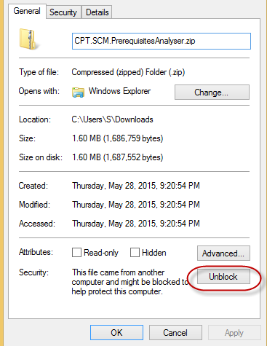

1. Now, unzip the **CPT.SCM.PrerequisiteAnalyzer_vX.X.zip** file to a temporary location.
2. Run the **CPT.SCM.PrerequisitesAnalyser.exe** file
   1. In the new window that appears on the screen entitled “CPT Prerequisite Analyzer” click on the “Analyze” button.

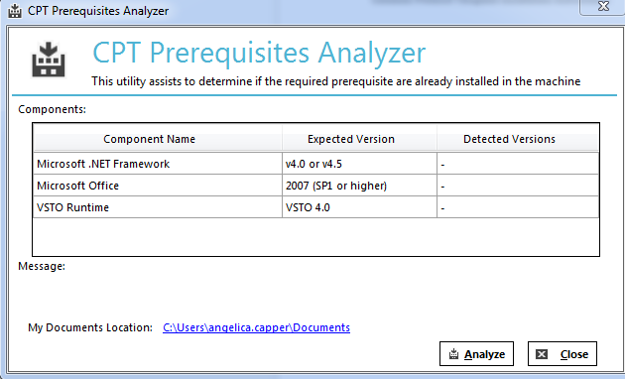

* 1. A new column will appear in the window called “Status”. If all the prerequisites are met then the status column will contain all green check marks. If not, a red “X” will appear which indicates a prerequisite needs to be met. Before continuing the installation process, you will need to install the necessary updates.

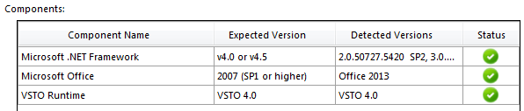

# Installing Technology Components

The technology components are delivered in form of MS Word Add-Ins. There are two add-ins required to leverage all available functionality in the technology enabled version of the CPT. This section describes the procedure for installing both the add-ins.

## Updating to the latest Release of the CPT Intelligent Content Management (ICM) and Intelligent Library Management Add-Ins

Before a user can upgrade to the latest release of the Technology Enabled Edition of the Protocol Template, they will need to uninstall the current version. Details on this step are listed in Section 5 of this document. Once the uninstall has been completed begin at the step below Section 3.2.

## Installing CPT Intelligent Content Management (ICM) Add-In

Please close all Word windows and execute the steps below to install the add-in.

1. Download CPT.SCM.ICM_vX.X.X.X.zip to a temporary location on your computer.
2. If your organization does not allow downloading of ZIP files, your web browser will not respond or download the file. If this happens:
   1. Please locate and download the alternate file with the extension **.tiz** in order to circumvent around this problem.
   2. Once downloaded, please rename it to **.zip** extension.
3. Please make sure the file is not blocked since it was downloaded from Internet.
   1. Right-click the file and select **Properties**.
   2. If you see a security warning with “Unblock” option at the bottom of the screen as shown below, click “Unblock” and click Ok.

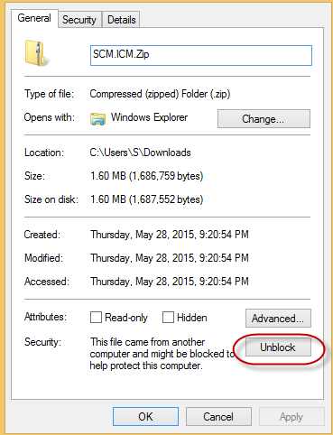

1. Now, unzip the **CPT.SCM.ICM_vX.X.X.X.zip** file to a temporary location.
2. Run the **Setup.exe** file and when prompted, click the **Install** button to install the Add-In.

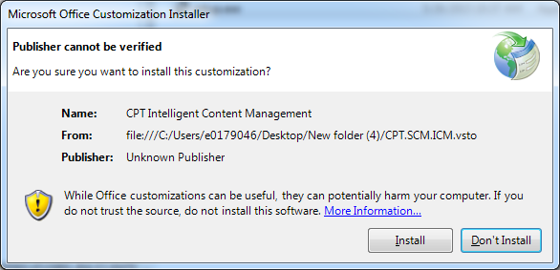

1. Once the installation is complete the following dialog will be displayed, click the **Close** button.

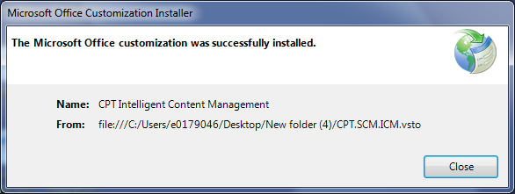

If you see an error message, please refer to Troubleshooting section or contact your IT Helpdesk for further support.

## Installing CPT Intelligent Library Management Add-In

Please close all Word windows and execute the steps below to install the add-in.

1. Download CPT.SCM.LibraryMgmt_VX.X.X.X.zip to a temporary location on your computer.
2. If your organization does not allow downloading of ZIP files, your web browser will not respond or download the file. If this happens:
   1. Please locate and download the alternate file with the extension **.tiz** in order to circumvent around this problem.
   2. Once downloaded, please rename it to **.zip** extension.
3. Please make sure the file is not blocked since it was downloaded from Internet.
   1. Right-click the file and select **Properties**.
   2. If you see a security warning with “Unblock” option at the bottom of the screen as shown below, click “Unblock” and click Ok.

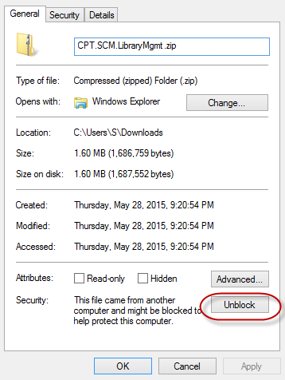

1. Now, unzip the CPT.SCM.LibraryMgmt_VX.X.X.X.zip file to a temporary location.
2. Run the Setup.exe file and when prompted, click the Install button to install the Add-In.

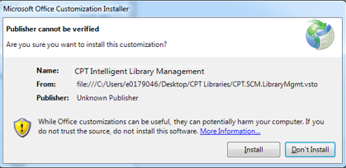

1. Once the installation is complete the following dialog will be displayed, click the Close button.

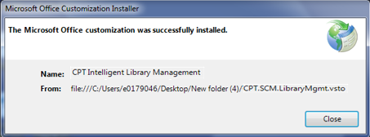

## Verifying the Installation

You can verify the installation procedure by following the instructions below.

1. Launch Microsoft Word.
2. CPT tab is now visible in the Ribbon section with the following commands.

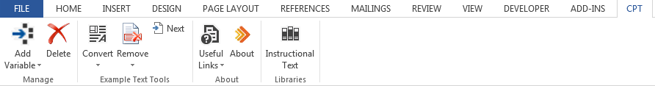

1. If you do not see the CPT tab, please contact your **IT Helpdesk** for further support.

# Installing CPT Template

The CPT template is delivered in both DOCX and DOTX formats. The DOTX file is a **MS Word Document Template** file that contains technology enablement in form of Word **Content Controls** and is accompanied by **Word Add-Ins**. Please follow the instructions below that are appropriate for your MS Office version.

NOTE: If you intend to use the DOCX version of the CPT template, please do not refer to the instructions in this document.

# Unblocking the Template

* + 1. Download applicable document to a temporary location on your computer.
    2. Please make sure the file is not blocked since it was downloaded from Internet.
       1. Right-click the file and select **Properties**.
       2. If you see a security warning with “Unblock” option at the bottom of the screen as shown below, click “Unblock” and click Ok.   
            
          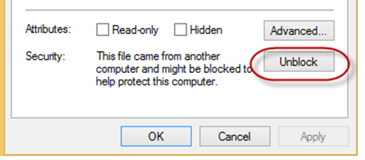

# MS Office 2007 & 2010

Please use the instructions below to configure the CPT template for use in Word 2007 or 2010.

1. Open **Windows Explorer.**
2. Type **%AppData%** in the location input box and press **Enter.**

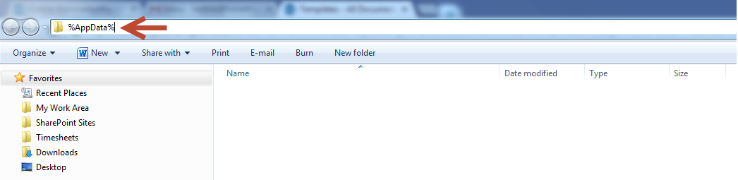

1. Click and Navigate to **Microsoft/templates** folder.
2. Create a folder called **CPT Templates.**
3. Download the **CPT Core Backbone Template (CPT_Core_TEEEvX.X.dotx)** file from CPT download location to the newly created **CPT Templates** folder or if already downloaded to your desktop as discussed above, move the file to the newly created CPT Templates folder.

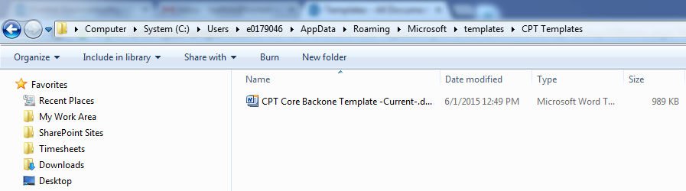

# MS Office 2013/2016

Please use the instructions below to configure the CPT template for use in Word 2013.

1. Open **Windows Explorer.**
2. Go to **Documents** libraries and navigate to **Custom Office Templates** subfolder.

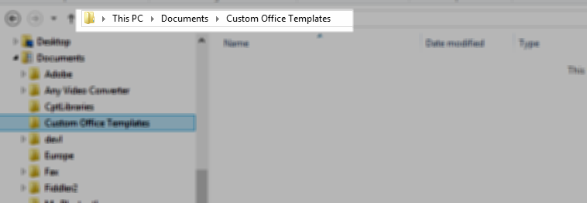

1. Download the **CPT Core Backbone Template (CPT_Core_TEEEvX.X.dotx)** file from CPT download location to this folder.
2. Copy the path to or make a note of this location. This will be needed in the next step.
3. Open MS Word. Go to **File** ribbon and select **Options**.



1. Click **Save** section and enter the copied path or location to “**Custom Office Templates**” folder in **Default personal templates** location box. Also, in the “Save Files in this format” section, confirm the option “Word Document (*.docx) is selected.

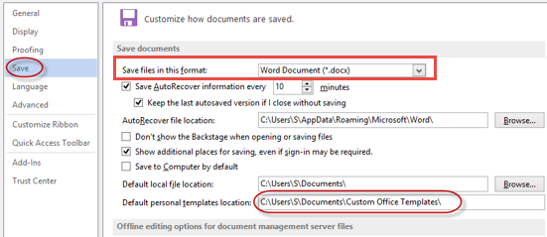

1. Click **Ok.**

# Verifying the Installation

* + - 1. Launch MS Word.
      2. Click **File**-> **New**.
      3. Create a new document from the CPT template as instructed below if you’re using Word 2010. **If using 2013/2016, skip to step 4 below**
         1. Click **My templates**  as shown below:

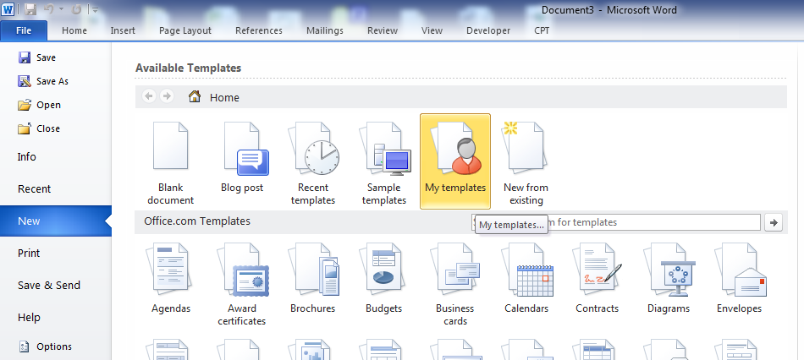

* + - * 1. Click CPT Templates tab. The dialog should display the installed CPT template as shown below. Select the template and click “OK”.

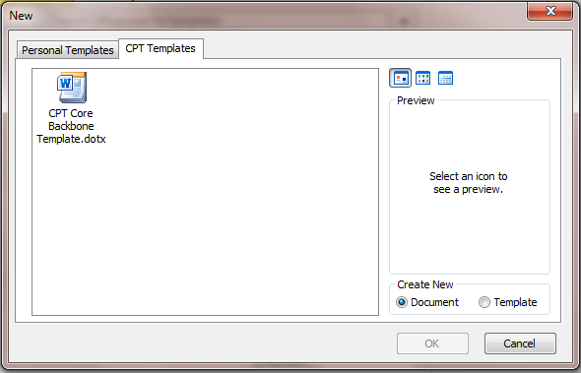

* + - 1. **If using 2010, skip to step 5 below**. Create a new document from the CPT template as instructed below if you’re using Word 2013:
         1. Click “**Personal**” as shown below:

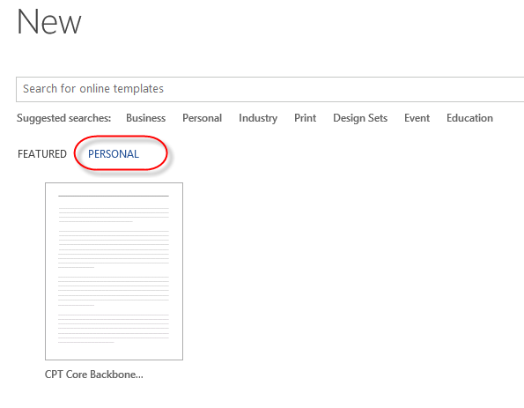

* + - * 1. Click the CPT template to select it and click OK to create a new document instance from the CPT template.
      1. A new document is created.
      2. Click on the folder icon within the right hand “CPT Panel”, it will open a newly created CptLibraries folder under your My Documents. Verify that the new library documents and their associated XML files exist.

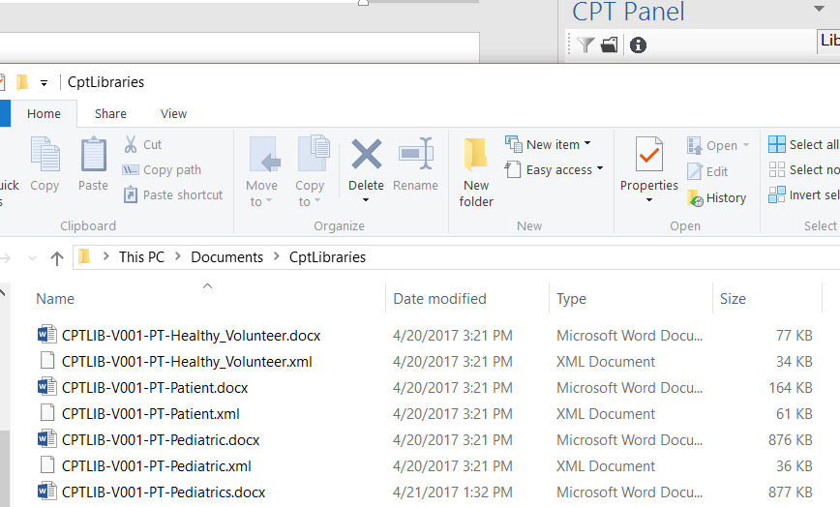

* + - 1. This concludes the verification of the installation procedure.

# Uninstalling Technology Components

## Uninstalling CPT Intelligent Content Management (ICM) Add-In

1. Make sure to close all your Word Instances before following the below steps.
2. Navigate to the **Control Panel** 🡪 Click on **Programs and Features.**

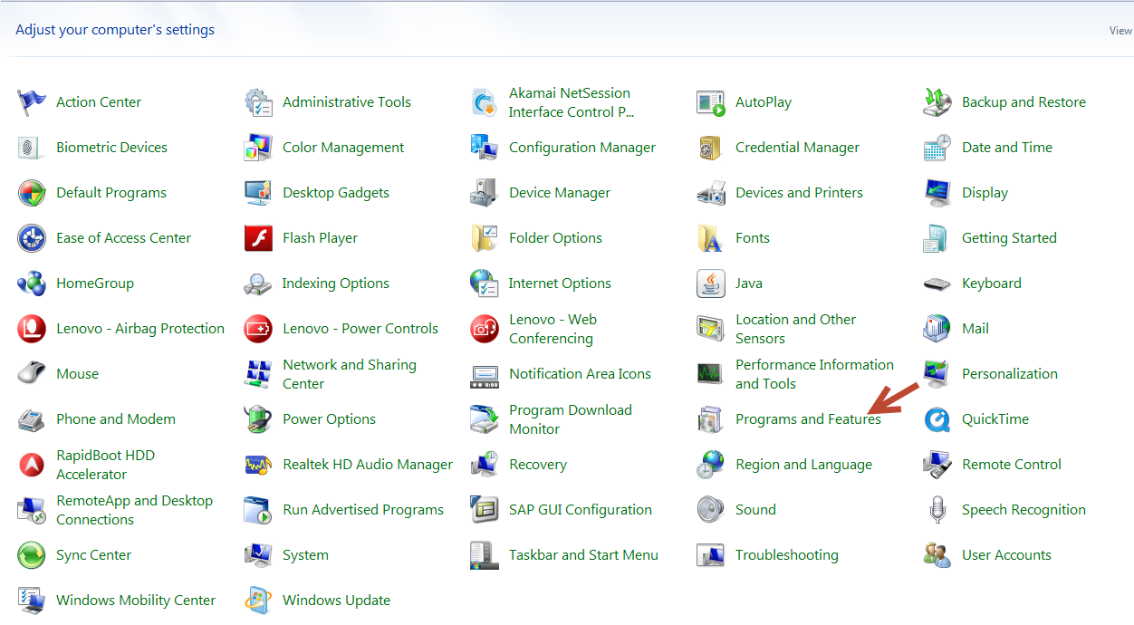

1. Select **CPT Intelligent Content Management** from the list of programs 🡪 Click on Uninstall button.

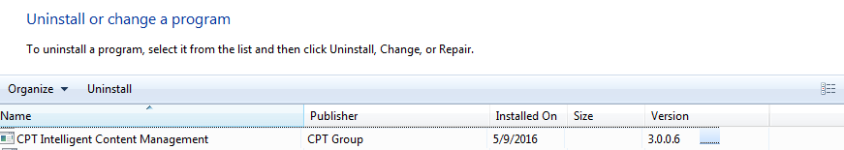

1. Click **OK** on the message prompt to uninstall the Add-In.

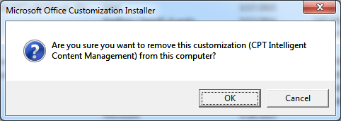

## Uninstalling CPT Intelligent Library Management Add-In

1. Make sure to close all your Word Instances before following the below steps.
2. Navigate to the **Control Panel** 🡪 Click on **Programs and Features.**



1. Select **CPT Intelligent Library Management** from the list of programs 🡪 Click on Uninstall button. 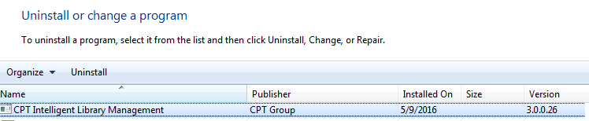
2. Click **OK** on the message prompt to uninstall the Add-In.

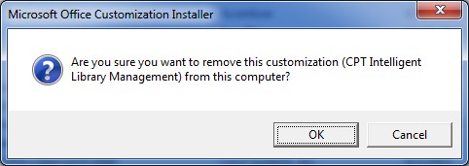

# Troubleshooting

## Installation Issues due to Certificate or Trusted Location

**Issue**: The Add-In displays the following error message during the installation.

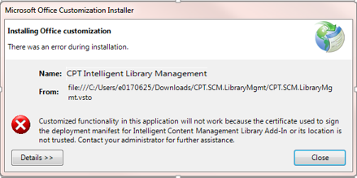

**Description:** This issue could be caused by a number of reasons. Two most common causes and resolutions are listed below:

**Cause #1:**

The installation files are blocked by your organization’s security policy because they were downloaded from an untrusted Internet source.

**Resolution**: Locate the installation ZIP file and unblock it by going into properties tab (right click menu).



**Cause #2:**

The installation files are blocked by your organization’s security policy because they are located on a network drive. Re-running the setup.exe should work now.

**Resolution**: Copy the installation ZIP file to a local disk folder (e.g., C:\ or C:\TEMP) and unzip. Re-running the setup.exe should work now.

## CPT Template Error

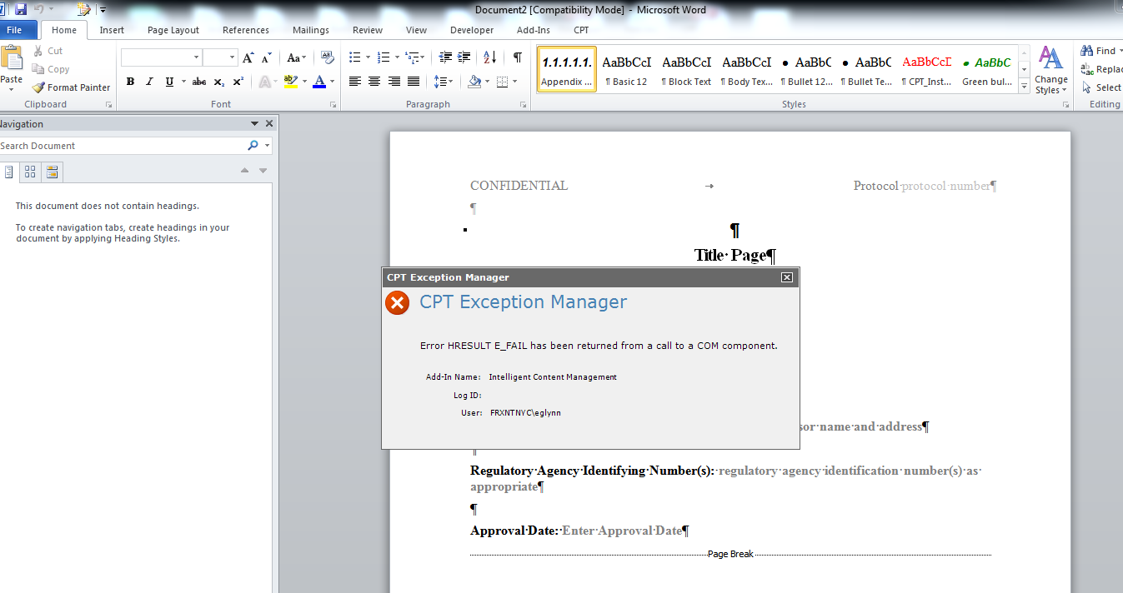

**Issue**: The template displays the following error message upon opening word “Error HRESULT E_FAIL has been returned from a call to a COM component”

**Description:** This issue is caused by the default settings in word that are saving the document format to .DOC instead of .DOCX. The format .DOCX is required for the CPT Template to work.

**Resolution**: This setting can be found in Word options. Please change it to .docx and create a new CPT document again. Go to File>Options>Save and update the drop down for “Save File in this Format:” to “Word Document (*.docx).

