***Read all of the following information before starting the exam:***

Due to the COVID19 quarantine, this exam is given online only, but it is a timed exam. We are depending on your engineering ethics to comply with the following rules:

*Permitted on exam*:

* Open book, open notes, open Python documentation, open internet (Google, etc.).
* All your code should be your own work. You are **encouraged** to copy/modify your existing code from homework 1-6 as necessary.

*Not permitted on exam*:

* You **MAY NOT** use any form of technology to communicate with, send to, or receive information from another person (other than the instructor), during the time of the exam.

*Exam submission*:

* You should create a folder called **EX2** to house all your files and then submit a zipped version of that folder.
* During the exam, you should SAVE YOUR WORK **often**!
* You will be uploading your exam solutions to the Canvas, **EX2**dropbox. You may upload multiple versions of your solution (so you can save early and often). We will grade the LAST submitted version of each problem.
* Given the fact that you will be submitting your exam from home, internet service may be variable. If you are having trouble submitting, please let me know with a text message (405)-742-8053. If you can’t submit on CANVAS, you may email your .zip file to me at jim.smay@okstate.edu

*Grading*:

* Each problem carries equal points (perhaps divided among several parts), but not all are of equal difficulty.
* You should test your output using appropriate test values. We will grade based on code correctness, readability and output results (i.e., print to screen values and plots).

**WELL COMMENTED AND DOCUMENTD CODE CAN RECEIVE UP TO 10 BONUS POINTS TOWARD YOUR TOTAL EXAM SCORE.**

1. Short answers (25 pts) (you should submit your answers in a text file in the same folder as your python files.)
2. Concerning numpy:
   1. How can I create a numpy array that is a 6×6 identity matrix?

import numpy as np

a = np.identity(6)

print(a)

* 1. What does numpy.linspace(10, 20, 30) do?

numpy.linspace creates a linear sequence with the range of numbers provided

* 1. Write a single line of code to fill a 10×10 numpy array with normally distributed random numbers from N(0,1)

s = np.random.randint(0,1,(10,10))

1. Concerning fsolve:
   1. Write the line of Python code to import fsolve.

from scipy.optimize import fsolve

* 1. In the Python code def Find_FlowRates(Q, *args): what does *args mean?

*args passes variables to a number of arguments in the function

* 1. Write a line of Python code to use fsolve with the callback function defined in ii. and the arguments density, roughness, viscosity, roughness, seg_names, seg_lengths, seg_diams passed as arguments.

fsolve(Find FlowRates, Q, (args))

* 1. What should be returned from the function in ii.?

A list of the values of the functions defined in the callback

* 1. What should be the result of fsolve from iii.?

It will return the value of Q where Find_FlowRate(Q, *args) is equal to zero. Therefore, it is finding the roots of the function.

1. Concerning odeint:Given the python code x=odeint(ode_system, ic, t, myargs)
   1. What arguments should ode_system have?

Arguments:

ic = initial condition

t = time

myargs = could include any argument that are constants needed for the function definition

* 1. What is returned from the function ode_system?

Returns a value from the first order derivative of the dependent variable

1. (25 points) You have analyzed a pipe network with sprinklers in your homework 6 -part1a. Modify your program, appropriately, to analyze the pipe network below and output a nicely formatted report for the: **i)** flow rate and direction in each pipe, **ii)** the head loss in each pipe (in in of water), and **iii)** the pressure at each node in psi with the knowledge that the node h pressure is 80 psi.

Notes: The 12” and 16” pipes are cast iron (roughness = 0.00085 ft) while the 18” and 24” pipes are concrete (roughness = 0.003 ft). Flow is fully developed and turbulent and minor losses may be ignored. cfs stands for cubic feet per second. Room temperature water is the fluid (μ=20.50 lb⋅s/ft2, γ=62.3 lb/ft3). Name your file EX2_2.py.

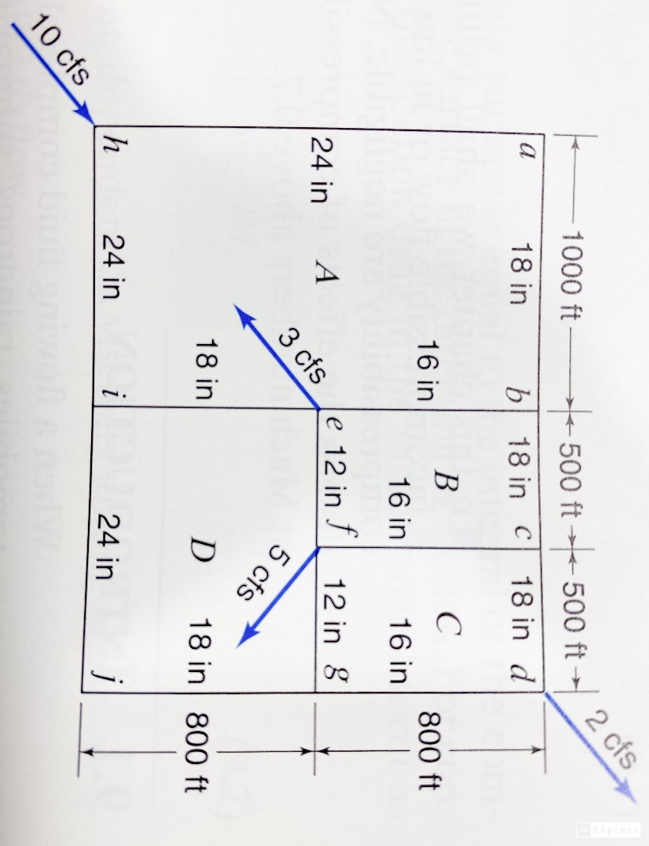

1. (25 points) Use pyplot to graph your Rankine cycle from homework 6 part 2 on a T-S diagram. The graphs should look like the following graphs (including title, axes labels, and summary notation):

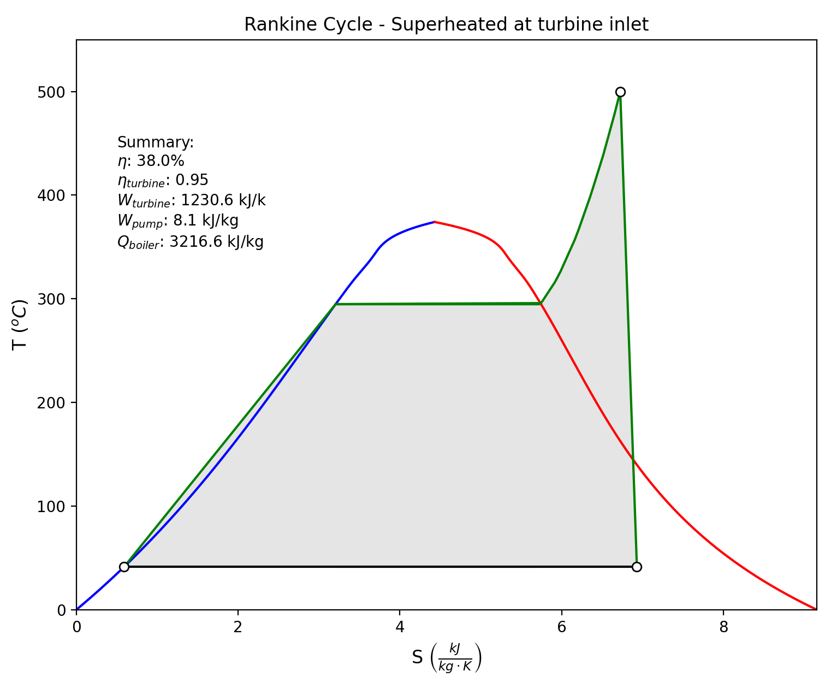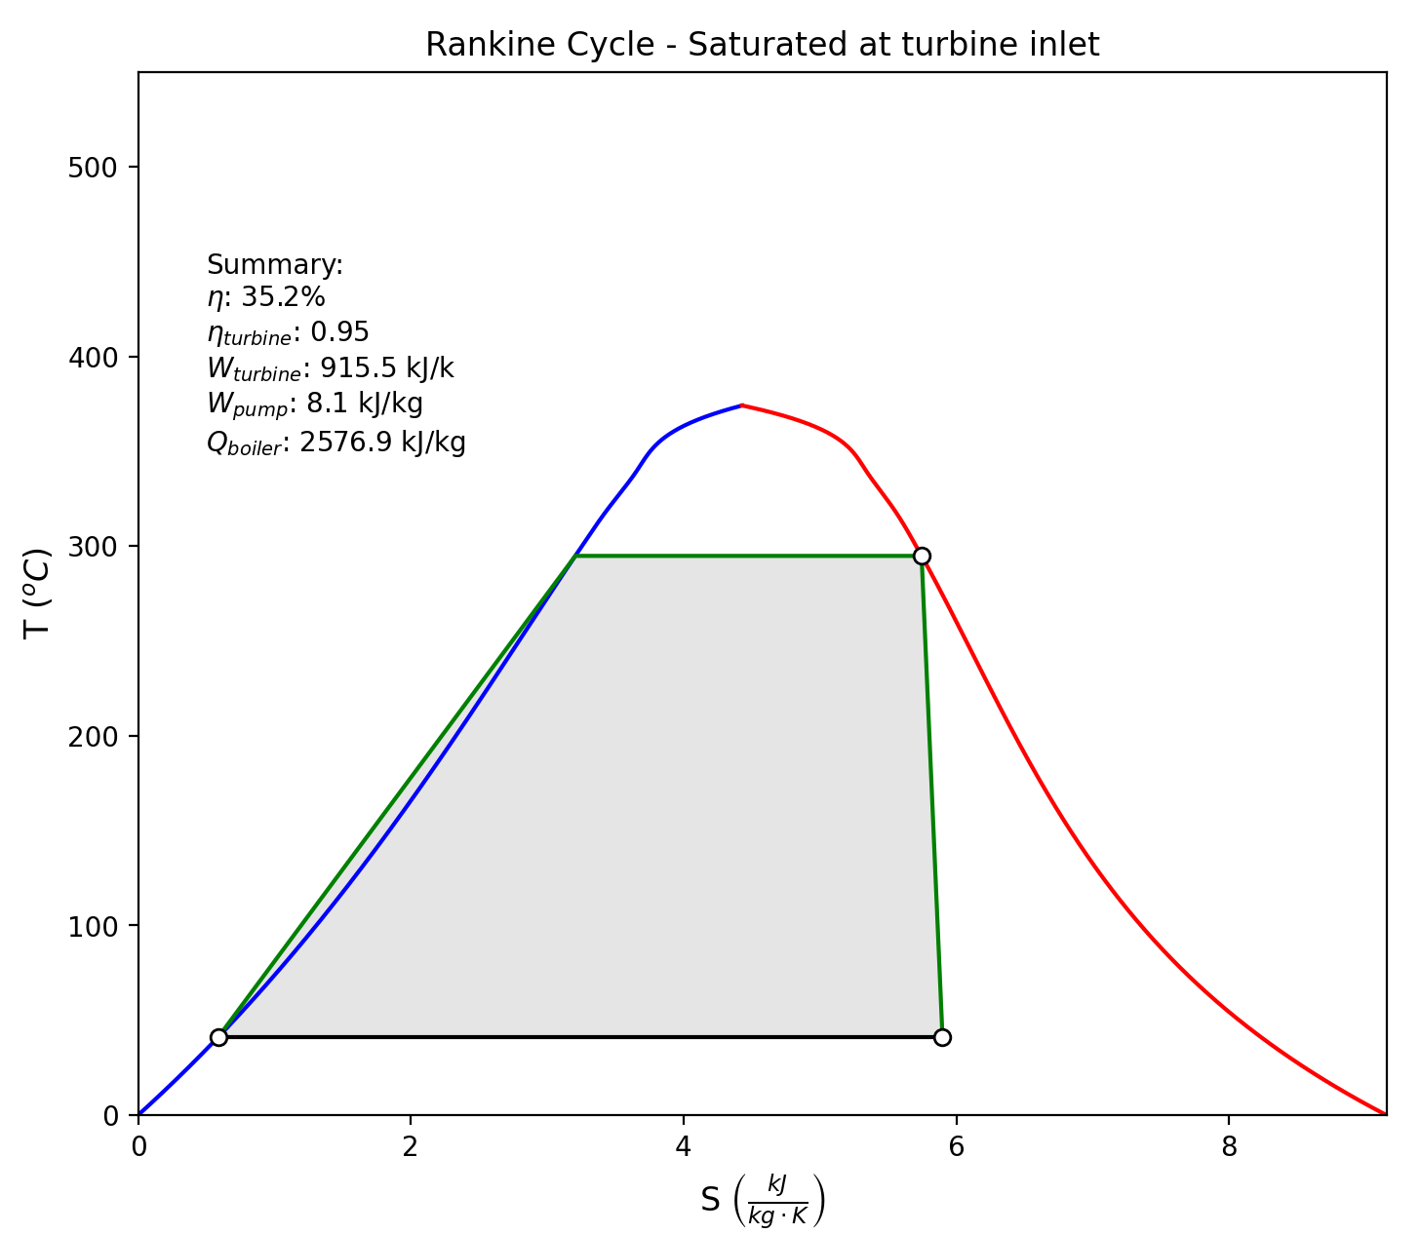

Notes: i) You should modify your rankine class to include a value for isentropic turbine efficiency (ηturbine­) and include ηturbine in your calculation for cycle efficiency. ii) You should include the plotting function as a method of the rankine class. And, iii) You should modify your test_rankine.py and call it EX2_3.py with the following main function:

def main():

'''

A test program for rankine power cycles.

R1 is a rankine cycle object that is instantiated for turbine inlet of saturated vapor.

R2 is a rankine cycle object that is instantiated for turbine inlet of superheated vapor.

:return: none

'''

R1=rankine(p_high=8000, p_low=8, name='Rankine Cycle - Saturated at Turbine Inlet')

R1.calc_efficiency()

R1.plot_cycle_TS()

R2=rankine(p_high=8000, p_low=8, t_high=500, name='Rankine Cycle - Superheated at Turbine Inlet')

R2.calc_efficiency()

R2.plot_cycle_TS()

1. (25 pts) Imagine you are trying to fill a leaky bucket with water.

i) If the inlet flowrate is 20 gpm, will the bucket runneth over or come to some steady level? Prove your answer by plotting the water level as a function of time.

ii) At what inlet flow rate would we just start to overflow the bucket?

Important factors:

1. Water flows out of the hole driven by pressure head according to: 
2. The hole diameter is 0.25”
3. The bucket is 1.3 ft in diameter and 2.3 ft tall.
4. Water density is 1000kg/m3