CprE 381, Computer Organization and

Assembly-Level Programming

Lab 2 Report

Student Name Ryan Hoefer

Submit a typeset pdf version of this on Canvas by the due date. Refer to the highlighted language in the lab document for the context of the following questions.

[Part 3 (a)] Draw the interface description (i.e., the “symbol” or high-level blackbox) for the RISC-V register file. Which ports do you think are necessary, and how wide (in bits) do they need to be?
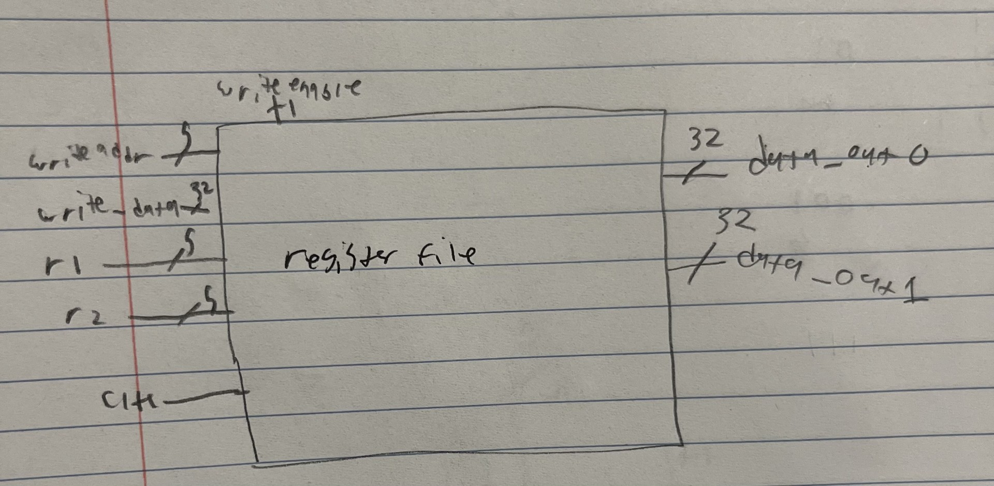

[Part 3 (b)] Create an N-bit register using this flip-flop as your basis.
ok
[Part 3 (c)] Waveform.
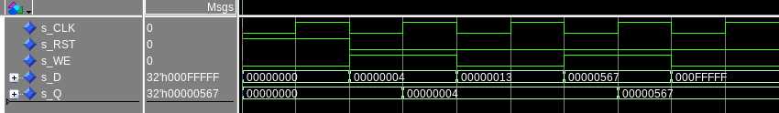
This correctly stores the values 4 and 567 when the we is enabled and doesn’t store 13 and FFFFF when it isnt

[Part 3 (d)] What type of decoder would be required by the RISC-V register file and why?
A 5 to 32 decode because there are 32 registers

[Part 3 (e)] Waveform.
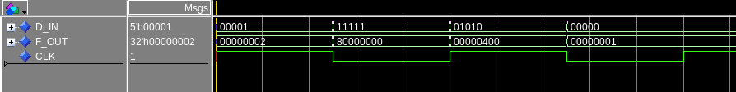
This correctly outputs to the line it should based on what the in is

[Part 3 (f)] In your write-up, describe and defend the design you intend on implementing for the next part.

I used a custom type to use a 32 wide array of 32 bit signals, this would reduce the boilerplate needed and make it more readable. Also this allows me to re use this component later on if I need to as well. Dataflow would be 32 lines long and be a lot of code to type.

[Part 3 (g)] Waveform.
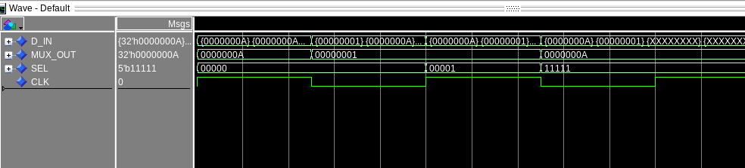
This one correctly passed what ever mux value was selected based on the select input

[Part 3 (h)] Draw a (simplified) schematic (i.e., components within the high-level blackbox) for the RISC-V register file, using the same top-level interface ports as in your solution describe above and using only the register, decoder, and mux VHDL components you have created.
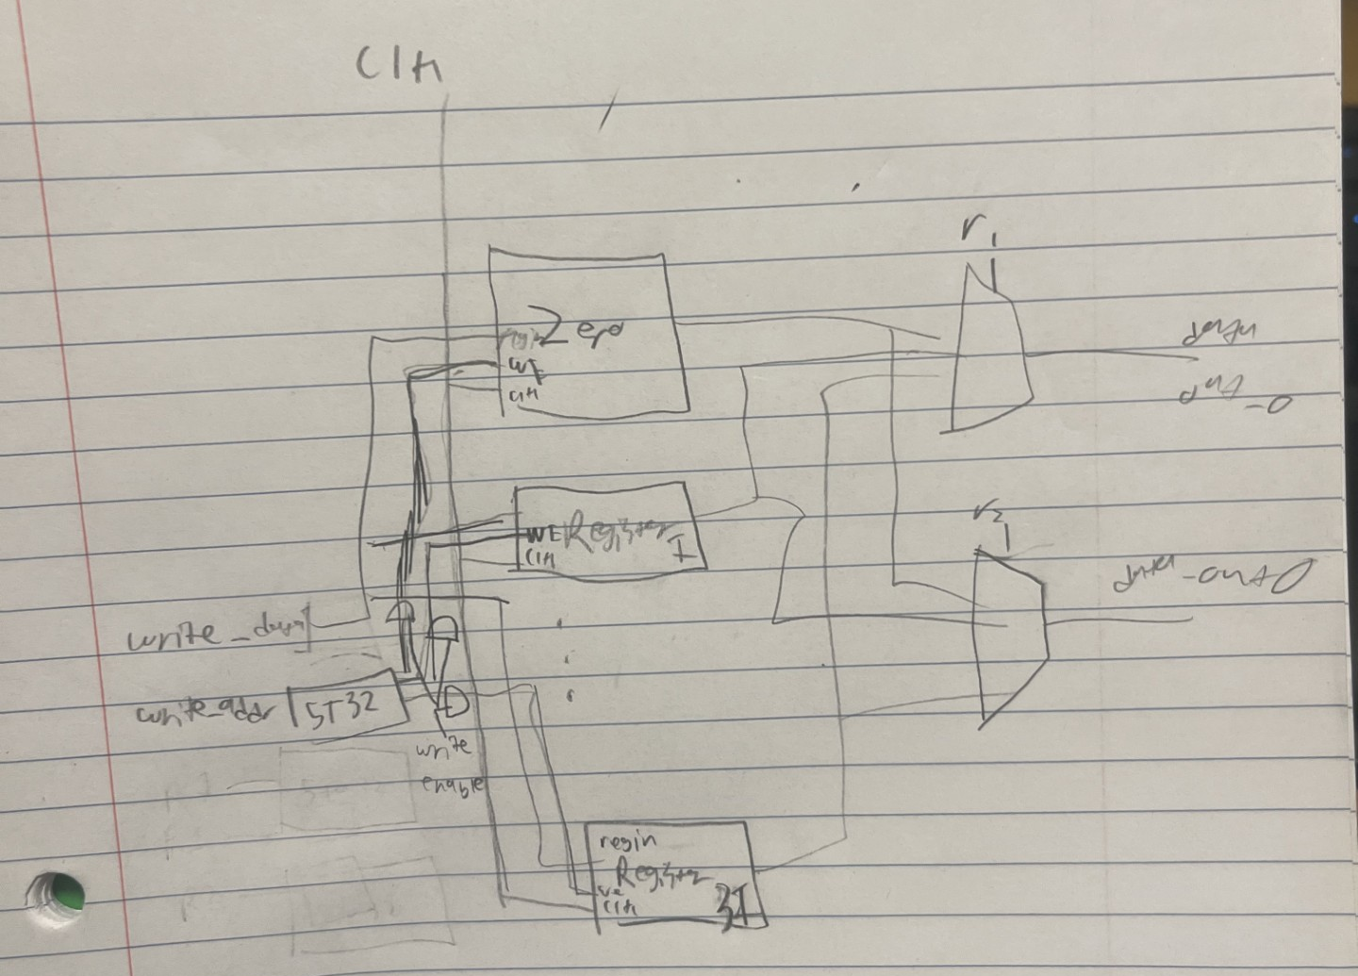

[Part 3 (i)] Waveform.

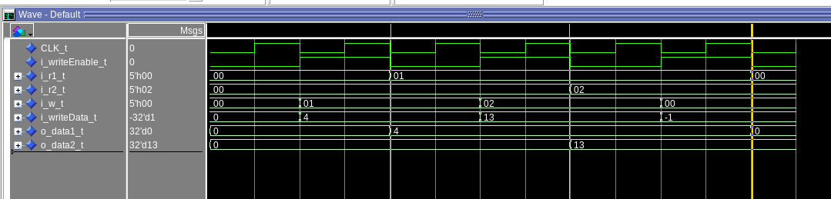
-- Test 1
-- read 0 from x 0 on both ports

-- Test 2
-- Store 4 in x1 and read

-- Test 3
-- write 13 to x2 then read x1 and x2

-- Test 4
-- write to x0 and read making sure it is still 0

[Part 4 (b)] Draw a symbol for this RISC-V-like datapath.
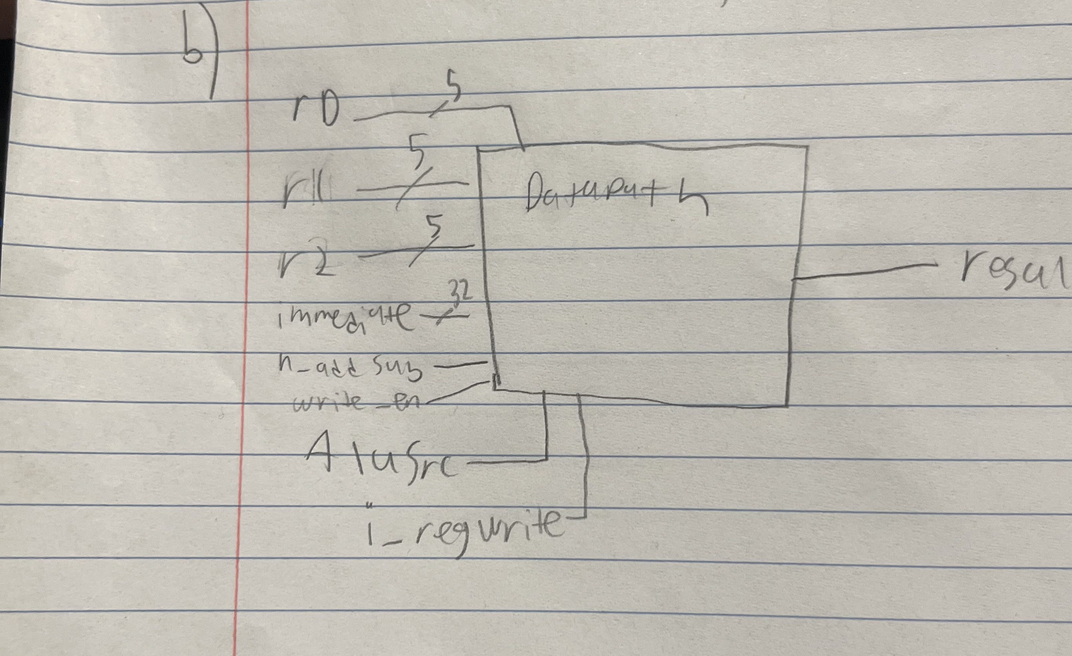

[Part 4 (c)] Draw a schematic of the simplified RISC-V processor datapath consisting only of the component described in part (a) and the register file from problem (1).
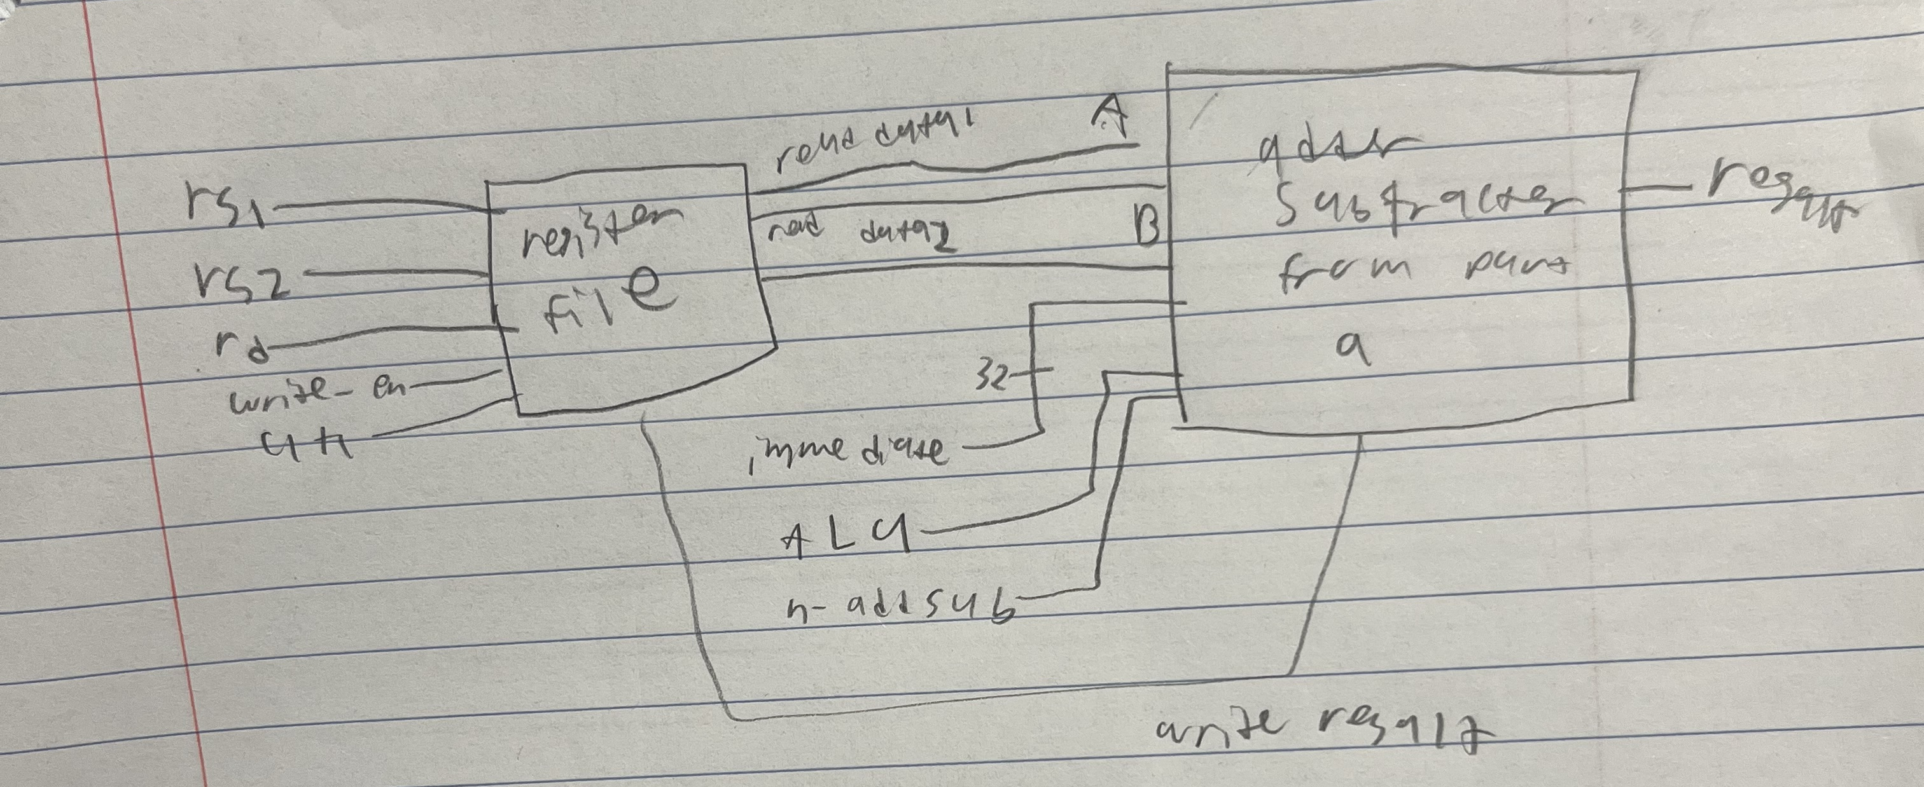
[Part 4 (d)] Include in your report waveform screenshots that demonstrate your properly functioning design. Annotate what the final state of the register file should be and provide a mapping of the registers used in your drawing to the register names.

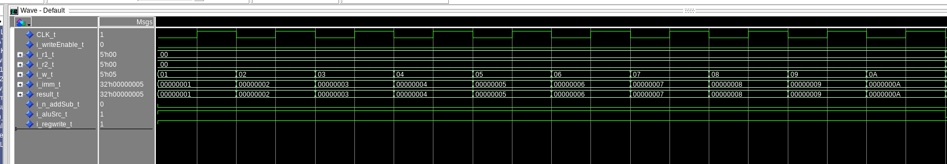
This is the tests loading data into registers

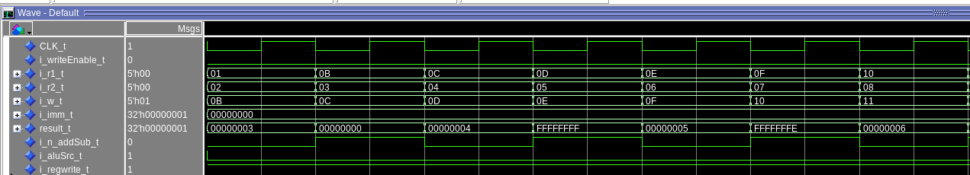

This is the assembly code here
add x11 , x1 , x2 # x11 = x1 + x2
sub x12 , x11 , x3 # x12 = x11 - x3
add x13 , x12 , x4 # x13 = x12 + x4
sub x14 , x13 , x5 # x14 = x13 - x5
add x15 , x14 , x6 # x15 = x14 + x6
sub x16 , x15 , x7 # x16 = x15 - x7
add x17 , x16 , x8 # x17 = x16 + x8

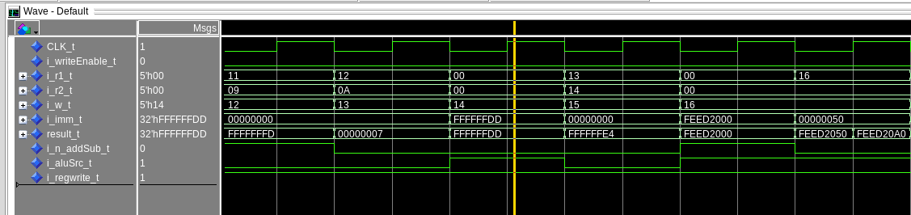

this is this code

sub x18 , x17 , x9 # x18 = x17 - x9
add x19 , x18 , x10 # x19 = x18 + x10
addi x20 , zero , -35 # Place " -35" in x20
add x21 , x19 , x20 # x21 = x19 + x20
lui x22 , 0XFEED2 # Place "0 xFEED2000 " in x22
addi x22 , x22 , 0x050 # Complete loading x22 with a large immediate

The final state of the register file should be the foillowing with mapping being the associated binary value to be x(value)

x0-0
x1-1
x2-2
x3-3
x4-4
x5-5
x6-6
x7-7
x8-8
x9-9
x10-10
x11-3
x12-0
x13-4
x14-(-1)
x15-5
x16-(-2)
x17-6
x18-(-3)
x19-7
x20-(-35)
x21-(-28)
x22-0xFEED2050
x23 through x31 is undefined

[Part 5 (a)] Read through the mem.vhd file, and based on your understanding of the VHDL implementation, provide a 2-3 sentence description of each of the individual ports (both generic and regular).

Clk: you need a clock because the data is stored synchronously so it needs a clock edge to change.
Addr: this is the memory location for both read and write. This selects each word not each individual byte
data: this is what will be written to memory. This happens on a rising edge.
be: this is the byte enable, which determines which of the four bytes is written. Examples are 1111 is all bytes are written but 1100 means only bytes 3 and 2 are written.
We: this is a global write enable so it will control if all the bytes are allowed to be written. This will be checked on the rising clock edge.
q: the read output of the memory. This is done asynchronously so you don’t need the clock edge to access this.
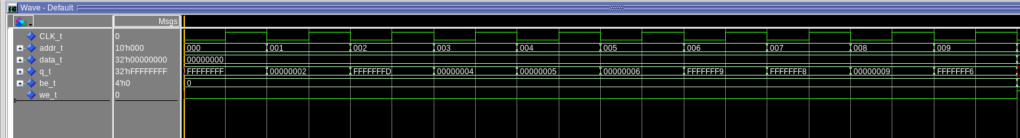
[Part 5 (c)] Waveforms and hex file.

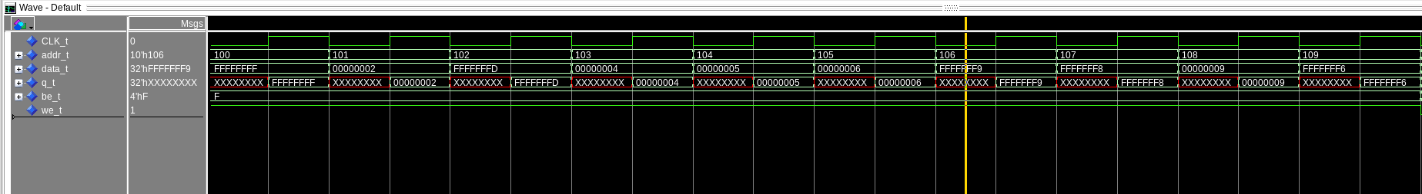
This reads the initial 10 values(part b)

this writes those values back into memory(part c)

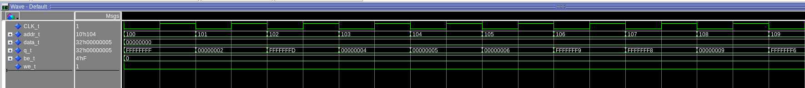
this reads it back(part d)

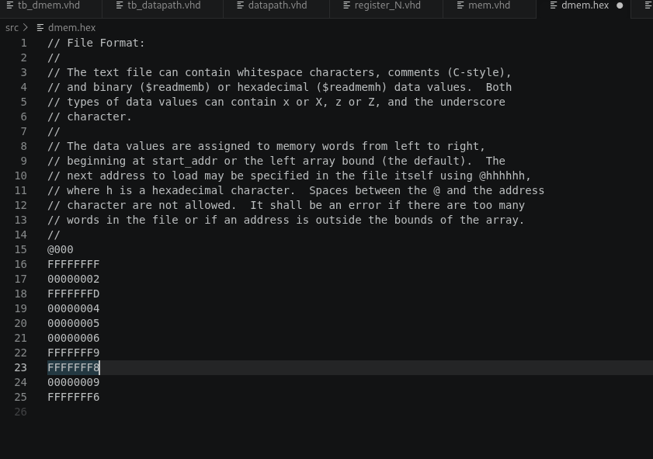

[Part 6 (a)] What are the RISC-V instructions that require some value to be sign extended? What are the RISC-V instructions that require some value to be zero extended? What are the RISC-V instructions that require some value to be appended with zero?

Sign extended: lbu, ori, lb, lw, sw

zero extended: lui, lhu

appended with zero: blt, bltu, bne, jal

[Part 6 (b)] what are the different “extender” components that would be required by a RISC-V processor implementation (i.e., number of bits of input and sign vs zero extension vs zero appending)?
12 to 32 sign extender, 8 to 32 sign extender
12 to 32 zero extender, 16 to 32 zero extender
[Part 6 (d)] Waveform.

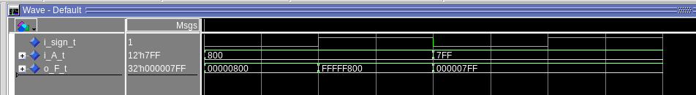
test 1: zero extends the 12 bit number where 1 is sign
test 2: sign extends the 12 bit number where 1 is sign
test 3: zero extends the 12 bit number where 0 is sign
test 4: sign extends the 12 bit number where 0 is sign

[Part 7 (a)] what control signals will need to be added to the simple processor from part 2? How do these control signals correspond to the ports on the mem.vhd component analyzed in part 3?

It would need to have a mem write enable that would connect to the we control bit in the mem file. It would also need to have the be field set to 1111 to enable all 4 bytes because risc-v doesn’t support enableing or disabling individual bytes

we would also need another control bit to select what the register file would receive betgween the memory and the alu.

[Part 7 (b)] Draw a schematic of a simplified RISC-V processor consisting only of the base components used in part 2, the extender component described in part 4, and the data memory from part 3.
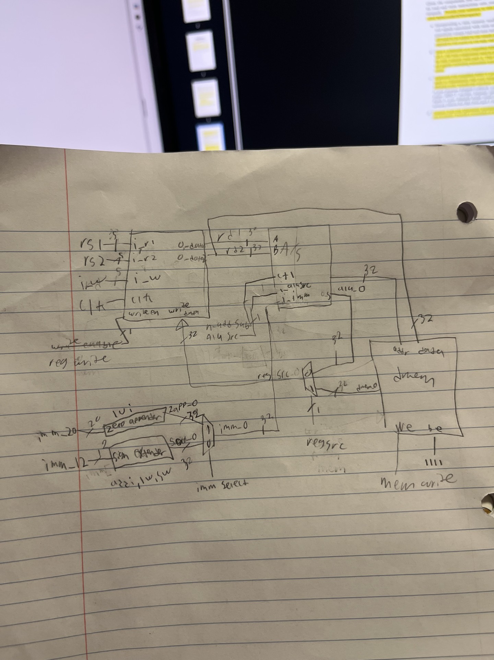
This is the top level schematic of the datapath

[Part 7 (c)] Waveform.
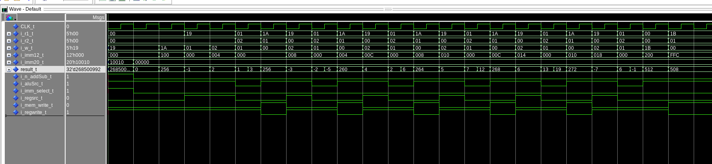
This implements the assembly code given, the highlighted result_t signal is the output from the mux to the register file that has control regsrc.
[Part 7 (d)] Compare the Questasim waveform/memory list against the RARs output/memory list.

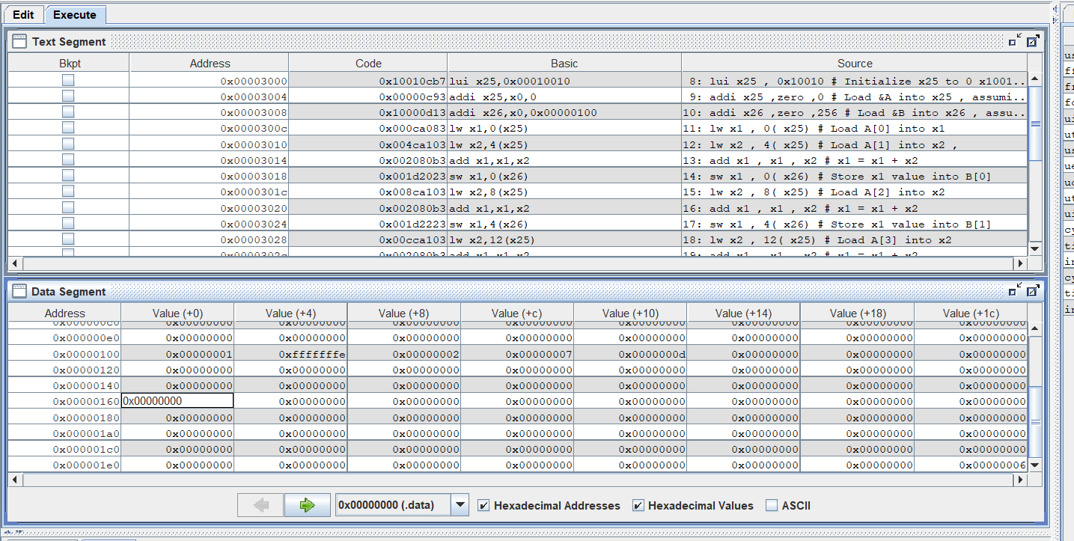

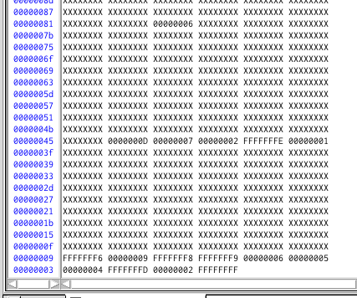

This looks to be all good and matching with the questasim starting at 40 and rars atarting at 100. This is because my implementation uses word addressing and RARS uses byte addressing. The word array sequentially follow and we have the stray 6 a little ways away.

