***Ultimate Tic-Tac-Toe***

By :

Nicole Silverthorn

Ryan Feyen

Ryan Hickman

*May 28th, 2014*

Table of Contents

**Section I : Project Overview**

Team Personnel

Executive summary

Core Gameplay

Game Features

Project Scope

Target Audience

Delivery Platforms

**Section II : Controls**

Android Controls

**Section III : Interface**

Camera

Heads up Display ( HUD)

Menus Flow Chart

Title Menu

New Game

Settings

Android Controls

Audio Settings

Credits

**Section IV : Artificial Intelligence**

NPC # 1

**Section V : Game Modes**

Single Player

Two Player

**Section VI : Asset List**

Model & Texture List

X’s

O’s

Animations List

Regular Animations

Situation Specific

Effects List

Sounds

Music

**SectionVII : Technical Summary**

Android

**Section I : Project Overview**

*Team Personnel*

Ryan Feyen

Ryan Hickman

Nicole Silverthorn

*Executive summary*

High Concept: This is Tic-Tac-Toe on a grand scale. The Objective in the game is still the same- Get three in a row, but with a smaller board inside each quadrant of the large board.

Genre & Scope: Board Game / Strategy

Visual Style: Doodle

*Core Gameplay:*

-Strictly Portrait style screen orientation.

This picture depicts what the game board will look like at the beginning of the game.

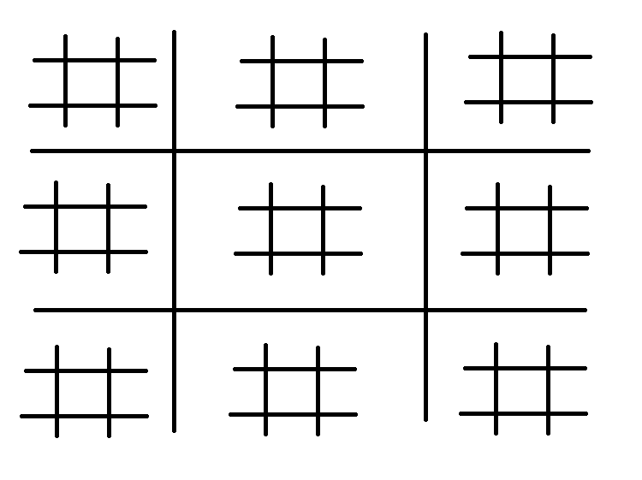

The game board consists of one large board with a smaller board in each of its sections. Player One will move first and can place their shape in any section of the board.

Player one has placed their shape in Square 3 of Square 1. This move now dictates that Player Two must now place their shape in Square 3 of the large board.

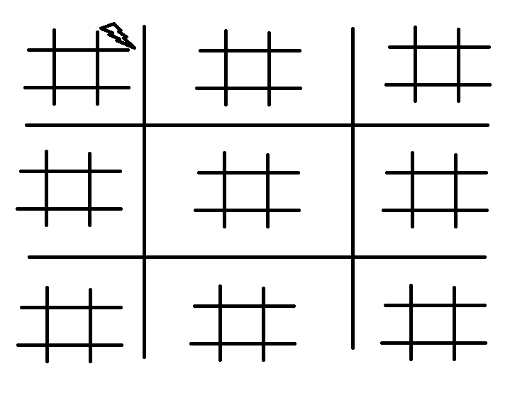\

Player Two has played their shape in Square 3 as dictated by Player One’s first move. Player Two’s shape has also been placed in Square 8 of the small board which forces Player One to play in Square 8 of the large board.

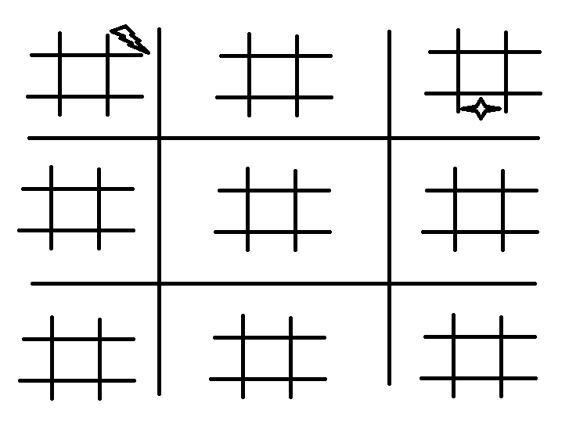

The objective of Ultimate tic-tac-toe is still the same as regular tic-tac-toe, but now you must win three small boards in a row to connect three boards together on the large board.

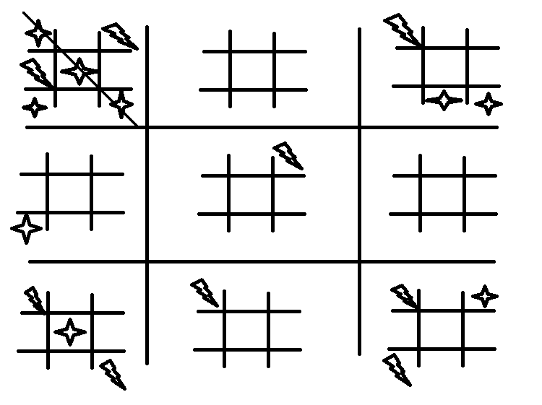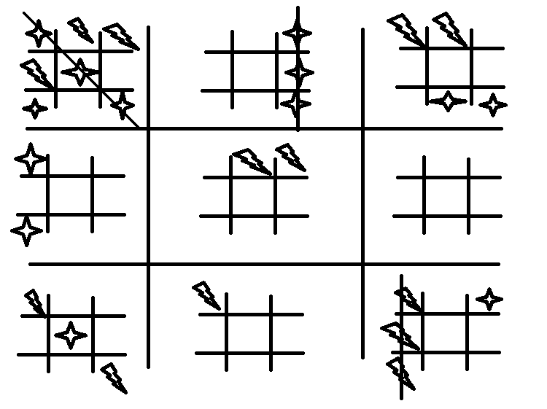

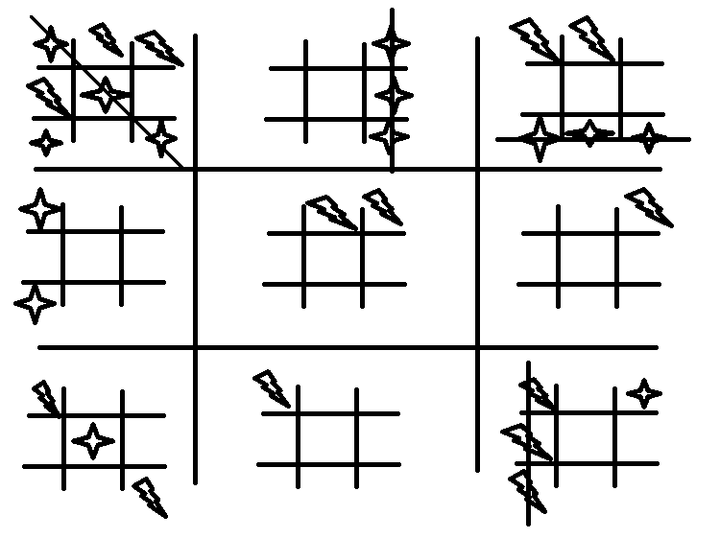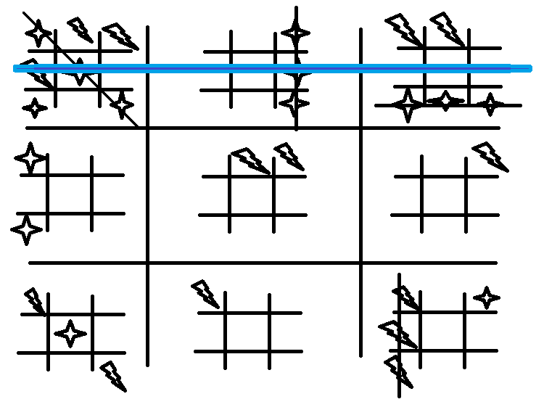

Below is a situation that will occur several times per iteration of the game. What has happened is that Player One has put their Star in Square 5 of Square 6, forcing Player Two to put their Bolt in Square 5. Player Two now has the option to send Player One to Square 1 of the big board - which is currently full.

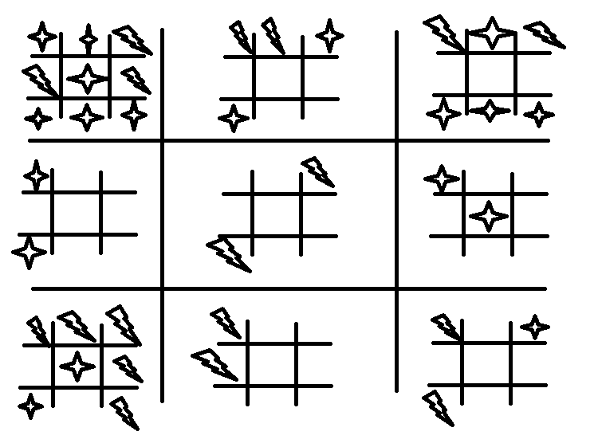

Player Two has done so and has now allowed Player One to place his Star where

ever he wants on the Big board- not a smart choice! This is a feature of the game, and adds more strategy.

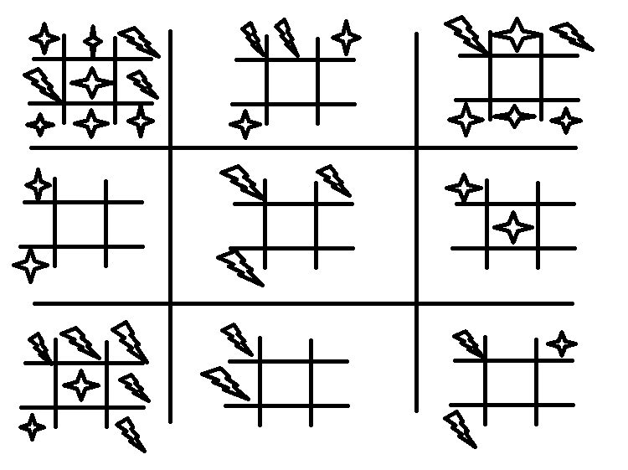

*Target Audience*

*8+*

*Delivery Platforms*

*Android*

**Section II : Controls**

*Android Phone Controls*

*Controls for The Ultimate Tic-Tac-Toe are simple. With touch compatible devices, play consists of tapping the screen where you wish to place your game piece. Selecting buttons on the menu is also done by tapping.*

**Section III : Interface**

*Camera*

- Top down

*Heads up Display ( HUD)*

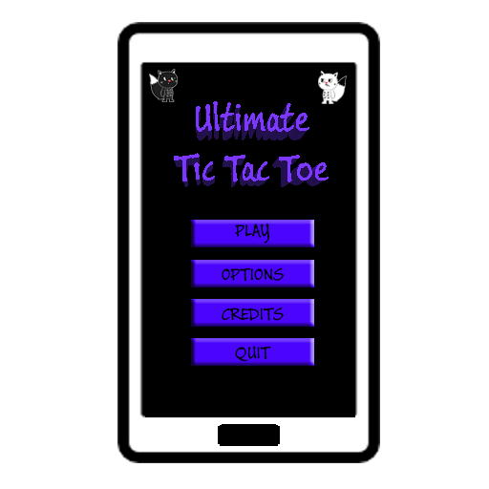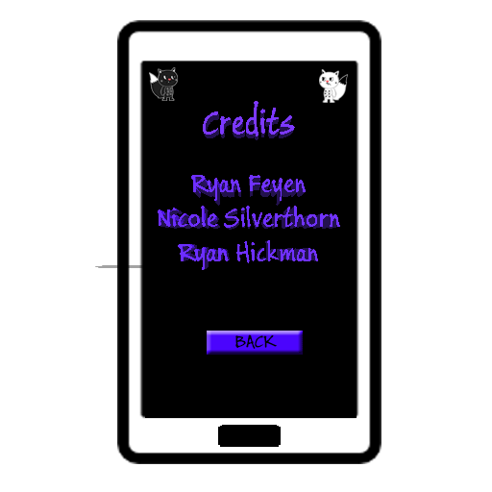

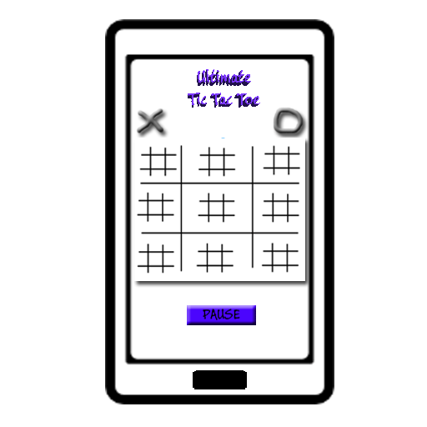

*Menus Flow Chart*

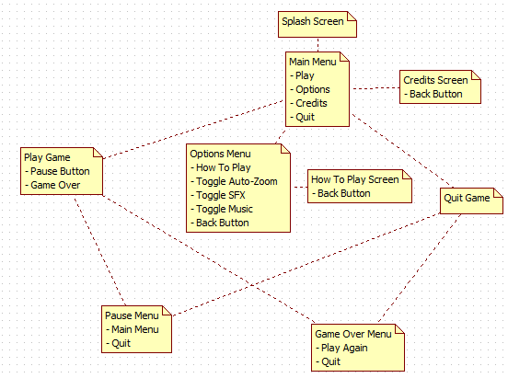

**Section IV : Artificial Intelligence**

The AI will be constructed with a definitive game tree algorithm using backward induction. Meaning the NPC will take all current moves and calculate all possible combinations of moves that can be made from then on. It will then calculate which moves to make by sorting through a list of possible final outcomes, descending from most favourable to least favourable. Most favourable moves will include not only moves that may help the NPC win but also moves that prevent the player from winning.

**Section V : Game Modes**

*Single Player*

*Two Player*

**Section VI : Asset List**

*Model & Texture List:*

*Game pieces (X’s and O’s) will be images.*

*Animations List*

*Regular Animations:*

*Drawing of the Game Piece*

*Button Press Animation*

*Situation Specific:*

*Piece at top of screen to show who’s turn it is. Changes When it switches player.*

*Sounds:*

Sound effect for placement of game pieces.

Game over Sound (“You Win!” sound )

Button press sound effect.

*Music:*

Appropriate Ambient BGM Looping

**Section VII : Technical Summary**

*Android Phone:*

*· Version 2.2+*

*· 600 x 800 resolution*

*· OpenGL ES 2.0+*

*Development Tools:*

*· Eclipse*

*· Java JDK 8*

**To Do / Wish List**

-DLC Customizable Game pieces