

An Employee Portal Incorporating a Chatting App with Sentiment Analysis and Automatic Myers-Briggs Type Indicator Personality Classification

Submitted as part of
CE301 Capstone Project

Submitted by:
Win Paing Hein
ID 2403240

Supervisor:
Dr. Richard Sutcliffe

Second Assessor:
Dr. Alexandros Voudouris
Acknowledgements
I would like to express my sincere gratitude to my parents and family for their continuous support and encouragement throughout my educational journey.

I would also like to express my sincere gratitude to my supervisor, Dr. Richard Sutcliffe, for his continuous guidance and support throughout this project. His active involvement was invaluable, providing clear direction, constructive feedback, and encouragement at every stage of development. I am particularly grateful for his assistance in preparing the ethical application and for taking the initiative to coordinate with participants for the study, which greatly supported the evaluation process. His expertise and dedication played a significant role in shaping the direction and quality of this work.

I would also like to thank Kristy Littlewood from FDM Group Limited, who proposed the project, and Katerina Kanlis, Work Based Learning Manager at University of Essex, who facilitated the collaboration.

Finally, I would like to thank all participants who took part in the evaluation. Their contributions were essential to the successful completion of this project.

Abstract
This project presents the design and implementation of a web-based Employee Portal that combines core organizational features with machine learning–based analysis of user communication. The system includes real-time messaging, leave management, announcements, document access, payroll viewing, and basic analytics, with role-based access for employees, managers, and administrators.

In addition to these features, the portal integrates two machine learning components: an emotion classification model and an MBTI-based personality classification model. The emotion model analyses user messages to identify emotional tone, giving an indication of employee mood, while the MBTI model estimates personality traits based on text. These features aim to improve communication and support more well-informed decisions within the organization.

Furthermore, a practical study was carried out by incorporating the sentiment and MBTI components into a separate chatting App. A group of participants used the App for a week and discussed five different topics (ETH2526-0922). This text data was then used to predict their personality and compare it with their self-reported MBTI.

The system is built using a React frontend and Firebase services, including Authentication, Firestore, and Hosting, allowing real-time changes and scalability. The machine learning models were trained and tested using publicly available datasets, achieving reasonable performance with some limitations.

Overall, the project shows that machine learning can be integrated into an employee portal in a practical way, combining standard functionality with additional insight.

Table of Contents
Chapter 1: Introduction 7
1.1 Background and Motivation 7
1.2 Aim and Objectives 8
1.3 Scope of the Project 8
1.4 Summary of Results 9
Chapter 2: Project Context and Background 10
2.1 Employee Portal Systems 10
2.2 Emotion (Sentiment) Analysis 10
2.3 Personality Models and MBTI 12
2.4 Legal, Ethical and Social Considerations 13
Chapter 3: System Requirements and Design 14
3.1 Functional Requirements 14
3.2 Non-Functional Requirements 14
3.3 System Architecture 14
3.4 Database Design 15
3.5 User Interface Design 16
3.6 Chat System Design (with ML Integration) 17
Chapter 4: Implementation of the Portal 18
4.1 Technologies Used 18
4.2 Frontend Implementation 19
4.3 Backend Implementation (Firebase) 20
4.4 Chat Feature Implementation 21
4.5 Integration of Machine Learning Models 23
4.6 Deployment 25
Chapter 5: Emotion Classification Model 26
5.1 Overview 26
5.2 Dataset 26
5.3 Data Preprocessing 27
5.4 Tokenisation 27
5.5 Model Architecture 28
5.5.1 BERT and Transformer Architecture 28
5.6 Handling Class Imbalance 29
5.7 Training Process 29
5.8 Evaluation Metrics 30
5.9 Results and Evaluation 30
5.10 Limitations 33
5.11 Integration with the Portal 33
5.12 Analysis and Summary of the Model 34
Chapter 6: MBTI Personality Classification Model 36
6.1 Overview 36
6.2 Dataset 36
6.3 Data Preprocessing 37
6.4 Converting MBTI Types into Four Axes 37
6.5 Handling Long Text Inputs (Chunking Strategy) 37
6.6 Model Architecture 38
6.7 Handling Class Imbalance 39
6.8 Training Process 39
6.9 User-Level Prediction Aggregation 39
6.10 Evaluation Results 40
6.11 Reconstructed MBTI Type Prediction 40
6.12 Integration with the Portal 40
6.13 Limitations 41
6.14 Analysis and Summary of the Model 42
Chapter 7: System Evaluation and User Testing 44
7.1 Overview 44
7.2 Evaluation Methodology 44
7.3 Participants 45
7.4 Ethical Considerations 45
7.5 Model Testing Environment 46
7.6 Chat Data Analysis 47
7.7 Emotion Analysis Results 48
7.8 Topic-Based Emotion Behaviour 49
7.9 MBTI Prediction Evaluation 49
7.10 System Performance Evaluation 50
7.11 Limitations of the Evaluation 50
7.12 Summary 50
Chapter 8: Project Planning and Reflection 51
8.1: Overview 51
8.2: Planning and Development Process 51
8.3 Project Management and Task Tracking 51
8.4 Machine Learning Development and Iteration 53
8.5 Adaptation to Change 53
8.6 Integration and Testing Workflow 53
8.7 Risk Identification and Management 54
8.8 Learning Outcomes 54
8.9 Project Context Considerations 54
Chapter 9: Conclusion and Future Work 56
9.1 Conclusion 56
9.2 Limitations 56
9.3 Future Work 56
9.4 Final Reflection 56
References 57
Appendices 58
Appendix A: Ethical Approval 58
Appendix B: Employee Portal Screenshots 64
Appendix C: The classification models and pilot test page 68

Chapter 1: Introduction

1.1 Background and Motivation
Organizations use digital systems to handle tasks such as communication, leave requests, announcements, and document sharing. In many cases, these features are spread across different platforms or used separately, which is inefficient. Employees often have to switch between multiple tools to complete simple tasks, which can reduce productivity and affect the overall user experience.

Most organizational communication now happens through text, especially in messaging systems. While these tools allow quick and easy interaction, they do not provide insight into how messages are interpreted or how employees are feeling.

Recent advances in Natural Language Processing (NLP) make it possible to analyses text and extract information such as emotions and personality traits. However, these techniques are not commonly integrated into employee portals and are usually used as separate tools rather than being part of everyday workflows.

The motivation for this project is to bring these ideas together in a single system. The aim is not only to combine key employee portal features into one platform, but also to explore how machine learning can be used to better understand employee mood and behavior. By analyzing messages using an emotion classification model, the system can give an indication of employee mood over time. This information could help organizations identify when overall morale is low and take appropriate actions, such as organizing activities or improving communication.

In addition, the MBTI-based model provides an estimate of personality traits from text. These insights could be used to support decisions such as planning activities that better match different groups of employees, for example choosing between more social or structured events. These results are intended to support employee wellbeing, while ensuring that user data is treated responsibly and with respect for privacy.

To achieve this, a web-based Employee Portal was developed that combines real-time messaging, announcements, and leave management with integrated emotion detection and MBTI personality analysis. The system is built using Firebase-based architecture, allowing smooth integration between the frontend and machine learning components.

1.2 Aim and Objectives
The aim of this project is to build a full-stack Employee Portal that combines core organizational features with machine learning–based analysis of user communication.

To achieve this aim, the following objectives were defined:
- Develop a responsive and user-friendly web-based portal interface.
- Implement secure user authentication and data management using a scalable backend.
- Design and implement a real-time messaging system.
- Provide core organizational features, including leave requests and approvals, announcements with user interaction, and document management.
- Develop payroll viewing and basic analytics features.
- Design and train an emotion classification model to analyses the emotional tone of user messages.
- Design and train a Myers–Briggs Type Indicator (MBTI) classification model to infer personality traits from text.
- Develop a testing interface to evaluate both machine learning models.
- Conduct a pilot study with users to assess the behavior and usability of the models.
- Integrate machine learning predictions into the portal workflow, mainly within the messaging system.
- Deploy the system using a scalable cloud-based infrastructure.

1.3 Scope of the Project
The system focuses on delivering a functional employee portal that integrates both core organizational features and machine learning capabilities. The implemented features include messaging, announcements, leave management, document access, payroll viewing, and basic analytics. The system supports multiple user roles—employees, managers, and administrators—allowing different levels of access and functionality.

Machine learning models are integrated to analyses user-generated text, providing emotion detection and MBTI-based personality classification within the messaging system.

While the system includes payroll and analytics features, more advanced features, such as complex financial processing, detailed organizational structures, and highly granular access control, are outside the scope of this project. Security is handled using Firebase services, but advanced enterprise-level security configurations are not fully implemented.

1.4 Summary of Results
The project resulted in a working web-based Employee Portal that brings together multiple organisational features in a single system. Users can communicate through real-time messaging, manage leave requests, view announcements, access documents, and use payroll and analytics features depending on their role.

The integration of machine learning adds additional functionality to the system. The emotion classification model can identify the general emotional tone of messages, providing insight into employee mood over time. The MBTI model is able to estimate personality traits from text, although its performance varies across different categories.

Overall, the system demonstrates that it is possible to combine standard employee portal features with machine learning in a practical and usable way, while maintaining scalability through a cloud-based architecture.

Chapter 2: Project Context and Background

2.1 Employee Portal Systems
Employee portals are widely used in organisations to manage internal operations and provide a central place for employees to access services. Common features include communication tools, announcements, document sharing, and administrative functions such as leave requests and payroll access.

Many organisations use separate systems for these features, for example one tool for messaging and another for HR-related tasks. While this approach can work, it often leads to seperated workflows. Employees may need to switch between different platforms to complete simple tasks, which can reduce efficiency and make the overall experience less convenient [1].

More modern systems aim to bring these features together into a single platform. This can improve usability by providing a consistent interface and reducing the need to move between tools. However, most employee portals still focus mainly on functionality and do not make full use of the data generated through user interactions.

In particular, communication features are usually limited to sending and receiving messages, without analysing the content of those messages. This means that useful information, such as patterns in employee mood or communication style, is not used.

This project builds on the idea of a unified employee portal but extends it by integrating machine learning techniques. By analysing user messages, the system aims to provide additional insight into employee mood and behaviour, rather than treating communication as a purely functional feature.

2.2 Emotion (Sentiment) Analysis
Emotion or sentiment analysis is a technique used in Natural Language Processing (NLP) to identify the emotional tone of text. It is commonly used in areas such as social media analysis, customer feedback, and recommendation systems [2].

Traditional sentiment analysis usually classifies text into a small number of categories, such as positive, negative, or neutral. While this can be useful, it does not capture more detailed emotional moods. More recent approaches use multi-class classification, assigning text to a larger set of emotion classes.

In this project, an emotion classification approach is used, where each message is classified into one of several emotion categories. The model is based on publicly available datasets that include multiple emotion labels. For example, the GoEmotions dataset contains 28 emotion categories such as joy, anger, sadness, surprise, and neutral [3].

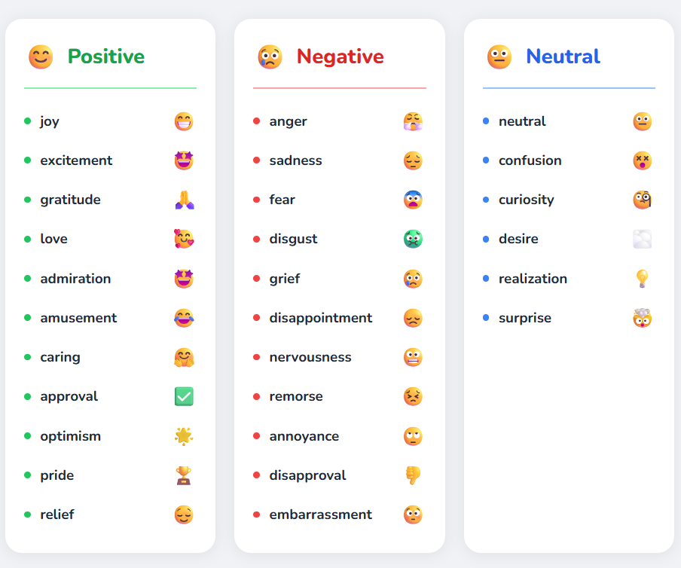
Figure 2.1: 28 emotion categories image obtained from [3]

Figure 2.1 shows example emotion categories based on the GoEmotions dataset, grouped into positive, negative, and neutral classes for this project.

This type of classification allows the system to provide a more detailed understanding of user mood over time. Instead of simply identifying whether a message is positive or negative, the system can highlight specific emotional patterns.

These insights can be useful in a workplace setting. For example, if messages over a period of time show an increase in negative emotions, it may indicate low morale. This could help organizations take action, such as improving communication or organizing activities to support employees.

However, emotion analysis is not always fully accurate. The meaning of text can depend on context, tone, or sarcasm, which can be difficult for models to interpret [4]. Because of this, the results should be treated as general indicators rather than exact measurements.

2.3 Personality Models and MBTI
Personality models are used to describe differences in how people think, behave, and interact with others. One widely known model is the Myers–Briggs Type Indicator (MBTI), which groups individuals into personality types based on four dimensions [5].

The MBTI model consists of the following pairs:
- Introversion (I) vs Extroversion (E)
- Sensing (S) vs Intuition (N)
- Thinking (T) vs Feeling (F)
- Judging (J) vs Perceiving (P)
Each person is classified by choosing one option from each pair, resulting in 16 possible personality types (for example, INTJ or ENFP).
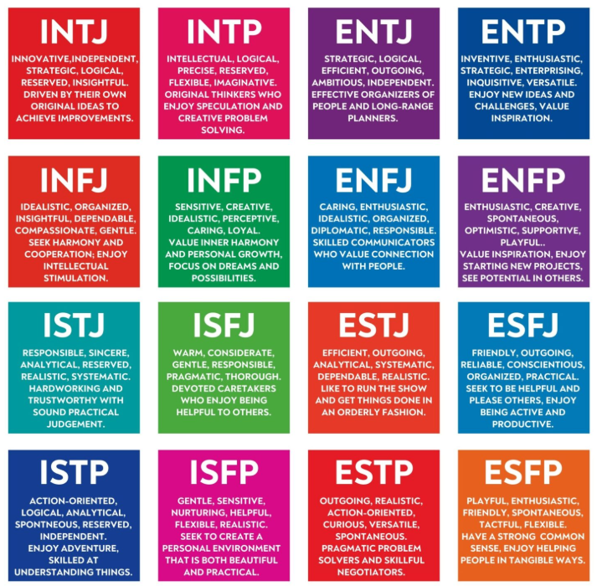
Figure 2.2: 16 Myers-Briggs Type Indicator (MBTI) personalities (image obtained from [8])

In this project, MBTI classification is used to estimate personality traits based on user-generated text. The model can analyses each dimension separately and then combine the results to form a final type.

These personality insights can be useful in understanding how different users may prefer to communicate or interact. In this project, they are explored as a way to support decisions such as planning activities that suit different personality types.

However, MBTI has been widely criticized for its lack of strong scientific validity and reliability [6]. Therefore, the predictions made by the model should be seen as approximate indicators rather than definitive personality assessments.

2.4 Legal, Ethical and Social Considerations
The use of machine learning to analyses user communication raises several legal and ethical considerations, particularly in a workplace setting.

One key issue is privacy. Messages exchanged between employees may contain personal or sensitive information. Analyzing this data requires careful handling to ensure that user privacy is respected. In real-world systems, this would typically involve obtaining user consent and being transparent about how data is used [7].

Data protection is also important. Regulations such as the General Data Protection Regulation (GDPR) require that personal data is processed securely and only for specific purposes [7].

Another concern is the accuracy of machine learning models. Emotion and personality predictions are not always correct, and incorrect predictions could lead to misunderstandings if they are taken too seriously.

There are also ethical considerations around how the information is used. The goal of this system is to support employee wellbeing and improve communication, not to monitor or judge individuals. For this reason, the insights provided by the system should be used carefully and responsibly.

Chapter 3: System Requirements and Design

3.1 Functional Requirements
The system is designed to provide a set of core features that support everyday organizational tasks. These features are accessible through a single platform and are adapted based on user roles (employee, manager, and administrator).
The main functional requirements are as follows:
- Users should be able to register and log in securely.
- Users should be able to send and receive messages in real time.
- Users should be able to submit and view leave requests.
- Managers should be able to approve or reject leave requests.
- Users should be able to view and interact with announcements.
- Users should be able to access and manage shared documents.
- Users should be able to view payroll information.
- Administrators should be able to access basic analytics.
- The system should analyses messages and provide emotion predictions.
- The system should estimate MBTI personality traits based on user messages.
These requirements form the core functionality of the portal and ensure that it can be used as a practical tool in an organizational setting.

3.2 Non-Functional Requirements
In addition to functionality, the system must meet several non-functional requirements to ensure it performs effectively and provides a good user experience.
- Usability: The interface should be simple and easy to navigate
- Performance: The system should respond quickly, especially for messaging features
- Scalability: The system should support multiple users without performance issues
- Security: User data should be protected through authentication and controlled access
- Reliability: The system should provide consistent behaviour with minimal downtime
Firebase services were selected to help meet these requirements, particularly for scalability and real-time data updates.

3.3 System Architecture
The system follows client-server architecture, with the front end interacting with backend services and machine learning components.
- Frontend: Built using React, responsible for the user interface and user interactions
- Backend: Firebase services, including Authentication, Firestore, and Hosting
- Machine Learning: Emotion and MBTI models used to analyses text data
The front end communicates with Firebase for data storage and authentication. When messages are sent, they can also be processed by machine learning models to generate predictions.
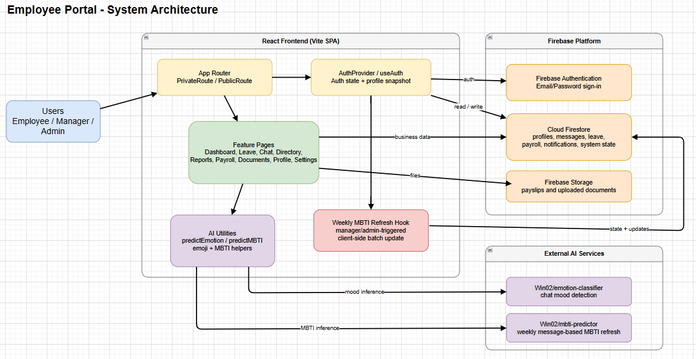
Figure 3.1: System Architecture of Employee Portal

3.4 Database Design
The system uses Cloud Firestore as the main database. Data is stored in collections, each representing a different part of the system.
Main collections include:
- users: stores user details such as name, role, and MBTI type
- messages: stores chat messages, including sender, content, timestamp, and emotion
- leave_requests: stores leave applications and their status
- announcements: stores posts and user interactions
- documents: stores file metadata and references
- payroll: stores salary-related information
Firestore allows real-time updates, meaning that changes (such as new messages) are reflected immediately in the user interface.

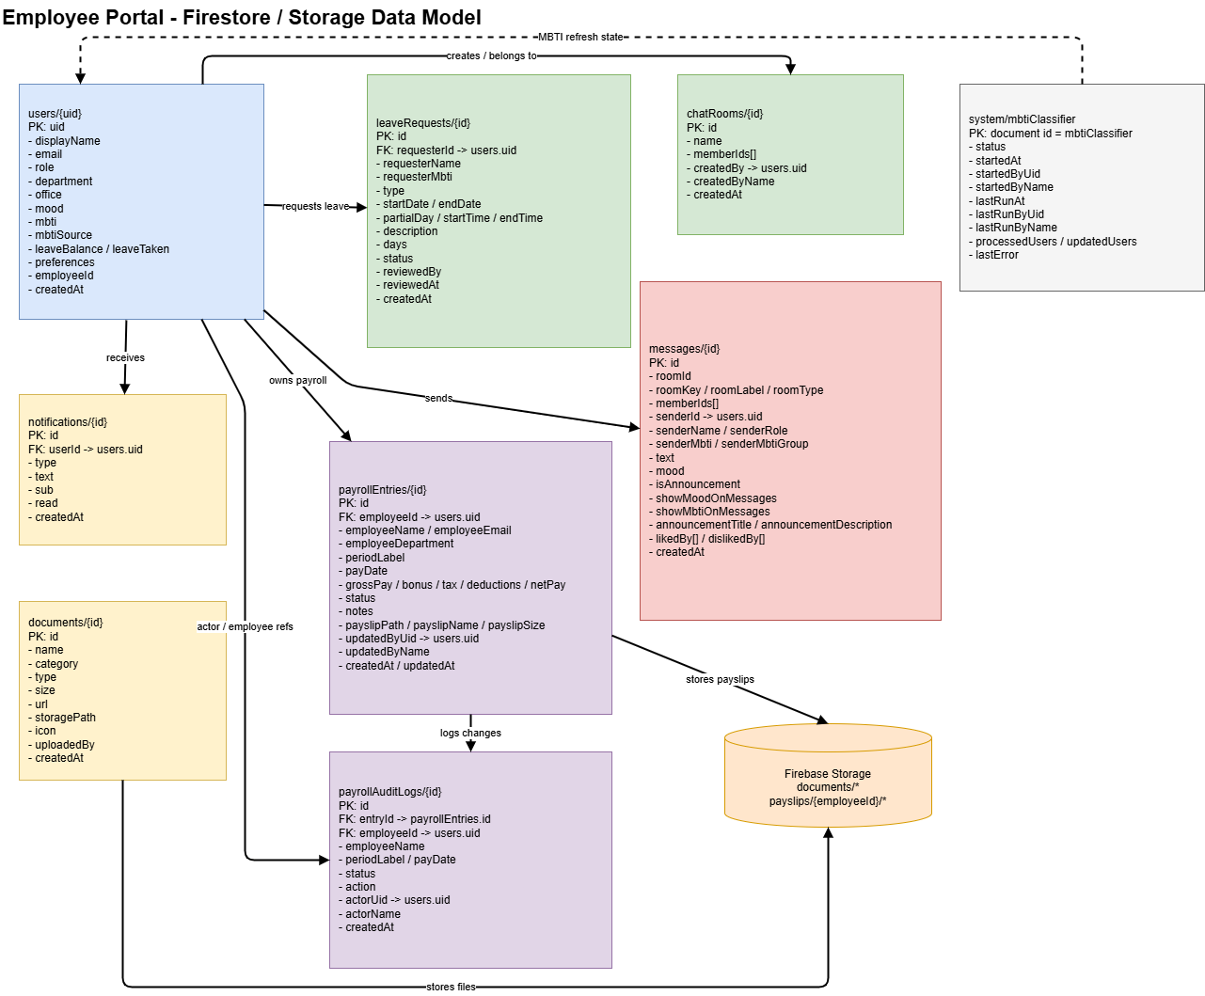
Figure 3.2: Database design of Employee Portal

3.5 User Interface Design
The user interface is designed to be simple and easy to use. A dashboard layout is used to provide quick access to key features such as messages, leave requests, and announcements.
The system includes:
- A navigation sidebar for switching between features
- A dashboard showing summary information
- A messaging interface for communication
- Pages for leave, documents, payroll, and analytics
The interface uses a clean layout and consistent design to improve usability and reduce confusion for users.

3.6 Chat System Design (with ML Integration)
The chat system is one of the main components of the portal. It allows users to send and receive messages in real time, while also integrating machine learning predictions.
When a user sends a message:
- The message is submitted through the front end.
- The message is stored in Firestore.
- The message is passed to the emotion classification model.
- An emotion label is generated.
- The result is stored alongside the message.
- The updated message is displayed to users.
The MBTI model works differently, as it analyses multiple messages over time to estimate personality traits rather than predicting a label for a single message.
This design allows the system to provide both real-time communication and additional insights without affecting usability.

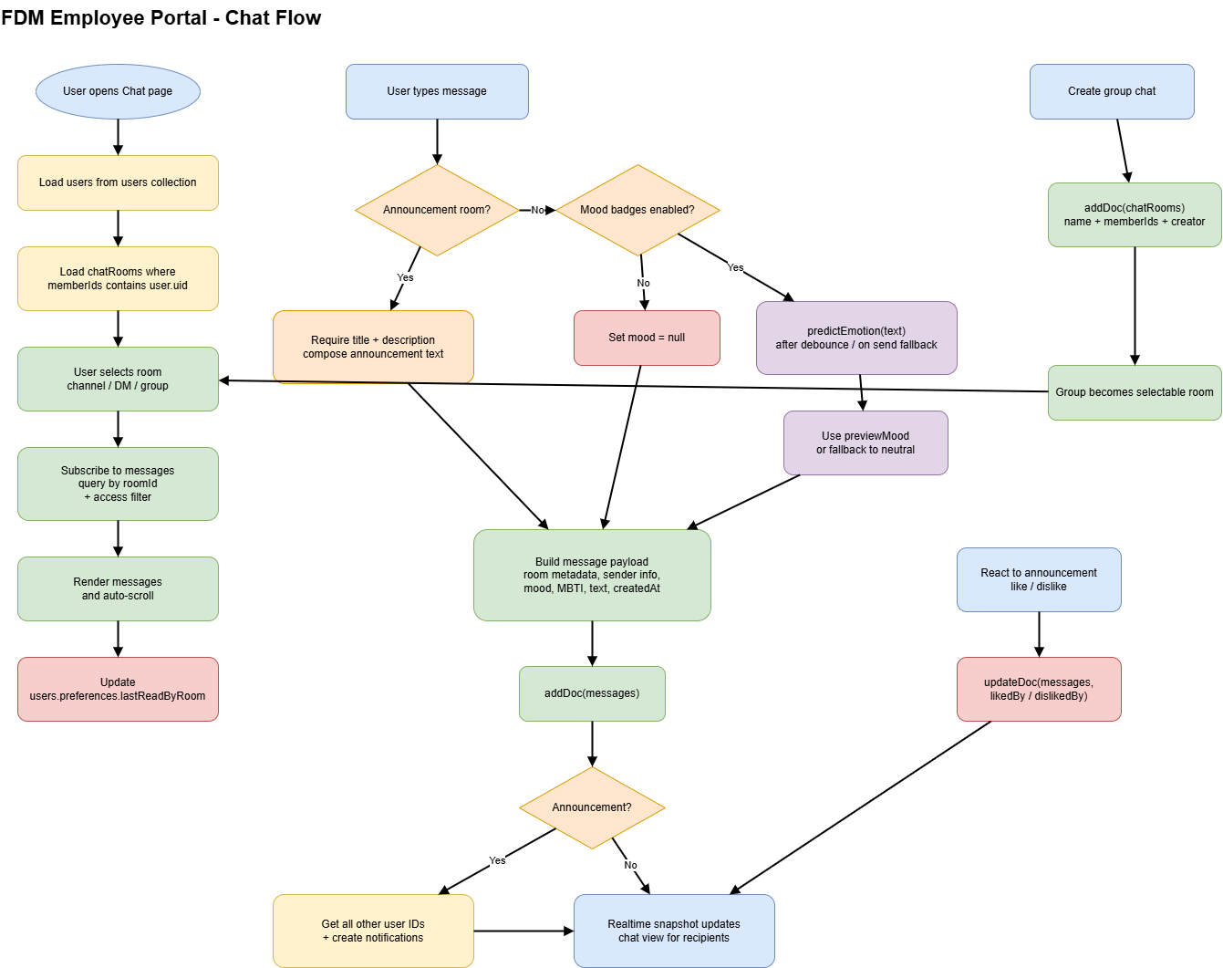
Figure 3.3: The design of the Chat system

Chapter 4: Implementation of the Portal

4.1 Technologies Used
The portal was implemented as a single-page web application using React 18, Vite, React Router, Firebase, and @gradio/client. These technologies were selected to support modular development, real-time updates, secure authentication, and integration with external machine learning services.
React is used to build the user interface by dividing the system into reusable pages such as Dashboard, Chat, Leave, Reports, Payroll, and Profile. This improves maintainability and allows features to be developed independently. Vite is used as the build tool because it provides fast development startup and efficient builds for deployment. React Router enables navigation between pages while maintaining a single-page application structure.
Firebase is used to provide backend functionality. Authentication manages user login and session state, Firestore stores application data such as messages and profiles, and Firebase Storage is used for file uploads such as documents and payslips. This setup removes the need for a traditional backend server while still supporting real-time updates.
Machine learning features are integrated using @gradio/client, allowing the system to connect to external APIs for emotion and MBTI prediction.

Component | Technology Used | Purpose
Frontend | React 18 | Builds the user interface
Build Tool | Vite | Fast development and production builds
Routing | React Router | Navigation between pages
Backend Services | Firebase | Provides backend infrastructure
Authentication | Firebase Auth | Manages user login and sessions
Database | Firestore | Stores application data
Storage | Firebase Storage | Stores files such as documents and pay slips
ML Integration | @gradio/client | Connects to external ML models
Emotion Model | External API | Predicts emotion from text
MBTI Model | External API | Predicts personality from messages
Table 4.1: Summary of technologies used in the system

4.2 Frontend Implementation
The frontend is implemented using modular React architecture. Each major feature is developed as a separate page component and rendered inside a shared layout. This layout provides consistent navigation, including the sidebar and top bar, across all pages.

Authentication-aware routing is implemented to ensure that only authorized users can access the system.
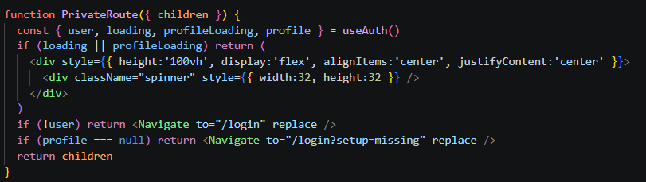
Figure 4.1: Authentication-aware routing implementation

This component ensures that protected pages are only accessible to authenticated users. It also handles loading states while user and profile data are being fetched, preventing incomplete rendering.

User and profile state are managed through a central authentication provider.
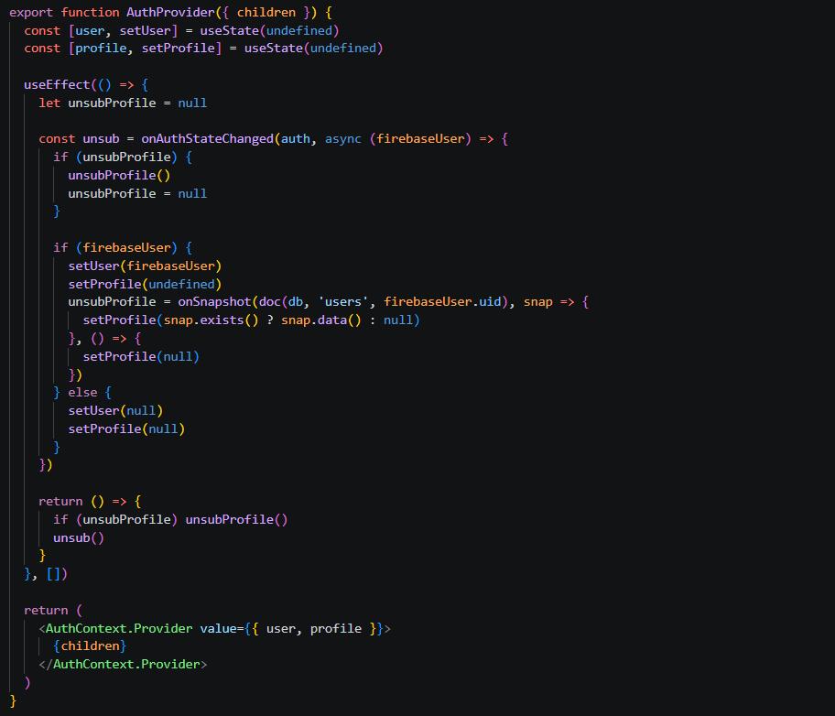
Figure 4.2: Authentication and profile state management
This implementation listens to authentication changes and subscribes to the user’s profile in Firestore. It ensures that updates to user data are reflected in real time across the interface.

The frontend also uses a shared application shell in Dashboard Layout, which maintains a consistent structure across pages. Feature-specific pages such as Dashboard, Reports, Payroll, and Profile each retrieve the data they need and render it inside this layout. The reports page is a good example of client-side processing because it loads several datasets and transforms them into charts, summaries, and analytical views.
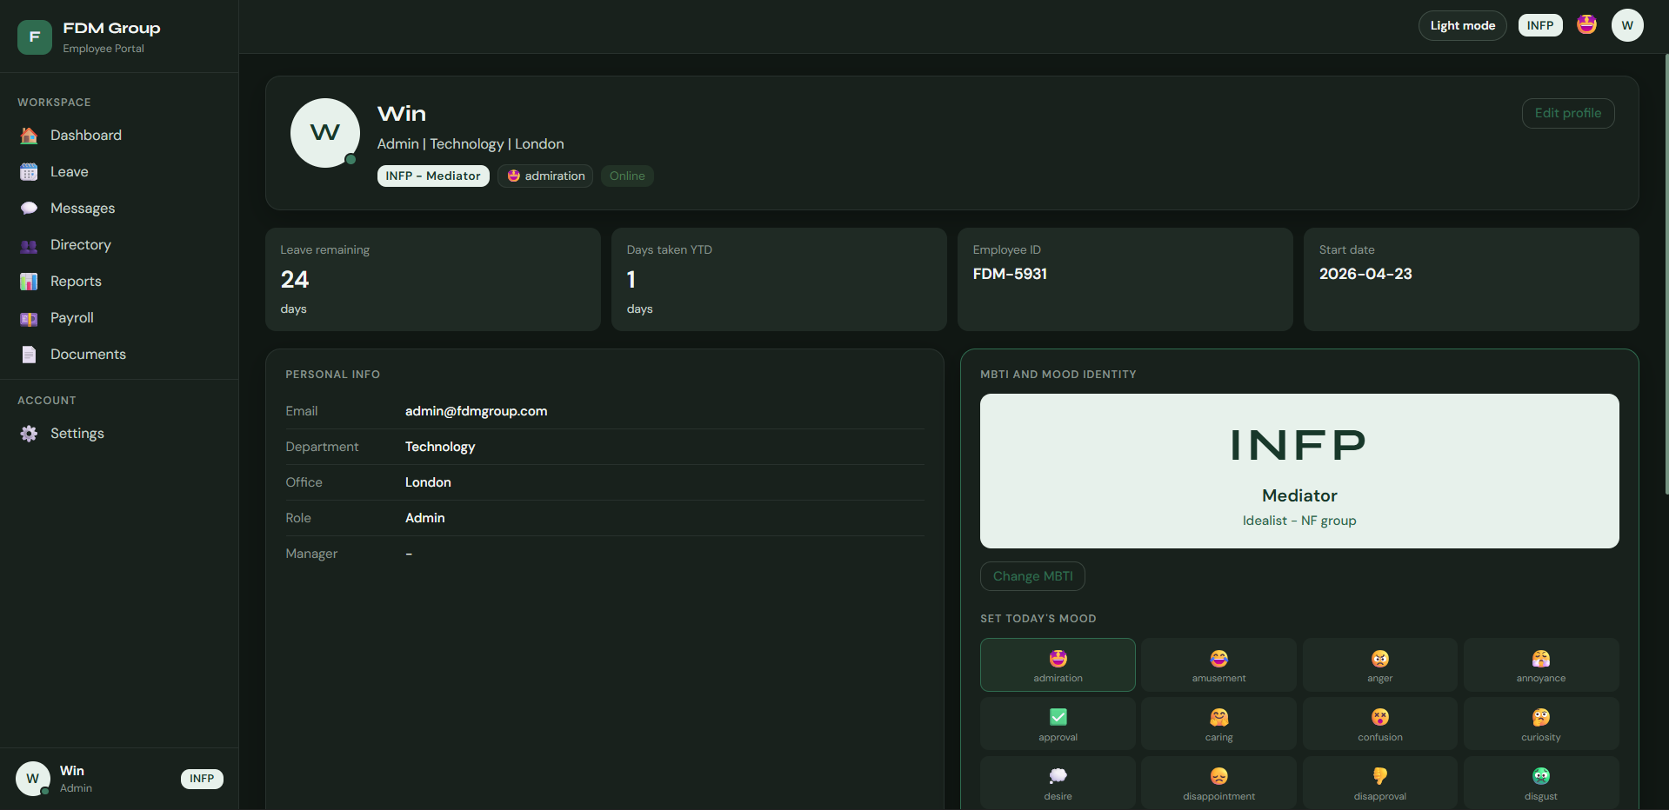
Figure 4.3: Dashboard layout with navigation sidebar

4.3 Backend Implementation (Firebase)
The backend is implemented using Firebase services, allowing the frontend to communicate directly with cloud-based resources. This removes the need for a custom backend server while still supporting secure access control, data persistence, and real-time updates.

Firebase Authentication manages user login and assigns a unique id to each user. When a user logs in for the first time, a profile document is created in Firestore to store additional information such as role, department, mood, and preferences.

Cloud Firestore is used as the main database. Data is organized into collections such as users, messages, leaveRequests, chatRooms, notifications, payrollEntries, and documents. Real-time listeners are used for features such as chat and dashboard activity, while direct queries are used for reports and export-related operations to reduce overhead.

Batch operations are used to maintain consistency when updating related data.
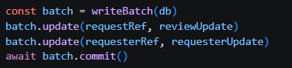
Figure 4.4: Batch update for leave approval

This ensures that both the leave request and the employee leave balance are updated together, preventing inconsistent data.
Firebase Storage is used for binary files such as documents and payroll payslips. In both cases, the file itself is stored in Storage while the metadata is stored in Firestore. This separation keeps the database lightweight and makes files easier to manage securely.

Backend access control is enforced using Firestore and Storage security rules. The Firestore rules define which users can read or update profiles, view payroll, post announcements, access private chat messages, or review leave requests. The Storage rules control who can upload, download, or delete files such as payslips and documents.

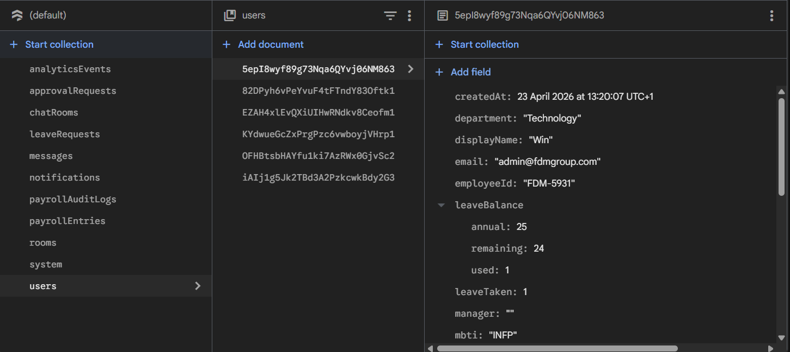
Figure 4.5: Firestore collections used in the system

4.4 Chat Feature Implementation
The chat system supports real-time communication using Firestore listeners. It allows users to communicate through channels, direct messages, and group chats. Static channels are predefined, while group chats are stored in the chatRooms collection.

When a room is opened, the application subscribes to the relevant Firestore query so that new messages are shown immediately. Message documents include not only the text itself but also metadata such as sender details, room type, display preferences, and mood.

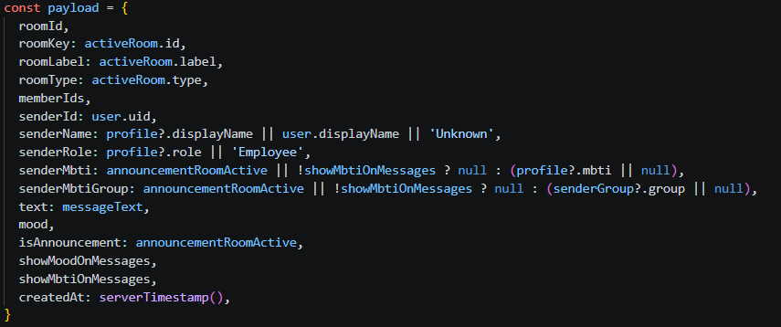
Figure 4.6: Message payload structure

This payload defines how each message is stored in Firestore. It includes user details, message content, and optional machine learning data such as mood and MBTI information.

The chat system also supports announcement posts. These are stored in the same messages collection but contain extra fields such as title, description, and reaction arrays. Unread tracking is implemented by storing the last-read timestamp for each room inside the user’s preferences object. This allows the dashboard to calculate unread counts without maintaining a separate read-receipt collection.

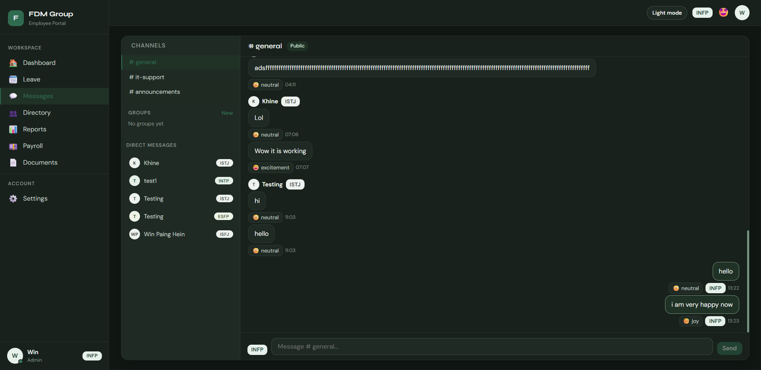
Figure 4.7: Chat interface showing real-time messages and mood labels

4.5 Integration of Machine Learning Models
Machine learning is integrated into the system to analyses user communication and personality indicators.
The emotion model is used during message sending. The application connects to an external endpoint using @gradio/client. When a user types a message and mood detection is enabled, the text is sent to the API, and the returned label is stored with the message. If prediction fails, a default value such as "neutral" is used so that the chat workflow still succeeds.

The MBTI model works differently by analyzing multiple messages over time. The system checks a Firestore document to ensure that the process is not already running and that the cooldown period has passed. It then loads user messages, builds a text corpus for each user, and sends that corpus to the MBTI predictor. If a different MBTI result is returned, the user profile is updated.

Error handling is included so that the system continues to function even if the external services are unavailable. This ensures that machine learning enhances the portal without becoming a point of failure. The design and evaluation of these models are discussed in Chapters 5 and 6.

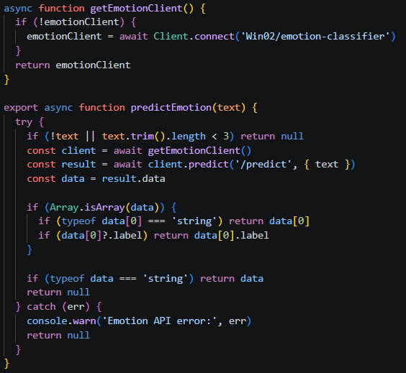
Figure 4.8: Emotion prediction integration using external API
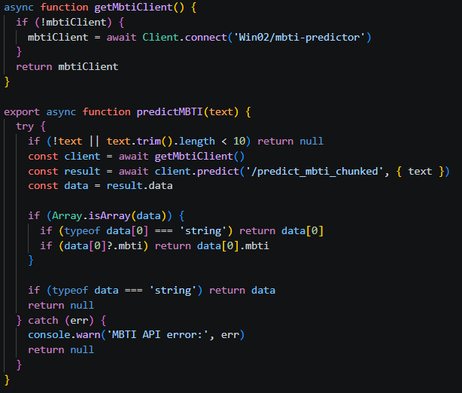
Figure 4.9: MBTI prediction integration using external API

4.6 Deployment
The portal is deployed using Firebase Hosting. During development, the application runs locally using Vite. For production, the system is built and deployed to Firebase.

The build process is defined in package.json, where npm run build generates the final production files in the dist folder. Firebase Hosting is configured in firebase.json, which points Hosting to the dist folder and rewrites all routes to index.html. This is necessary because the portal uses client-side routing.

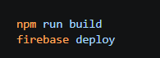
Figure 4.10: The commands to build and deploy

These commands build the application and deploy it to Firebase Hosting, making the system accessible online at all times.

Chapter 5: Emotion Classification Model

5.1 Overview
The emotion classification model is designed to analyses user messages and identify their emotional tone. This allows the system to go beyond basic text communication and provide additional insight into user mood, which can be useful for understanding employee behavior and improving communication within the organization.

Unlike simple sentiment analysis, which typically classifies text as positive, negative, or neutral, this project uses a multi-class classification approach. Each message is assigned to one of 28 emotion categories. This provides a more detailed and meaningful interpretation of user communication, as it captures a wider range of emotional states.

The model is based on transformer architecture and is integrated into the portal to support real-time predictions in the chat system. This allows emotional information to be generated dynamically as users interact with the system.

5.2 Dataset
The model is trained using the GoEmotions dataset [3], which consists of Reddit comments annotated with 28 emotion labels such as joy, anger, sadness, surprise, and neutral.

The dataset is publicly available at:
https://github.com/google-research/google-research/tree/master/goemotions

One important characteristic of this dataset is that many samples contain multiple emotion labels. While this reflects real-world emotional expression, it introduces complexity for classification tasks. Since this project uses a single-label classification approach, these multi-label samples are removed.

This decision simplifies the training process and makes the model easier to evaluate. However, it also introduces a limitation, as real-world messages can contain mixed emotions.

Figure 5.1: Filtering multi-label samples
This ensures that each training sample belongs to only one emotion class, simplifying the
learning task and improving training stability.

5.3 Data Preprocessing
The dataset contains informal text from Reddit, which includes usernames, subreddit references, and inconsistent formatting. Basic preprocessing is applied to clean the data before training.

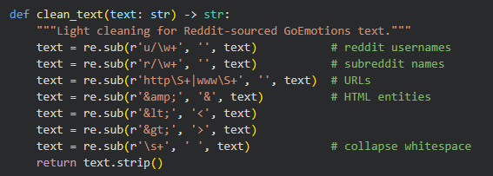
Figure 5.2: Text cleaning
This removes unnecessary patterns and helps the model focus on meaningful content.

5.4 Tokenisation
Text data is converted into numerical form using a tokenizer from the Hugging Face Transformers library [10].

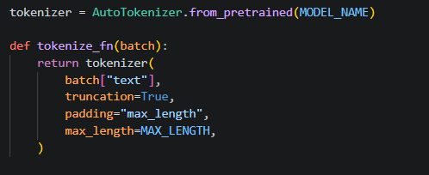
Figure 5.3: Tokenization process
Tokenization converts text into tokens that the model can process. Each word or sub word is mapped to a numerical representation.

Padding is used to ensure that all input sequences are of the same length, while truncation is used to limit the maximum length of input text. This is important for maintaining consistent input size and improving computational efficiency.

The choice of maximum sequence length represents a trade-off between capturing more context and maintaining performance.

5.5 Model Architecture
The model is based on DistilBERT [11], which is a lightweight version of BERT. It retains much of the performance of the original BERT model while reducing computational cost and training time.

5.5.1 BERT and Transformer Architecture
BERT is a deep learning model based on the transformer architecture, which uses attention mechanisms to process text effectively [14].

Unlike traditional models such as recurrent neural networks (RNNs), transformer models process all words in a sentence simultaneously. This allows the model to capture relationships between words regardless of their position in the sequence.

The transformer architecture consists of multiple encoder layers. Each layer includes:
- A self-attention mechanism
- A feed-forward neural network
The self-attention mechanism enables the model to determine how each word relates to every other word in the sentence. This allows the model to capture long-range dependencies and contextual meaning.

BERT is also bidirectional, meaning it considers both left and right context when processing text. This improves its ability to understand word meaning within a sentence [14].

In this project, DistilBERT is used because it provides a good balance between performance and efficiency, making it suitable for real-time applications.

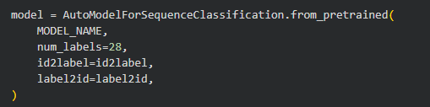
Figure 5.4: Model initialization
The model is fine-tuned for a 28-class classification task, where each output corresponds to a specific emotion category.
Using a pre-trained model allows the system to leverage existing language knowledge. Fine-tuning adapts the model to the specific task of emotion classification.

5.6 Handling Class Imbalance
The dataset is imbalanced, meaning some emotions appear much more frequently than others. Without handling this imbalance, the model would tend to favour more common emotions and ignore less frequent ones.

To address this issue, class weights are applied during training.

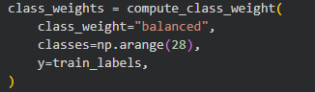
Figure 5.5: Class weight calculation

Class weights increase the importance of less frequent classes, ensuring that the model learns to recognize them more effectively.
This approach improves fairness in predictions, although it may slightly reduce performance on more common classes. In addition, I personally adjusted the weight of the neutral which was calculated as 0.1011 into 0.300.

5.7 Training Process
The model is trained using a custom trainer that applies weighted loss. This allows the training process to take class imbalance into account.
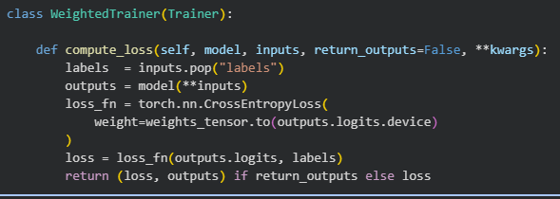
Figure 5.6: Weighted training
The weighted loss function ensures that rare classes contribute more to the training process, improving overall balance.
Training is performed over multiple epochs, where the model gradually improves its predictions by minimizing the loss function.

5.8 Evaluation Metrics
The model is evaluated using accuracy and F1-score. Due to class imbalance, F1-score is the most important metric.

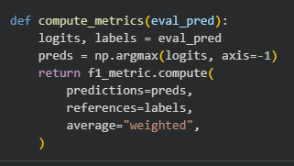
Figure 5.7: Metric calculation

F1-score balances precision and recall, making it suitable for evaluating performance on imbalanced datasets.

5.9 Results and Evaluation
This section presents the performance of the emotion classification model using training and validation metrics, as well as class-level evaluation. Figure 5.8 illustrates the training loss, validation loss, and F1 score across epochs. It can be observed that the training and validation loss decrease steadily during the initial epochs, indicating effective learning. The validation loss stabilizes after a certain point, suggesting that the model begins to converge. At the same time, the F1 score increases and reaches a plateau, demonstrating improved predictive performance and balanced precision–recall behavior.

Figure 5.9 shows the confusion matrix for the emotion classification task. The matrix highlights that the model performs well on dominant classes such as joy and sadness, where correct predictions are concentrated along the diagonal. However, there are noticeable misclassifications between semantically similar emotions such as fear and surprise, and love and joy. This suggests that the model sometimes struggles to distinguish between closely related emotional expressions, which is expected given the overlapping linguistic features in natural language.

Figure 5.10 presents the per-class F1-score distribution, providing a more detailed view of performance across individual emotion categories. It is evident that certain classes achieve higher F1 scores, indicating strong precision and recall, while others perform comparatively lower. This variation reflects class imbalance and differences in linguistic complexity within the dataset. Overall, the model demonstrates robust performance, achieving high F1 scores for most classes while maintaining generalization across unseen data.

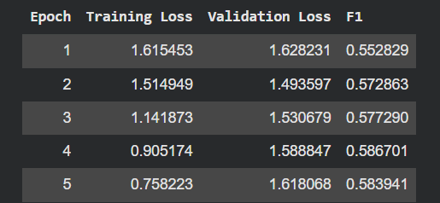
Figure 5.8: The training loss, validation loss, and F1 score for each Epoch

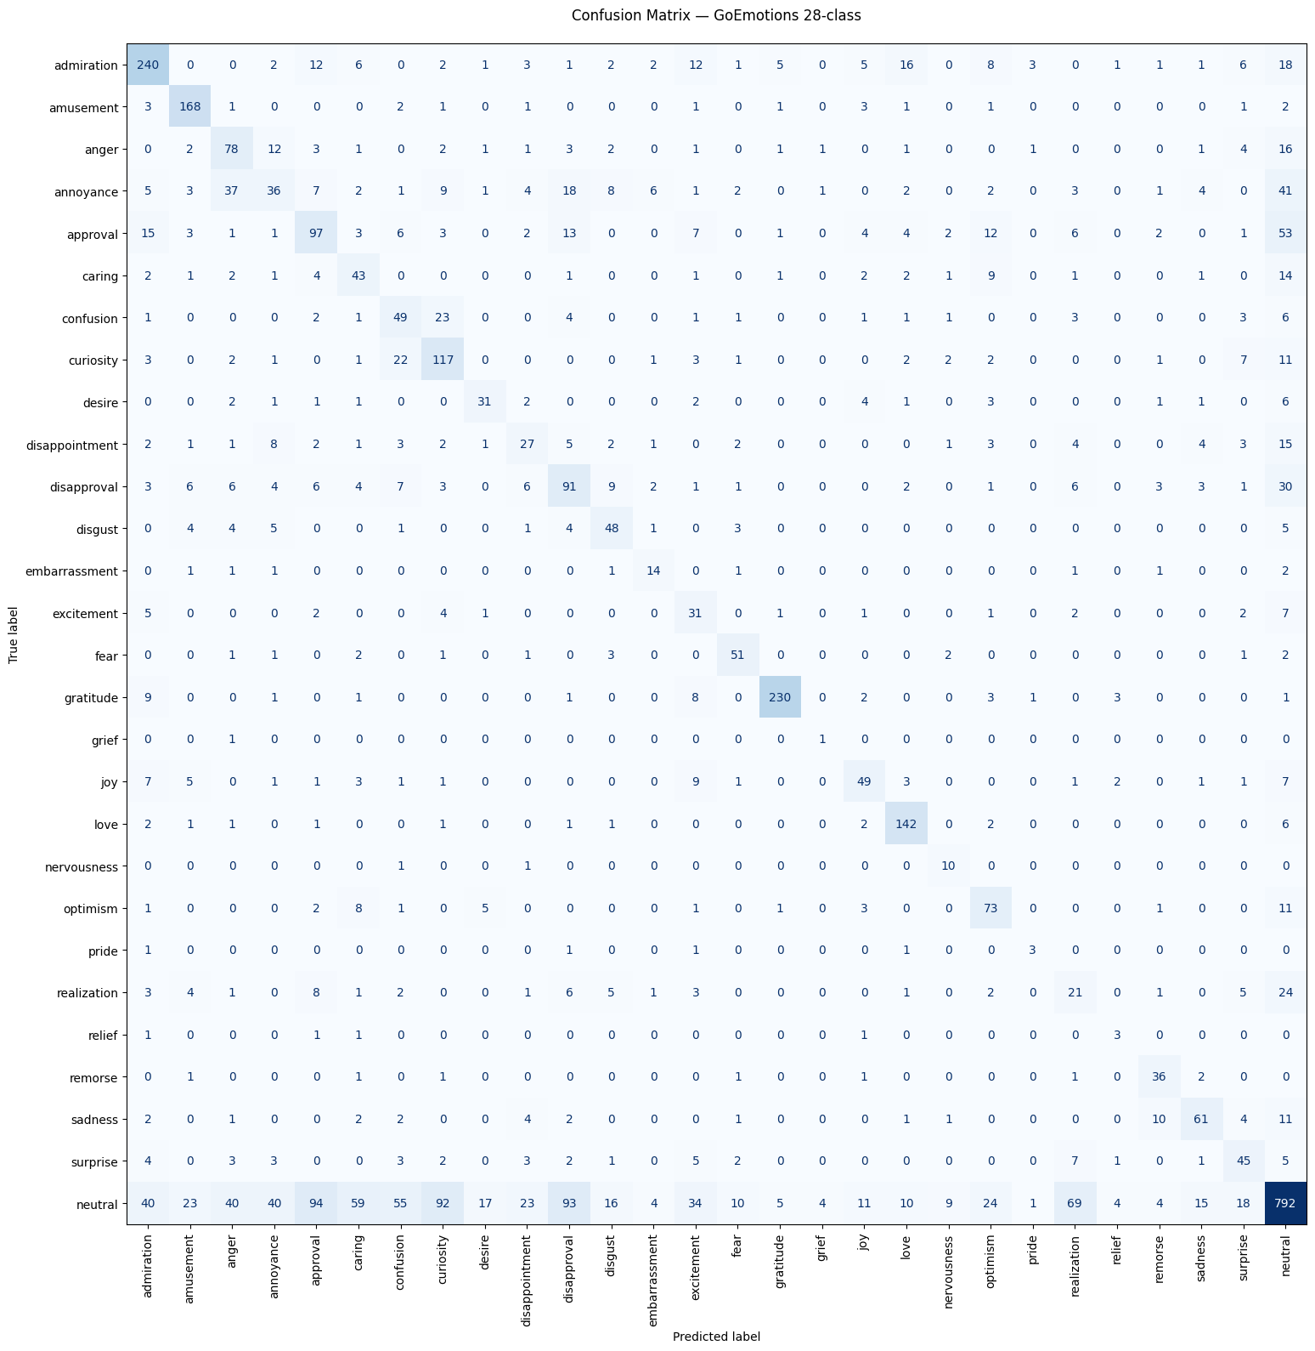Figure 5.9: Confusion matrix for emotion classification
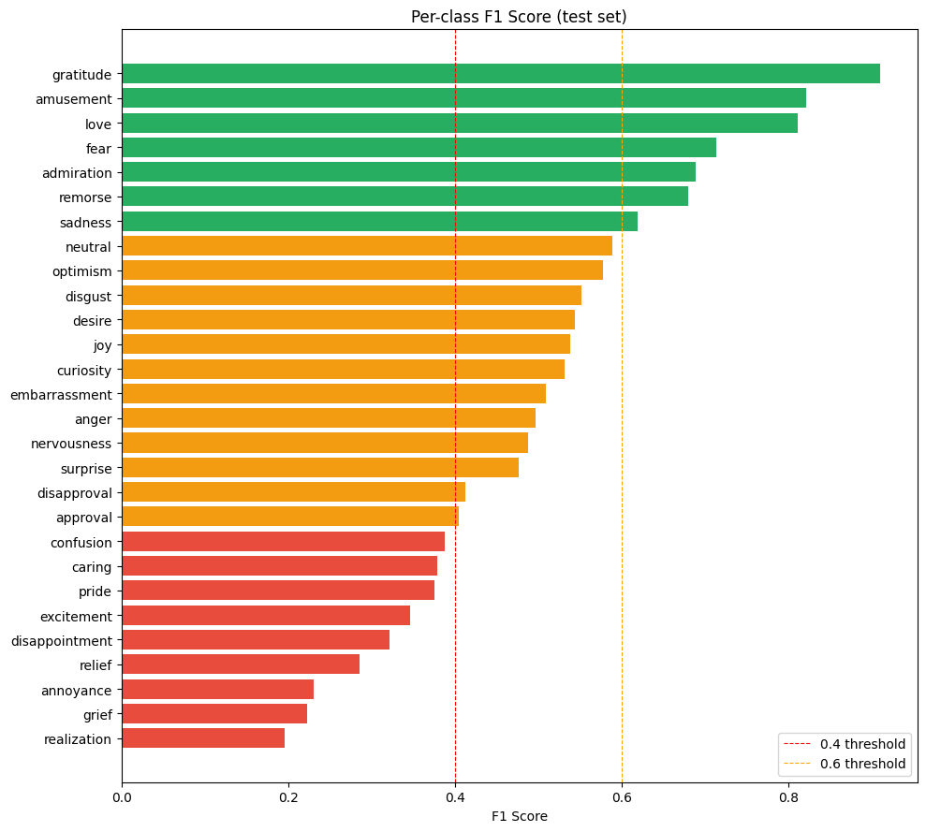
Figure 5.10: Per-class F1-score distribution

5.10 Limitations
- Multi-label samples are removed, reducing realism of the data
- Some emotions are difficult to distinguish
- Performance is affected by class imbalance
- Model does not consider long-term conversational context

5.11 Integration with the Portal
The trained model is deployed as an external service and integrated into the portal.
When a message is sent:
- Text is sent to the model
- Emotion label is returned
- Label is stored in Firestore
- Results are displayed in chat
If the model fails, a default value (“neutral”) is used to ensure system stability.

5.12 Analysis and Summary of the Model
The evaluation results, including the per-class F1-score distribution and confusion matrix (Figures 5.9 and 5.10), provide a detailed understanding of the model’s performance across different emotion categories.

Overall, the model achieves moderate performance, with a weighted F1-score of 0.568 and a macro F1-score of 0.504. The difference between these values indicates that the model performs better on frequently occurring classes, while performance in less frequent classes remains limited.

From the per-class F1-score distribution, several emotions demonstrate strong performance. Categories such as gratitude (F1 = 0.909), amusement (F1 = 0.822), and love (F1 = 0.811) achieve high scores, indicating that the model can reliably identify these emotions. This is supported by the confusion matrix, where these classes show strong diagonal dominance, meaning that most predictions for these emotions are correct. These results suggest that such emotions have clearer linguistic patterns and are well represented in the dataset.

A second group of emotions, including fear, remorse, sadness, and optimism, shows moderate performance with F1-scores generally between 0.55 and 0.75. The confusion matrix indicates that while these classes are often predicted correctly, there are still noticeable misclassifications, particularly with semantically similar emotions. For example, sadness is sometimes confused with disappointment, and remorse may overlap with other negative emotions.

A large number of classes fall within the mid-performance range (approximately 0.4 to 0.6), including anger, surprise, approval, and neutral. The confusion matrix shows that these classes are more frequently misclassified, often due to overlapping meanings or context-dependent interpretation. For instance, anger and annoyance are commonly confusing, while approval and admiration also show bidirectional misclassification. These patterns highlight the difficulty of distinguishing between closely related emotional expressions.

Lower-performing classes, such as realization, annoyance, and relief, shows F1-scores below 0.4. The confusion matrix shows that predictions for these categories are widely distributed across multiple classes, indicating that the model struggles to learn clear patterns for these emotions. This is largely due to their subtle nature and lower representation in the dataset.

The neutral class, which has the highest support, achieves a moderate F1-score of 0.589. Although many neutral samples are correctly classified, the confusion matrix shows that neutral messages are frequently misclassified as emotional categories and vice versa. This suggests that neutral text can be ambiguous and difficult to separate from low-intensity emotional expressions.

Another important observation is the impact of class imbalance. Rare classes such as grief, pride, and relief show unstable performance, as reflected in both the F1-scores and confusion matrix. These classes have very limited training samples, which prevents the model from learning robust representations.

Overall, both the F1-score distribution and confusion matrix highlight that the model performs well for clear and frequently occurring emotions, but struggles with:
- semantically similar emotion categories
- rare or underrepresented classes
- context-dependent emotional expressions
These findings are consistent with expectations for fine-grained emotion classification and demonstrate the challenges associated with modelling subtle human emotions from short text inputs.

Chapter 6: MBTI Personality Classification Model

6.1 Overview
The MBTI (Myers–Briggs Type Indicator) classification model is designed to estimate a user’s personality type from text. Unlike the emotion classification model, which focuses on short-term emotional states, the MBTI model aims to capture longer-term behavioral patterns reflected in a user’s writing.

The MBTI framework is based on four personality dimensions: Introversion (I) vs Extraversion (E), Sensing (S) vs Intuition (N), Thinking (T) vs Feeling (F), and Judging (J) vs Perceiving (P) [5], [8]. These four dimensions combine to form 16 possible personality types.

Rather than directly predicting one of the 16 types, this project models MBTI as four independent binary classification tasks. This approach allows each personality dimension to be learned separately and evaluated more effectively.

It should be noted that MBTI is widely used but has been criticized in psychological research for issues related to reliability and validity [6]. Therefore, the predictions produced by this model should be interpreted as approximate indicators rather than definitive personality classifications.

6.2 Dataset
The model was trained using the MBTI Personality Types 500 dataset [15], which contains user-generated text posts labelled with MBTI personality types.

The dataset includes a large collection of text samples where each entry consists of multiple user posts combined into a single text field, along with the corresponding four-letter MBTI label. This format allows the model to learn patterns from extended writing rather than individual sentences.

The dataset is publicly available at:
https://www.kaggle.com/datasets/zeyadkhalid/mbti-personality-types-500-dataset

The dataset is derived from online user-generated content and includes preprocessed text. While this makes it suitable for training transformer-based models, it may not fully represent communication styles in a workplace environment.

6.3 Data Preprocessing
Before training, the dataset was cleaned to ensure consistency and quality. Invalid MBTI labels were removed, and only entries with valid four-letter types were retained. Additionally, very short text samples were filtered out, as they are unlikely to contain sufficient information for personality prediction.

Basic preprocessing steps included trimming whitespace and standardizing text format. Heavy preprocessing was intentionally avoided, as transformer-based models are capable of extracting meaningful features directly from raw text [10].

6.4 Converting MBTI Types into Four Axes
To simplify the classification task, each MBTI label was converted into four binary values corresponding to the personality dimensions.
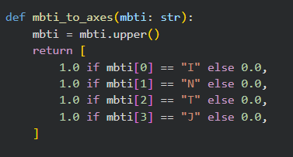
Figure 6.1: Converting MBTI Types into Four Axes
For example:
- INTP → [1, 1, 1, 0]
- ESFJ → [0, 0, 0, 1]
This transformation allows the problem to be treated as a multi-label classification task, where each axis is predicted independently.

This approach is more flexible than directly predicting 16 classes and allows for clearer evaluation of each personality dimension.

6.5 Handling Long Text Inputs (Chunking Strategy)
A key challenge in MBTI classification is handling long input text. Transformer-based models such as DistilBERT have a fixed maximum input length, which limits the amount of text that can be processed at once [14].

To address this, a chunking strategy is used. Each user’s text is split into smaller segments, which are processed independently by the model.

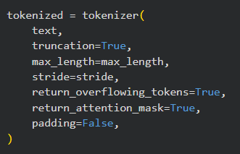
Figure 6.2: Chunking long text

The tokenizer is configured with a maximum sequence length and a stride, allowing overlapping chunks to be created. This overlap helps preserve context between segments.

This approach ensures that:
- longer text inputs can be fully utilized
- important contextual information is not lost
- the model can learn patterns across multiple parts of the text

6.6 Model Architecture
The model is based on DistilBERT, a lightweight version of BERT that retains most of its performance while reducing computational cost [11].

DistilBERT is built on the transformer architecture introduced by BERT, which uses self-attention mechanisms to capture contextual relationships between words [14].

In this project, the model is configured for multi-label classification with four output nodes, corresponding to the four MBTI axes.

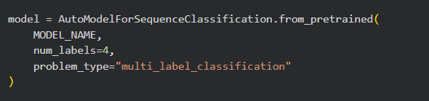
Figure 6.3: MBTI model setup
This design allows the model to:
- process text efficiently
- capture writing style patterns
- generate independent predictions for each personality dimension

6.7 Handling Class Imbalance
The dataset is imbalanced across some personality dimensions. For example, certain traits such as Intuition (N) appear more frequently than Sensing (S).

To address this, class weights are calculated and applied during training. These weights increase the importance of underrepresented classes, helping the model learn more balanced representations.

The class weighting approach is implemented using techniques similar to those provided in Scikit-learn [12].

6.8 Training Process
The model is trained using PyTorch and the Hugging Face Transformers framework [10, 13].
A binary cross-entropy loss function with logits is used, as the task involves predicting multiple independent binary outputs. Class weights are incorporated into the loss function to reduce bias toward dominant classes.

Training is performed over multiple epochs, with evaluation conducted on a validation set to monitor performance and select the best model.

6.9 User-Level Prediction Aggregation
Since each user’s text is split into multiple chunks, predictions are initially generated at the chunk level. These predictions are then aggregated to produce a single result per user.
The aggregation process involves averaging the logits across all chunks belonging to the same user. The final predictions are obtained by applying a threshold to the average outputs.

Figure 6.4: User-level prediction aggregation

This approach improves prediction stability and ensures that the final MBTI type reflects overall writing behavior rather than individual text segments.

6.10 Evaluation Results
The model was evaluated separately for each MBTI axis using accuracy and F1-score metrics [12].

Axis | Accuracy | Macro F1-score | Weighted F1-score
I/E | 0.9443 | 0.9231 | 0.9442
N/S | 0.9671 | 0.9019 | 0.9680
T/F | 0.9514 | 0.9467 | 0.9515
J/P | 0.9162 | 0.9140 | 0.9162
Table 6.1: MBTI axis evaluation results

The model performs strongly across all axes, with accuracy values above 0.91. The N/S axis achieves the highest accuracy, although its macro F1-score is lower due to class imbalance.

The T/F axis shows the most balanced performance, indicating that the model is effective at distinguishing between thinking and feeling traits.

The J/P axis has the lowest accuracy, suggesting that these traits are more difficult to infer from text.

6.11 Reconstructed MBTI Type Prediction
After predicting the four axes, the outputs are combined to reconstruct the final MBTI type.The overall accuracy of predicting the full 16-type MBTI label is lower than the individual axis accuracy, as all four predictions must be correct simultaneously.

This highlights the increased difficulty of predicting complete personality types compared to individual dimensions.

6.12 Integration with the Portal
The MBTI model is integrated into the portal using a batch-based approach. Unlike the emotion model, which processes individual messages in real time, the MBTI model analyses aggregated user text.

User messages are collected over time and periodically processed to update the MBTI prediction. This is implemented using a scheduled refresh mechanism, which ensures that predictions are updated regularly without affecting system performance.

This design allows the model to provide stable and meaningful personality insights while maintaining efficiency.

6.13 Limitations
Although the model achieves strong performance, several limitations remain.

First, MBTI labels are self-reported and may not always be accurate [6]. This affects the reliability of the training data.

Second, personality traits are complex and may not be fully captured through text alone.
Third, dataset imbalance affects model performance, particularly for less frequent traits.

Finally, the dataset is based on online posts, which may differ from workplace communication, potentially affecting generalization.

6.14 Analysis and Summary of the Model
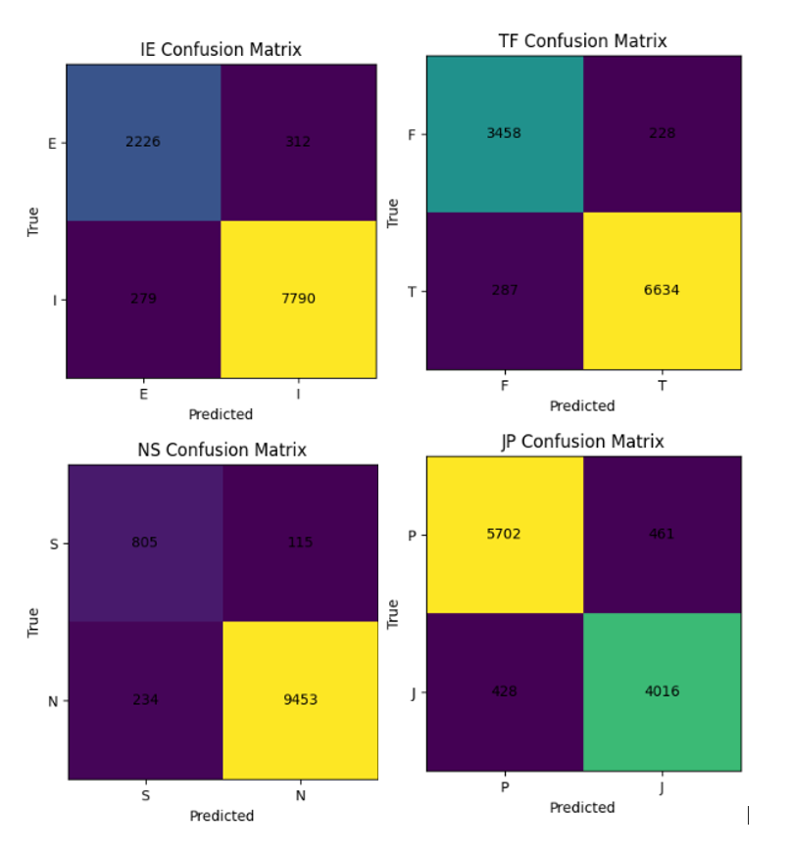
Figure 6.5: Confusion Matrices for four personality axes (I/E, N/S, T/F, J/P)

The confusion matrices shown in Figure 6.5 provide a detailed view of the model’s classification performance across each MBTI axis. Overall, the results indicate strong performance, with most predictions concentrated on the diagonal, representing correct classifications.
For the I/E axis, the model achieves high accuracy with relatively few misclassifications between Introversion (I) and Extraversion (E). However, the dataset contains a higher number of I samples, which slightly influences prediction distribution.

For the N/S axis, the model performs particularly well on the dominant Intuition (N) class, with a large number of correct predictions. In contrast, Sensing (S) instances are more frequently misclassified, reflecting the imbalance in the dataset and the lower representation of S examples.

The T/F axis demonstrates the most balanced performance among all axes. Both Thinking (T) and Feeling (F) classes are predicted accurately, with relatively low confusion between them. This suggests that the model is able to distinguish these personality traits more effectively based on textual patterns.

For the J/P axis, performance remains strong but shows slightly higher misclassification compared to the other axes. This indicates that Judging (J) and Perceiving (P) traits are more difficult to distinguish from text, likely due to overlapping behavioral characteristics.

Overall, the confusion matrices confirm that the model performs reliably across all personality dimensions. However, performance is influenced by two key factors: class imbalance and the subtle nature of certain personality traits. Despite these challenges, the model demonstrates consistent and robust classification behavior across the four MBTI axes.

Chapter 7: System Evaluation and User Testing

7.1 Overview
This chapter presents a critical evaluation of the Employee Portal system, focusing on usability, system performance, and the effectiveness of the integrated machine learning components. The evaluation combines qualitative user testing with quantitative analysis of system-generated data to provide a comprehensive assessment of real-world performance.

A pilot study was conducted in which participants interacted with the system and generated communication data through discussion-based tasks. This data was subsequently analyzed to assess both user behavior and model outputs. In addition, the machine learning models were evaluated independently using a separate testing interface prior to integration, allowing their performance characteristics to be examined in isolation.

The objective of this chapter is not only to determine whether the system functions correctly, but also to critically assess its reliability, limitations, and practical value in a realistic usage context.

7.2 Evaluation Methodology
The evaluation adopts a mixed-method approach, combining user interaction testing with data-driven analysis. This allows both system usability and model behavior to be examined simultaneously.
Participants were required to complete a set of representative tasks, including:
- accessing the system through authentication
- participating in chat discussions
- interacting with topic-based posts
- exploring core system features
Alongside user interaction, system-generated data was collected and analysed. This includes emotion predictions attached to messages and MBTI predictions derived from user text.
This dual approach provides a more robust evaluation compared to relying solely on user feedback or model metrics, as it captures both how the system is used and how it behaves internally.

7.3 Participants
The pilot study involved seven participants, represented using anonymised animal-based identifiers (e.g., elephant, dolphin, butterfly). This anonymization ensures that no personally identifiable information is included, supporting privacy and ethical requirements.

Participants engaged in discussion-based activities across multiple topics, generating the dataset used for evaluation.
Participant Activity:
- Total participants: 7
- Total comments: 68
- Participants appeared across multiple topics, with some contributing more frequently than others
Some users participated in all topics, while others contributed selectively depending on interest. This variation reflects realistic user behavior and strengthens the validity of the evaluation.

The small sample size is appropriate for a pilot study but limits generalizability. Additionally, the controlled testing environment may influence participant behavior, potentially leading to more positive interactions.

Despite these limitations, the dataset is sufficient to evaluate system functionality and model behavior in a realistic context.

7.4 Ethical Considerations
The evaluation was conducted in accordance with standard ethical principles for user studies. Participants were informed about the purpose of the study and how their data would be used.
An ethical application and consent form was provided prior to participation, outlining:
- the purpose of the study
- the type of data collected
- data usage and storage
- participant rights, including withdrawal
All participants were anonymized, and no personally identifiable information was used in the analysis.
The system design also considers data protection requirements, particularly in relation to processing user-generated text for emotion and personality analysis. This aligns with data protection regulations such as the General Data Protection Regulation (GDPR) [7].

7.5 Model Testing Environment
Before integration into the Employee Portal, the machine learning models were evaluated using a separate testing page implemented with HTML, CSS, JavaScript, and Firebase.
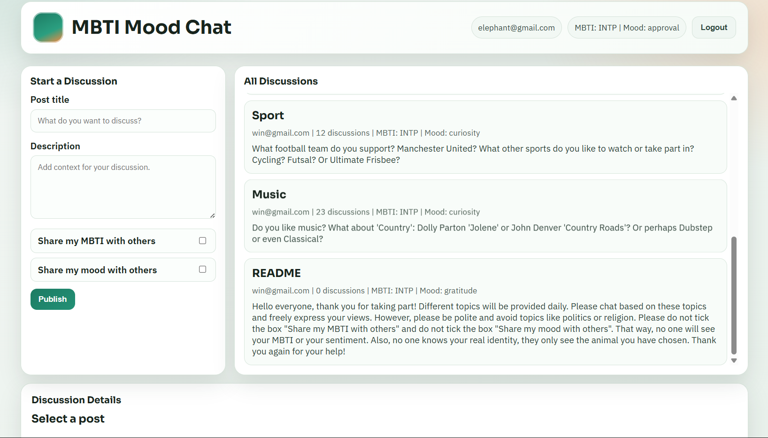
Figure 7.1: Testing page for emotion and MBTI models

This interface allowed direct interaction with the models, enabling controlled testing of prediction outputs without involving the full system.

Separating the testing environment from the main application provided several advantages:
- isolation of model behavior
- faster debugging and iteration
- reduced risk of system-wide errors
- improved reliability before integration

While this approach improves development and validation, it introduces a limitation: model behavior observed in isolation may differ slightly from behavior within the full system, where additional factors such as user interaction and latency are present.

7.6 Chat Data Analysis
To evaluate the system in practice, chat data was collected from five discussion topics.
Topic | Comments | Participants | Emotion Types
Music | 23 | 5 | 8
Sport | 12 | 5 | 8
Phone | 10 | 7 | 7
Music Clubs and Pubs | 11 | 6 | 6
Transport | 12 | 7 | 6
Table 7.1: Chat activity summary by topic

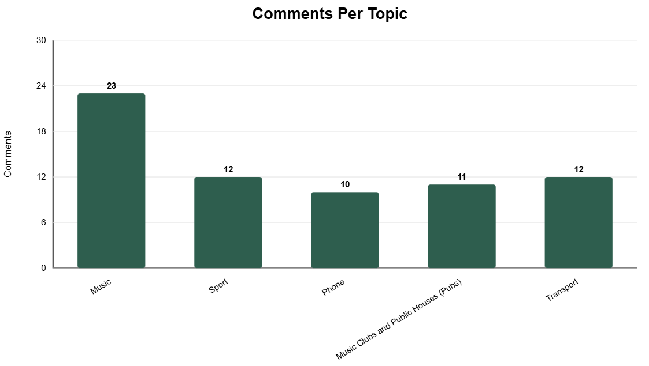
Figure7.2: Number of comments per discussion topic

Music shows the highest engagement and emotional diversity, indicating that interest-based topics encourage more expressive interaction.

More functional topics such as Phone and Transport show lower emotional variation, suggesting more neutral communication patterns.

7.7 Emotion Analysis Results
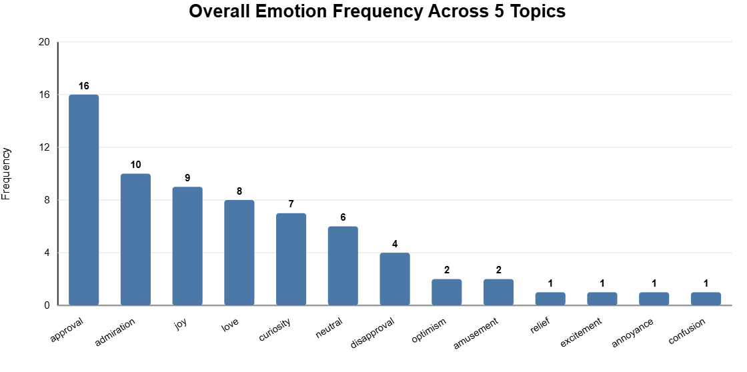
Figure 7.3: Frequency of emotion labels across all topics
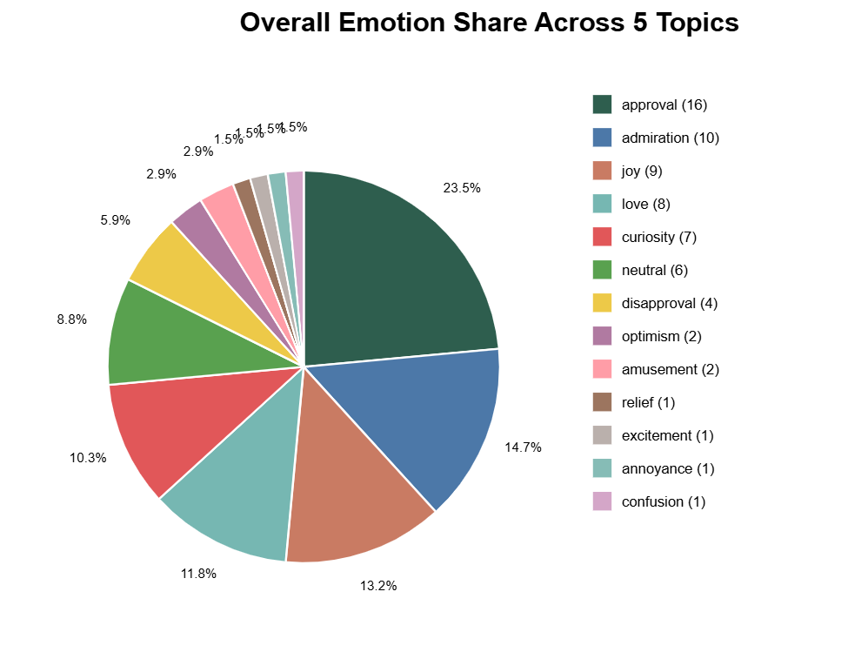
Figure 7.4: Proportion of emotions across all discussion topics
The results show a strong dominance of positive emotions, particularly approval, admiration, joy, and love. This indicates that interactions within the system are generally supportive.

However, this distribution should be interpreted critically. The low presence of negative emotions may reflect the controlled nature of the study rather than real-world conditions.

The model also captures neutral and curiosity-based interactions, suggesting it can distinguish between emotional and informational communication.

7.8 Topic-Based Emotion Behaviour
Different topics exhibit distinct emotional patterns:
- Social topics show stronger positive emotions
- Informational topics show more neutral responses
- Problem-related discussions introduce occasional negative emotions
This variation demonstrates that the model is context-sensitive and reflects differences in user communication.

7.9 MBTI Prediction Evaluation
User | Predicted MBTI | True MBTI | Difference
antelope | ISTP | INTJ | 2 letters
aardvark | ISFP | INFP | 1 letter
butterfly | ISFJ | ISTP | 2 letters
elephant | ISFP | INTP | 2 letters
jaguar | ISFP | ESTP | 2 letters
dolphin | ISFP | ISTP | 1 letter
koala | ISFJ | ESFJ | 1 letter
Table 7.2: Comparison of predicted and expected MBTI types
The results show that the model captures partial personality traits, with most predictions differing by one or two letters.

This reflects the complexity of personality classification and indicates that the model identifies general tendencies rather than exact personality types.

7.10 System Performance Evaluation
The system performs efficiently across core features:
- real-time chat is responsive
- Firebase ensures fast data access
- navigation is smooth
Machine learning integration introduces minimal delay, as:
- emotion predictions are lightweight
- MBTI predictions are processed asynchronously
However, reliance on external services introduces potential risks such as latency and availability.

7.11 Limitations of the Evaluation
- small participant sample size
- controlled testing environment
- limited topic diversity
- potential bias in user behavior
- differences between training data and real-world usage
These factors limit the generalizability of the results.

7.12 Summary
The results show that the core employee system is functional, responsive, and capable of integrating machine learning features effectively (The screenshots of real employee portal will be in Appendix B). The emotion model captures realistic communication patterns, while the MBTI model provides useful but approximate insights.

Despite limitations, the system demonstrates strong potential for further development and real-world deployment.

Chapter 8: Project Planning and Reflection

8.1: Overview
This section reflects the planning, execution, and development process of the project. It evaluates how effectively progress was maintained, how challenges were addressed, and whether the chosen methodology was suitable. It also considers broader contextual factors, including legal, ethical, and inclusivity considerations.

8.2: Planning and Development Process
The project began with minimal prior experience using Firebase, which introduced an initial learning curve. Early development focused on creating a basic prototype of the Employee Portal, including simple features such as authentication, leave requests, and basic data storage.

At this stage, the system was implemented using HTML, CSS, and JavaScript, allowing rapid prototyping and experimentation. A separate testing page was also created early in development to trial new features independently from the main system. This became an important part of the workflow, particularly for experimenting with machine learning integration.

As the project progressed, the frontend architecture was later redesigned and migrated to React, resulting in a more scalable and maintainable system. This transition significantly improved code organization and allowed more complex features to be implemented effectively.

8.3 Project Management and Task Tracking
Project planning and task tracking were supported using the Tuleap platform, which was used to organize development into structured work items.
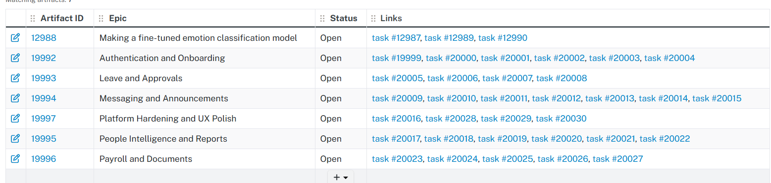
Figure 8.1: Tuleap project backlog showing epics and linked tasks

The project was divided into several key areas, including:
- authentication and onboarding
- messaging and announcements
- leave management
- reporting and analytics
- payroll and document handling
- machine learning model development
Each area was structured as an epic, with smaller linked tasks representing individual implementation steps.
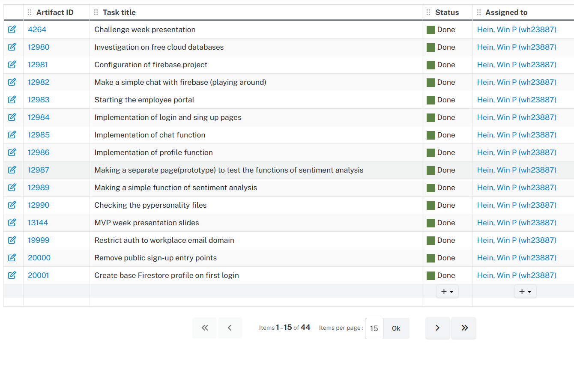
Figure 8.2: Tuleap task tracking interface showing completed development tasks

Tasks were tracked and marked as completed once implemented. This provided a clear overview of development progress and helped priorities core features before moving on to more advanced functionality.

The use of Tuleap helped maintain development momentum and provided structure to the project. However, some tasks—particularly those involving machine learning—required more time than initially expected, highlighting the need for flexibility alongside structured planning.

8.4 Machine Learning Development and Iteration
A significant portion of the project involved developing the emotion classification model. Initially, a model was trained using a 6-class dataset, but this version showed bias, particularly towards anger. Attempts to correct this were unsuccessful, leading to a change in approach.

The project then transitioned to the GoEmotions dataset, which provides 28 emotion categories. This resulted in more balanced outputs. Multiple training iterations were performed using Google Colab, with early versions achieving an F1 score of approximately 0.50.

Further refinement, including manual adjustment of class weights, improved performance to approximately 0.58 F1-score, which was selected as the final model.

In parallel, MBTI classification was developed. Both models were trained using Google Colab due to hardware limitations. This introduced challenges such as session timeouts and interrupted training, requiring repeated retraining.

8.5 Adaptation to Change
The project required continuous adaptation in response to technical challenges.
A key change was moving from a simple emotion model to the GoEmotions dataset. Another major change was the transition from a basic frontend to a React-based architecture.

The introduction of a separate testing page also played a crucial role. Models were first tested independently before integration, reducing risk and simplifying debugging.
These changes demonstrate flexibility and the ability to respond effectively to constraints.

8.6 Integration and Testing Workflow
Once the models reached acceptable performance, they were first integrated into the testing page, where participant-based testing was conducted.

After this, the models were integrated into the Employee Portal and tested using new accounts. This two-stage process ensured that both model performance and system integration were validated.

8.7 Risk Identification and Management
Several risks were encountered:
- model bias and performance issues
- hardware limitations due to Google Colab
- interrupted training sessions
- integration complexity
These were managed through:
- dataset changes and retraining
- use of fallback outputs (e.g., “neutral”)
- independent testing via the testing page
- gradual integration into the main system

8.8 Learning Outcomes
This project provided learning across multiple areas:
- full-stack development using React and Firebase
- training and evaluating NLP models
- handling real-world constraints such as limited hardware
- integrating machine learning into a live system
A key learning outcome was understanding the difference between theoretical model performance and practical system behavior.

8.9 Project Context Considerations
Legal Considerations
The system processes user-generated data and considers GDPR principles [7], including data minimization and secure storage.

Ethical Considerations
Ethical considerations were addressed through participant consent and anonymization. An ethical application and consent form was prepared and used during the study. The full document is provided in Appendix A.
The use of emotion and personality prediction introduces risks of misinterpretation, and outputs are treated as indicative rather than definitive.

Health and Safety
The project does not introduce physical risks, but considerations such as workload and user fatigue during testing were present.

Equality, Diversity, and Inclusivity
The system interface was designed to be simple and accessible. However, limitations exist in the machine learning models, as training data may not fully represent diverse populations.

Chapter 9: Conclusion and Future Work

9.1 Conclusion
This project successfully developed an Employee Portal that combines standard organizational features with machine learning capabilities. Core functionalities such as authentication, messaging, leave management, and reporting were implemented using React and Firebase, resulting in a responsive and functional system.
The integration of emotion classification and MBTI prediction adds analytical value to the system. The emotion model is effective at identifying general sentiment trends, while the MBTI model provides approximate personality insights. Although the models are not perfectly accurate, they enhance the overall functionality and demonstrate the potential of combining machine learning with web applications.

9.2 Limitations
The system has several limitations, including moderate model performance, reliance on external services, and limited evaluation with a small number of users. In addition, hardware constraints during training affected model development.

9.3 Future Work
Future improvements could include:
- improving model accuracy and handling class imbalance
- deploying models within a dedicated backend service
- enhancing visualization of emotion and personality insights
- conducting larger-scale user evaluations
- exploring Retrieval-Augmented Generation (RAG) to support document search and internal knowledge retrieval.

9.4 Final Reflection
Overall, the project demonstrates the practical integration of machine learning into a real-world system. It highlights both the benefits and challenges of applying data-driven models in user-facing applications.

References
[1] A. Marler and S. Parry, “Human resource management, strategic involvement and e-HRM technology,” The International Journal of Human Resource Management, vol. 27, no. 19, pp. 2233–2253, 2016.
[2] B. Liu, “Sentiment analysis and opinion mining,” Synthesis Lectures on Human Language Technologies, vol. 5, no. 1, pp. 1–167, 2012.
[3] D. Demszky et al., “GoEmotions: A Dataset of Fine-Grained Emotions,” Proceedings of ACL, 2020.
[4] E. Cambria et al., “Sentic computing for sentiment analysis,” IEEE Intelligent Systems, vol. 28, no. 2, pp. 92–101, 2013.
[5] I. B. Myers and P. B. Myers, *Gifts Differing: Understanding Personality Type*. CPP, 1995.
[6] D. Pittenger, “Measuring the MBTI... and coming up short,” Journal of Career Planning and Employment, vol. 54, no. 1, pp. 48–52, 1993.
[7] European Union, “General Data Protection Regulation (GDPR),” 2016.
[8] S. McLeod, “The Myers-Briggs Type Indicator (MBTI),” Simply Psychology,
[10] Hugging Face, "Transformers Documentation," https://huggingface.co/docs/transformers
[11] V. Sanh et al., "DistilBERT," arXiv:1910.01108, 2019.
[12] Scikit-learn, https://scikit-learn.org
[13] PyTorch, https://pytorch.org/docs
[14] J. Devlin et al., "BERT," NAACL-HLT, 2019.
[15] Z. Khalid, “MBTI Personality Types 500 Dataset,” Kaggle, [Online]. Available: https://www.kaggle.com/datasets/zeyadkhalid/mbti-personality-types-500-dataset.

Appendices

Appendix A: Ethical Approval
Ethical Approval from University of Essex, ETH2526-0922.
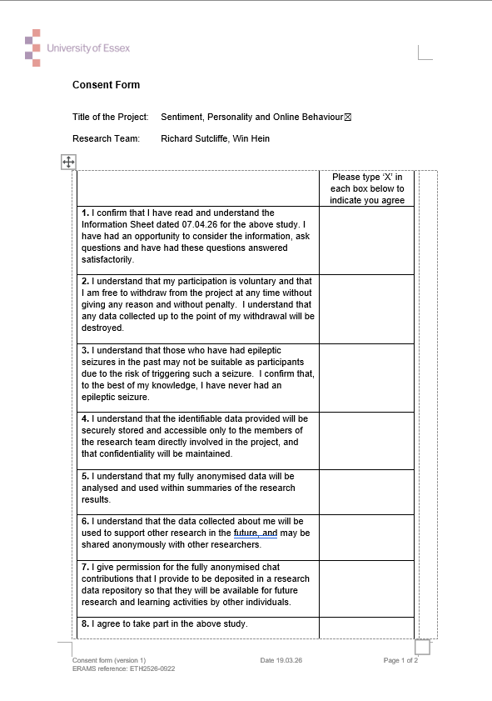
Figure A.1: The Consent Form Page 1
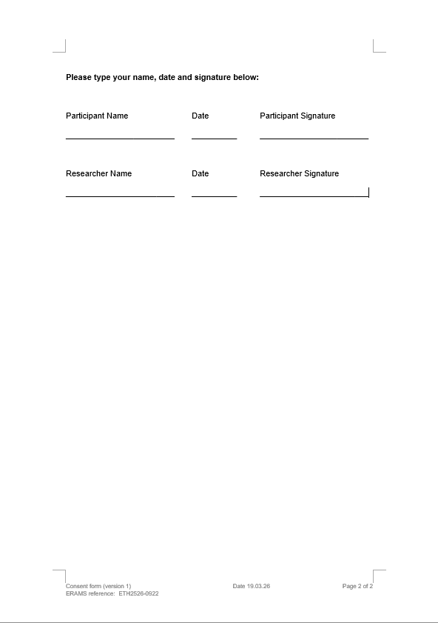
Figure A.2: The Consent Form Page 2


Figure A.3: Information Sheet Page 1
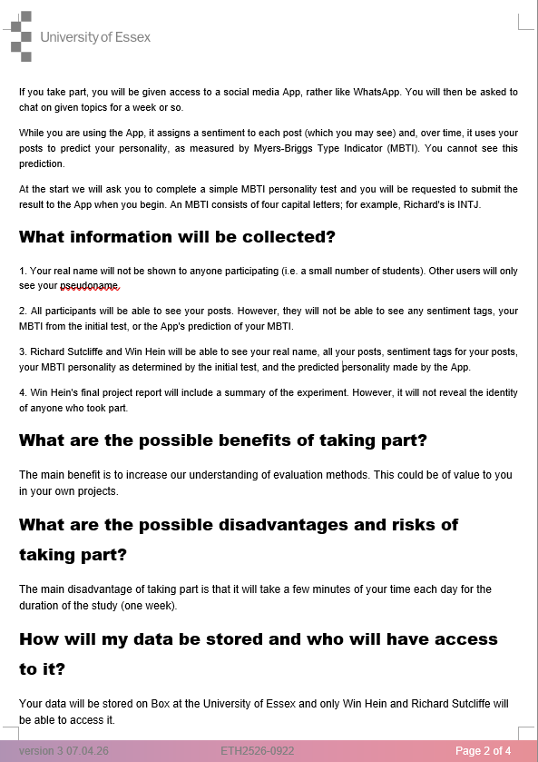
Figure A.4: Information Sheet Page 2
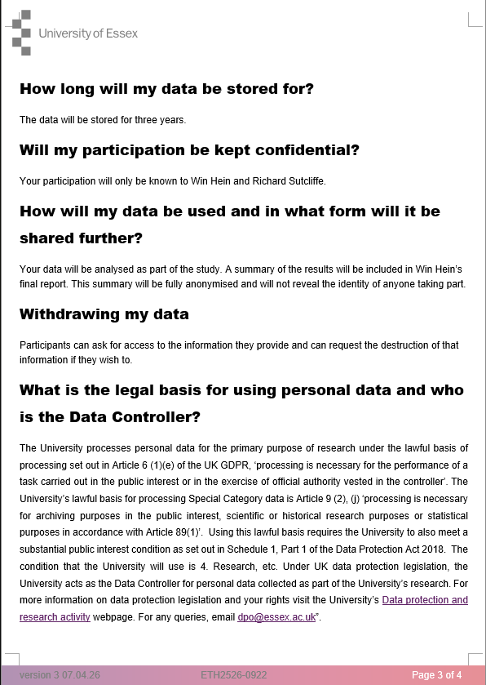
Figure A.5: Information Sheet Page 3

Figure A.6: Information Sheet Page 4

Appendix B: Employee Portal Screenshots
The employee portal is online and available at this link: https://employee-portal-v2-bbe68.web.app/

As the sign-up page was intentionally removed for security reasons, access requires pre-created test credentials.
Figure B.1: Sign in Page
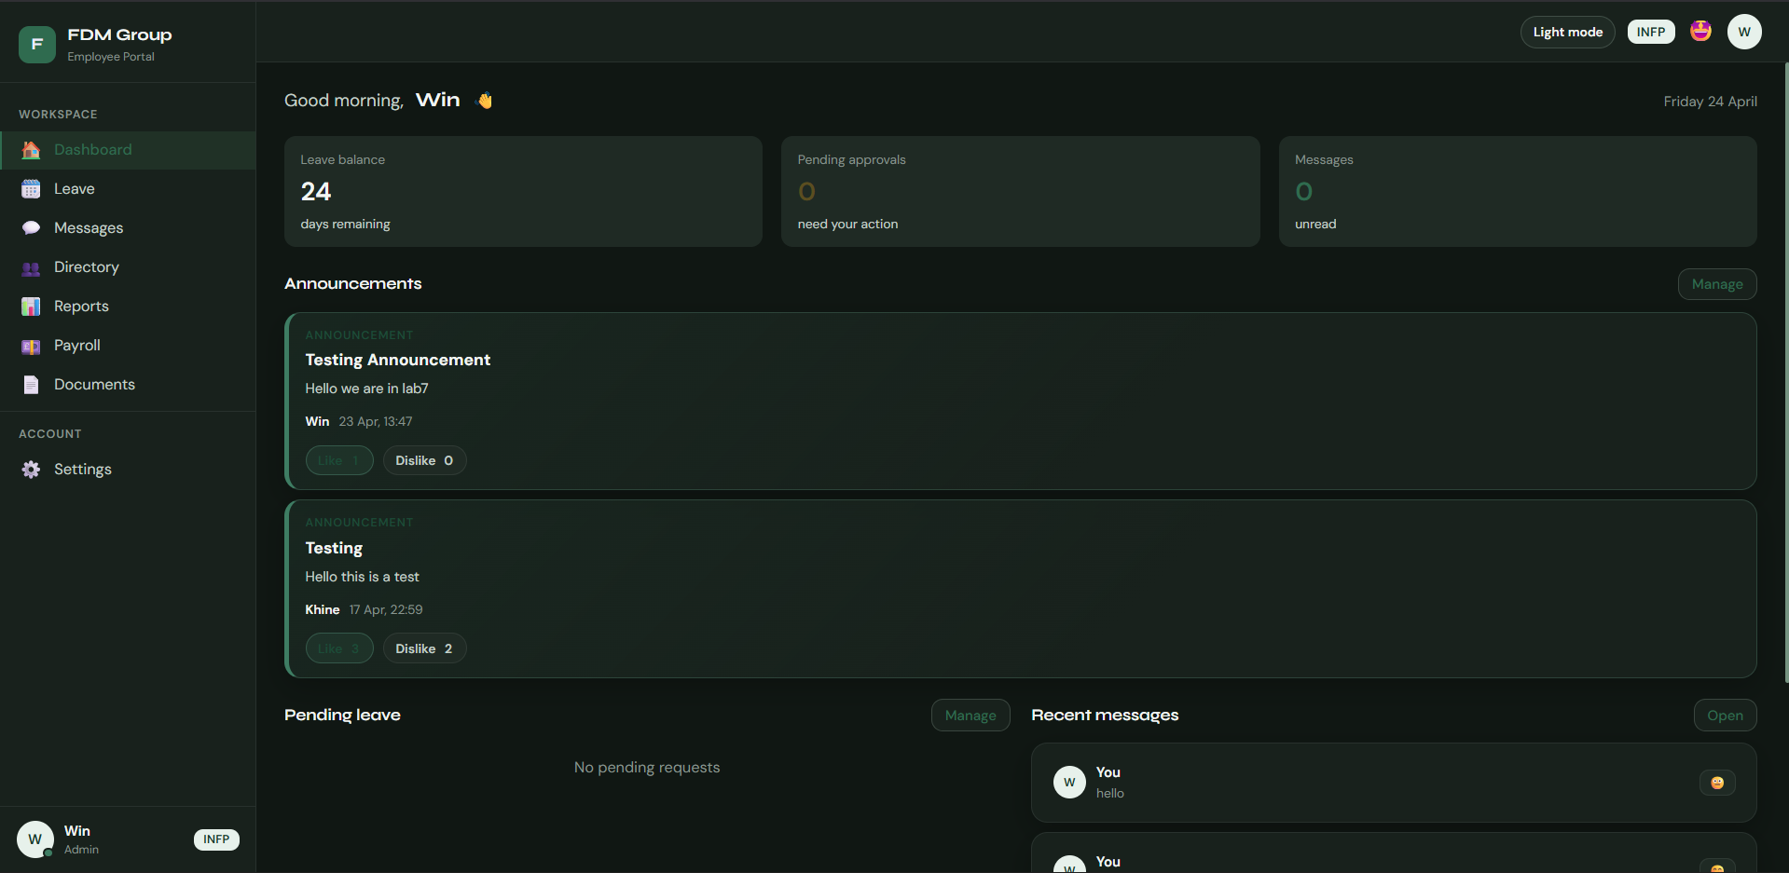
Figure B.2: Dashboard of the portal
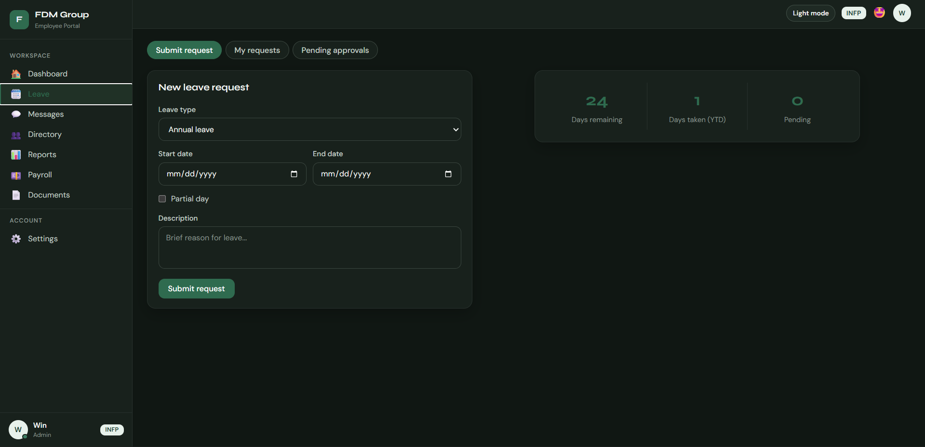
Figure B.3: Leave request page

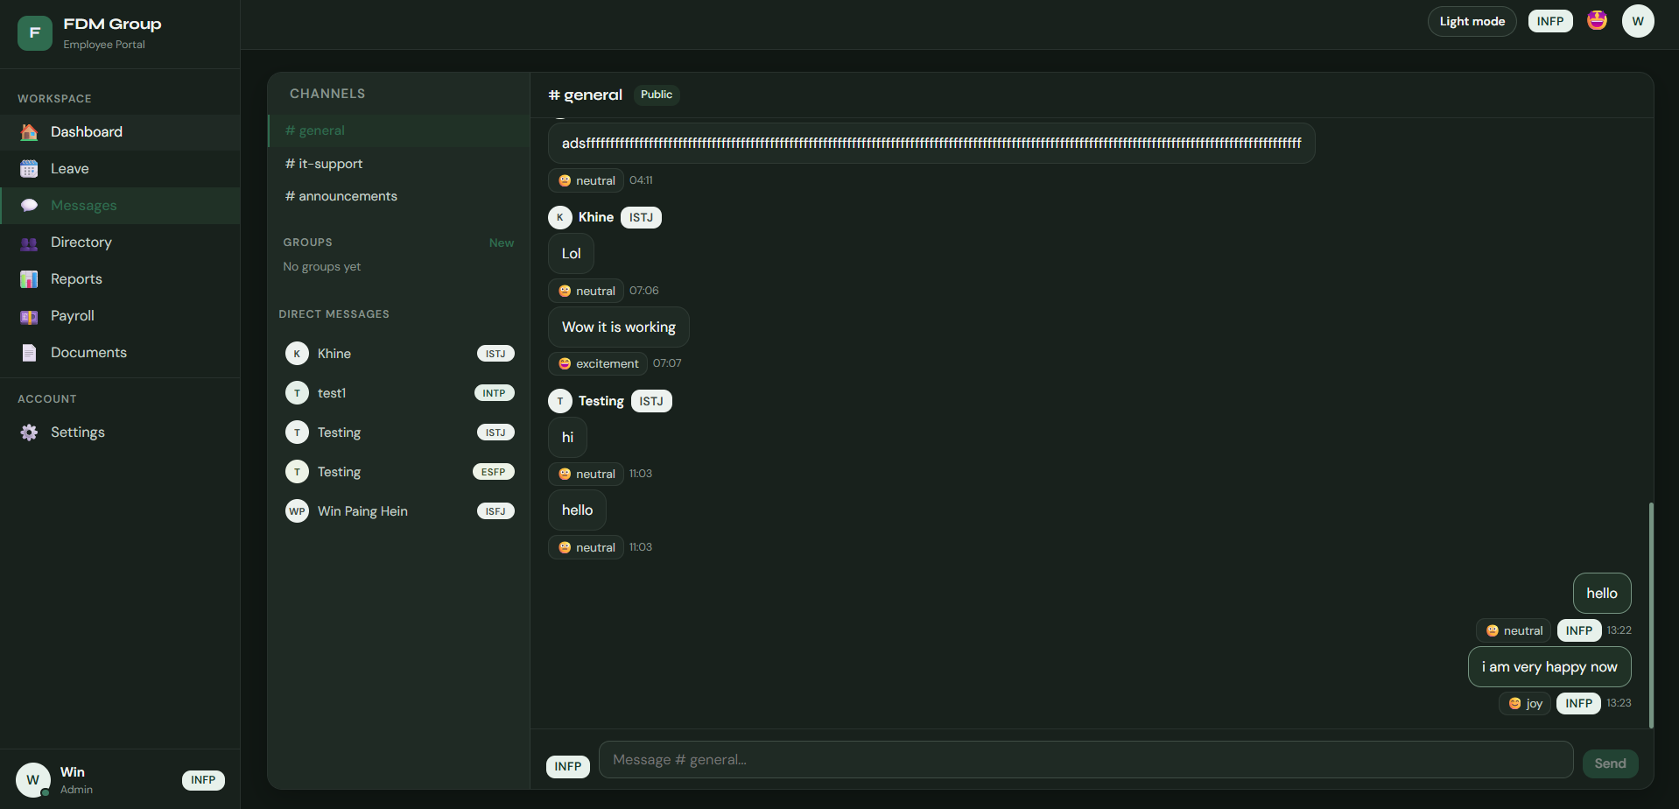
Figure B.4: Messages page
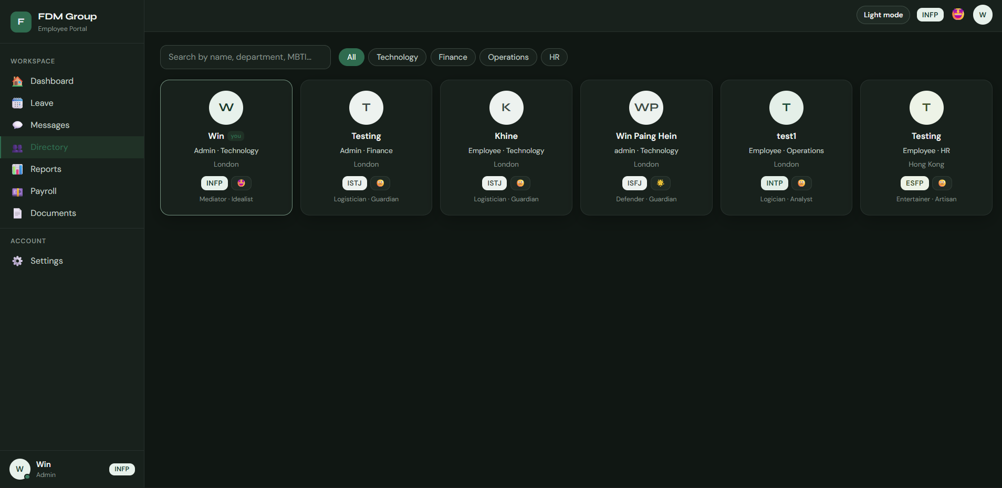
Figure B.5: Directory Page
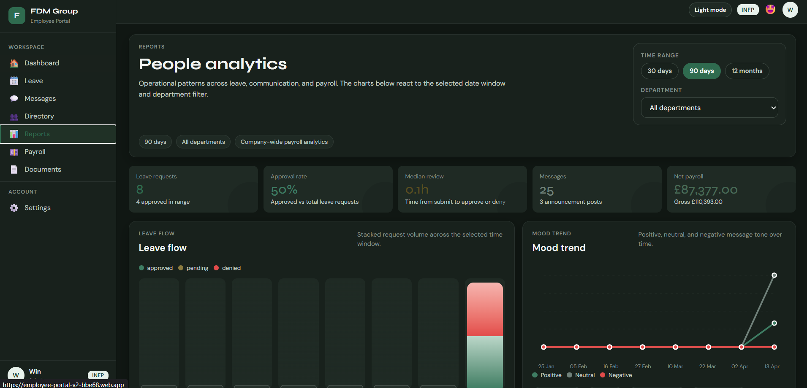
Figure B.6: Report Page
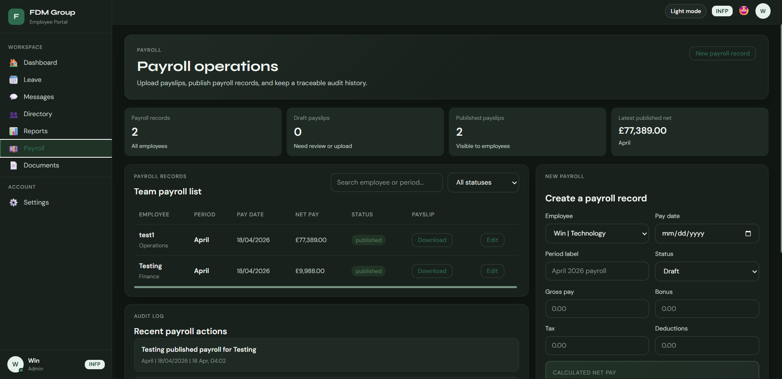
Figure B.7: Payroll Page

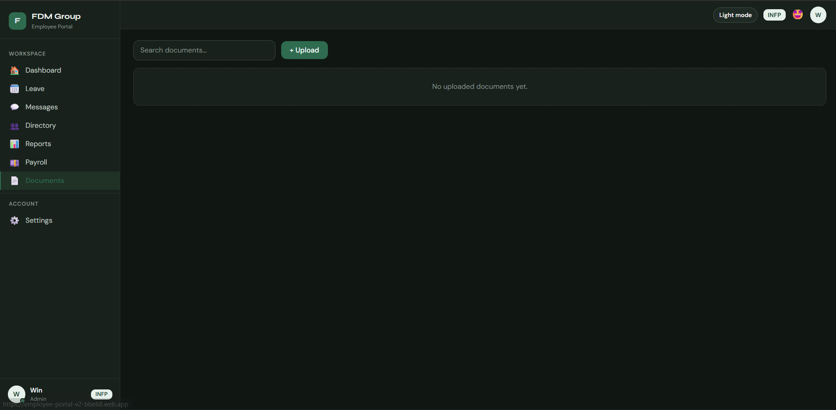
Figure B.8: Documents Page
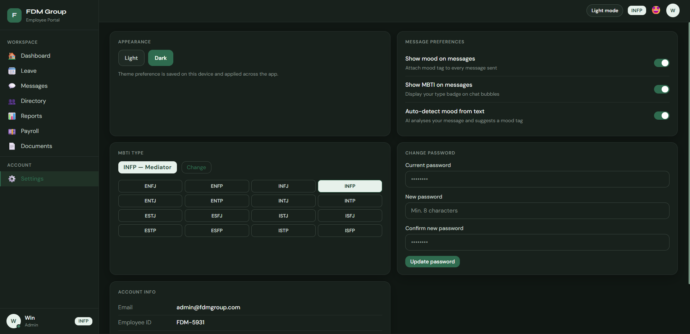
Figure B.9: Settings Page

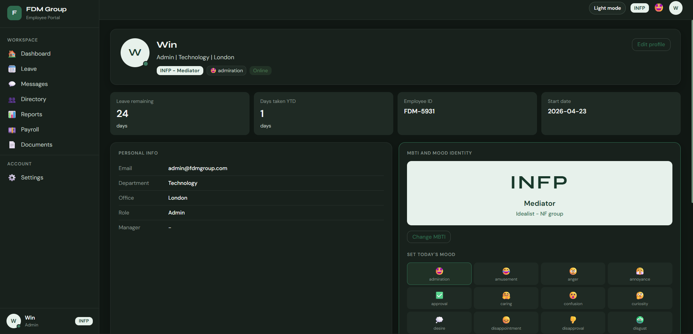
Figure B.10: Profile Page

Appendix C: The classification models and pilot test page
Both emotion and MBTI models are online. You can check out those on here:
Emotion classification: https://huggingface.co/spaces/Win02/emotion-classifier
MBTI classification: https://huggingface.co/spaces/Win02/mbti-predictor

Testing page is also available online : https://chatmood-95f3e.web.app/

