**Company Name:** Data Trace International Ltd (DTI)

**Contact:** Prof Joseph Wafula, Phone: +254721404317, email address: [muliaro@yahoo.com](mailto:muliaro@yahoo.com)

**Mission Statement**: To observe high standards and integrity at all times when handling data. Enable customers manage efficiently data as an asset and attain insights from data for better and timely decision making- through products and services, training, research and innovation.

**About Us**: Data Trace International Ltd (DTI) was incorporated as a Private Limited Company on 12th January 2021 under the companies Act, 2015 of Kenya. DTI participated in the formulation of the Kenya Open Government Partnership (OGP) IV Strategic Plan 2020-2022 and is relied upon as one of the leading ICT solution providers for the successful OGP strategy implementation (https://www.opengovpartnership.org/documents/kenya-action-plan-2020-2022/).

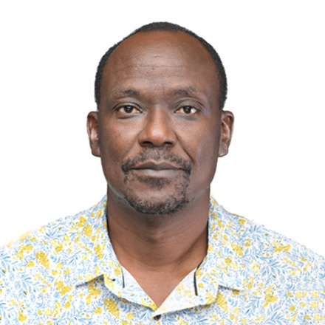

**Team Leader and Director: Prof Joseph Muliaro Wafula.**  Holds a PhD Information Technology (JKUAT), Summer Doctoral Program (Berkman Centre for Internet & Society/Oxford Internet Institute’s -Harvard University Law School), Master of Philosophy in Microelectronics Engineering and Semiconductor Physics, University of Cambridge UK, MSc. Physics (University of Nairobi), and BSc. Science (Hons) (Kenyatta University). He is a professionally certified Data Engineer, Mobile Application Developer, Cyber Security expert, IT Project Management expert, and implementer Information Security Management System. Resend consultancies undertaken include: Review of the Global Biodiversity Information Facility’s activities and accomplishments; Development of an African Policy Framework and Policy Roadmap for Open Science and Open Data’; Performing Skills Audit and development of strategies to fill the gaps in Northern Corridor Integrated Project (NCIP) Member States -Kenya, Rwanda, South Sudan, and Uganda.

A collaborator on Melinda and Gates Foundation award 2017 for developing a Blockchain-based Vaccines Supply Chain Management Application. Recipient of two IBM awards namely: the 2016 IBM Shared University Research Award on Open Data Cloud Project for JKUAT for building an open data platform for researchers in Africa, and the 2014 IBM MEA Award, for capacity building in Mobile Application development. Won the Kenya Open Data Champion Award of 2016. Member of the Global Challenges Research Fund/ ESRC Strategic Network on Digital Development: Leveraging Data Science and Digital Participatory Practice for Development Impact (2017-2018) and a Co-convinor of a network bringing together 29 participants (academics, NGOs and business partners) from 13 countries to develop joint cutting-edge research agendas. Member of Immunization Technical Working Group of the Kenya National Vaccine and Immunization Programme. Member of CODATA Executive 2017-2021, and member of the CODATA International Data Policy Committee that advocates for **F**indable **A**ccessible **I**nteroperable and **R**eusable (FAIR) data principles adoption. Member of the Advisory Council of the Africa Open Science Platform. Member of the Kenya Open Government Partnership Steering Committee. A fellow of the Computer Society of Kenya and the Cambridge Commonwealth Society. An Associate Professor in the Department of Computing at JKUAT

**Director Research & Innovation: Dr Agnes Naliaka Mindila** holds a PhD Information Technology (JKUAT) and MSc. Management of Information Technology (University of Sunderland UK) and B.Sc. Electrical and Electronic Engineering (JKUAT). She is a member of DLT and Blockchain ITU working group and a member of the System Dynamics society. She is a professionally certified Data Engineer and Mobile Application Developer. She is a 2017 Grantee of Bill and Melinda Gates foundation Designing, development and testing of the Blockchain-based Vaccines Supply Chain Management Application that was piloted at NVIP (2017-2019). Designed, developed and implemented a Wireless Sensor Network (WSN) for monitoring air quality using IoTs (2018-todate); and designed, developed and implemented a blood donation sourcing application based on geofencing technologies (2017). She is an accomplished researcher, Senior lecturer, Postgraduate Supervisor and Innovator.

**Our Products/Services**:

The objects for which DTI is established are:-

* 1. VizAfrica Conference/Symposium series
     1. Data Management Plan Training
     2. Data publishing tools and skills training
     3. Citizen Science
     4. Summer School
     5. Open Science
     6. Open Government
     7. **F**indable **A**ccessible **I**nteroperable **R**eusable (FAIR) and **C**ollective **A**uthoritative **R**esponsibility **E**thics (CARE) principles
  2. Train ICT professionals in collaboration with industry players
  3. Build and Support Data and Innovation ecosystems
  4. Research, Development and Innovation of products and services using
     1. Blockchain
     2. Artificial Intelligence-Al
     3. Internet of Things-loTs
     4. Quantum Computing-QC
     5. System Dynamics-SD
  5. Research and Development for ICT Policies and strategies
     1. Data
     2. Infrastructure
     3. Human Resource
  6. ICT Conferences, workshops and Exhibitions organization and management
  7. Data Management Training
  8. Design, procurement and implementation of ICT infrastructure
  9. Data Interoperability and systems Integration support

**Recognition**: DTI is listed among ICT solution providers for the implementation of the Open Government Partnership National Action Plan IV 2020- 2022.