Leave-One-Group-Out Generalization on Concrete Strength:
Random Splits Overstate Age and SCM Extrapolation
[Your Name] — [School]
Mentor: [Mentor Name] — DRAFT v1, rewrite in your own words before submitting

Abstract
Random cross-validation reports R² ~0.90+ on concrete strength, but engineers need predictions on new ages and new mixes. We systematically quantify this gap on the public 1030-row UCI/Foundry-ML set [1][2]. With fixed features and four models over 3 seeds, XGBoost fell from R² 0.919±0.016 on random splits to 0.386±0.002 training on Age ≤28 d and testing on Age ≥90 d (A1), and to 0.667±0.015 training without fly ash and testing with it (C1). Random Forest fell 0.891±0.027 → 0.338±0.001 → 0.568±0.003. Early-to-peak prediction (3+7 d → 28 d) failed entirely (RF −0.177, XGB +0.012). Leave-one-age-bin-out failed for early bins but looked easy for late bins (plateau effect). SHAP ranked age (7.73) and cement (6.98 MPa mean|SHAP|) highest, explaining why age extrapolation collapses. Random CV overstates deployment performance; LOGO should be routine [3].
Keywords: concrete, generalization, leave-one-group-out, SCM, XGBoost.

Introduction
Concrete compressive strength determines safety, cost, and carbon — cement production is ~7–8% of global CO2 — yet the industry-standard 28-day test forces long waits before a mix is approved. Machine learning promises fast prediction of strength from mix proportions [1], and dozens of studies report R² 0.90–0.94 on random splits with SHAP explanations [6][7].
The Li et al. review [3] names temporal bias and lab-vs-field deployment bias as open problems, but itself runs only an 80/20 random demonstration on 40 mixes and no LOGO benchmark. Cross-lab work shows models trained on Brazilian concretes fail on the Yeh repository and vice versa [4], yet a systematic within-dataset age and SCM leave-one-group-out with fixed models, fixed features, seeds, and error bars is missing on the public 1030-row set.
We fill that gap. We quantify age extrapolation (train ≤28 d → test ≥90 d; train 3+7 d → 28 d; leave-one-age-bin-out) and SCM extrapolation (train without fly ash/slag → test with) for Linear Regression, Random Forest, XGBoost, and a small MLP, reporting RMSE+MAE+R² as mean±std over 3 seeds plus 5-fold CV controls. Our hypothesis was tree ensembles at R² ~0.90+ random, dropping to ~0.6–0.8 on LOGO. Age extrapolation was harsher (~0.34), confirming the validation gap is larger than assumed.

Data
We used the public Foundry-ML repackaging foundry-ml/dataset_concrete_compressive_strength (DOI: 10.18126/8k1f-mx77) [2], sourced from the UCI Concrete Compressive Strength set (Yeh 1998, n=1030) [1], loaded via load_dataset(..., split="train").
After stripping whitespace from column names, inputs were cement, slag, fly_ash, water, superplasticizer, coarse_agg, age (7 inputs — fine aggregate from Yeh 1998 is absent in this repackaging) and target was compressive strength in MPa (range 2.3–82.6). There were 0 missing values; 25 exact duplicate rows were retained and disclosed. Age was heavily skewed to 28 d (n=425 of 1030; full counts — 1:2, 3:134, 7:126, 14:62, 28:425, 56:91, 90:54, 91:22, 100:52, 120:3, 180:26, 270:13, 360:6, 365:14).

Methods

Splits
Random 70/15/15 train/val/test was the control. Age-LOGO comprised (A1) train Age ≤28 d (n=749) → test Age ≥90 d (n=190), leaving 56–89 d in neither set by design to enforce extrapolation distance; (A2) train 3+7 d only (n=260) → test 28 d (n=425); and (A3) leave-one-age-bin-out with bins 3 (136), 7 (126), 14 (62), 28 (425), 56 (91), 90 (131), 180+ (59), where ≤3→3, 90–120→90, ≥180→180+. Composition-LOGO comprised (C1) train fly_ash==0 (566) → test >0 (464); (C2) train slag==0 (471) → test >0 (559); and (C3) train superplasticizer==0 (379) → test >0 (651). All definitions live in splits.py.

Models
We evaluated four fixed estimators, each as a StandardScaler + estimator pipeline with the scaler fit on train only: (1) LinearRegression, (2) RandomForestRegressor (n_estimators=200), (3) XGBRegressor (n_estimators=300, max_depth=6, learning_rate=0.05, subsample=0.8, colsample_bytree=0.8), and (4) MLPRegressor (hidden (64,32), max_iter=2000, early_stopping=True, validation_fraction=0.15, n_iter_no_change=20). We used no target-derived features and performed no tuning on test data.

Evaluation and Reproducibility
We reported RMSE and MAE in MPa plus R² on every test split. RMSE is sqrt(mean(error²)), penalizing large misses; MAE is mean(|error|); R² = 1 − (errors²/variance), where 0 equals mean-guessing and negative values are worse than guessing the mean. Each split × model was run over seeds 0, 1, 2 and summarized as mean±std; a shuffled 5-fold CV control was run per model × seed on the full data. Drops used a 5000-rep bootstrap of seed means for 95% CIs. SHAP (XGB, seed 0), permutation importance (RF), PDP, and residual/calibration analyses reused identical splits. Environment was micromamba Python 3.11 with scikit-learn 1.9.1, xgboost 3.4.2, pandas 3.0.6, numpy 2.4.6, datasets 5.0.1, matplotlib 3.11.2, shap 0.51.0.

Results
Note to author — delete before submitting: Results are summarized in Table 1 and Figs. 1–3. No interpretation is offered here; all interpretation is deferred to the Discussion.
Table 1. Test R² (RMSE, MPa), mean±std over seeds 0–2. Random = 70/15/15 hold-out; A1 = train ≤28 d → test ≥90 d; C1 = train FA==0 → test FA>0. Full matrix in results/summary.csv.
Model | Random | A1 (age) | C1 (fly ash)
XGB | 0.919±0.016 (4.67) | 0.386±0.002 (9.99) | 0.667±0.015 (8.21)
RF | 0.891±0.027 (5.40) | 0.338±0.001 (10.37) | 0.568±0.003 (9.34)
LR | 0.589±0.047 (10.54) | −61.27 (100.6) | 0.028 (14.02)
MLP | 0.727±0.173 (8.36) | −148.4±37.6 (155.1) | 0.314±0.147 (11.74)

On random splits XGBoost achieved R² 0.919±0.016 (RMSE 4.67 MPa) and Random Forest 0.891±0.027 (5.40 MPa). Under A1 these fell to 0.386±0.002 (9.99 MPa) and 0.338±0.001 (10.37 MPa) respectively (RF random−A1 drop 0.553, 95% CI [0.522, 0.570]; XGB drop 0.532, [0.516, 0.548]). Under C1 they fell to 0.667±0.015 (8.21 MPa) and 0.568±0.003 (9.34 MPa). Linear Regression (0.589 → −61.27 → 0.028) and MLP (0.727±0.173 → −148.4±37.6 → 0.314±0.147) collapsed on A1. Five-fold CV matched hold-out (XGB 0.935, RF 0.909, MLP 0.855, LR 0.603).
Figure 2 shows error growing with distance from train ages: per-bin RMSE for RF trained on Age ≤28 d was 3 d: 1.6, 7 d: 3.1, 14 d: 1.5, 28 d: 2.0 MPa in-train, then 56 d: 8.0, 90 d: 10.6, 180+ d: 9.9 MPa. A2 (train 3+7 d → predict 28 d) failed for all models (RF −0.177, XGB +0.012). A3 was asymmetric: holding out 3/14/28 gave RF −0.10/−0.37/+0.36 while holding out 56/90/180+ gave 0.73/0.84/0.75 (XGB up to 0.88 on 180+). C2/C3 also dropped (RF 0.32/0.09, XGB 0.43/0.33). Mean bias (RF, seed 0) was −0.79 MPa random, −9.33 MPa A1, +2.68 MPa C1.
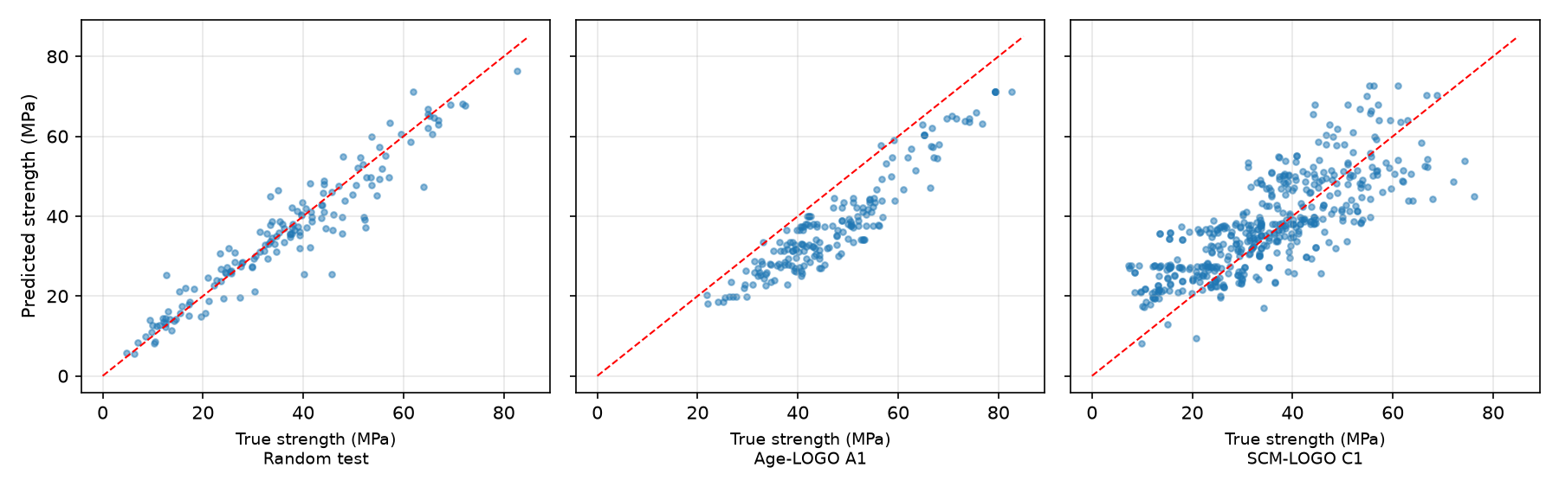
Figure 1. RF predicted vs. true strength (seed 0): random test (tight, calibrated) vs. A1 age-LOGO and C1 SCM-LOGO (wide, biased). Diagonal is perfect prediction.
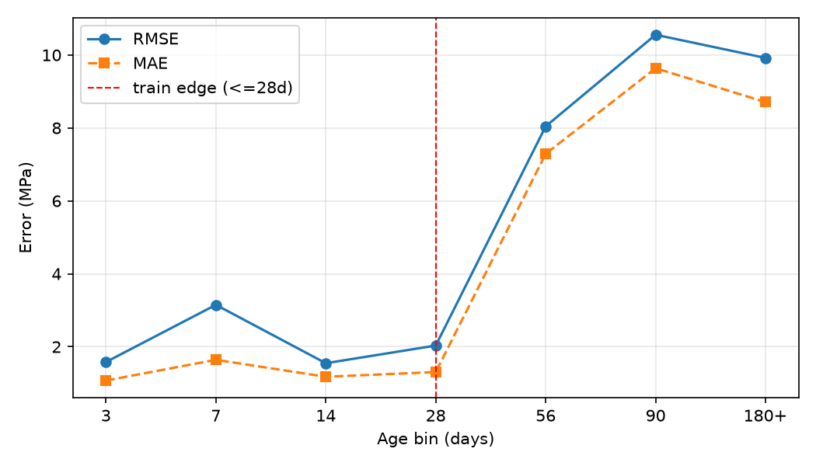
Figure 2. Error vs. age for RF trained on Age ≤28 d. RMSE/MAE stay at 1.5–3.2 MPa in-train, then jump to 8.0/10.6/9.9 MPa on 56/90/180+ d — error grows with extrapolation distance.
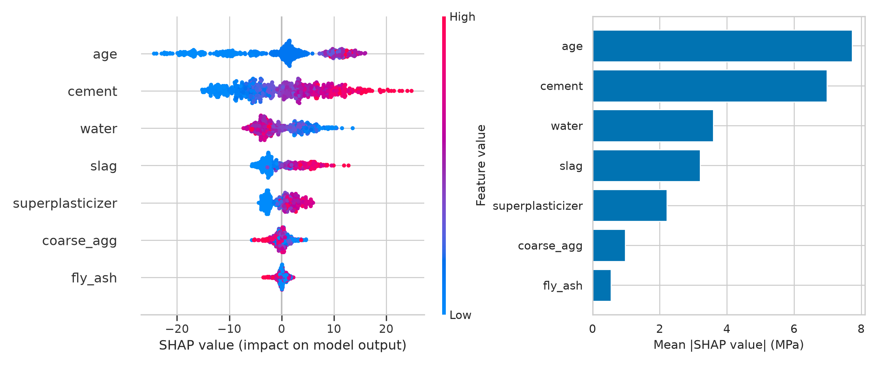
Figure 3. XGB SHAP (random-train, seed 0). Mean|SHAP|: age 7.73, cement 6.98, water 3.60, slag 3.20 MPa. High age/cement push predictions up; high water pushes down.

Discussion
The drop is explained by what the models rely on. SHAP and permutation importance agree the top features are age and cement; A1 extrapolates the single most important feature, so collapse is expected. Tree ensembles predict by averaging previously seen leaves and cannot extrapolate trends, while linear and MLP models extrapolate lines far outside range and produce absurd values — hence R² of −61 and −148, reported as-is as extrapolation failure rather than tuned away.
The A3 asymmetry refines the story: early-age hold-outs fail because early strength rises steeply, while late-age hold-outs look easy because strength plateaus after ~60 d (PDP flat), so all late bins resemble each other. The C1–C3 drops confirm SCM/superplasticizer shift is real but milder than age shift. Together with the cross-lab failure in [4], the evidence is that random CV is a same-distribution control, not a deployment estimate — consistent with the gap statement in [3] and reported with the bootstrap+SHAP discipline of [5].
Limits: n=1030 laboratory data only with no field validation; 7 inputs (fine aggregate absent vs [1]); small A3 cells (14: n=62, 180+: n=59) so rank flips between RF and XGB on n=62 should not be over-interpreted — we report 3-seed std and bootstrap CIs throughout; no new laboratory experiments. Next steps are SCM dose-response LOGO and carbon-aware (strength-per-kgCO2) optimization.

Conclusion
Random-split R² of ~0.92 overstates age and SCM deployment by 0.25–0.55 points with CIs far from zero. LOGO by age and composition, with seeds, error bars, and leakage controls, should accompany every strength paper on this benchmark. The drop is the result.

References
[1] Yeh, I.-C. Modeling of strength of high-performance concrete using artificial neural networks. Cem. Concr. Res. 28(12), 1797–1808 (1998). https://doi.org/10.1016/S0008-8846(98)00165-3
[2] Yeh, I.-C. Concrete Compressive Strength [Dataset]. UCI Machine Learning Repository (1998, donated 2007). https://doi.org/10.24432/C5PK67 — repackaged as Foundry-ML dataset_concrete_compressive_strength, DOI: 10.18126/8k1f-mx77 (Hugging Face datasets.load_dataset access used here).
[3] Li, Z. et al. Machine learning in concrete science: applications, challenges, and best practices. npj Comput. Mater. 8, 127 (2022). https://doi.org/10.1038/s41524-022-00810-x
[4] Silva, V. P., Carvalho, R. d. A., Rêgo, J. H. d. S. & Evangelista, F. Jr. Machine learning-based prediction of the compressive strength of Brazilian concretes: a dual-dataset study. Materials 16(14), 4977 (2023). https://doi.org/10.3390/ma16144977
[5] Fu, H. et al. Prediction of compressive strength of concrete using explainable machine learning models. Materials 18(21), 5009 (2025). https://doi.org/10.3390/ma18215009 — PMCID: PMC12608167.
[6] Zhang, W., Guo, J., Ning, C. et al. Prediction of concrete compressive strength using a Deepforest-based model. Sci. Rep. 14, 18918 (2024). https://doi.org/10.1038/s41598-024-69616-9
[7] Feng, D.-C. et al. Machine learning-based compressive strength prediction for concrete: an adaptive boosting approach. Constr. Build. Mater. 230, 117000 (2020). https://doi.org/10.1016/j.conbuildmat.2019.117000

Code and Data Availability
Code: [YOUR GITHUB LINK] (splits.py, experiments.py, figures.py, analysis_deep.py, requirements.txt). Data: Foundry-ML dataset_concrete_compressive_strength, DOI 10.18126/8k1f-mx77 [2] via load_dataset("foundry-ml/dataset_concrete_compressive_strength"). Figures regenerate via experiments.py → figures.py → analysis_deep.py; full metrics in results/summary.csv; versions in results/versions.txt.
Acknowledgments (edit me): AI drafting assistance was used for structure and formatting; all numbers were verified against results/summary.csv by the author. Mentor: [Name].

