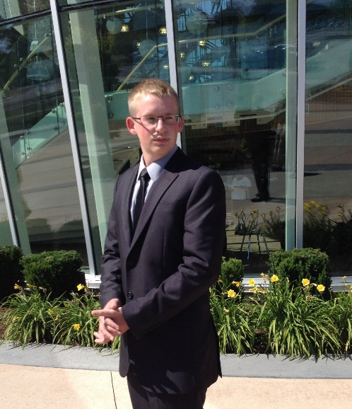

**Ryan Lebeau**

|  |  |
| --- | --- |
| **University Program** | Computer Science [Honours] |
| **Year of Study** | First Year |
| **Goal** | Graduate with my Bachelor in Computer Science |
| **Programming Skills** | * Skilled in Python * Familiar with Java, JavaScript, HTML, CSS, Lau, and Swift |
| **Interests** | Music, Cars, Football |
| **Hometown** | Windsor, ON |