**School:** Computer Science

**Institution:** University of Windsor

**Term:** Winter 2019

**Course:** 03-60-315-1 : Database Management Systems

**Instructor:** Dr. C. I. Ezeife

**Assignment #**2 : Total: 50 marks

**Handed Out:Thurs. Jan. 24, 2019; Due: Thurs Feb. 14, 2019**

**Objective of Assignment**: To test on knowledge and design of relational model constraints, relational database schemas, functional dependencies and normalization of relational databases.

**Scope**: Assignment covers materials from Chapters 5 and 14 of book discussed in class.

**Electronic Assignment Submission:** Done through <http://blackboard.uwindsor.ca>

**Marking Sheme** : The mark for each of the questions is indicated beside each question.

**Academic Integrity Statement**: Remember to submit only work that is yours and include the following confidentiality agreement and statement at the beginning of your assignment.

**CONFIDENTIALITY AGREEMENT & STATEMENT OF HONESTY**

**I confirm that I will keep the content of this assignment/examination confidential.**

**I confirm that I have not received any unauthorized assistance in preparing for or doing this assignment/examination. I confirm knowing that a mark of 0 may be assigned for copied work.**

________________________________________ ________________________________________

Student Signature Student Name (please print)

________________________________________ ________________________________________

Student I.D. Number Date

**Marking Scheme : The mark for each question and sub question is shown with the question below. Place your solutions in tables where possible.**

**For office Use only**

|  |  |
| --- | --- |
| **Question** | **Mark** |
| **1** | **/20** |
| **2** | **/10** |
| **3** | **/10** |
| **4** | **/10** |
| **Total** | **/50** |

**CHAPTER 5: THE RELATIONAL DATA MODEL AND RELATIONAL DATABASE CONSTRAINTS**

1. (total marks 20) Given the same simple Customer-Subscribesto_Phonecompany database schema you worked on in Assignment 1, which contains three files describing information about telephone company subscribers as follows:

Customer (SSN: integer, CName: string, Caddress: string, balance: real)

Subscribesto (SSN: integer, CompId: string, phonetype: string, month: string, billamt: real)

PhoneCompany (CompId: string, CompName: string, Address: string, Numproducts:integer)

Note : SSN, CName, Caddress and balance stand for the customer’s social security number, name, address and phone bill balance owing respectively. Also, CompId, phonetype, month and billamt stand for the phone company identifier, the phone type the customer subscribes to, the month of subscription and the phone bill amount for that month. The rest of the attributes are for the company’s name, their address and the number of phone products they provide to customers.

Assume that an update is to be made to this database to enter information about a new PhoneCompany not yet in the database that an existing Customer has now switched to (replacing the customer’s old PhoneCompany). Answer the following questions on what specific relations, attributes and operations (eg. insert, modify, delete) that need to be done for this update to be implemented in this database.

Provide your answers both in descriptive sentence and using the formal database operations of INSERT, MODIFY, DELETE as used in Chapter 5 of book with specific attributes and relations when possible. An example formal insert of a customer record into the Customer table is:   
INSERT < SSN, CName, Caddress, balance> into Customer; // for new Customer record

And an example descriptive sentence is:   
i). do an insert operation for a new customer record into the Customer table.

(a) Give the set of needed insert, modify or delete operations for this update. 5 marks

(b) What types of constraints (explain using attributes, eg SSN of relevant files) would you expect to check for this update to be done? 5 marks

(c) Which of these constraints are key, entity integrity, and referential integrity constraints and which are not? 5 marks

(d) Specify all the referential integrity (foreign key) constraints on this database. 5 marks

(Total for que 1 is 20 marks)

Solution:

|  |  |
| --- | --- |
| **Question** | **Answers** |
| a. Give the operations for this update.  5 marks | * INSERT < CompId, CompName, Address, Name > into PhoneCompany * MODIFY Subscribeto for the current SSN updating attributes .CompId, .phonetype, .month, .billamt |
| b. What types of constraints would you expect to check?  5 marks | When using the first INSERT into PhoneCompany you must check to make sure CompId does not already exist as a key constraint. Then when using MODIFY you must check to make sure CompId already exists within Subscribeto as a foreign key constraint. |
| c. Which of these constraints are key, entity integrity, and referential integrity constraints and which are not?  5 marks | INSERT in PhoneCompany and MODIFY in Subscribeto will check all entity, integrity, referential and key constraints within the relations. |
| d. Specify all the referential integrity constraints on this database.  5 marks | Subscribeto.SSN to Customer  Subscribeto.CompId to CompId |

1. (total marks 10) Using your own Customer-Subscribesto_Phonecompany database instance from assignment 1, login to the SQL query processor on our cs server, called Oracle Sqlplus to create the three database table and insert the tuples in your database state with the following sequence of instructions. Note that this exercise is to get you beginning to connect to SQLplus while preparing to learn full SQL language syntax in Chapters 6 and 7. You will be given the instructions to use now. Show the result of this exercise through a script file you will attach.

(Total for que 2 is 10 marks)  
  
i. First connect to our cs.uwindsor.ca through either SSH client or NoMachine

ii. Then create a script file to capture your Unix session and connect to Sqlplus with:

>script username_assn2que2  
>sqlplus <username>  
>password   
SQL> CREATE TABLE Customer

(SSN NUMBER(6) NOT NULL,

CName VARCHAR2(15),

Caddress VARCHAR2(35),

balance NUMBER(5, 2),

PRIMARY KEY(SSN));

SQL> CREATE TABLE PhoneCompany

(CompId NUMBER(4) NOT NULL,

Cname VARCHAR2(15),

Caddress VARCHAR2(35),

Numproducts NUMBER(3),

PRIMARY KEY(Compid));

SQL> CREATE TABLE Subscribesto

(SSN NUMBER(6) NOT NULL,

CompId NUMBER(4) NOT NULL,

phonetype VARCHAR2(15),

month VARCHAR2(15),

billamt NUMBER(6,2),

PRIMARY KEY(SSN, CompId),

FOREIGN KEY (SSN) REFERENCES Customer(SSN),

FOREIGN KEY (CompId) REFERENCES PhoneCompany(CompId));

SQL> INSERT INTO Customer

VALUES (10111, ‘John Smith’, ‘2 Sunset Avenue, Windsor’, 56.60);

SQL> COMMIT;

// Repeat similar INSERT instructions for all the data in your tables

// starting with the entity tables first, eg, Customer, PhoneCompany,   
// before Subscribeto.

SQL> select * from cat; // to show all the constructs in your catalogue

SQL> select * from Customer; // to show the contents of this table

// Also use similar select * from PhoneCompany and from Subscribeto

SQL> exit //to exit sqlplus

exit // to exit and create script file that has a log of your unix session

Solution: (10 marks)

|  |
| --- |
| Script file submitted separately (every time I went to sign into SQLPlus I had connection timeouts shown in my script file, if there’s anyway else I can make up the marks for the question please let me know). |

**CHAPTER 14: Database Design Theory: Introduction to Normalization Using Functional and Multivalued Dependencies**

**3.** (total marks 10) Consider the following relation:

Enrolled (Studid, Crsid, Ctitle, Score, Lettergrade)

Assume that a student (Studid) may be enrolled in multiple courses (Crsid) and hence   
{Studid, Crsid} is the primary key.   
Thus, the following functional dependency exists:

{Studid, Crsid } -> {Ctitle, Score, Lettergrade}

Additional dependencies are:

Crsid -> Ctitle

Score -> Lettergrade

Based on the given primary key,

1. Is this relation in 1NF, 2NF, or 3NF? Why or why not?
2. If not in 2NF at least, normalize it completely into 2NF and 3NF? Provide your answers using functional dependencies (FDs). (Total for que 3 is 10 marks)

Solution (i): (5 marks)

|  |
| --- |
| ***Answer:***  Crsid to Ctitle  Since Crsid (a primary key) determines to value of a non key attribute (Ctitle), the relation Enrolled is only 1NF and not 2NF. Since the relation is not 2NF it is not possible to be 3Nf since the former is a perquisite for 3NF. |

Solution (ii) (5 marks)

|  |
| --- |
| Breaking down the relations into relations specifically containing only FD’s that are FFD to the primary key it creates:  Enrolled1(**Crsid, Studid,** Score, Lettergrade)  Enrolled2(**Crsid**, Ctitle) |

1. (total marks 10) What (i) update, (ii) delete and (iii) insertion anomalies occur in the DEPARTMENT_PROJECT relation obtained by doing a cross product (used for natural joins but excluding project.Dnum) of the two relations DEPARTMENT and PROJECT of Fig 14.2 on page 463 of book? Explain with examples using this database, the DEPARTMENT_PROJECT relation schema and the functional dependencies with a state given below as Figures 4.1 and 4.2. (Total for que 4 is 10 marks)

Note: 3 marks for correct discussion of each anomaly and 1 marks for attempt.

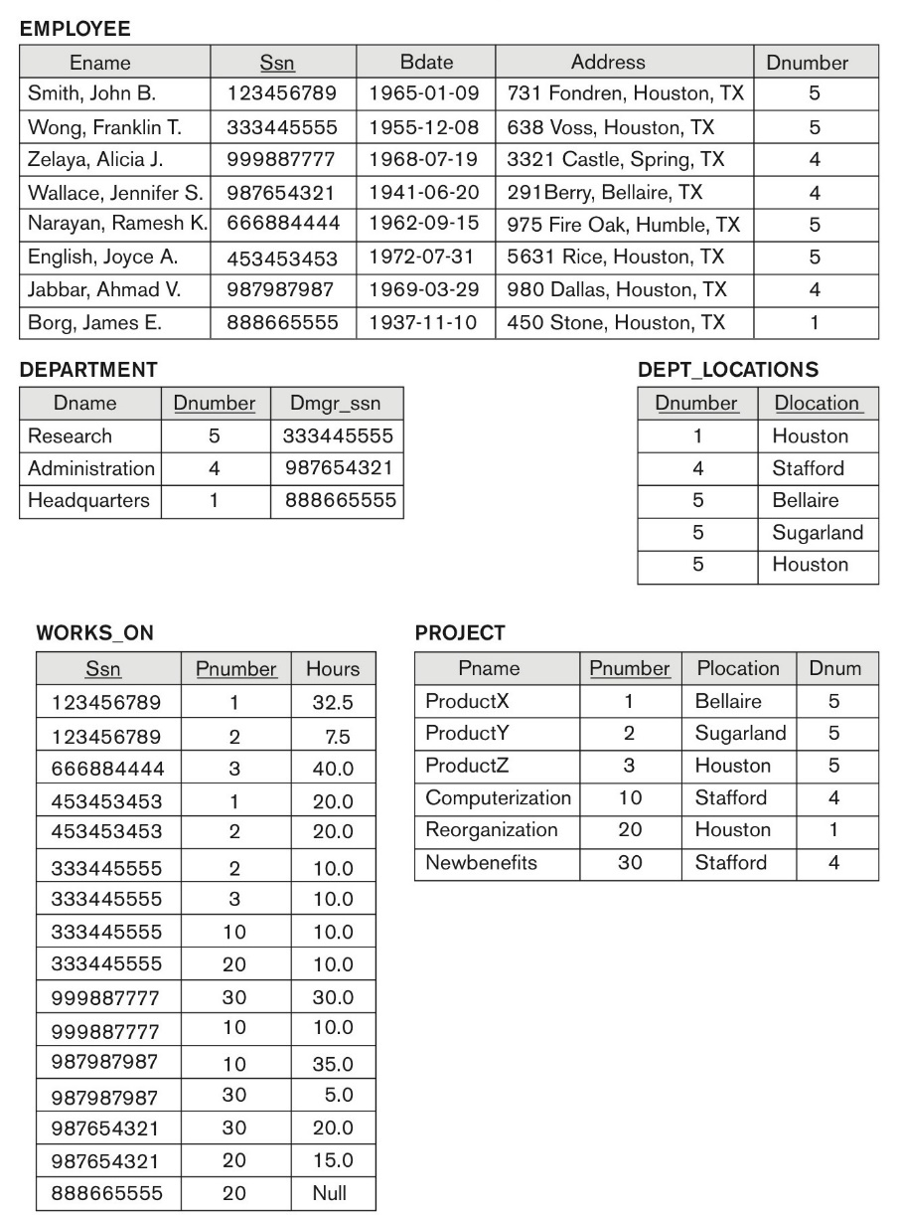

**Figure 14.2 (book):** Sample database state for a simplified COMPANY relation DB

****

Fig 4.1: DEPARTMENT_PROJECT DB schema suffering from update anomalies

FD1

FD2

FD3

Dnumber Pnumber Dname Dmgr_ssn Pname Plocation

***

Fig 4.2: A database state of the DEPARTMENT_PROJECT DATABASE derived from Fig 14.2

DNUMBER PNUMBER DNAME DMGR_SSN PNAME PLOCATION

---------- ---------- --------------- --------- --------------- ---------------

5 3 Research 333445555 ProductZ Houston

5 10 Research 333445555 Computerize Stafford

5 20 Research 333445555 Reorganize Houston

5 30 Research 333445555 Nbenefits Stafford

5 1 Research 333445555 ProductX Bellair

5 2 Research 333445555 ProductY Sugarland

4 3 Administration 987654321 ProductZ Houston

4 10 Administration 987654321 Computerize Stafford

4 20 Administration 987654321 Reorganize Houston

4 30 Administration 987654321 Nbenefits Stafford

4 1 Administration 987654321 ProductX Bellair

4 2 Administration 987654321 ProductY Sugarland

1 3 Headquarters 888665555 ProductZ Houston

1 10 Headquarters 888665555 Computerize Stafford

1 20 Headquarters 888665555 Reorganize Houston

1 30 Headquarters 888665555 Nbenefits Stafford

1 1 Headquarters 888665555 ProductX Bellair

1 2 Headquarters 888665555 ProductY Sugarland

18 rows selected.  
  
  
Solution: (3 + 3 + 3 + 1 marks)

|  |
| --- |
| 1. Inside Department_Project the relations PNUMBER to PNAME,PLOCATION and DNUMBER to DNAME can cause anomalies within the update. As an example, if Departments record where DNAME is stored were to be updated the integrity of the database would be violated since the FDs will no longer hold up. 2. A deletion anomaly can occur simply when a Project has no Departments working on it, all information within Project will not be accurately stored and represented. 3. The most obvious insert anomaly can occur when a before a project is assigned to a department, it’s records can’t technically be added into the database. |