**Music-Synced Smart Lighting System**

A dissertation submitted in

partial fulfilment of  
The requirement for the degree of  
**MASTER OF SCIENCE**

in

**Software Development**

in  
**The Queen’s University of Belfast**  
By  
**Ryan Urquhart**

**40099112  
06/05/2025**

**Acknowledgements:**

* Bee-Yen Toh – My supervisor, who was with me every step of the way
* Cherise McClean – My wife, a constant (and welcome) distraction
* SoDes – On GitHub, created a package that made this whole project possible on Windows (PyAudioWPatch)
* aiXander – On GitHub, created a repository that I adapted, it provided fast Fourier transformations that I built the beat detection algorithm on top of.

Abstract:

This report covers the development of a Music-Synced Smart Light System. The development of this system was successful; however, due to time constraints, the system (Bulb Bop) is missing several aspects that would be desirable should the project be continued. The initial style of development aids the continued development of Bulb Bop; it has been developed in such a manner as to allow easy continued development. Bulb Bop takes advantage of FFT of audio data from PyAudio to allow Bulb Bop to detect the beat of music and change bulb brightness in time with that beat.

Table of Contents

Introduction: 5

1. Understanding the Problem 6

2 User Interface Design 8

3 Architecture Design and Algorithm Explanation 13

**3.1** **API Endpoints** 13

**3.2** **Bulb Database Model** 15

**3.3** **Bulb communication** 15

**3.4** **Host Audio Parsing** 17

**3.5** **Beat Detection Algorithm** 18

**3.6** **Future Development Mindset** 20

**4** **Testing** 25

**4.1** **Automated Testing** 25

**4.2** **Manual Testing** 27

**5** **Evaluation and Conclusion** 30

**5.1** **Evaluation of Project Success** 30

**5.2** **Reflection of Process** 31

**5.3** **Evaluation of Software** 32

**5.4** **Suggestions for Further Work** 32

**5.5** **Conclusion** 32

## Introduction:

The project discussed in this report is hosted on a repository at https://github.com/RyanMcClean/wizlight-music-sync. If you have trouble accessing the repository, please contact rurquhart01@qub.ac.uk.

This report focuses on the development of a Music-Synchronised Light Control System (hereafter referred to as Bulb Bop). The report will consist of six chapters: Chapter One, Understanding the Problem; Chapter Two, User interface design; Chapter Three, Architecture design and algorithm explanation; Chapter Four, Experimentation; Chapter Five, Testing; and Chapter Six, Evaluation and Conclusion. The content of these chapters will be explained in the rest of the introduction.

Chapter One will explore the problem and the basis on which the Bulb Bop was developed. This will include my initial understanding of the project based on the title and the preliminary meetings with my supervisor. It will then progress into my initial investigations about potential solutions to the problem at hand. Finally, this chapter will end with the decided-upon plan of action for development.

Chapter Two will contain the plan and development of the user interface. This will include the early iterations of the user interface and how these early iterations influenced the final design. It should be noted, however, that the bulk of the work in this project was the beat detection algorithm, and therefore, less thought was put into the user interface than into the back end of Bulb Bop.

Chapter Three will contain the plan and development of the architecture and algorithm design. This section will explain the architecture upon which Bulb Bop can be run and the algorithms that allow it to run. This is the chapter in which the bulk of this project's work will be explained.

Chapter Four will contain the testing carried out on the project, during its development, and before the submission of the project. This will include risk assessments of the project, and a discussion of the rationale of the tests that were designed, as well as an examination of the areas of the project that were not thoroughly tested and an explanation as to why.

Chapter Five will be the final evaluation and conclusion of the project. Discussing the success or failure of the development of Bulb Bop. It will evaluate different technologies utilised and how they have impacted the final system shape. There will be a reflection on my own development of the project, highlighting areas that were handled well, and areas where there could have been further development.

# Understanding the Problem

The initial description of the project is as follows,

“Develop a system that integrates music with dynamic lighting displays to create an 'instant smart disco light' function or a 'smart lighting solution for improved well-being.’ The system should control a Wi-Fi-enabled smart light bulb, adjusting its brightness and colour in sync with music rhythms, enhancing the atmosphere in any setting.”

In addition, there were four main functional criteria for developing Bulb Bop.

1. The system should connect to and control a Wi-Fi-enabled smart light bulb
2. The system should detect music rhythm and tempo from an audio source and synchronise the light settings accordingly
3. The system should provide a primary control interface
4. The system should offer multiple lighting modes

No restriction was placed on the technologies to be utilised in this project, such as specific bulbs, programming languages, or web frameworks. However, due to having to use third-party hardware (the smart bulbs), a particular API dictated by the manufacturer would have to be used.

The initial prompt does not define the user for whom the application is supposed to be designed. However, through discussions, the intended user was defined broadly, from families to DJS to people hosting a party. The decided goal was narrowed down to someone hosting a party in their house. This user would either use a microphone attached to the computer running Bulb Bop or play the music from its speakers.

Research was carried out from the initial description of the project, which covered two main areas. The first was the bulb, whose brand would be appropriate for the project. The second was the programming language; this programming language had to fulfil two criteria: it needed access to the audio from the operating system (Windows and Linux) and be able to host a web server, which would provide the user interface.

The research into the bulbs brought up many different options for use, Wiz, TP-Link Kasa, TP-Link Tapo, YeeLight, Shelly, Philips Hue, Athom tech, and Switchbot. From all these bulbs, it was decided to use Wiz bulbs. The reasons for this were the cost, the open API (bulbs like TP-Link Tapo have a closed API so users must use their app), the app does not require a hub to operate (Philips Hue requires a hub), and from my reading of various forums*,* wiz was highly recommended as a bulb brand. Based on this research, A WizBulb A60.E27 bulb (A colour-changing bulb) was purchased, and later a non-colour-changing bulb was procured.

The research into the programming language to use initially started with Java, the reason for this simply being that much of the CSC7063 Computer Programming course has been taught in Java. Two libraries I looked at were TarsosDSP(Six, 2011/2025) and Jipes by Tagtraum(Schreiber, 2013/2024), both of which I was unable to gain access to audio data from the host machine using. Jipes was unsuited as it was not made for real-time processing of audio information. With regards to TarsosDSP, it used Gradle to build it, which was something that, given the time I needed to get the project started, I was unable to figure out.

As such, I looked for another programming language that would allow me access to this host audio data. For this, I turned to Python; there is a Python package named PyAudio, and it reliably and easily allows developers access to the host machine's audio data. The issue, however, is that PyAudio does not allow access to the loopback API present on Windows machines, which allows the developer access to real-time speaker audio data. This was solved when I found a Windows-specific patch of the PyAudio library, called PyAudioWPatch. This allows PyAudio the ability to access the loopback API, with the Django library that can serve web apps with a great deal of flexibility, making Python the perfect choice.

A significant consideration to take into account was the security of Bulb Bop. In the case of this project, there is little to no system security. While it was considered to add security, it was decided against for the following reasons. There are no personal details saved in Bulb Bop, nor would the addition of security, like a login page or OAuth authentication, protect the bulbs from being manipulated by someone who knows how to do so (as the bulbs themselves have no security on the local network). The only security for this system comes externally to Bulb Bop and comes in the form of the firewall on the local network.

# User Interface Design

Figure - Index Page (PC View)

The user interface for this system is quite simple. The user can access four different views, each of which is dynamic to varying degrees. Django gives the option to develop HTML that will dynamically change based on a context provided by the developer. For instance, the bulbs on the index page render depending on whether they are present in the database or not.

The first part of the user interface we will discuss is the parts common to all views. The central part of this is the navbar, which contains the title, links to other views, buttons to activate functions of Bulb Bop, and a light/dark mode toggle button. There is also a footer on the page, a line that contains the text, ‘2023-25: Bulb Bop: Ryan Urquhart: 40099112’. Part of these aspects are dynamic; the audio sync option, for instance, only shows when bulbs are recorded in the database.

The second view we will look at is the home page, the index page (Figures 1 and 2), which is the main page that the user will be engaging with. This page displays icons for the bulbs that are recorded in the database, their names, as well as graphically displaying their state. Some tooltips appear when the user hovers their mouse over the bulbs, which inform the user that, should they click on it, it will toggle the state of the bulb. Should the user not yet have connected Bulb Bop with any bulbs, then the index page will prompt the user to use the discover function of Bulb Bop (Figure 3).

Figure - Index View (Mobile View)

Figure - User prompts to add bulbs

Figure - FAQ's Page (PC View)

The third aspect of the user interface we will discuss is the ‘FAQ’ (frequently asked questions) page (figure 4). This page covers some basic setup questions a user may have, from connecting lights to troubleshooting, and a contact email for support (not a real email). This page is referenced in the tooltip to help new users get started with the application. It also links to the WizBulb app, to show users how to connect their bulbs to the local network (unfortunately, using Bulb Bop to connect the bulbs to the local network was impossible as it requires Bluetooth and is undocumented).

Figure - About View (PC View)

The fourth page of Bulb Bop to discuss is the ‘About’ page. This page simply displays information about the project, its goals, and some information about the project author. Like every other page, this page has the navigation bar, which allows the user, should they have bulbs saved in the database, to activate the audio sync. As this page is mostly static, apart from the navigation bar, there is nothing else to say.

The final page to discuss in this section is the ‘Edit’ page for the bulbs. This page allows the user to edit or delete the bulbs that they have saved in the database. The user can edit the bulb's name and IP address. When Bulb Bop has a bulb saved with a name and an IP address, then it will query the bulb and update its status in the database itself. When the user clicks on edit, it will show a modal that the user can interact with to edit the bulb. When the user clicks save, edit, or delete, the page will display a success or error message in the bottom right corner.

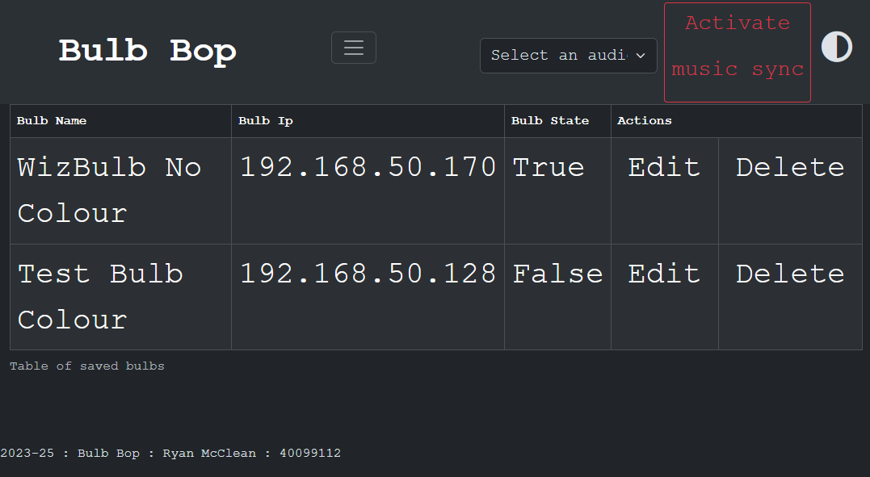

Figure - Edit View with two bulbs

Figure - Example Error Message

Figure - Example Success Message

# Architecture Design and Algorithm Explanation

In this section of the report, the discussion will centre on the ‘backend’ of Bulb Bop. This will include a description of the API endpoints, the bulb database model, how Bulb Bop was configured to interface with bulbs on the network, a description of how access was gained to the audio data of the host machine, an explanation of the algorithm to detect beats in music, and finally a section on how Bulb Bop was produced so with future development in mind. This section will encompass most of the work done on this project and, therefore, will be the longest section in this report.

# TODO EXPAND ON SECURITY HERE #

# TODO Installation process #

## **API Endpoints**

This project has 14 API endpoints, not including requests that get images and JavaScript code. Four of these endpoints are for different views or pages, of the user interface, one is reused for bulb form submission, therefore, these will not be discussed in this section, as the views were mentioned in chapter 2. There are three endpoints for bulb control, four (including the reused view endpoint) for database operations and, two for error and success handling.

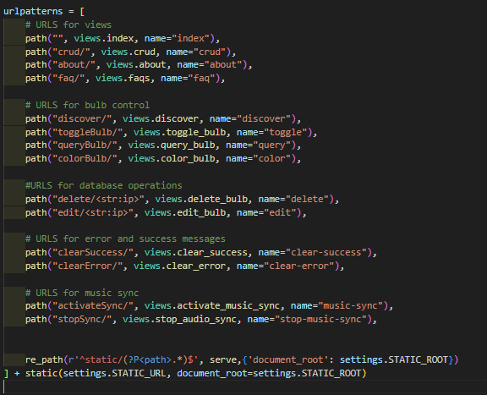

Figure - List of API endpoints

The endpoints for bulb control are as follows: “/discover/”, “/toggleBulb/”, “/queryBulb/”, and “/colorBulb/”. Of these four, only three are currently utilised in Bulb Bop, “/colorBulb/” was developed for use, but when testing with a colour changing bulb, and a non-colour changing bulb this endpoint caused issues, so was left for future development, which ultimately ended up being scoped out of the project. “/discover/” is used to discover new bulbs on the network. It sends a broadcast UDP packet, to which bulbs connected to the network respond with their current state. This response is shown to the user, who can give the bulb a name, which is then sent to another endpoint, which will be mentioned later. “/toggleBulb/” is the primary endpoint the user will trigger from the user interface, when they click on the icon of a bulb it will trigger this endpoint, which sends a packet to the specific bulb and instructs it to turn off, or on, depending on the state of the bulb recorded in Bulb Bop. “/queryBulb/’ is similar to “/discover/”, except rather than sending a broadcast packet to all IP addresses, it sends packets to specific addresses to query the state of particular bulbs.

The endpoints that control database operations are “/”, “/delete/<str:ip>/”, and “/edit/<str:ip>”. The “/” endpoint is the index endpoint. When this endpoint is triggered with a GET request, it renders the home page; when it’s triggered with a POST request, it submits a Django model form. This Django model form is how Bulb Bop saves new bulbs in the database. When the form is submitted, it is checked to ensure that it contains no errors. The criteria for this check is that the Ip address is valid, and that the name of the bulb is not null. The other information for the bulb is filled in from the return from the broadcast packet that was sent during discovery. The next two endpoints are accessible to the user through the edit bulbs page, “/delete/<str:ip>/” and “/edit/<str:ip>/” both of these endpoints require the Ip address of the bulb in which they are editing, as a unique identifier. “/delete/<str:ip>/” will delete the bulb with the specified Ip address, and “/edit/<str:ip>/” will submit a form, that is verified, of a new Ip address or name for the bulb, this then updates the model in the database for that bulb.

There are two endpoints that control error and success handling, these clear the error and success messages, both are to prevent error, and success messages being displayed multiple times. These endpoints are never interacted with by the user manually, they are triggered through JavaScript that runs when every page loads. While this does not interfere with a message that is being displayed in the page that has just been loaded, it will prevent a message from being displayed in another page that the user navigates to.

There are two endpoints for controlling the audio synchronisation, “/activateSync/”, and “/stopsync/”. These are self-explanatory, “/activateSync/”, this endpoint accepts a POST request that contains the index number of the audio device selected by the user. This then activates the audio sync in Bulb Bop for that audio device, Bulb Bop waits thirty seconds to ensure that the sync program has activated, then it sends a status message to the user interface.

This concludes the API endpoints activated by the user or by the JavaScript that the pages contain. The next step of this chapter is to discuss how Bulb Bop achieved communication with the bulbs, the documentation that was followed, and the technologies involved in its process.

## **Bulb Database Model**

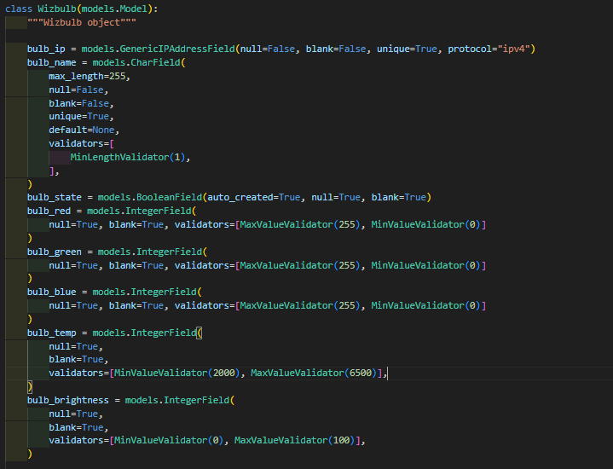

Figure - Bulb Database Django Model

The database design in this project is rather simple, it only contains one model, the bulb. This model consists of seven fields: the IP address, name, state, red, green, blue, temperature, and brightness. While all of these fields are updated when a bulb is queried, only the IP address, the name, and the state are used in Bulb Bop. For each field, there are several Django validators applied, which prevent bulbs from being created unless the criteria are met. For example, the IP address must be unique, it cannot be null or blank, and it must be a valid IPV4 address.

## **Bulb communication**

# TODO Mention difficulty with communicating with multiple bulbs with different capabilities here #

One of the reasons that the Wiz brand of bulbs was chosen for this project was the level of documentation about the bulb (*WiZ Pro API Reference*, n.d.). To augment this, there is also a Python package called, ‘pywizlight’ which utilises this documentation to provide communication to wiz devices (Traub, 2020/2025)I did not use this package and primarily relied on the Wiz documentation to enable communication with the bulbs.

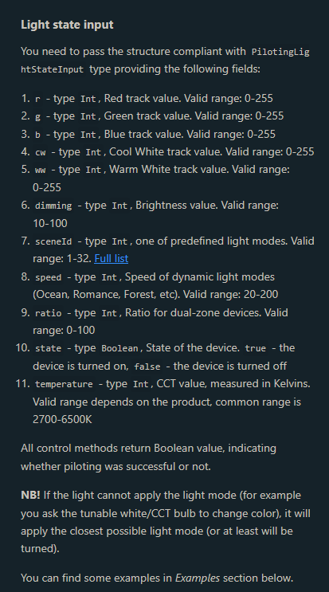

Figure - Excerpt from API Reference Site

Utilising the API reference, five UDP packets have been implemented for Bulb Bop to use. Two other UDP packets are also present, which are not currently used, but can be implemented in further development. The seven total packets have the following functions: bulb discovery, turn on bulb, turn off bulb, turn to half brightness, turn to full brightness, bulb registration, and turn bulb to colour. Bulb registration and turning the bulb to a colour are unused by Bulb Bop, while both were used in the development of Bulb Bop, so it was unfeasible to implement them properly in the time given for the project.

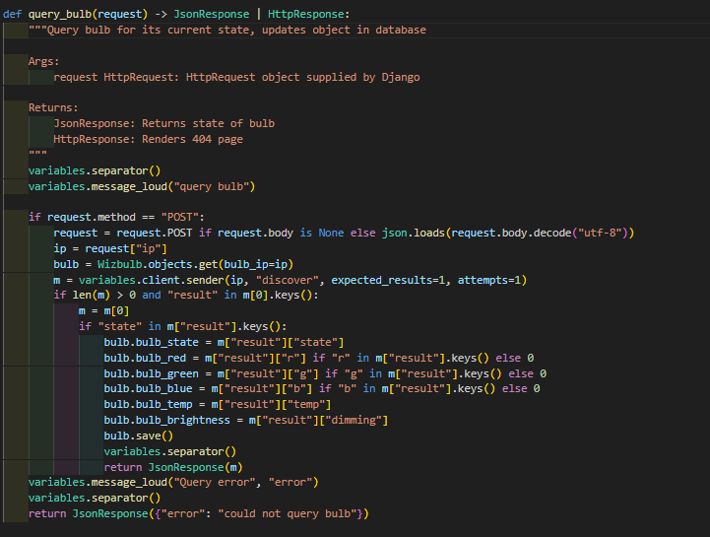

Figure - Query Bulb Function that parses the bulb packet return

Functions that can read and parse the return UDP packets from the bulbs have also been implemented. These packets contain information that allows Bulb Bop to update the bulb object and database model with their current state. This allows the index view, for instance, to change the colour of the bulb icons depending on the current state of the bulbs.

## **Host Audio Parsing**

The reason that Python was used over Java was that Python has easy access to the audio of the host machine. Initially, only PyAudio was used, and Bulb Bop was able to access microphones attached to the host machine; however, then PyAudioWPatch was discovered. PyAudioWPatch takes advantage of Windows Audio Session API (WASAPI) (drewbatgit, 2021), this allows the audio of output devices to be intercepted and parsed by the library. With the discovery of PyAudioWPatch I was then able to allow Bulb Bop to parse music played from Bulb Bop and control the lights accordingly, this is a considerable improvement over having to use Bulb Bop with a microphone which would have picked up all stray noises, making the beat detection a much harder task (using a microphone is still as possible as using a speaker is). On Linux PyAudioWPatch does not work, as WASAPI is a windows only API, however, using PulseAudio on a Linux machine, it is easy to create a loopback of a speaker so that it registers as an input device.

So due to this I had access to the raw audio output of a selected microphone or speaker of the host machine. This however, was unhelpful when it comes to detecting beats, as from PyAudio (or PyAudioWPatch) I am just getting a stream of un-processed data. This un-processed data needed to be sorted into frequencies and amplitudes, necessitating the use of Fast Fourier Transformations. This however, is a complicated process, so to handle this for me, I found a repository on GitHub that would handle this calculation for me, Realtime_PyAudio_FFT (*aiXander/Realtime_PyAudio_FFT: Realtime Audio Analysis in Python, Using PyAudio and Numpy to Extract and Visualize FFT Features from Streaming Audio.*, n.d.). The repository itself was helpful; however, it was not designed for my needs, this meant that I had to modify it. This meant making it work with PyAudioWPatch, but it had to still work with PyAudio (to allow it to work on Windows and on Linux).

Figure - List of commits to submodule

To manage this edit, I changed it so that rather than visualising the audio output the repository would instead just return the stream of frequencies and amplitudes that are being produced by the audio device. I also changed the repository so that it would use the ‘PyAudioWPatch’ library, if possible, but would fallback to ‘PyAudio’ if ‘PyAudioWPatch’ is not available (i.e. on Linux rather than windows). Another change that I made, was the editing of channels and audio rate, this was necessary to allow the use of speakers with Bulb Bop. This final change was necessary, as speakers often use two channels, for left and right, they also tend to use a higher rate for the audio than microphones do.

With the libraries and changes made above once the user selects an audio device and clicks to start the synchronisation of music, then Bulb Bop will start a stream of amplitudes and frequencies. This stream is then parsed by Bulb Bop and using the beat detection algorithm will send UDP packets to the bulb(s) to turn them up, or down, in brightness in time with each other and the music. This beat detection algorithm is what will be discussed in the final section in this chapter.

## **Beat Detection Algorithm**

Now Bulb Bop is getting a stream of computed frequencies and amplitudes from the audio device, as the final goal of the project is to have the beat of the music be what influences the control of the bulbs, the audio data will need to be manipulated to detect the beat. From my research this is an extremely difficult task, a lot of beat detection does not happen in real-time, rather it observes an audio file in it’s entirety and detects the beat that way (‘Beat Detection’, 2021). Therefore, I looked at an example of beat detection that is used in real-time (*Beat Detection Algorithm – Parallelcube*, 2018), this example comes with formulas that I was able to adapt to serve the purposes of Bulb Bop.

When it comes to Bulb Bop parsing the audio, the start was to figure out the frequencies that needed attention, and which ones could be ignored. I ultimately decided that all frequencies over one hundred and fifty hertz were to be ignored. The higher frequencies contain vocals and other instruments that are not indicative of a beat in the melody. The lower frequencies, however, are where most of the drum set is contained, this is where the beat will be most noticeable, and therefore these are the frequencies that Bulb Bop will be using in the beat detection. The rest of this section will cover the input of frequencies and amplitudes and how it is manipulated to define a threshold for beat detection.

$$E=\sum_{i=k}^{k+n}{FFT\left[i\right]}$$

The above equation is how Bulb Bop gets the sum of the amplitudes (E) for a particular set of frequencies (i to k+n). This is achieved by calculating the sum of the FFT amplitudes (FFT[i]) where ‘i’ is the frequency. This is done for the range i=k, i.e. the starting frequency of the sum, and k+n, where k+n is the max frequency of the sum. In Bulb Bop this is done for three ranges of frequencies, where n always equals 50, but i is equal to, 0, 50, and 100. This leaves Bulb Bop with a sum of amplitudes, from 0hz to 49hz, 50hz to 99hz, 100hz, to 149hz. Every frequency above 150hz is ignored.

$$H=E_{t0},E_{t1},…E_{t\left(buffersize\right)}$$

This sum of amplitudes is then added to an array, one amplitude for each unit time. The unit of time in this case is dependent on how fast the host machine can compute the amplitudes of the audio data which it is manipulating. This means that an average can be calculated for each array of amplitudes, this is done as below.

$$\operatorname{avg}\left(H\right)=\frac{1}{buffersize}\sum_{i=0}^{buffersize}{H\left[i\right]}$$

This average can then be used to determine the fraction of the average compared to the sum of the amplitudes for that frequency range, this fraction can be considered the variance. The sum of these variances for the length of ‘buffersize’ can then be considered to be ‘F’.

$$F=\sum_{i=0}^{buffersize=n}{\frac{avg\left(H\right)}{E}}$$

This sum can then be used to calculate the average variance (V), however, to ensure that the average variance is greater than the one (this is needed so that the beat limit is greater than the average frequency range amplitude), when calculating the average variance, if the variance is less than one, then the inverse of the variance is taken.

$$V=\left\{\begin{aligned}\frac{F}{buffersize} if F ≥1 \\ \frac{F^{-1}}{buffersize} if F <1\end{aligned}\right.$$

Now that the average variance (V) has been calculated, this can be used to calculate a threshold value, this is the threshold which if the sum of amplitudes for a frequency is greater than, then it will be considered a beat. The equation to calculate the threshold is as follows.

$$threshold=avg\left(H_{x}\right)+\left(avg\left(H\right)*V\right)$$

$$E>threshold$$

Upon the detection of a beat by the explained algorithm above, Bulb Bop will then send a UDP packet to all bulbs connected to Bulb Bop and it will change the brightness of the bulbs appropriately.

## **Future Development Mindset**

Part of the requirements of this project was to ensure that the project was left in a position that would be conducive to future development. This means that the code is clean, organised, and written in such a way that should another developer with no experience of Bulb Bop (but experience in the language and framework), pick up this project where it has been left off, they would have no difficulty understanding the development choices and code. To go beyond, this project also includes organisation of the GitHub repository that it is hosted on (McClean, 2024/2025).

With regards to clean code, this means that Bulb Bop is organised into directories, each of which is named to clearly label the contents. For example, the templates folder holds all the Django template files that are used to render the webpages.

Figure - Display of Directory structure

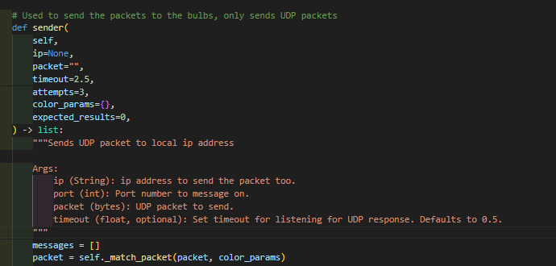

Figure - Example of docstring’s and comments

While this is helpful, it is not enough if the content of these files is hard to read or understand. To combat this deficiency, two approaches have been taken. One, the code base is automatically formatted by one of two formatters. For python files, the code is formatted by the “Black” formatter (*Black*, 2025), if the file is an ‘html’ file, or a ‘JavaScript’ file, then it will be formatted by the ‘Prettier’ formatter (*Prettier · Opinionated Code Formatter · Prettier*, 2025). The second approach is the manual addition of comments, docstrings, and helper files.

The addition of formatters into the project means, that whoever is adding code into the project, the style will be consistent. ‘Prettier’ formatter, is manually configured with settings that will maintain consistent ‘html’ and ‘JavaScript’ formatting. The ‘Black’ formatter maintains python files in a format that is consistent with Pythons PEP 8 guidelines (*PEP 8 – Style Guide for Python Code | Peps.Python.Org*, 2025).

The project also makes use of linting, Pylint is used to provide this linting (*Pylint 3.3.6 Documentation*, 2025). This linting provides a score out of ten for how closely the code follows the PEP8 standards. This score is displayed on the README on the GitHub page.

The focus of the PEP8 style guide from Python is on readability. This is also the intended purpose of the addition of comments, docstrings, and helper files. Each module, function, class, and method have docstrings present on them, these simply explain the intended purpose of the following code.

There are specific parts of Bulb Bop that are written but not in use. One example of this is a function that produces a packet that can turn a WizBulb to a specific colour. This is something that was hoped to be included in the final project, however given time constraints this was not implemented. These such sections of code were left in place to allow for their use without further research in the future. These sections contain comments to ensure that they are not misunderstood.

The GitHub repository for this project contains extensive organisational rules, guidelines, and continuous integration (CI) to ensure it maintains a consistent order for future development. Some of these rules have had to be ignored for the initial development of Bulb Bop. Others, like the CI for instance were extremely helpful in catching bugs and maintaining code style.

This includes branch rules, to prevent anyone pushing git commits to the main branch without the pull request getting reviewed by another coder. For future and larger development teams this is integral to preventing the addition of ‘bad’ code to protected branches. With regards to pull requests I have also implemented a pull request template, and the addition of various labels to help organise pull requests and issues.

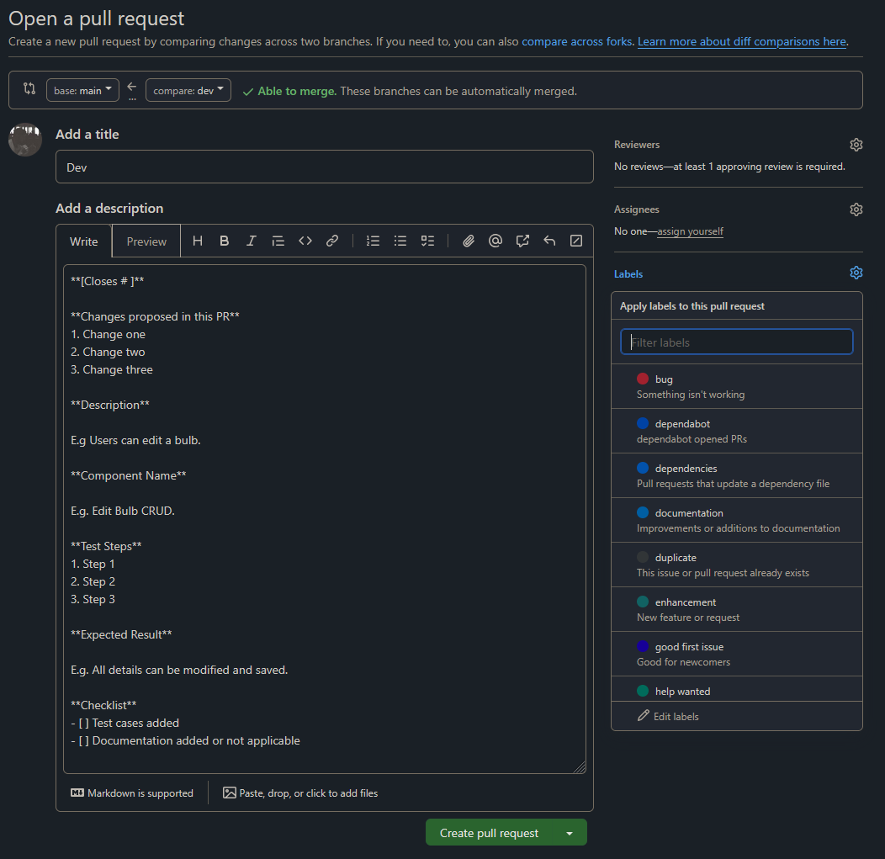

Figure - Example of Pull Request Template

The most helpful feature of GitHub was the CI, this allowed me to test commits and pull requests made to the GitHub repository automatically. Using CI the repository was able to run the entire testing suite on each pull request, and scheduled each night at midnight, this then sends email notifications should a CI run fail. On top of that, the CI is able to handle other automations that are helpful to maintaining an awareness of the state of the code in the repository, such as the Pylint badge, the coverage badge, and a badge that displays the status of the last CI run.

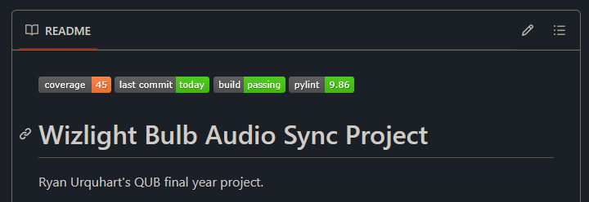

Figure - Screenshot of GitHub buttons

# **Testing**

In this chapter the testing that has been carried out on Bulb Bop will be discussed. This will cover two main sections, automated testing, and manual testing. Test cases for both will be discussed, their results, future testing that could take place, and weaknesses of the testing procedure will also be discussed.

## **Automated Testing**

Most of the testing that has been carried out on Bulb Bop was automated, this is due to the CI on GitHub that allowed the automated tests to be carried out again and again. The automated testing was extremely helpful as it allowed for the ability to check on the status of code changes before committing to the repository. The development of the tests focused on the ability of the user to start the audio synchronisation, as this was the main objective of the project. This was also the main objective of the manual testing on the project, that will be discussed in the next section.

The automated testing in this project takes on three shapes, directly testing the code, its function, and the database, running a mock live server and testing that the UI functions as expected, and finally testing the API endpoints to ensure that the code functions as expected. With these three approaches, it is possible to cover most of the users experience with Bulb Bop, as well as many of the functions that the user does not interact directly with. There are however, some functionality that is not tested in this approach, this can be due to several reasons. Code that is too complex, code that can only be ran on a live and active (has bulbs connected and live) system, or simulating the inputs is too complex, for example, simulating the input of an audio device into Bulb Bop is too complex for the scope of this project.

To discuss the testing the format will follow the user journey to starting the audio synchronisation. The steps this includes are as follows:

1. Install Bulb Bop
2. Load the index view
3. Discover bulbs
4. Save bulbs
5. Select an audio device
6. Start the audio synchronisation

There are other actions that the user can take, these are also tested, such as loading the FAQ view, or editing a bulb, these are also tested for, and the documentation for these can be found in the attached appendix.

There are two ways that Bulb Bop can be installed from scratch, one is manual, one is automated. The automated way to install Bulb Bop from scratch is via GitHub actions. The actions are configured to pull the GitHub repository and then to build it and run tests against it. Each time the GitHub actions run Bulb Bop is installed on two separate windows virtual hosts, and two separate ubuntu virtual hosts, one of each of these sets is ran with Python 3.11 and the other with Python 3.12. This ensures that Bulb Bop remains installable, but also that it works with Python 3.11, Python 3.12, Windows, and Ubuntu.

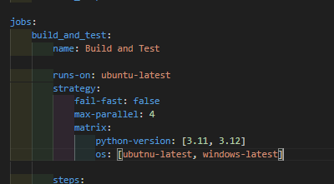

Figure - Configuration of systems to run GitHub actions on

This test has been incredibly helpful in discovering bugs in Bulb Bop, for instance, there was a bug that when Bulb Bop was installed it would try and access the Wizbulb database model before the table was created. This caused an error that would prevent installation of Bulb Bop, this bug was discovered by a run of the GitHub actions that failed. Bulb Bop on the development host machine missed this bug as the database was already created on the machine.

For tests that involve loading and ensuring that the page has been loaded correctly Playwright was used to run these tests. Django has a feature that means it can load a live server with an empty database, this allows for Playwright to load the views of Bulb Bop and ensure that elements are loaded and in the appropriate state (i.e. visible, attaches, etc). This is more valuable than just simply checking that the correct template was rendered, as it more accurately checks the users experience of the user interface.

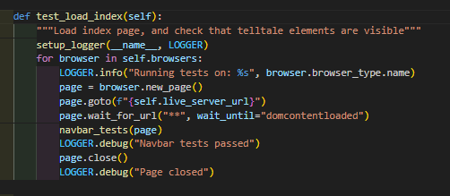

Figure - Playwright load index test

The Playwright testing allows for some small compatibility testing as well. The tests can be run on multiple kinds of browsers, they are configured to run on Firefox, and Chrome. Due to this testing, it is proven that Bulb Bop is not only cross OS compatible, but it is cross-browser compatible as well. There are a series of these tests that run, testing each view in turn, as well as navigation between views. Those not discussed here are documented in the appendix.

For the user to discover bulbs they must click the ‘Find Bulbs’ button on any of the views on Bulb Bop. This navigates the user to the ‘/discover/’ view. This page is almost identical to the index view; however, Django has templates that allow the HTML files to change dynamically based on the context. Navigating to the discover page changes this context and now the page will display un-saved bulbs connected to the local network on the index view.

There is a difficulty in automated testing of the bulb discovery function of Bulb Bop. When running these tests on GitHub runners, which are virtual machines with virtual networks, there are no bulbs that can be discovered. This means that the discovery function of Bulb Bop is unable to be fully tested by automated testing as it would fail when the bulbs were not discovered. This is something that must be handled via manual testing, however, successful navigation to the discover page can be tested as below (Figure 20).

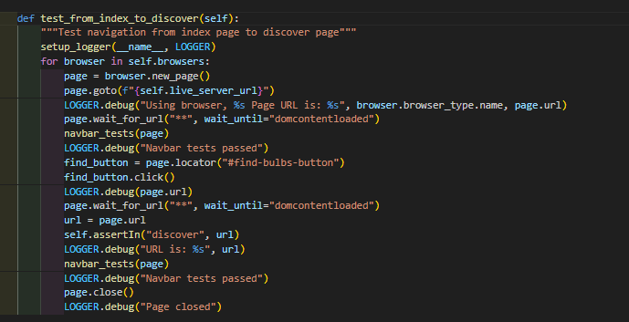

Figure - Test Navigation from Index to Discover Views

The final three sections of the user journey to starting the audio synchronisation need manual testing to fully test. There is some small amount of testing that can be carried out via automated testing. Such as ensuring forms submitted properly or improperly are accepted or rejected as appropriate or testing the API endpoint to start the audio synchronisation. These are helpful but not complete until the manual testing is finished.

## **Manual Testing**

To be able to completely test the user journey of Bulb Bop manual testing is needed. These covers testing the ability to discover bulbs, to toggle bulbs, to start the audio synchronisation, and to stop the audio synchronisation. There are many functions of Bulb Bop that are covered by the manual tests, the ones discussed here will cover the user journey for the main functionality, other tests not discussed here will be available in the appendix.



Figure - Discover Bulbs Manual Test

The above test covers the first step in the user journey to activating the audio sync, discovering the bulbs, this can only be done manually because the automated tests don’t always run on a network that has bulbs connected, and therefore, the tests cannot be configured to expect them to be present. Documentation for the tests will all follow the format of Figure 21 and will be present in the appendix.

Figure - Steps for saving a bulb to Bulb Bop

The next step of the user story is the ability to save bulbs, this has been tested successfully multiple times. The next step is then to test the ability to select an audio device, this step had to be done manually because when using GitHub runners, they are virtual machines which have no access to an audio device, therefore the dropdown menu in Bulb Bop has nothing to be populated with. Even when manually running this test the dropdown menu can be confusing, as the names for the audio devices are pulled directly from the host machine. These names can be confusing unless the user has some awareness of the audio devices attached to their host machine.

Figure - Test Steps for Selecting an Audio Device

With the ability to discover bulbs, save bulbs, and then select an audio device, the final step that needs tested in the main user journey is the ability to start the audio synchronisation. This again is a step that needs manual testing as the tester needs to watch the bulbs to make sure they change in time with the music. This final step is also the step that was used to test the beat detection algorithm, this was rather difficult to test as beats in music can be quite fast, or hard to pick up.



Figure - Test steps for Starting the Audio Sync

Once these manual tests were run in accordance with the automated testing the main requirements of Bulb Bop were tested and proven functional.

# **Evaluation and Conclusion**

## **Evaluation of Project Success**

At the start of this section, the initial requirements of Bulb Bop will be reiterated:

1. The system should connect to and control a Wi-Fi-enabled smart light bulb
2. The system should detect music rhythm and tempo from an audio source and synchronise the light settings accordingly
3. The system should provide a primary control interface
4. The system should offer multiple lighting modes

This section shall take each of the four requirements in turn and discuss their completion or lack thereof.

“The system should connect to and control a Wi-Fi-enabled smart light bulb” As seen through the manual testing (Figures 21 and 22), Bulb Bop is able to discover bulbs connected to the network and save them in the database for future control. The only weakness of Bulb Bop here is the inability of Bulb Bop to pair bulbs to the network in the first place. This weakness cannot be solved, WizBulb does not document the pairing process of the bulbs to the network and must be done via their proprietary application.

“The system should detect music rhythm and temp from an audio source and synchronise the light settings accordingly”, as seen in Figure 23 and 24, Bulb Bop is able to detect audio devices on the host machine, parse their audio input/output, and use that to change the brightness setting of bulbs saved to Bulb Bop. The algorithm that is used was documented in Chapter 3, section 5, this algorithm, is not perfect, through manual testing it can been seen to react to the beat, but will occasionally miss a beat, or flicker the bulbs when there is no beat.

“The system should provide a primary control interface”. The index view of Bulb Bop handles this. When bulbs are saved in the database and present on the network, the bulbs can be toggled (turned on and off) by clicking on the appropriate icon (Figure 25). The user is also able to edit the name of the bulbs, that are saved in the database (as well as the IP address). The user can also start or stop the audio synchronisation from any page on Bulb Bop. All of these make up the primary control interface.

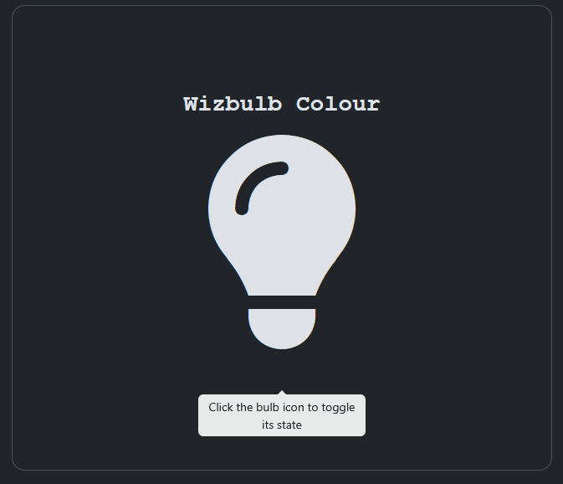

Figure - Bulb Icon with User prompt to toggle bulb

The only requirement that was not met by the final iteration of Bulb Bop is “The system should offer multiple lighting modes.” Initial work was done to allow changing coloured bulbs, and this is still present in the code repository, but it is not currently implemented. This requirement should be a priority for any further iterations of Bulb Bop.

Bulb Bop has met three-quarters of the initial system requirements; however, substantial strides have been made towards the final requirement. Examples of this are API endpoints that can change the colour of capable bulbs and registration packets that are still present in the code repository. Not only this, but the code repository has been created in such a way as to make future development as easy as possible.

As such, the final evaluation of this project's success is that it was indeed a success, with the caveat that future development is needed before it will fulfil the full user requirements, but for the limited time given for the project, it has been developed as much as was possible.

## **Reflection of Process**

The software development process of Bulb Bop was well planned out, initial research and software development proceeded well. As the project progressed, the development became less structured, it still progressed at a healthy pace despite this. As mentioned previously, there was a significant amount of enforced structure through GitHub. This saved a significant amount of work in development, from allowing the maintenance of a working git branch while working on a development branch, to nightly tests that showed issues extremely quickly.

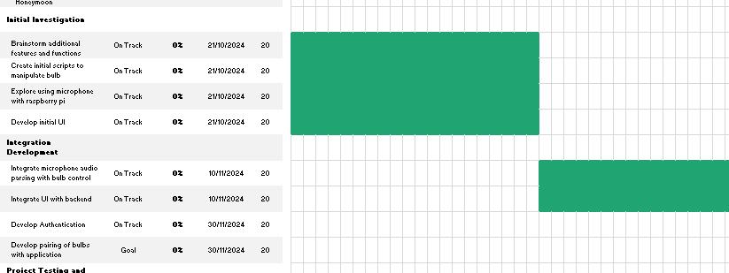

Figure - Start of Gantt Chart

One part of the process that the development of Bulb Bop significantly benefited from was the early addition of testing. While it was also an example of the development of Bulb Bop becoming less structured, as testing was planned to be implemented in the final few weeks of the development timeline, it also massively benefited Bulb Bop by ensuring consistently working code and highlighting issues when they appeared.

The lack of structure that came to the development in it’s later stages was unhelpful in a few ways. Occasionally there would be some issues in the software that would go untouched for quite a while before it was handled. Often the main issue that needed sorted would be ignored while other less important issues were handled. Such as time being spent picking a font, rather than working on the beat detection algorithm.

The development of this software would have benefited from a mid-way review of the process. This was not carried out, but would have allowed for a review of the user requirements and the current state of Bulb Bop. Thus, the final half of the development could have been planned out, and it would have prevented the loss of structure.

## **Evaluation of Software**

In this section, a fair evaluation of Bulb Bop will be carried out; this will cover an evaluation of the user interface, the backend of Bulb Bop, and the overall functionality of Bulb Bop. The final conclusion of this section is that while Bulb Bop is functional, and usable, it still requires work. Some work is required to expand the functionality, and to ensure a more usable environment for the end-user.

Figure - Screenshot of Index Page in light mode

As can be seen in the images of the user interface in this report (Figures 1, 2, 3, 4, 5, 6, 7, 8, 25, 27) the interface is very basic. There are a lot of dynamic icons, the ability to toggle dark and light mode, and multiple different views. Bootstrap 5 is used to manage the css styling and the various elements of the html, there is minimal custom css which means that the user interface is very stable and cross compatible with many devices. Despite these the user interface is bland and at times unintuitive. This would require a developer with more experience in user interface design to remedy. However, as the main function of the user interface is to allow the user to activate the audio/light synchronisation the user interface still serves its function, just doing so un-aesthetically.

Figure - Index Endpoint Backend Code Screenshot

With regards to the backend of Bulb Bop, the code quality, functionality, and testability will be commented on here. In general, the code quality of Bulb Bop is excellent; it follows the PEP8 style guide and has enough comments to enhance the understandability of the function of the code without adding to the confusion of the code itself. The code is functional, there is little delay in the code, with threading being used as often as possible to speed up response time. If there was an issue in the code, it would be the complexity of the beat detection algorithm, which makes it extremely difficult to test. It is impractical to simulate the input of an audio device into the algorithm due to this, as such the detection algorithm has had to be manually tested to ensure that it works as expected. Not only this, but the detection algorithm is the only part of the code base that suffers from lower quality code, it has more nested for loops than is ideal for instance.

Figure - Beat Detection Algorithm in code

Finally, regarding the overall functionality of Bulb Bop, as previously mentioned, Bulb Bop meets three of the four initial user requirements. The missed requirement was missed due to several factors, the biggest of which was the time needed to figure out how to manage multiple Wi-Fi bulbs of different capabilities. Despite this Bulb Bop does provide a good base for future development on this requirement.

## **Suggestions for Further Work**

This report is going to make five suggestions for future development, which will be listed in order of priority, from highest priority to lowest priority.

1. Complete work on the fourth user requirement.

This work should be prioritised above all others so that Bulb Bop can meet all of the user requirements. To achieve this requirement, work will need to be carried out to programmatically discover the type of bulb that is connected, to allow for packets to change depending on the bulb that is connected to ensure that colour change packets aren’t sent to a bulb that does not have that capability, and for the user interface to be modified to allow the user to control this extra functionality.  
To reiterate, some of the needed work for this development is already present in the repository; there is a function that creates a packet to change the colour of a bulb.

1. Easy installation

The current state of Bulb Bop means that the user needs to have an understanding of how to run a Python script so that they can run the web application. This could be simplified to an exe for Windows or a simple bash script for Linux.

The first point of call for future development in Bulb Bop is the completion of work on the fourth requirement. Figuring out how to discover the type of bulb, and manage that by querying its state and sending the correct packet to the correct bulb. Once that is finished, the next priority suggested is that the development focus on a way to easily install Bulb Bop on other computers. Finally, when the previous two suggestions have been completed, the final recommendation is to redesign the user interface to allow for the increased functionality and a greater user experience.

Once this essential further work is carried out, the last recommendation would be to expand the number of bulb brands which Bulb Bop can work with. This would make Bulb Bop much more desirable to many more users of these brands of bulbs.

## **Conclusion**

To conclude this report, Bulp Bop is a limited success, it met three of the four main user requirements, only losing out to the fourth due to complexity and time constraints. Bulb Bop is robustly tested and well organised, aiding any future development that occurs.

**SCHOOL OF ELECTRONICS, ELECTRICAL ENGINEERING and COMPUTER SCIENCE**

**CSC7058 – INDIVIDUAL SOFTWARE DEVELOPMENT PROJECT**

A signed and completed cover sheet must accompany the submission of the Individual Software Development dissertation submitted for assessment.

Work submitted without a cover sheet will **NOT** be marked.

**Declaration of Academic Integrity**

Before signing the declaration below please check that the submission:

1. Has a full bibliography attached laid out according to the guidelines specified in the Student Project Handbook
2. Contains full acknowledgement of all secondary sources used (paper-based and electronic)
3. Does not exceed the specified page limit
4. Is clearly presented and proof-read
5. Is submitted on, or before, the specified or agreed due date. Late submissions will only be accepted in exceptional circumstances or where a deferment has been granted in advance.
6. Software and files are submitted via Canvas.

**I certify that that the submission is my own work, all sources are correctly attributed, and the contribution of any AI technologies is fully acknowledged.**

**I declare that I have read both the University and the School of Electronics, Electrical Engineering and Computer Science guidelines on plagiarism - http://www.qub.ac.uk/schools/eeecs/Education/StudentStudyInformation/Plagiarism/ - and that the attached submission is my own original work. No part of it has been submitted for any other assignment and I have acknowledged in my notes and bibliography all written and electronic sources used.**

**I am aware of the disciplinary consequences of failing to abide and follow the School and Queen’s University Regulations on Plagiarism.**

|  |  |  |  |
| --- | --- | --- | --- |
| **Name: (BLOCK CAPITALS)** |  | | |
| **Student Number:** |  | | |
|  |  |  |  |
| *Student’s signature* |  | *Date of submission* |  |