Ryan McFarland
 | Paste in your answers for each step below in this column. Paste your actual SQL text, not a screen shot of it. Paste a screen shot of your Result Grid. Be sure to “Snip” your screen shots as instructed in Assignment 02.
1 | Executive Summary | Brenda’s Bakeries is an expanding business that has grown into five shops and a central kitchen. Brenda’s Bakeries provide upscale bakery that other shops do not offer. Due to this growth, Brenda stated the need for an organized system, or database, of keeping track of her stores.  A database will be created to organize vital information that is a key to Brenda’s continued success. This database will be able to store every aspect of running her business. It will allow for each shop to keep track of its sales, as well as the employee that made the sale and who the customer is and what they purchased. This database will also allow Brenda to see what she bought from each vendor and how much it cost. Additionally, this database will keep track of the ingredients and recipes needed to create her pastries.  This database will not include product or ingredient waste. It also will not keep track of product inventory, since the kitchen only makes pastries that will be sold the following day.
2 | EER Diagram | 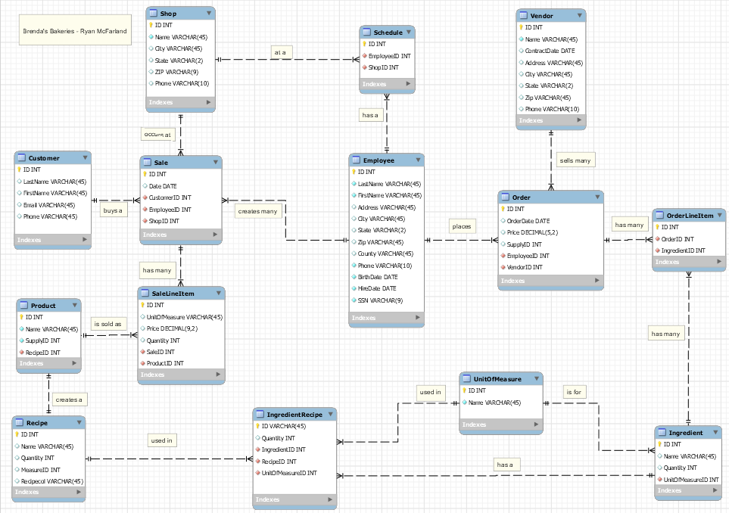
3 | Crayon Definition
  Entity Name | Crayon Definition
  Customer | The customer table provides the customer’s last and first name, email address, and phone number.
  Sale | The sale table provides the customer, employee, and shop ID’s that pertain to each sale.
  Employee | The employee table provides the last and first name of the employee as well as the hire date.
  Ingredient | The ingredient table stores all the ingredients used in the kitchen.
  Order | The order table stores the date the bakery purchased items from the vendor.
  OrderLineItem | The OrderLineItem table stores the items that were ordered from the vendor and their cost.
  Product | The product table stores all the products offered.
  Recipe | The recipe table provides the name of the recipe.
  SaleLineItem | The SaleLineItem table stores the cost and quantity of a product that is sold.
  Schedule | The schedule table provides the employees working at the shops.
  Shop | The shop table stores the name and city of the shop.
  UnitOfMeasure | The UnitOfMeasure table provides the name of the unit for the ingredients.
  Vendor | The vendor table stores the vendor name and contract date.
3 | Biz Rules | 1. A vendor can sell many orders.  2. An ingredient can be used in many recipes.  3. An employee can create many sales.  4. A sale can have multiple products.  5. An employee may work in different stores in any day.  6. A unit of measure can be used for more than one ingredient.  7. An order can contain multiple ingredients
4 | Output Requirements | - Show the sales for any given day across all the shops.  - Show the most sold product in a shop.  - Show the employees who sold the most amount of sales.  - Show the employees working in a shop.  - Show the order that is purchased through the vendors.

