Ryan McFarland
 | Paste in your answers for each step below in this column.
1 | Phase 1 EER Diagram | 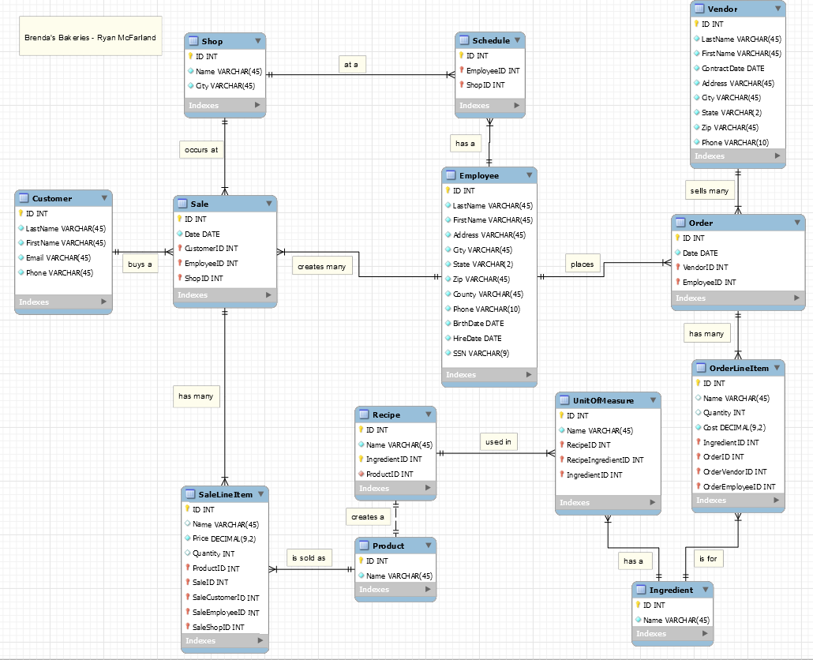
2 | Phase 2 EER Diagram | 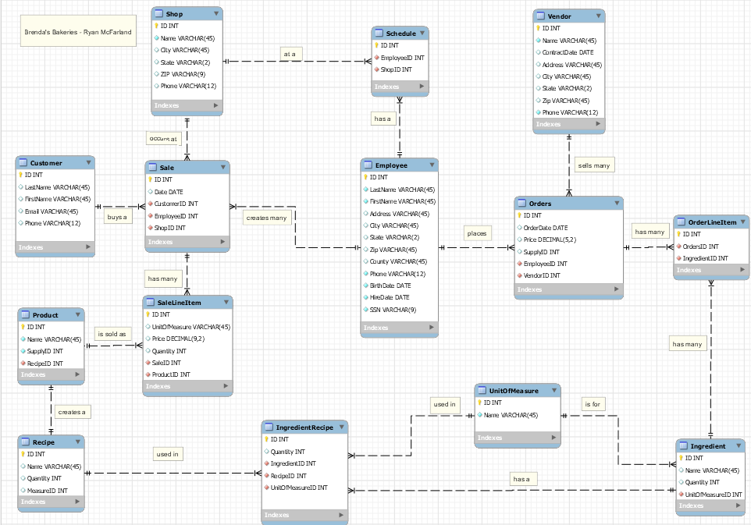
3 | Crayon Definition
  Entity Name | Crayon Definition
  Customer | The customer table provides the customer’s last and first name, email address, and phone number.
  Sale | The sale table provides the customer, employee, and shop ID’s that pertain to each sale.
  Employee | The employee table provides the last and first name of the employee as well as the hire date.
  Ingredient | The ingredient table stores all the ingredients used in the kitchen.
  Orders | The orders table stores the date the bakery purchased items from the vendor.
  OrderLineItem | The OrderLineItem table stores the items that were ordered from the vendor and their cost.
  Product | The product table stores all the products offered.
  Recipe | The recipe table provides the name of the recipe.
  SaleLineItem | The SaleLineItem table stores the cost and quantity of a product that is sold.
  Schedule | The schedule table provides the employees working at the shops.
  Shop | The shop table stores the name and city of the shop.
  UnitOfMeasure | The UnitOfMeasure table provides the name of the unit for the ingredients.
  Vendor | The vendor table stores the vendor name and contract date.
  IngredientRecipe | The IngredientRecipe table stores the quantity and unit of measure for the ingredients used in recipe.
4 | Tree View Screenshot with columns expanded | 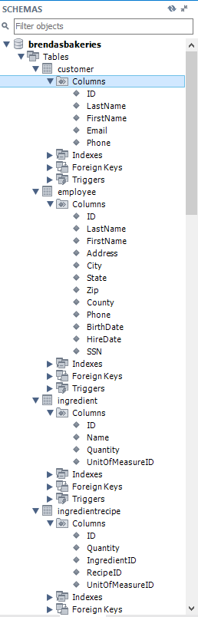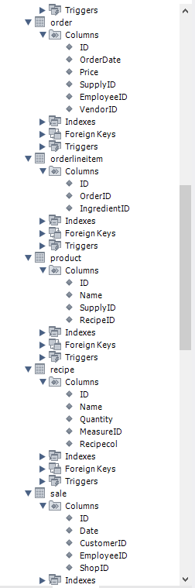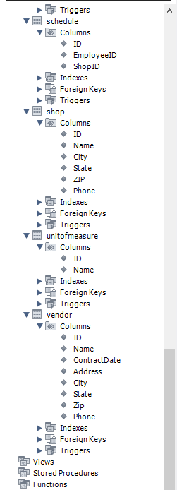
5 | SQL that adds two records in each table. | 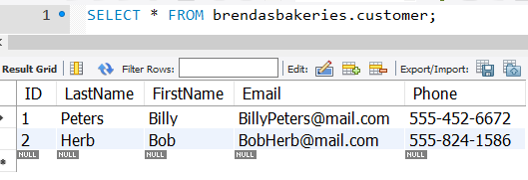  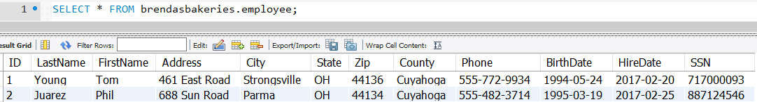  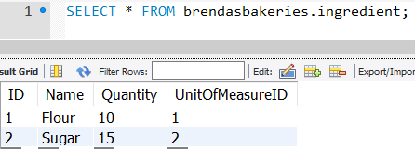  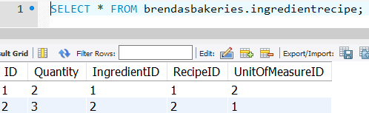  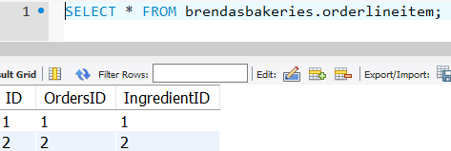  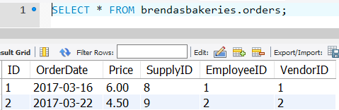  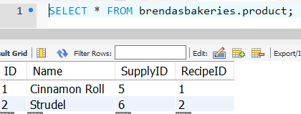  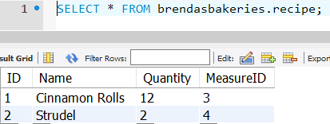  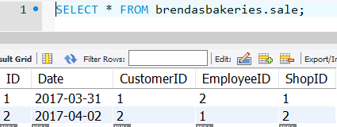  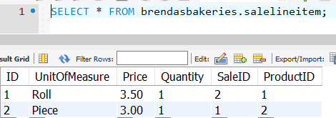  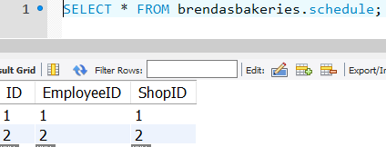  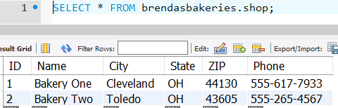  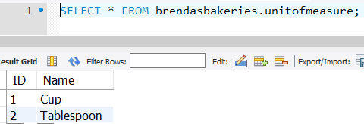  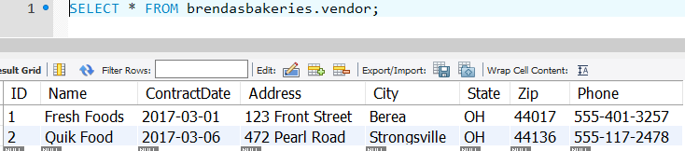
6 | Describe any changes. | I changed my design to more accurately reflect the relationship between recipe and ingredient. I did not need to change the design based off of inserting records into the tables.

