Ryan McFarland
 |  | Paste in your answers for each step below in this column. Paste your actual SQL text, not a screen shot of it. Paste a screen shot of your Result Grid. Be sure to “Snip” your screen shots.
 | Final EER Diagram | 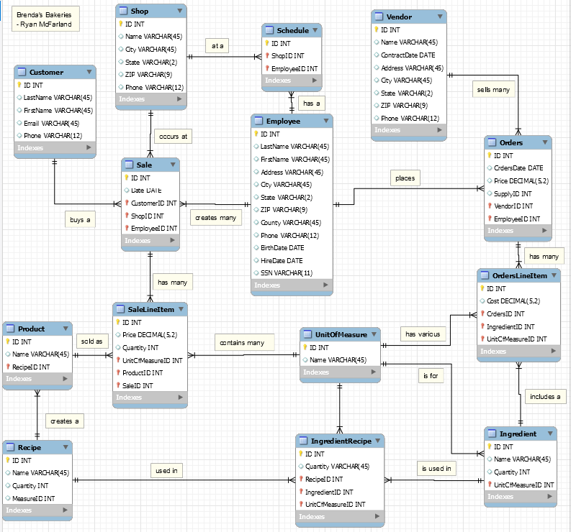
 | Crayon Definitions
  Entity Name | Crayon Definition
  Customer | The customer table provides the customer’s last and first name, email address, and phone number.
  Sale | The sale table provides the customer, employee, and shop ID’s that pertain to each sale.
  Employee | The employee table provides the last and first name of the employee as well as the hire date.
  Ingredient | The ingredient table stores all the ingredients used in the kitchen.
  Orders | The orders table stores the date the bakery purchased items from the vendor.
  OrdersLineItem | The OrdersLineItem table stores the items that were ordered from the vendor and their cost.
  Product | The product table stores all the products offered.
  Recipe | The recipe table provides the name of the recipe.
  SaleLineItem | The SaleLineItem table stores the cost and quantity of a product that is sold.
  Schedule | The schedule table provides the employees working at the shops.
  Shop | The shop table stores the name and city of the shop.
  UnitOfMeasure | The UnitOfMeasure table provides the name of the unit for the ingredients.
  Vendor | The vendor table stores the vendor name and contract date.
  IngredientRecipe | The IngredientRecipe table stores the quantity and unit of measure for the ingredients used in recipe.
 | Mockarroo.com screen shot of your Customer table setup | Mockaroo screen shot of your Customer table setup  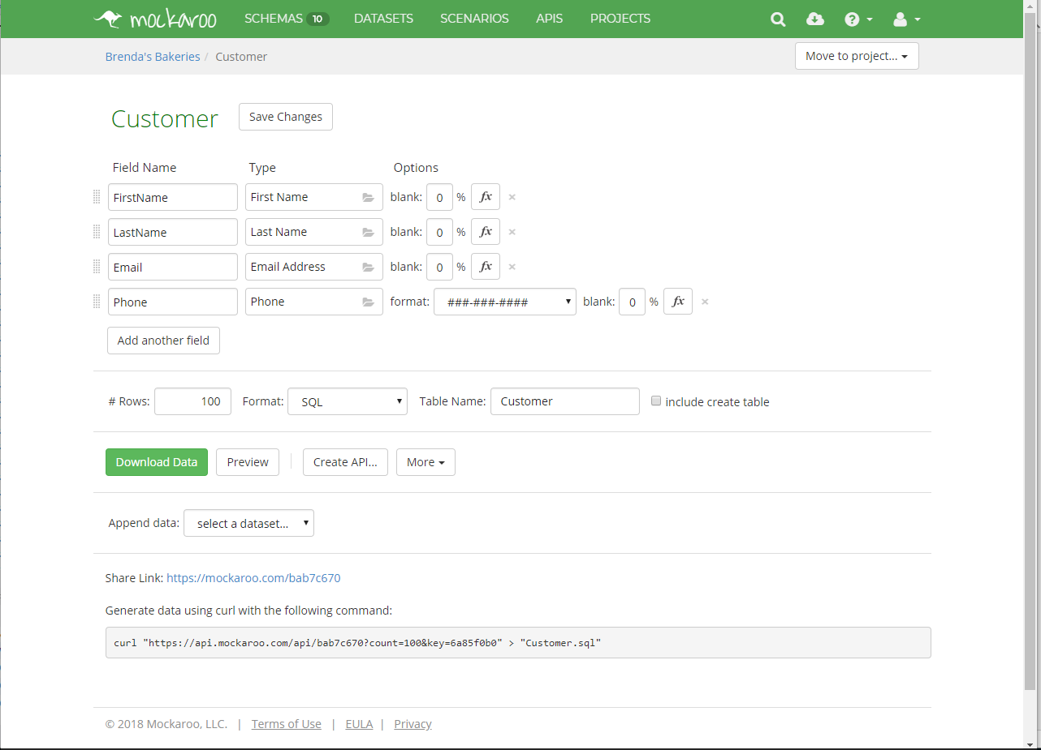
 | SELECT * on each table and up to 10 records from the result grid of each | SELECT * statement and Result Grid from each table  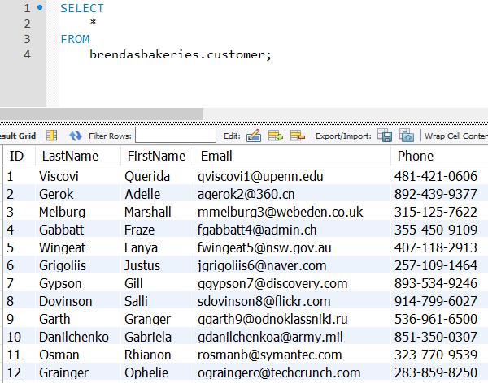  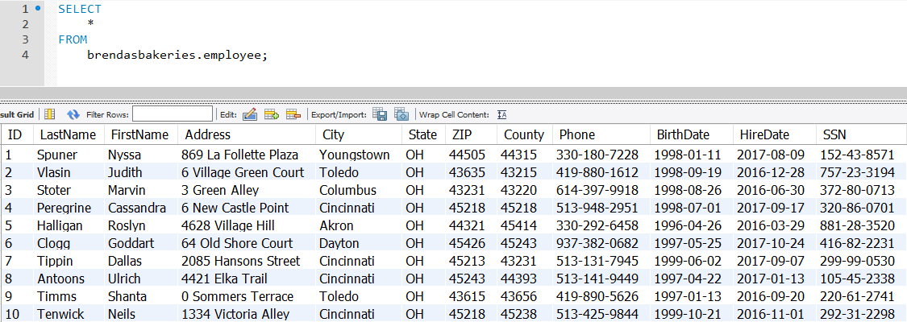  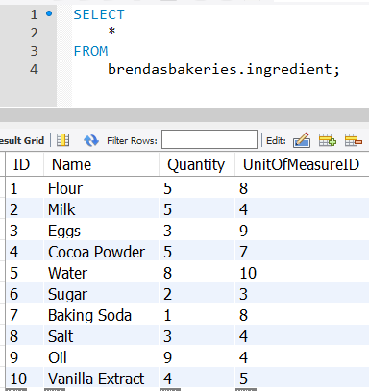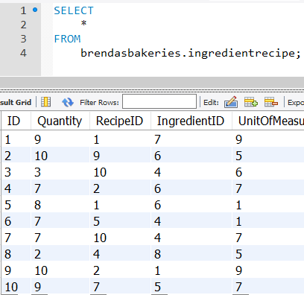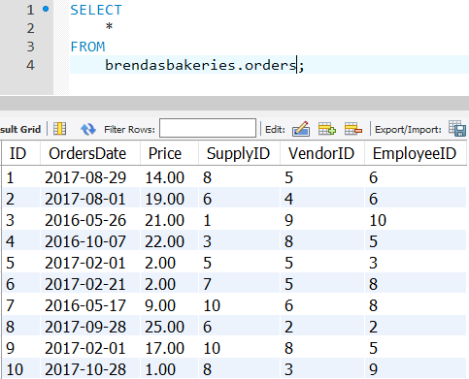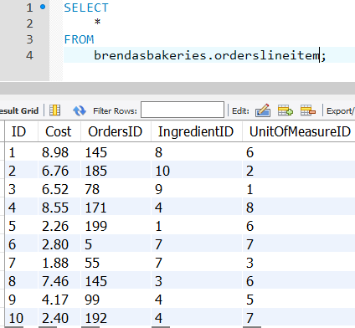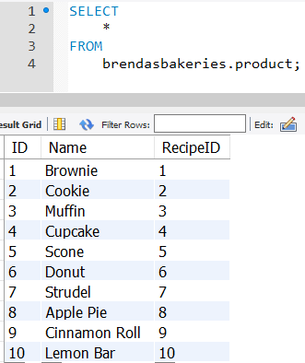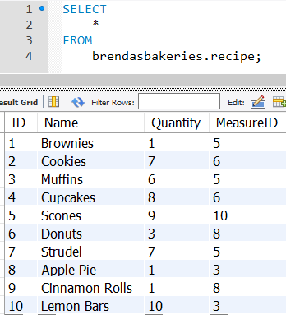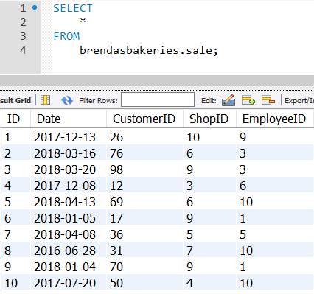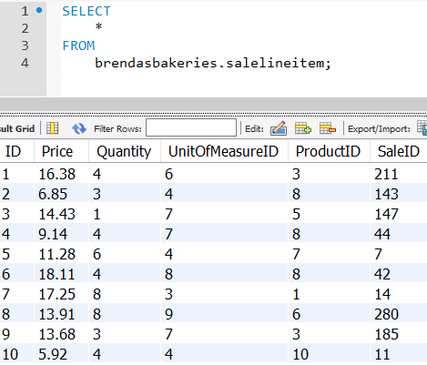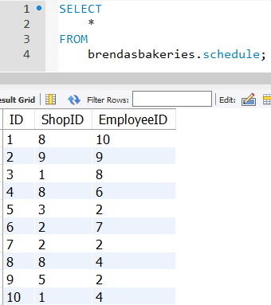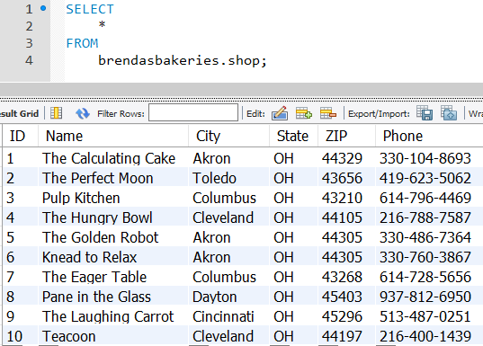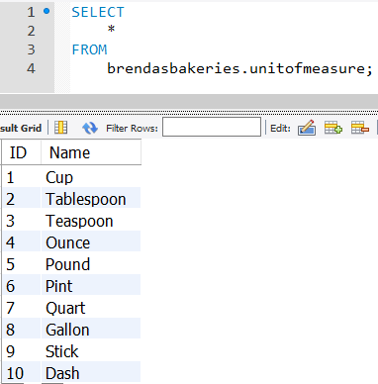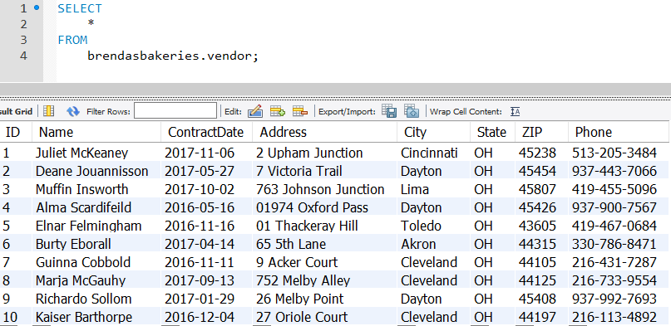
 | Explanation | A WHERE and an ORDER BY clause.  Viewing the sales that were over $15 each
 | Result Grid | 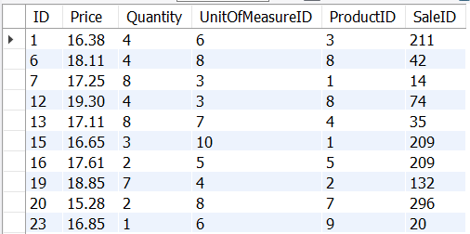
 | SQL | USE brendasbakeries;  SELECT  *  FROM  salelineitem  WHERE  price > 15;
 | Explanation | An AND or OR in the WHERE clause.  Viewing the sales of customers 1 or 2
 | Result Grid | 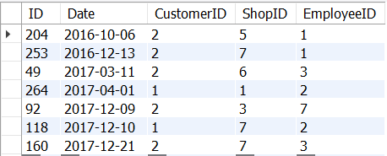
 | SQL | SELECT  *  FROM  Sale  WHERE  CustomerID = 1 OR customerID = 2  ORDER BY Date;
 | Explanation | GROUP BY  This query shows the products that have sold more than 18 units and the total amount of dollars each product has created
 | Result Grid | 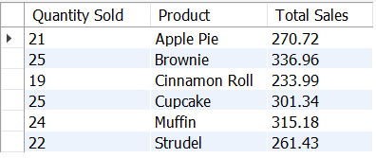
 | SQL | SELECT  COUNT(Quantity) AS 'Quantity Sold',  Product.Name AS Product,  SUM(Price) AS 'Total Sales'  FROM  SaleLineItem  INNER JOIN  Product ON SaleLineItem.ProductID = Product.ID  GROUP BY Product.Name  HAVING COUNT(quantity) > 18;
 | Explanation | INNER JOIN  This shows who the customer was and their email address, who the employee who created the sale, when the sale occurred, and the total of the sale
 | Result Grid | 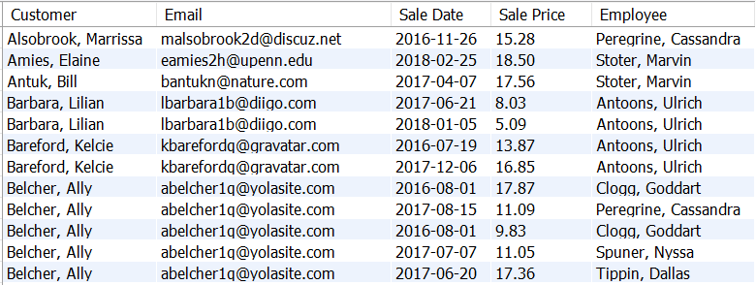
 | SQL | SELECT  CONCAT(customer.lastname,  ', ',  customer.firstname) AS Customer,  customer.email AS Email,  sale.date AS 'Sale Date',  salelineitem.price AS 'Sale Price',  CONCAT(employee.lastname,  ', ',  employee.firstname) AS Employee  FROM  Customer  INNER JOIN  Sale ON Customer.ID = Sale.CustomerID  INNER JOIN  SaleLineItem ON Sale.ID = SaleLineItem.SaleID  INNER JOIN  Employee ON Sale.EmployeeID = Employee.ID  ORDER BY Customer;
 | Explanation | OUTER JOIN  All of the customers who purchased bakery, even showing those that have not bought bakery after April 17, 2016
 | Result Grid | 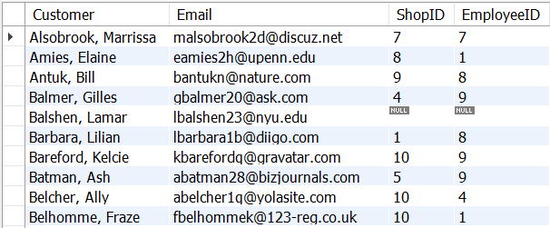
 | SQL | SELECT  CONCAT(customer.lastname,  ', ',  customer.firstname) AS Customer,  Email,  ShopID,  EmployeeID  FROM  Customer  LEFT OUTER JOIN  Sale ON Sale.CustomerID = Customer.ID  GROUP BY Customer.LastName  ORDER BY Customer.LastName;
 | Explanation | Roll Your Own query  This shows when the employees last sale occurred in each shop and the total customers that the employee had in the different shops that he/she worked in.
 | Result Grid | 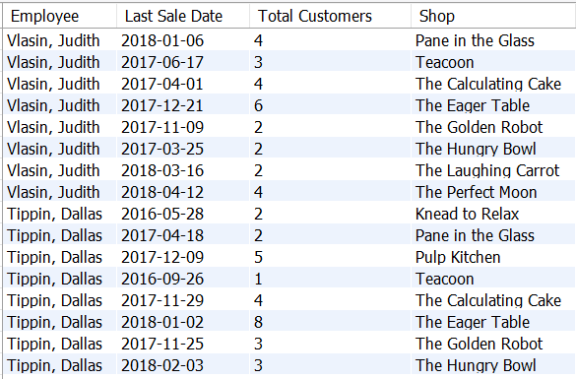
 | SQL | SELECT  CONCAT (employee.lastname, ', ' , employee.firstname) AS Employee,  Max(Sale.Date) AS 'Last Sale Date',  COUNT(customer.id) AS 'Total Customers',  Shop.Name AS 'Shop'  FROM  Employee  INNER JOIN Sale ON Sale.EmployeeID = Employee.ID  INNER JOIN Customer ON Sale.CustomerID = Customer.ID  INNER JOIN Shop ON Sale.ShopID = Shop.ID  GROUP BY employee, Shop.Name  ORDER BY Date;
 | Explanation | View  This view shows the order date and prices and the vendor who sold the order and their phone number in case anything is wrong with the supply.
 | SQL | SELECT  ordersdate AS 'Order Date',  Orders.Price AS 'Order Price',  Vendor.Name AS 'Vendor',  Vendor.Phone AS 'Vendor Phone'  FROM  Vendor  INNER JOIN Orders ON Orders.VendorID = Vendor.ID  ORDER BY ordersdate;
 | Result Grid | 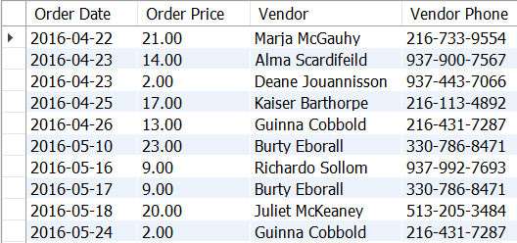
 | Explanation | Stored Procedure  This procedure takes in the vendor id and returns the total price, or cost, that their orders were bought for. This can show if the vendor is meeting his/her goals.
 | SQL | DROP PROCEDURE IF EXISTS Vendor_Orders;  DELIMITER $$  CREATE PROCEDURE Vendor_Orders(inVendorID INT, OUT outPrice DECIMAL (5,2))  BEGIN  SET outPrice = (SELECT sum(Price)  FROM Orders  INNER JOIN Vendor on Orders.VendorID = Vendor.ID  WHERE VendorID = inVendorID);  END  $$  DELIMITER ;  CALL Vendor_Orders(5, @outPrice) ;  SELECT @outPrice AS 'Total Price';
 | Result Grid | 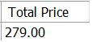
 | Result Grid | INSERT Trigger  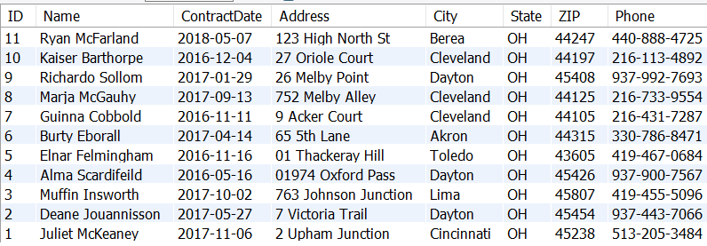
 | SQL | DROP TRIGGER IF EXISTS Vendor_Before_Insert;  DELIMITER $$  CREATE TRIGGER Vendor_Before_Insert  BEFORE INSERT ON Vendor  FOR EACH ROW  BEGIN  IF NEW.contractdate > curdate() THEN  SET NEW.ContractDate = Curdate();  END IF;  END $$  DELIMITER ;  INSERT INTO Vendor (Name, ContractDate, Address, City, State, ZIP, Phone)  VALUES ('Ryan McFarland', '2018-08-09', '123 High North St', 'Berea', 'OH', '44247', '440-888-4725');  SELECT  *  FROM  Vendor;
 | Explanation | This before insert does not allow a vendor's contract date to be anything other than the current date so that if the person entering information messes up and types and old year or puts the incorrect date in, it will be changed automatically to the current date
 | Result Grid | UPDATE Trigger  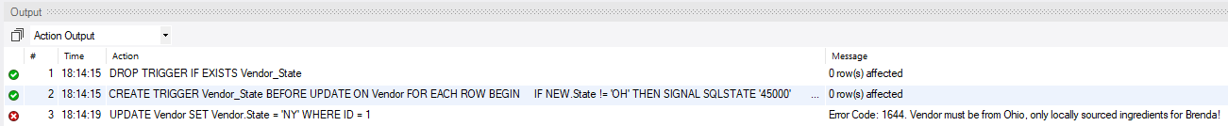
 | SQL | DROP TRIGGER IF EXISTS Vendor_State;  DELIMITER $$  CREATE TRIGGER Vendor_State  BEFORE UPDATE ON Vendor  FOR EACH ROW  BEGIN  IF NEW.State != 'OH' THEN  SIGNAL SQLSTATE '45000'  SET MESSAGE_TEXT= 'Vendor must be from Ohio, only locally sourced ingredients for Brenda!';  END IF;  END $$  DELIMITER ;  UPDATE Vendor  SET Vendor.State = 'NY'  WHERE ID = 1 ;
 | Explanation | This does not allow the state to be changed from Ohio since Brenda only likes locally sourced ingredients.
 | Result Grid | DELETE Trigger  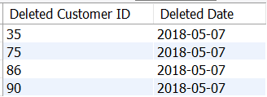
 | SQL | CREATE TABLE log_table (  old_customer_id VARCHAR(20),  when_deleted DATE);  DROP TRIGGER IF EXISTS user_delete;  DELIMITER $$  CREATE TRIGGER user_delete  AFTER DELETE ON Customer  FOR EACH ROW BEGIN  INSERT INTO log_table(old_customer_id,when_deleted) VALUES (OLD.id,NOW());  END $$  DELIMITER ;  DELETE FROM Customer  WHERE  Customer.ID IN (75 , 35, 90, 86);  SELECT  old_customer_id AS 'Deleted Customer ID',  when_deleted AS 'Deleted Date'  FROM  log_table;
 | Explanation | This trigger deletes the customer IDs of those customers who have not bought anything in two years.
 | Summary | What is the most important thing you personally learned in this project?  Triggers in SQL are very important to help regulate data without screwing everything up. When adding new data, it makes sure that the data being added in matches the style and requirements of the database.  If you had to do this over again, what would you do differently?  If I could do anything differently, it would be to continue the pace from phase 2 to phase 3. After completing phases 1 and 2 in a timely manner, I struggled to keep the same pace up for phase 3. I’m not sure why or what got in the way, but I ended up pushing phase 3 back and I felt in a time crunch although I still completed it ahead of time. I just didn’t complete it as efficiently as the others.

