Ryan McFarland

Step | Your Answers (This document is formatted double space – don’t change that!)
1 | MySQL Screenshot and discussion (put your answer in the boxes below)
1 | Screen shot  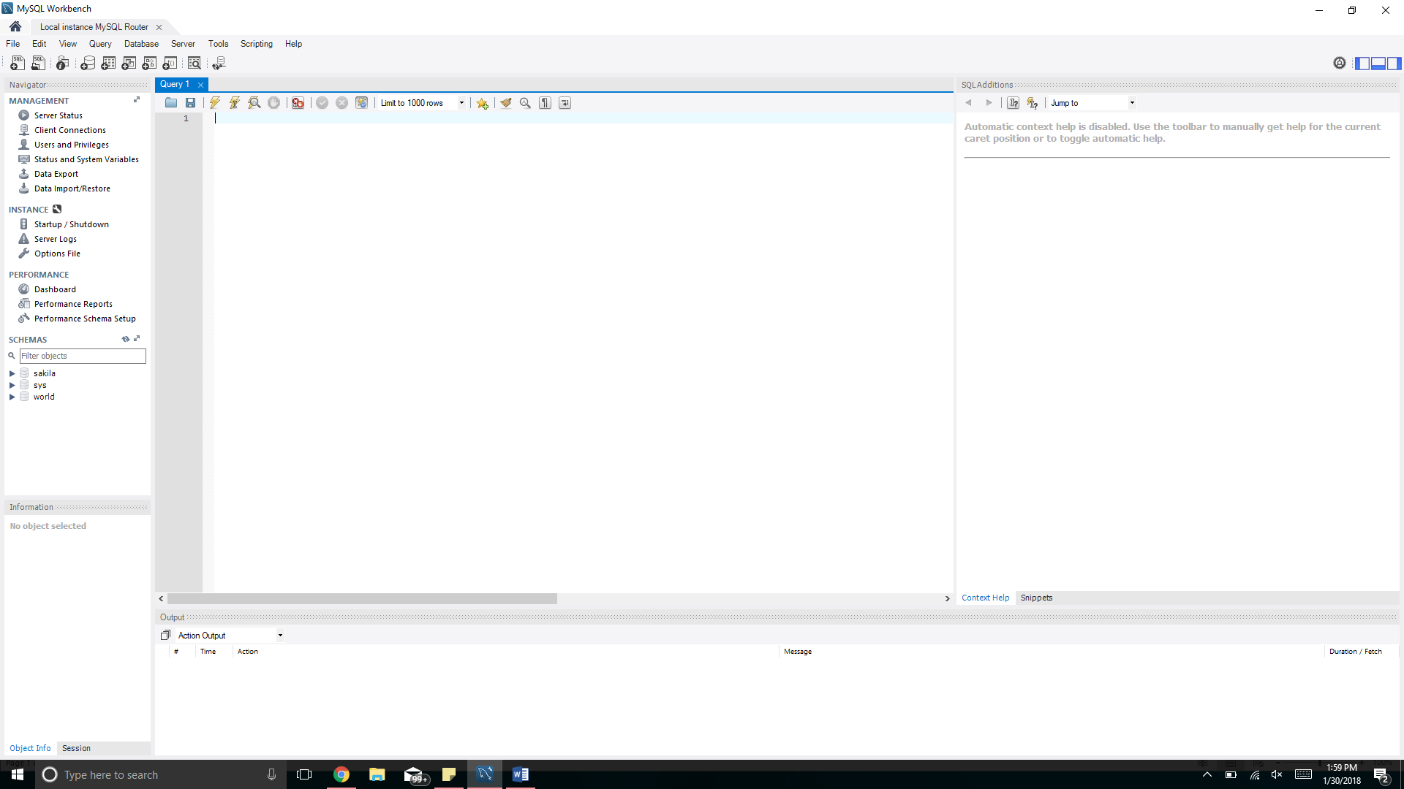
1 | I first installed at home without the pictures of the step by step process, but I never found the password portion, so I uninstalled and tried again. In class, I found the step by step process easy to follow and had no issues while following along.
2 | Starter database Screenshot and discussion (put your answer in the boxes below)
2 | Screen shot  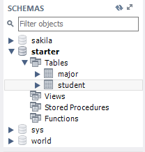
2 | Creating the starter database after having MySQL installed was fairly easy. I overlooked the button to open the script and was looking at the toolbar to open it. I couldn’t find it anywhere but then I saw the correct button to press to run the script.
3 | Run a query against the Starter database
3 | Screen shot of the Result Grid  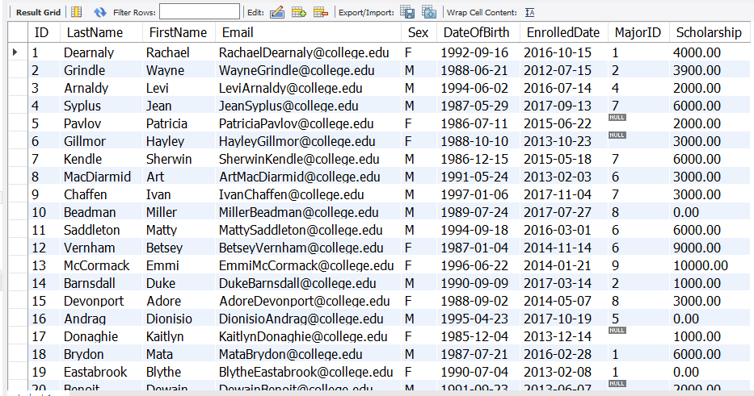
3 | Creating the first query against the starter database was easy and straight-forward. Using the snipping tool is also very convenient. I used to print the screen and cropped it in paint, but snipping saves me a lot of time.

4 | Run a query with an error
4 | Screen shot of the Output pane
4 | It is nice to see the output tells you which part the error is in. Rather than thinking that the code worked and created the sorting correctly, it shows you with a red “x” that it failed and that something is wrong. That is very convenient to save time instead of manually checking the code.

