Ryan McFarland

 | Your Answers
1 | SELECT statement listing fields
1 | Screen shot of the Result Grid  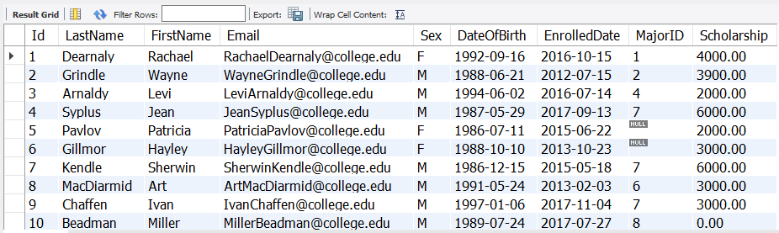
1 | Text of your SQL statement  -- 2.1 Ryan McFarland  -- This query lists all the demographics of the students from the starter database  USE Starter;  SELECT  Id,  LastName,  FirstName,  Email,  Sex,  DateOfBirth,  EnrolledDate,  MajorID,  Scholarship  FROM  `starter`.`student`;
2 | SELECT statement using *
2 | Screen shot of the Result Grid  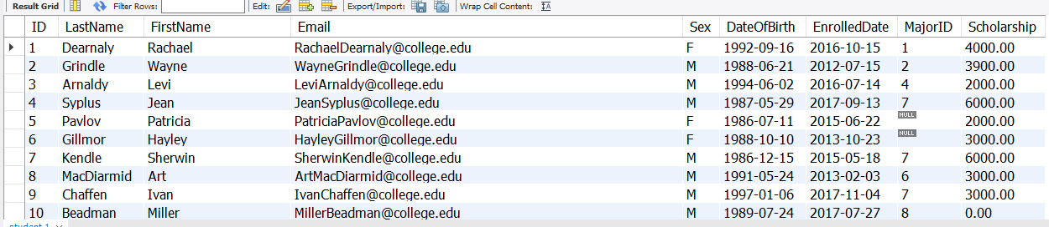
2 | Text of your SQL statement  SELECT  *  FROM  starter.student;
3 | Selected columns
3 | Screen shot of the Result Grid  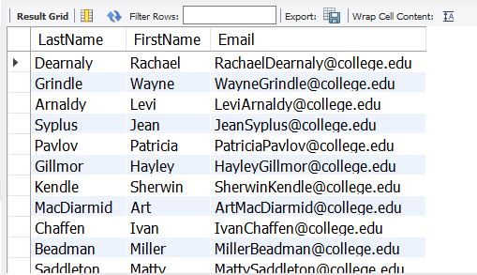
3 | Text of your SQL statement  -- 2.2 Ryan McFarland  -- This query lists only the last name, first name, and the email of the students from the starter database  USE Starter;  SELECT  LastName,  FirstName,  Email  FROM  starter.student;

4 | Rename fields
4 | Screen shot of the Result Grid  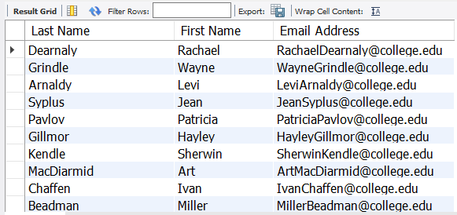
4 | Text of your SQL statement  -- 2.3 Ryan McFarland  -- This query selects the last name, first name, and email of the students in the database. It also renames each of the column headings to make it easier to read.  SELECT  LastName AS 'Last Name',  FirstName AS 'First Name',  Email AS 'Email Address'  FROM  starter.student;
5 | Do it yourself query
5 | A sentence describing the purpose of the query  This query lists all the students’ full names, scholarship amount, and their sex. It is sorted first by descending scholarship amount and then sorted by descending student’s last names. This provides an easy way to see groups of students and what they received in terms of scholarship money.
5 | Screen shot of the Result Grid  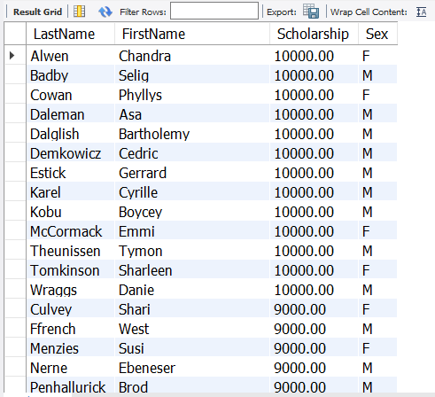
5 | Text of your SQL statement  SELECT  LastName, FirstName, Scholarship, Sex  FROM  starter.student  ORDER BY Scholarship DESC , LastName ASC;

