Ryan McFarland

 | Your Answers
1 | WHERE Numeric
1 | Screen shot of the Result Grid  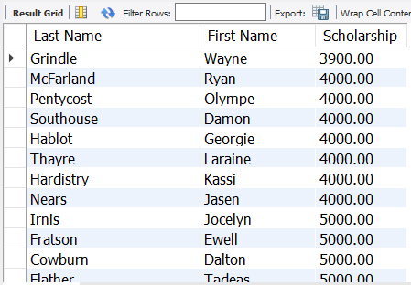
1 | Text of your SQL statement  -- 3.1 Ryan McFarland  -- Students with more than $3,500 scholarship  USE Starter ;  SELECT  LastName AS 'Last Name',  FirstName AS 'First Name',  Scholarship  FROM  starter.student  WHERE  Scholarship >= 3500  ORDER BY Scholarship;
2 | WHERE character
2 | Screen shot of the Result Grid  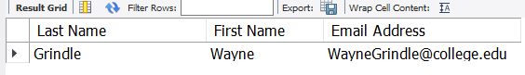
2 | Text of your SQL statement  -- 3.2 Ryan McFarland  -- Students named Grindle  USE Starter;  SELECT  LastName AS 'Last Name',  FirstName AS 'First Name',  Email as 'Email Address'  FROM  starter.student  WHERE  LastName = 'Grindle'  ORDER BY FirstName;
3 | WHERE date
3 | Screen shot of the Result Grid  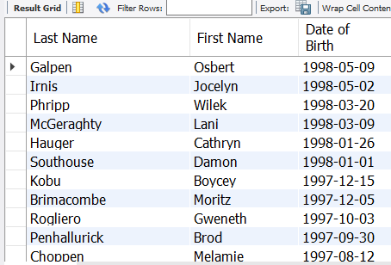
3 | Text of your SQL statement  -- 3.3 Ryan McFarland  -- Students born before July 1st, 1998  USE Starter;  SELECT  LastName AS 'Last Name',  FirstName AS 'First Name',  DateOfBirth AS 'Date of Birth'  FROM  starter.student  WHERE  DateOfBirth < '1998-07-01'  ORDER BY DateOfBirth DESC;

4 | WHERE combined
4 | Screen shot of the Result Grid  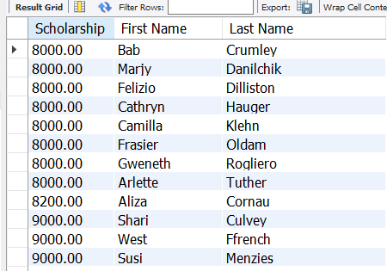
4 | Text of your SQL statement  -- 3.4 Ryan McFarland  -- Students with more than $7,000 but less than $9,500 in scholarship  USE Starter;  SELECT  Scholarship,  FirstName AS 'First Name',  LastName AS 'Last Name'  FROM  starter.student  WHERE  Scholarship > 7000 AND Scholarship < 9500  ORDER BY Scholarship, LastName;
5 | WHERE combined
5 | Screen shot of the Result Grid  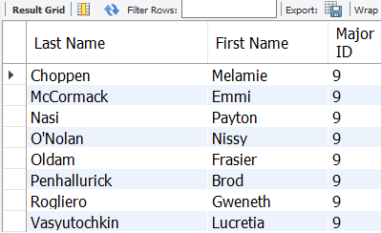
5 | Text of your SQL statement  -- 3.5 Ryan McFarland  -- Students majoring in Veterinary Tech or Zoology  USE Starter;  SELECT  LastName AS 'Last Name',  FirstName AS 'First Name',  MajorID AS 'Major ID'  FROM  starter.student  WHERE  MajorID = '9,10'  ORDER BY LastName;
6 | WHERE combined
6 | Screen shot of the Result Grid  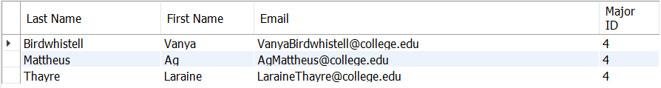
6 | Text of your SQL statement  -- 3.6 Ryan McFarland  -- Woman students majoring in Biology or Zoology  USE Starter;  SELECT  LastName AS 'Last Name',  FirstName AS 'First Name',  Email,  MajorID AS 'Major ID'  FROM  starter.student  WHERE  MajorID = '4,10' AND sex = 'f'  ORDER BY LastName;
7 | WHERE IN
7 | Screen shot of the Result Grid  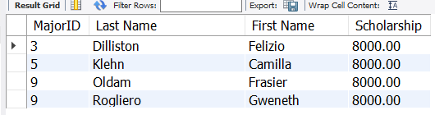
7 | Text of your SQL statement  -- 3.7 Ryan McFarland  -- Students majoring in Mathematics, Nursing, and Veterinary Tech with a $8,000 scholarship  USE Starter;  SELECT  MajorID,  LastName AS 'Last Name',  FirstName AS 'First Name',  Scholarship  FROM  starter.student  WHERE  Scholarship = 8000  AND MajorID IN (3 , 5, 9)  ORDER BY MajorID , LastName;
8 | WHERE BETWEEN
8 | Screen shot of the Result Grid  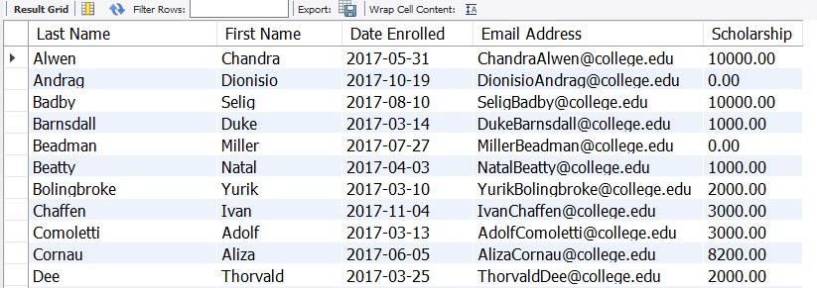
8 | Text of your SQL statement  -- 3.8 Ryan McFarland  -- Students enrolled last year, sorted by last name and then first name  USE Starter;  SELECT  LastName AS 'Last Name',  FirstName AS 'First Name',  EnrolledDate AS 'Date Enrolled',  Email AS 'Email Address',  Scholarship  FROM  starter.student  WHERE  EnrolledDate BETWEEN '2017-01-01' AND '2017-12-31'  ORDER BY LastName , FirstName;
9 | WHERE LIKE
9 | Screen shot of the Result Grid  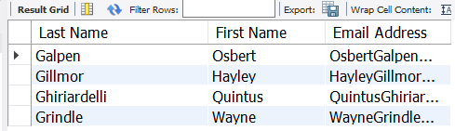
9 | Text of your SQL statement  -- 3.9 Ryan McFarland  -- All students whose last name starts with a "G", sorted by last name  USE Starter;  SELECT  LastName AS 'Last Name',  FirstName AS 'First Name',  Email AS 'Email Address'  FROM  starter.student  WHERE  LastName LIKE 'G%'  ORDER BY MajorID , LastName;
10 | WHERE LIMIT
10 | Screen shot of the Result Grid  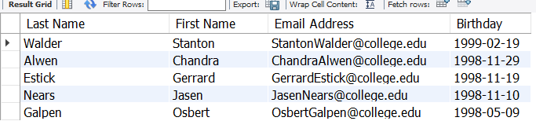
10 | Text of your SQL statement  -- 3.10 Ryan McFarland  -- The five youngest students, sorted so the youngest student is first  USE Starter;  SELECT  LastName AS 'Last Name',  FirstName AS 'First Name',  Email AS 'Email Address',  DateOfBirth AS 'Birthday'  FROM  starter.student  ORDER BY DateOfBirth DESC  LIMIT 5;
11 | DIY Query
11 | One sentence describing the purpose of your query  This query shows students with last name that ends in a 'n' or 'y' ordered by first name and limited to 15 students.
11 | Screen shot of the Result Grid  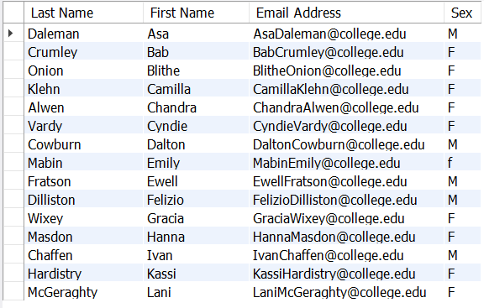
11 | Text of your SQL statement  -- 3.11 Ryan McFarland  -- Students with last name that ends in a 'n' or 'y' ordered by first name and limited to 15 students  USE Starter;  SELECT  LastName AS 'Last Name',  FirstName AS 'First Name',  Email AS 'Email Address',  Sex  FROM  starter.student  WHERE  LastName LIKE '%n' OR LastName LIKE '%y'  ORDER BY FirstName  LIMIT 15

