Ryan McFarland

 | Your Answers
1 | Only students receiving scholarships
1 | Screen shot of the Result Grid  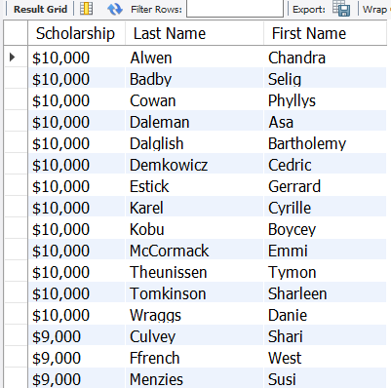
1 | Text of your SQL statement  -- 4.1 Ryan McFarland  -- Students receiving scholarships, formatted, sorted from largest to smallest, then last and first ascending  SELECT  CONCAT('$', FORMAT(Scholarship, 0)) AS Scholarship,  LastName AS 'Last Name',  FirstName AS 'First Name'  FROM  starter.student  WHERE  Scholarship > 0  ORDER BY CAST(Scholarship AS SIGNED) DESC , LastName , FirstName;
2 | Average scholarship across all students
2 | Screen shot of the Result Grid  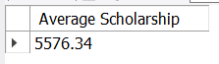
2 | Text of your SQL statement  -- 4.2 Ryan McFarland  -- Average Scholarship  SELECT  ROUND(AVG(Scholarship), '2') AS 'Average Scholarship'  FROM  starter.student  WHERE  scholarship > 0;
3 | Show your name and the name of the day
3 | Screen shot of the Result Grid  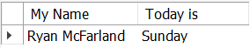
3 | Text of your SQL statement  -- 4.3 Ryan McFarland  -- Name and today's date  Select  'Ryan McFarland' as 'My Name',  dayname(current_date()) as 'Today is';

4 | The date that is 31 days from today
4 | Screen shot of the Result Grid  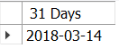
4 | Text of your SQL statement  -- 4.4 Ryan McFarland  -- Date that is 31 days from today  SELECT  DATE_ADD(CURRENT_DATE(),  INTERVAL 31 DAY) AS '31 Days';
5 | Show how many days old you are as of today
5 | Screen shot of the Result Grid  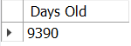
5 | Text of your SQL statement  -- 4.5 Ryan McFarland  -- How many Days old I am as of today  SELECT DATEDIFF('2018/02/11', '1992/05/28') AS 'Days Old';
6 | DIY Date/Time Query
6 | One sentence describing the purpose of your query  This query shows the current time of the day in seconds.
6 | Screen shot of the Result Grid  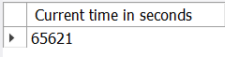
6 | Text of your SQL statement  -- 4.6 Ryan McFarland  -- Current time in seconds  SELECT TIME_TO_SEC(CURRENT_TIME()) AS 'Current time in seconds';

7 | DIY String Query
7 | One sentence describing the purpose of your query  This query adds another student and locates the last names with an m in it, which is then limited to only those students who has the m in the first position in their last name.
7 | Screen shot of the Result Grid  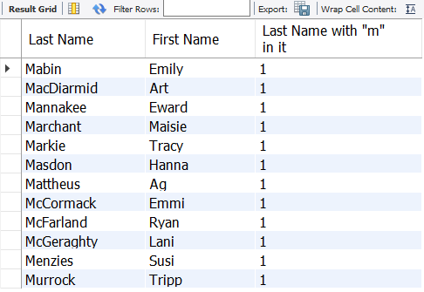
7 | Text of your SQL statement  -- 4.7 Ryan McFarland  -- M in first poisiton in last name  INSERT INTO starter.student (lastname, firstname, email, DateOfBirth, sex, EnrolledDate, Scholarship, MajorID)  VALUES ('Mabin', 'Emily', 'MabinEmily@college.edu', '1994-04-17', 'f', '2017-07-09', '4500', '3');  SELECT  lastname AS 'Last Name',  firstname AS 'First Name',  LOCATE('M', Lastname) AS 'Last Name with "m" in it'  FROM  starter.student  WHERE  LOCATE('m', lastname) = 1  ORDER BY lastname;

