Ryan McFarland

 | Your Answers
1 | Faculty & Department
1 | Screen shot of the Result Grid  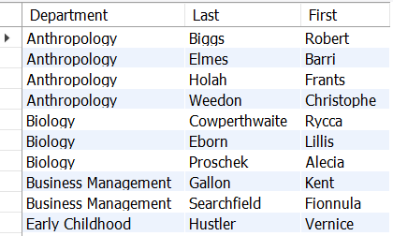
1 | Text of your SQL statement  -- 5.1 Ryan McFarland  -- Faculty names in each department sorted left to right  USE College;  SELECT  Department.name AS Department,  Faculty.LastName AS Last,  Faculty.FirstName AS First  FROM  Department  INNER JOIN  Faculty ON Faculty.Departmentid = Department.ID  ORDER BY department.name , faculty.LastName , faculty.FirstName;
2 | Sex and Major
2 | Screen shot of the Result Grid  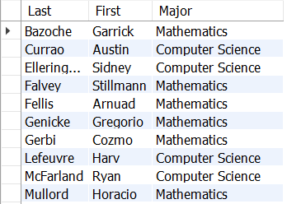
2 | Text of your SQL statement  -- 5.2 Ryan McFarland  -- Male students in math or computer science, sorted left to right  USE College;  SELECT  Student.LastName AS Last,  Student.FirstName AS First,  Major.Name AS Major  FROM  Student  INNER JOIN  Major ON Student.Majorid = Major.ID  WHERE  Student.Sex = 'M'  AND Major.ID IN (1 , 3)  ORDER BY Student.LastName , Student.FirstName , Major.Name;
3 | Students with courses and grades
3 | Screen shot of the Result Grid  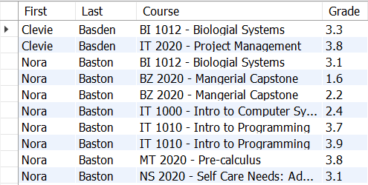
3 | Text of your SQL statement  -- 5.3 Ryan McFarland  -- Students' names, courses taken, and the grades earned, sorted by last  -- name, first name, and then course  SELECT  Student.FirstName AS First,  Student.LastName AS Last,  Course.Name AS Course,  Registration.Grade AS Grade  FROM  Student  INNER JOIN  Registration ON Registration.StudentID = Student.id  INNER JOIN  Section ON Registration.SectionID = Section.ID  INNER JOIN  Course ON Section.CourseID = Course.ID  ORDER BY LastName , FirstName , Course.Name;
4 | Departments & Courses including department(s) that don’t have any courses.
4 | Screen shot of the Result Grid  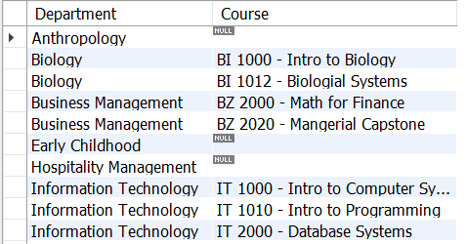
4 | Text of your SQL statement  -- 5.4 Ryan McFarland  -- Departments and the courses offered  USE college;  SELECT  Department.name AS Department, Course.name AS Course  FROM  Department  LEFT OUTER JOIN  Course ON Department.ID = Course.DepartmentID;
5 | Majors with no students
5 | Screen shot of the Result Grid  
5 | Text of your SQL statement  -- 5.5 Ryan McFarland  -- Only majors with no students in that major  SELECT  Major.name AS Major  FROM  Major  LEFT OUTER JOIN  student ON student.majorid = major.ID  WHERE  Student.ID IS NULL;
6 | DIY four-table inner join
6 | Once sentence explanation  This query shows the faculty members, the departments they belong to, and the courses they teach and the days/time they teach those courses
6 | Screen shot of the Result Grid  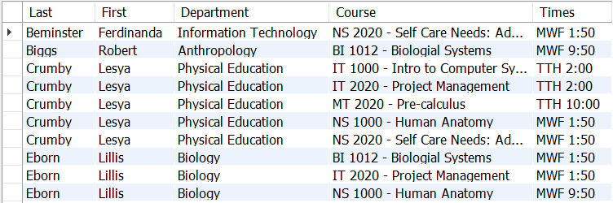
6 | Text of your SQL statement  -- 5.6 Ryan McFarland  -- Faculty, the department they belong to, the courses they  -- teach and when they teach the course  SELECT  Faculty.LastName AS Last,  Faculty.FirstName AS First,  Department.name AS Department,  course.Name AS Course,  Section.Name AS Times  FROM  Faculty  INNER JOIN  Section ON Faculty.id = Section.TaughtByID  INNER JOIN  Course ON Section.courseID = Course.ID  INNER JOIN  Department ON Faculty.departmentID = Department.id  ORDER BY LastName , FirstName , Course.Name;
7 | DIY four-table outer join
7 | Once sentence explanation  This query shows all of the clubs available and their first member’s information including their name, major, and when they joined the club.
7 | Screen shot of the Result Grid  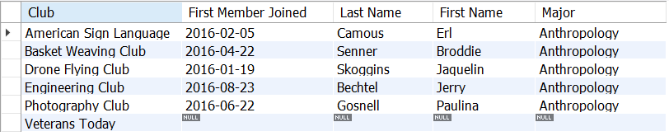
7 | Text of your SQL statement  -- 5.7 Ryan McFarland  -- Each club and the date the first member joined, including clubs  -- without any members, and their names and majors  USE college;  SELECT  Club.name AS Club,  MIN(Membership.DateJoined) AS 'First Member Joined',  Student.LastName AS 'Last Name',  Student.FirstName As 'First Name',  Major.name As 'Major'  FROM  club  LEFT OUTER JOIN  Membership ON Club.ID = Membership.clubid  LEFT OUTER JOIN  Student ON Membership.StudentID = Student.ID  LEFT OUTER JOIN  Major ON Student.MajorID = MajorID  GROUP BY club.name  ORDER BY Club.name , MIN(Membership.DateJoined);

