Ryan McFarland

 | Your Answers
1 | Count of Sections
1 | Screen shot of the Result Grid  
1 | Text of your SQL statement  -- 6.1 Ryan McFarland  -- Count of section records in database  Use College;  SELECT  COUNT(*) AS Sections  FROM  section;
2 | Faculty Information
2 | Screen shot of the Result Grid
2 | Text of your SQL statement  -- 6.2 Ryan McFarland  -- Faculty Member Salaries  USE college;  SELECT  COUNT(*) AS 'Faculty Members',  CONCAT(FORMAT(MIN(faculty.salary), 2)) AS 'Lowest Salary',  CONCAT(FORMAT(AVG(faculty.salary), 2)) AS 'Average Salary',  CONCAT(FORMAT(MAX(faculty.salary), 2)) AS 'Highest Salary'  FROM  Faculty;
3 | Major Information
3 | Screen shot of the Result Grid  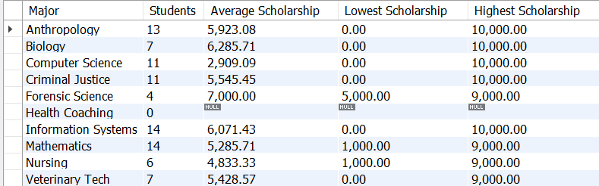
3 | Text of your SQL statement  -- 6.3 Ryan McFarland  -- Each major with number of students and the scholarships  USE college;  SELECT  Major.Name AS Major,  COUNT(student.id) AS Students,  CONCAT(FORMAT(AVG(student.scholarship), 2)) AS 'Average Scholarship',  CONCAT(FORMAT(MIN(student.scholarship), 2)) AS 'Lowest Scholarship',  CONCAT(FORMAT(MAX(student.scholarship), 2)) AS 'Highest Scholarship'  FROM  Major  LEFT OUTER JOIN  Student ON Major.ID = Student.MajorID  GROUP BY Major.name;
4 | Faculty members teaching at least 15 students
4 | Screen shot of the Result Grid  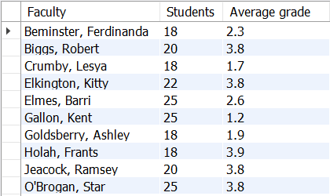
4 | Text of your SQL statement  -- 6.4 Ryan McFarland  -- Faculty teaching at least 15 students and the average grade earned  USE college;  SELECT  CONCAT(Faculty.LastName,  ', ',  Faculty.FirstName) AS Faculty,  Section.capacity AS Students,  ROUND(Registration.grade, 1) AS 'Average grade'  FROM  Faculty  INNER JOIN  Section ON Faculty.id = Section.TaughtByID  INNER JOIN  Registration ON Section.id = Registration.sectionid  WHERE  Section.capacity >= 15  GROUP BY CONCAT(Faculty.LastName,  ', ',  Faculty.FirstName)  ORDER BY CONCAT(Faculty.LastName,  ', ',  Faculty.FirstName);
5 | Dean’s List
5 | Screen shot of the Result Grid  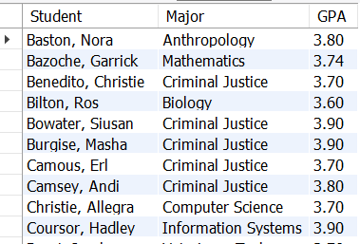
5 | Text of your SQL statement  -- 6.5 Ryan McFarland  -- All students on the Dean's List  USE College;  SELECT  CONCAT(student.lastname,  ', ',  student.firstname) AS Student,  major.name AS Major,  FORMAT(AVG(registration.grade), 2) AS 'GPA'  FROM  student  INNER JOIN  major ON student.majorid = major.id  INNER JOIN  Registration ON Student.id = Registration.StudentID  WHERE  registration.grade >= '3.5'  GROUP BY CONCAT(student.lastname,  ', ',  student.firstname);
6 | Club Membership
6 | Screen shot of the Result Grid  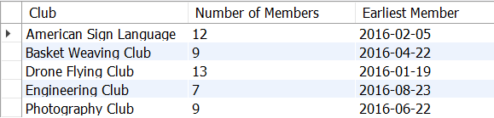
6 | Text of your SQL statement  -- 6.6 Ryan McFarland  -- Club with the number of members in it and the date the first member joined  USE college;  SELECT  club.name AS Club,  COUNT(*) AS 'Number of Members',  MIN(DateJoined) AS 'Earliest Member'  FROM  Club  INNER JOIN  Membership ON club.id = membership.clubid  GROUP BY club.name;
7 | DIY four-table outer join
7 | Once sentence explanation  This query shows the courses offered in the 2017 Fall semester and the lowest capacity and highest capacity for students each course has.
7 | Screen shot of the Result Grid  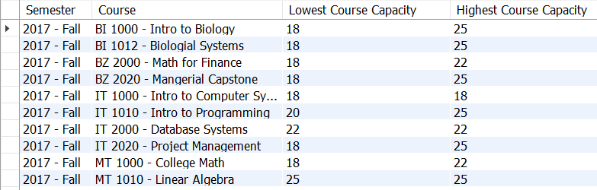
7 | Text of your SQL statement  -- 6.7 Ryan McFarland  -- Courses offered in Fall 2017 and their low and high capacity  -- to show how many the range of seats availiable in the courses  USE college;  SELECT  Semester.name AS Semester,  Course.name AS Course,  MIN(Section.capacity) AS 'Lowest Course Capacity',  MAX(Section.Capacity) AS 'Highest Course Capacity'  FROM  Semester  INNER JOIN  Section ON SemesterID = Section.SemesterID  INNER JOIN  Course ON Section.CourseID = Course.ID  WHERE  Semester.name = '2017 - Fall'  GROUP BY Course.name  ORDER BY Semester , Course;

