Ryan McFarland

 | Your Answers
1 | Schema
1 | Screen shot of the your EER diagram. (Please don’t delete these notes, just paste in the space below.)  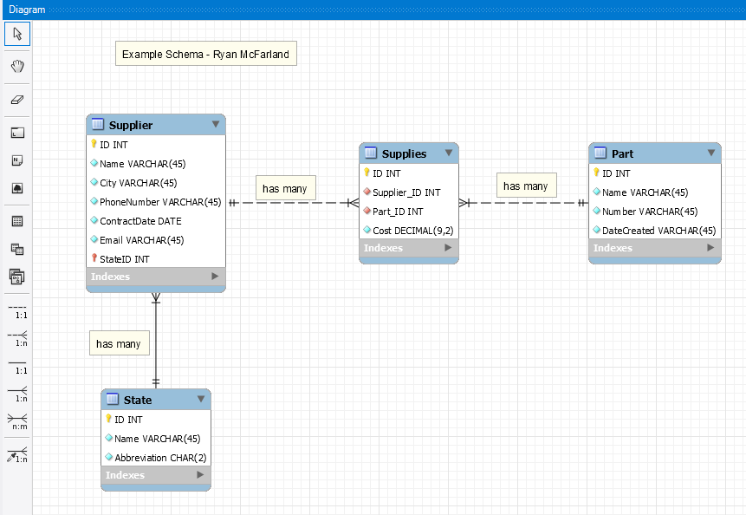
2 | Forward Engineer
2 | Screen shot of the Schema window tree-view with your new database and its tables expanded so I can see the columns for every table. Clip this to show only the schema window.  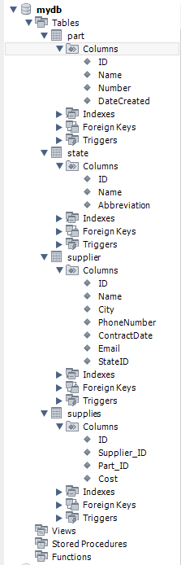
3 | INSERT statements
3 | Screen shot of the Result Grid showing the first 10 or so the records in the State Table  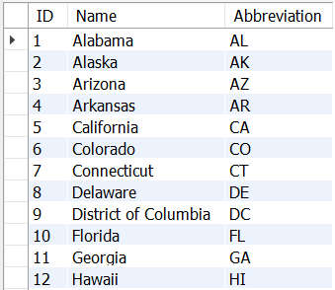
3 | Screen shot of the Result Grid showing all the records in the Parts Table  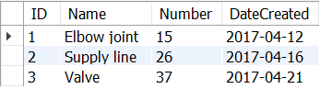
3 | Screen shot of the Result Grid showing all the records in the Supplier Table  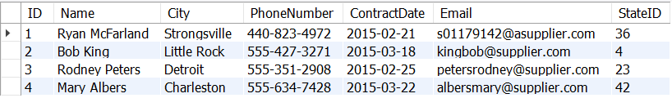
3 | Screen shot of the Result Grid showing all the records in the Supplies Table  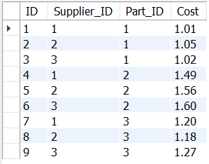
4 | Query
4 | Screen shot of the Result Grid  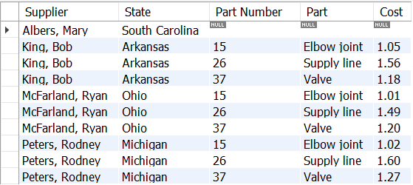
4 | Text of your SQL statement  USE mydb;  SELECT  Supplier.name AS Supplier,  State.name AS State,  Part.number AS 'Part Number',  Part.name AS Part,  Supplies.cost AS Cost  FROM  State  INNER JOIN  Supplier ON State.id = Supplier.StateID  LEFT OUTER JOIN  Supplies ON Supplier.ID = Supplies.Supplier_ID  LEFT OUTER JOIN  Part ON Supplies.Part_ID = Part.ID  ORDER BY Supplier.name , Part.number;

