Ryan McFarland
 | Your Answers
1 | Result Grid | 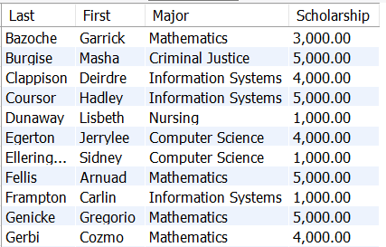
1 | SQL Text | -- 9.1 Ryan McFarland  -- Students who have a scholarship that is less than the average amount of scholarship  USE college;  SELECT  Student.LastName AS Last,  Student.FirstName AS First,  Major.Name AS Major,  FORMAT(Student.Scholarship, 2) AS Scholarship  FROM  Student  INNER JOIN  Major ON Student.majorID = major.id  WHERE  Scholarship > 0  AND Scholarship < (SELECT  AVG(scholarship)  FROM  student  WHERE  scholarship > 0)  ORDER BY Student.LastName;
2 | Result Grid | 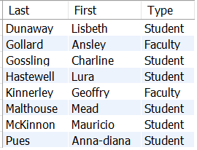
2 | SQL Text | -- 9.2 Ryan McFarland  -- Students and Faculty members in Nursing into one result set  USE college;  SELECT  LastName AS 'Last',  FirstName AS First,  'Student' AS Type  FROM  Student  INNER JOIN  Major ON student.majorID = major.ID  WHERE  major.id = 5  UNION SELECT  LastName AS 'Last', FirstName AS First, 'Faculty' AS Type  FROM  Faculty  INNER JOIN  Department ON Faculty.DepartmentID = Department.ID  WHERE  Department.ID = 3  ORDER BY last;
3 | Scholarships view
3 | Screen shot of the result grid from SELECT * FROM StudentScholarships  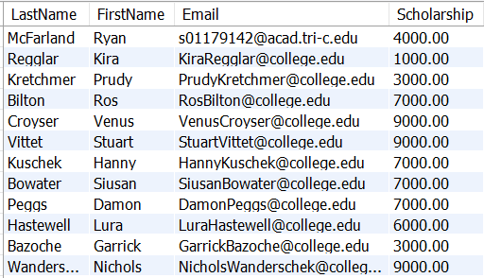
3 | Screen shot of your Schema window showing the scholarships view with its columns expanded  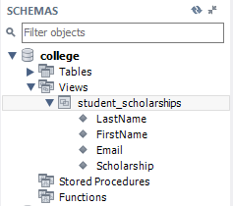
3 | Text of your CREATE VIEW SQL  CREATE  ALGORITHM = UNDEFINED  DEFINER = `root`@`localhost`  SQL SECURITY DEFINER  VIEW `college`.`student_scholarships` AS  SELECT  `college`.`student`.`LastName` AS `LastName`,  `college`.`student`.`FirstName` AS `FirstName`,  `college`.`student`.`Email` AS `Email`,  `college`.`student`.`Scholarship` AS `Scholarship`  FROM  `college`.`student`  WHERE  (`college`.`student`.`Scholarship` > 0)
4 | Student Flatten View
4 | Screen shot of the result grid from SELECT * FROM StudentFlatten  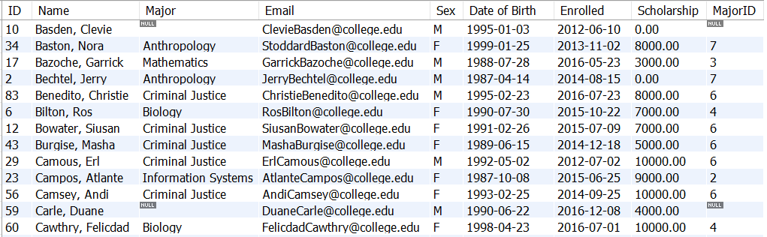
4 | Screen shot of your Schema window showing the view with its columns expanded  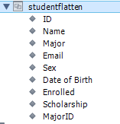
4 | Text of your CREATE VIEW SQL  CREATE  ALGORITHM = UNDEFINED  DEFINER = `root`@`localhost`  SQL SECURITY DEFINER  VIEW `college`.`studentflatten` AS  SELECT  `college`.`student`.`ID` AS `ID`,  CONCAT(`college`.`student`.`LastName`,  ', ',  `college`.`student`.`FirstName`) AS `Name`,  `college`.`major`.`Name` AS `Major`,  `college`.`student`.`Email` AS `Email`,  `college`.`student`.`Sex` AS `Sex`,  `college`.`student`.`DateOfBirth` AS `Date of Birth`,  `college`.`student`.`EnrolledDate` AS `Enrolled`,  `college`.`student`.`Scholarship` AS `Scholarship`,  `college`.`student`.`MajorID` AS `MajorID`  FROM  (`college`.`student`  LEFT JOIN `college`.`major` ON ((`college`.`student`.`MajorID` = `college`.`major`.`ID`)))  ORDER BY CONCAT(`college`.`student`.`LastName`,  ', ',  `college`.`student`.`FirstName`)
Discussion of how this view might be useful
This view might be useful to connect each student to their major and the name of that major. If the major name were to change, we would be able to follow it because we have the MajorID column. This column will never switch the numbers, only the name may change slightly. This will allow us to follow each student and the major name as it may change.

5 | Nursing view
5 | Screen shot of the result grid Nursing Students with a scholarship  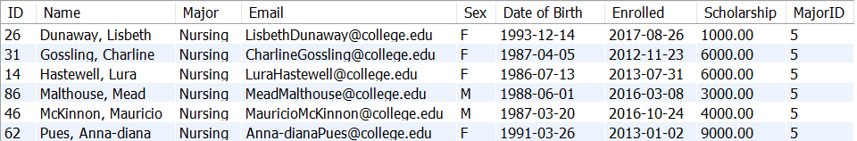
5 | Screen shot of your Schema window showing the view with its columns expanded  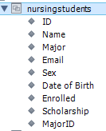
5 | Text of your CREATE VIEW SQL  CREATE  ALGORITHM = UNDEFINED  DEFINER = `root`@`localhost`  SQL SECURITY DEFINER  VIEW `college`.`nursingstudents` AS  SELECT  `studentflatten`.`ID` AS `ID`,  `studentflatten`.`Name` AS `Name`,  `studentflatten`.`Major` AS `Major`,  `studentflatten`.`Email` AS `Email`,  `studentflatten`.`Sex` AS `Sex`,  `studentflatten`.`Date of Birth` AS `Date of Birth`,  `studentflatten`.`Enrolled` AS `Enrolled`,  `studentflatten`.`Scholarship` AS `Scholarship`,  `studentflatten`.`MajorID` AS `MajorID`  FROM  `college`.`studentflatten`  WHERE  ((`studentflatten`.`Scholarship` > 0)  AND (`studentflatten`.`MajorID` = 5))
Discussion of why you shouldn’t select on the name of the major.
The name of the major shouldn’t be selected because the major names are always changing. It might be the slightest change, but it doesn’t matter because if we have it set to something specific such as “nursing’, it will only select the students with “nursing”. If we have it select the major ID, then it will always select the correct major, even if the name changes.

6 | Do It Yourself View
6 | Screen shot of the result grid from SELECT * FROM your view  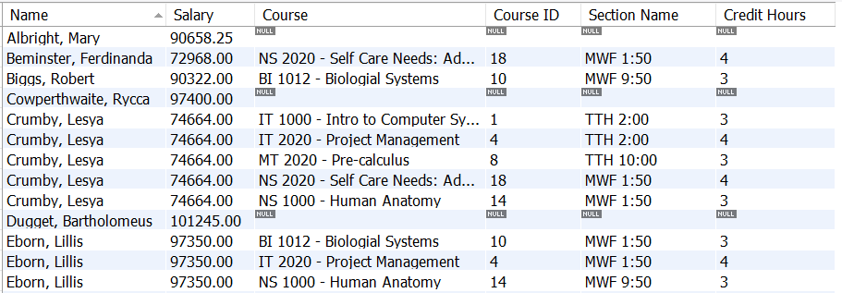
6 | Brief explanation of the purpose of your view. Tell me what it’s for, not how it works.  This view was created to show the faculty and their salary for the courses they are teaching. This uses the course ID so that if the name of the course were to change we would be able to use the ID to still find a specific course ID that we are looking for. This includes the faculty members salaries that don’t have a course and can help determine what they are getting paid for and whether they should or shouldn’t still be getting paid.
6 | Text of your CREATE VIEW SQL  CREATE  ALGORITHM = UNDEFINED  DEFINER = `root`@`localhost`  SQL SECURITY DEFINER  VIEW `facultycourses` AS  SELECT  CONCAT(`faculty`.`LastName`,  ', ',  `faculty`.`FirstName`) AS `Name`,  `faculty`.`Salary` AS `Salary`,  `course`.`Name` AS `Course`,  `section`.`CourseID` AS `Course ID`,  `section`.`Name` AS `Section Name`,  `course`.`CreditHours` AS `Credit Hours`  FROM  ((`faculty`  LEFT JOIN `section` ON ((`faculty`.`ID` = `section`.`TaughtByID`)))  LEFT JOIN `course` ON ((`section`.`CourseID` = `course`.`ID`)))  ORDER BY CONCAT(`faculty`.`LastName`,  ', ',  `faculty`.`FirstName`)

