Ryan McFarland

 | Your Answers
1 | Update student record
1 | Screen shot of the result grid showing the updated record
1 | Text of your UPDATE  -- 11.1 Ryan McFarland  -- Update last name and major  UPDATE Student  SET  LastName = 'Ritcher',  Email = 'PaulinaRitcher@college.edu',  MajorID = 3  WHERE  id = 16;
2 | Add new student
2 | Screen shot of the result grid showing the new record
2 | Text of your INSERT statement  -- 11.2 Ryan McFarland  -- New student into the table  INSERT INTO Student (LastName, FirstName, Email, Sex, DateOfBirth, EnrolledDate, MajorID, Scholarship)  VALUES ('Grindle', 'Wayne', 'WayneGrindle@college.edu', 'M', '1997-06-16', CURRENT_DATE(), 8, 4250);
3 | Attempt to add a student a second time
3 | Screen shot of the Output Windows showing the error that resulted from attempting the second add.
3 | Line of code that prevents the second insert from CollegeCreate  UNIQUE INDEX Email_UNIQUE (Email ASC) COMMENT '',
3 | Explain why this was designed this way  Every email address is unique to the one person who created the email address.
4 | Removing a course
4 | SQL to remove the course  -- 11.4 Ryan McFarland  -- Delete blood letting course  DELETE FROM Course  WHERE id = 15;
4 | Screen shot of the result grid showing the course is no longer in the system.  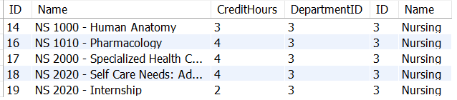

5 | Removing a department
5 | Screen shot of the Output Window. Be sure to widen column so I can see the complete message.  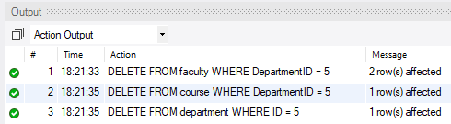
5 | Three DELETE SQL statements  -- 11.5 Ryan McFarland  -- Remove Romance language department, faculty, and courses  DELETE FROM faculty  WHERE DepartmentID = 5;  DELETE FROM course  WHERE DepartmentID = 5;  DELETE FROM department  WHERE ID = 5;
6 | Add course, section, student and registration.
6 | Screen shot of the four results of the SELECT statement.  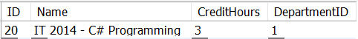  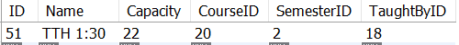  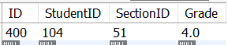
6 | Four INSERT SQL statements  -- 11.6 Ryan McFarland  -- Insert new course, section, and add student  -- and put into correct department  INSERT INTO Course (Name, CreditHours, DepartmentID)  VALUES ('IT 2014 - C# Programming', '3', '1');  INSERT INTO Section (Name, Capacity, CourseID, SemesterID, TaughtByID)  VALUES ('TTH 1:30','22','20','2','18');  INSERT INTO Student (LastName, FirstName, Email, Sex, DateOfBirth, EnrolledDate, MajorID, Scholarship)  VALUES ('McFarland', 'Ryan', 'RyanMcFarland@college.edu', 'M', '1992-05-28', CURRENT_DATE(), '1', '4000');  INSERT INTO Registration (StudentID, SectionID, Grade)  VALUES ('104', '51', '4.0');

