Ryan McFarland

 | Your Answers
1 | Students_With_Scholarships
1 | Text of your CREATE PROCEDURE  -- 12.1 Ryan McFarland  -- Students_With_Scholarships  DROP PROCEDURE IF EXISTS Students_With_Scholarships;  DELIMITER $$  CREATE PROCEDURE Students_With_Scholarships()  BEGIN  SELECT  LastName, FirstName, Scholarship  FROM  Student  WHERE  Scholarship > 0  ORDER BY LastName;  END  $$  DELIMITER ;
1 | Screen shot of the result grid from CALL Students_With_Scholarships() ;  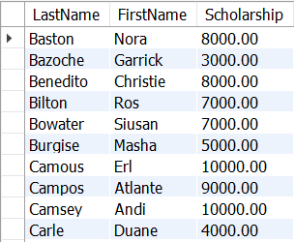
2 | Students_Major
2 | Text of your CREATE PROCEDURE  -- 12.2 Ryan McFarland  -- Students_Major  DROP PROCEDURE IF EXISTS Students_Major;  DELIMITER $$  CREATE PROCEDURE Students_Major (inMajorID INT)  BEGIN  SELECT  LastName AS 'Last Name', FirstName AS 'First Name', Major.name AS Major  FROM  Student  INNER JOIN Major on Student.MajorID = Major.ID  WHERE MajorID = inMajorID  ORDER BY LastName;  END  $$  DELIMITER ;
2 | Screen shot of the result grid from CALL Students_Major(1) ;  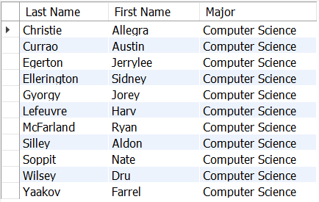
3 | Student_Add
3 | Text of your CREATE PROCEDURE  -- 12.3 Ryan McFarland  -- Student_Add  DROP PROCEDURE IF EXISTS Student_Add;  DELIMITER $$  CREATE PROCEDURE Student_Add (inLastName VARCHAR(45), inFirstName VARCHAR(45),  inSex CHAR(1), inMajorID INT, inDateOfBirth DATE)  BEGIN  INSERT Student (LastName, FirstName, Email, Sex, DateOfBirth, EnrolledDate, MajorID, Scholarship)  Values (inLastName, inFirstName, CONCAT(inFirstName, inLastName, '@college.edu'),  inSex, inDateOfBirth, current_date(), inMajorID, 0);  END  $$  DELIMITER ;
3 | Text of your CALL Student_Add(…  CALL Student_Add ('Hepp', 'Dot', 'F', 1, '1992-02-10');
3 | Screen shot of the result grid listing the new student

4 | Faculty_GPA
4 | Text of your CREATE PROCEDURE  -- 12.4 Ryan McFarland  -- Faculty_GPA  DROP PROCEDURE IF EXISTS Faculty_GPA;  DELIMITER $$  CREATE PROCEDURE Faculty_GPA(inFacultyID INT, OUT outGPA DECIMAL (4,2))  BEGIN  SET outGPA = (SELECT AVG(Grade)  FROM Registration  INNER JOIN Section on Registration.SectionID = Section.ID  WHERE Section.TaughtByID = inFacultyID and Grade > 0);  END  $$  DELIMITER ;
4 | Screen shot of the result grid showing average GPA  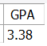

5 | FUNCTION Student_Section_Count
5 | Text of your CREATE FUNCTION  -- 12.5 Ryan McFarland  -- Student_Section_Count  DROP FUNCTION IF EXISTS Student_Section_Count;  DELIMITER $$  CREATE FUNCTION Student_Section_Count(inStudentID INT)  RETURNS int  BEGIN  DECLARE sectionCount int ;  SET sectionCount =  (SELECT count(Registration.SectionID)  FROM  Student  INNER JOIN Registration ON registration.studentid = student.id  INNER JOIN Section on registration.sectionid = section.id  WHERE inStudentID = StudentID);  RETURN sectionCount ;  END $$  DELIMITER ;
5 | Screen shot of the result grid showing the call to the function  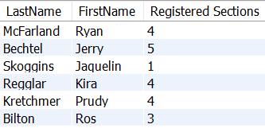
6 | Do It Yourself Stored Procedure
6 | Screen shot of the result grid showing the call to your stored procedure  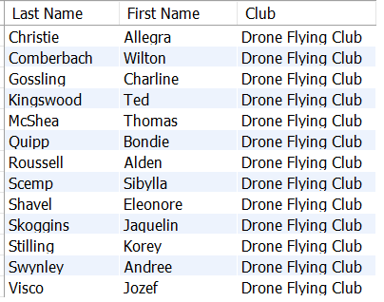
6 | Brief discussion of the purpose of your stored procedure. Tell me what it’s for, not how it works.  The stored procedure I created, students_club, will display all of the students that are members of the various clubs.
6 | Text of your CREATE PROCEDURE  -- 12.6 Ryan McFarland  -- DIY, students who are in a specific club  DROP PROCEDURE IF EXISTS Students_Club;  DELIMITER $$  CREATE PROCEDURE Students_Club (inClubID INT)  BEGIN  SELECT  LastName AS 'Last Name', FirstName AS 'First Name', Club.name AS Club  FROM  Student  INNER JOIN membership on student.id = membership.studentID  INNER JOIN club on Membership.ClubID = club.id  WHERE inClubID = club.ID  ORDER BY LastName;  END  $$  DELIMITER ;

