Ryan McFarland

 | Your Answers
1 | Before INSERT trigger
1 | Screen shot of the result grid from SELECT statement shown in the homework  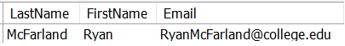
1 | SQL that creates your trigger, including the UPDATE statement  -- 14.1 Ryan McFarland  -- Faculty_Before_Insert  USE COLLEGE;  DROP TRIGGER IF EXISTS Faculty_Before_Insert;  DELIMITER $$  CREATE TRIGGER Faculty_Before_Insert  BEFORE INSERT ON Faculty  FOR EACH ROW  BEGIN  SET NEW.EMail = CONCAT(NEW.FirstName, NEW.LastName, '@college.edu');  END $$  DELIMITER ;  INSERT INTO Faculty (LastName, FirstName, Email, HireDate, Salary, DepartmentID)  VALUES ('McFarland', 'Ryan', 'bad@bad.com', current_date(), 250000, 1);  SELECT  LastName, FirstName, Email  FROM  Faculty  WHERE  ID = LAST_INSERT_ID();
2 | Before UPDATE trigger
2 | Screen shot of the Output Window showing the output both UPDATE statements  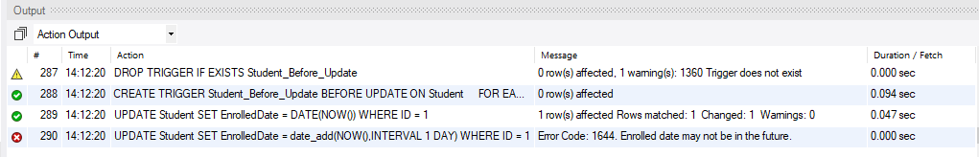
2 | SQL that creates your trigger  -- 14.2 Ryan McFarland  -- Student_Before_Update  USE COLLEGE;  DROP TRIGGER IF EXISTS Student_Before_Update;  DELIMITER $$  CREATE TRIGGER Student_Before_Update  BEFORE UPDATE ON Student  FOR EACH ROW  BEGIN  IF New.EnrolledDate > current_date() THEN  SIGNAL SQLSTATE '45000'  SET MESSAGE_TEXT= 'Enrolled date may not be in the future.';  END IF;  END $$  DELIMITER ;  UPDATE Student  SET EnrolledDate = DATE(NOW())  WHERE ID = 1 ;  UPDATE Student  SET EnrolledDate = date_add(NOW(),INTERVAL 1 DAY)  WHERE ID = 1 ;

3 | Add another rule of your choosing
3 | Screen shot of the Output Window showing the output with the error.  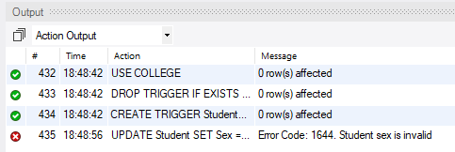
3 | SQL that creates your trigger  USE COLLEGE;  DROP TRIGGER IF EXISTS Student_Before_Update;  DELIMITER $$  CREATE TRIGGER Student_Before_Update  BEFORE UPDATE ON Student  FOR EACH ROW  BEGIN  IF NEW.Sex != 'm' or 'f' THEN  SIGNAL SQLSTATE '45000'  SET MESSAGE_TEXT= 'Student sex is invalid';  END IF;  END $$  DELIMITER ;

4 | After UPDATE trigger
4 | Screen shot of the Output Window showing the output both UPDATE statements  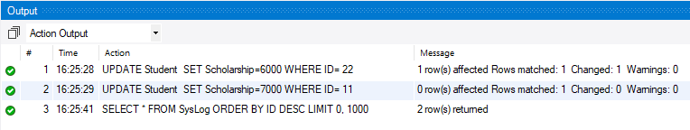
4 | SQL that creates your trigger  USE COLLEGE;  DROP TRIGGER IF EXISTS Student_After_Update;  DELIMITER $$  CREATE TRIGGER Student_After_Update  AFTER UPDATE ON Student  FOR EACH ROW  BEGIN  INSERT INTO SysLog (TableName, Message, Created)  VALUES ('Student', CONCAT('Updated ID=' , NEW.ID), NOW());  END $$  DELIMITER ;

5 | Before Insert Trigger on Registration
5 | Paste the text of your INSERT statement and a screen shot of the Output Window showing the output from two runs of the statement.  INSERT INTO Registration(StudentID, SectionID, Grade)  VALUES(100, 16, 4.2);  INSERT INTO Registration(StudentID, SectionID, Grade)  VALUES(100, 16, 4.2);  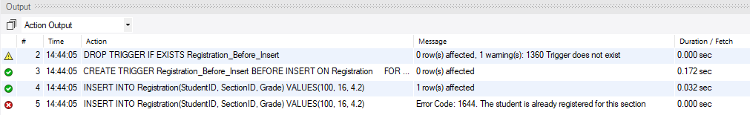
5 | SQL that creates your trigger  -- 14.5 Ryan McFarland  -- Registration_Before_Insert  USE COLLEGE;  DROP TRIGGER IF EXISTS Registration_Before_Insert;  DELIMITER $$  CREATE TRIGGER Registration_Before_Insert  BEFORE INSERT ON Registration  FOR EACH ROW  BEGIN  DECLARE countOfRegRecords INT;  SET countOfRegRecords =  (SELECT COUNT(*) FROM Registration WHERE StudentID= NEW.StudentID  and new.sectionid = sectionid);  IF countOfRegRecords > 0 THEN  SIGNAL SQLSTATE VALUE '45000'  SET MESSAGE_TEXT= 'The student is already registered for this section';  END IF ;  END $$  DELIMITER ;

