Ryan McGrath

June 7, 2022

Web Services

Final Project

I worked alone on this project so I will not be creating a breakdown on contributions as it would be unnecessary. Below are screen shots of how the pages should look as test images. The bulk of the project is centered around the chart in which the user can enter in a varying number of charges and Node will render the charges in the form of a pie chart. The original idea is that a user would sign up and enter in their credit card information in which charges made with the card would appear on this website to help visualize the breakdown of expenses. For obvious reasons I would not hook up a credit card to this site so to emulate how this would work I included the table below (included in the image for reference) to demonstrate how the chart would behave. Chart.js is used to render the chart, all files will be included in the zip file.

Index Page:

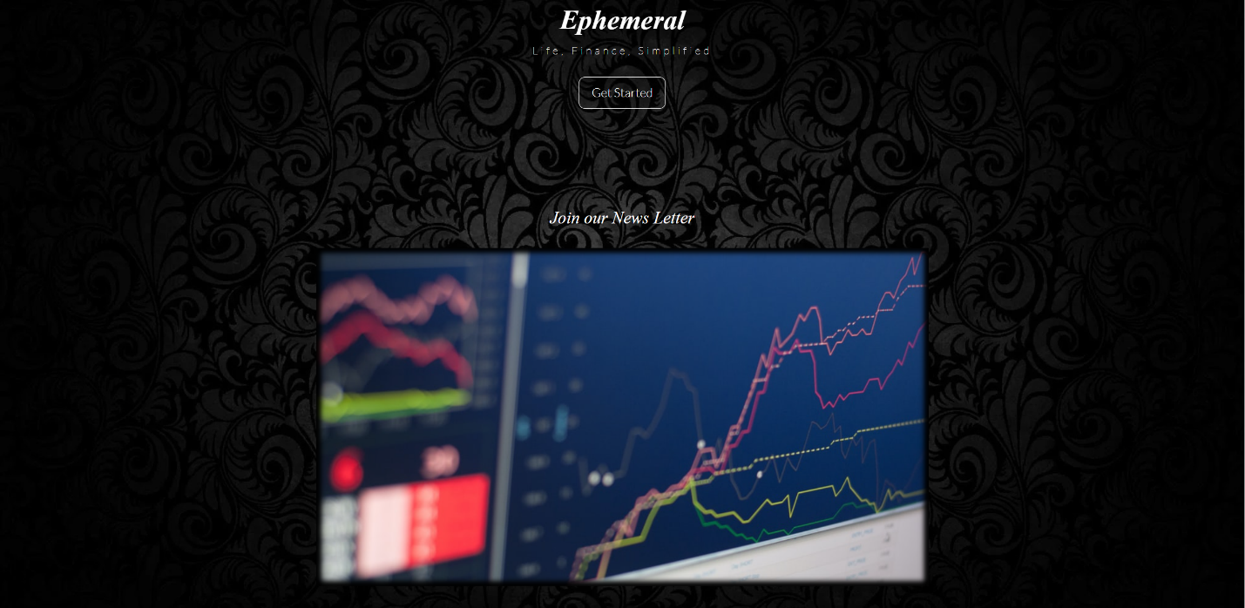

Log in Page:

Register Page:

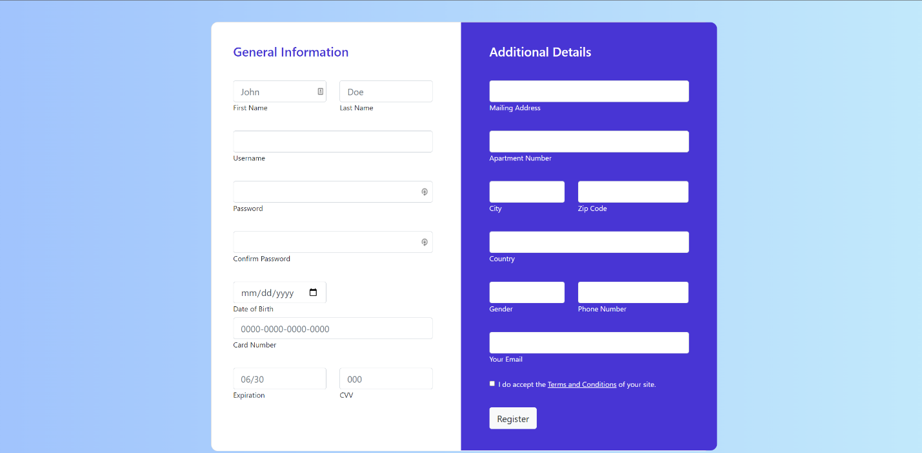

Interactive Chart Page:

