C16419862  
Ryan McGrane  
DT 228/3 – Software Engineering 3 Assignment   
Deliverable Part 1

<http://youtu.be/_GToZQT28pU?hd=1>

**Summary of Web Application:**

Many people in the world require a nurse or a doctor’s attention immediately, but due to some circumstances they cannot be seen. This online health system allows users to get instant guidance on their health issues, through an intelligent health care system online. The user logs onto the online system and discusses their symptoms to an automated system, which has cached symptoms (illness’, breaks, pains, …etc) stored in the database. The user will be asked to describe their symptoms and if there’s a match, will schedule an hospital appointment according to the symptoms diagnosed. If there is no match to the symptoms in the database the patient will automatically be put onto an online chat service with a doctor where they can discuss their symptoms, upload images, message, acquire prescriptions. Both patients and users can log into the system and discuss issues In the online chat.

**Requirements model:**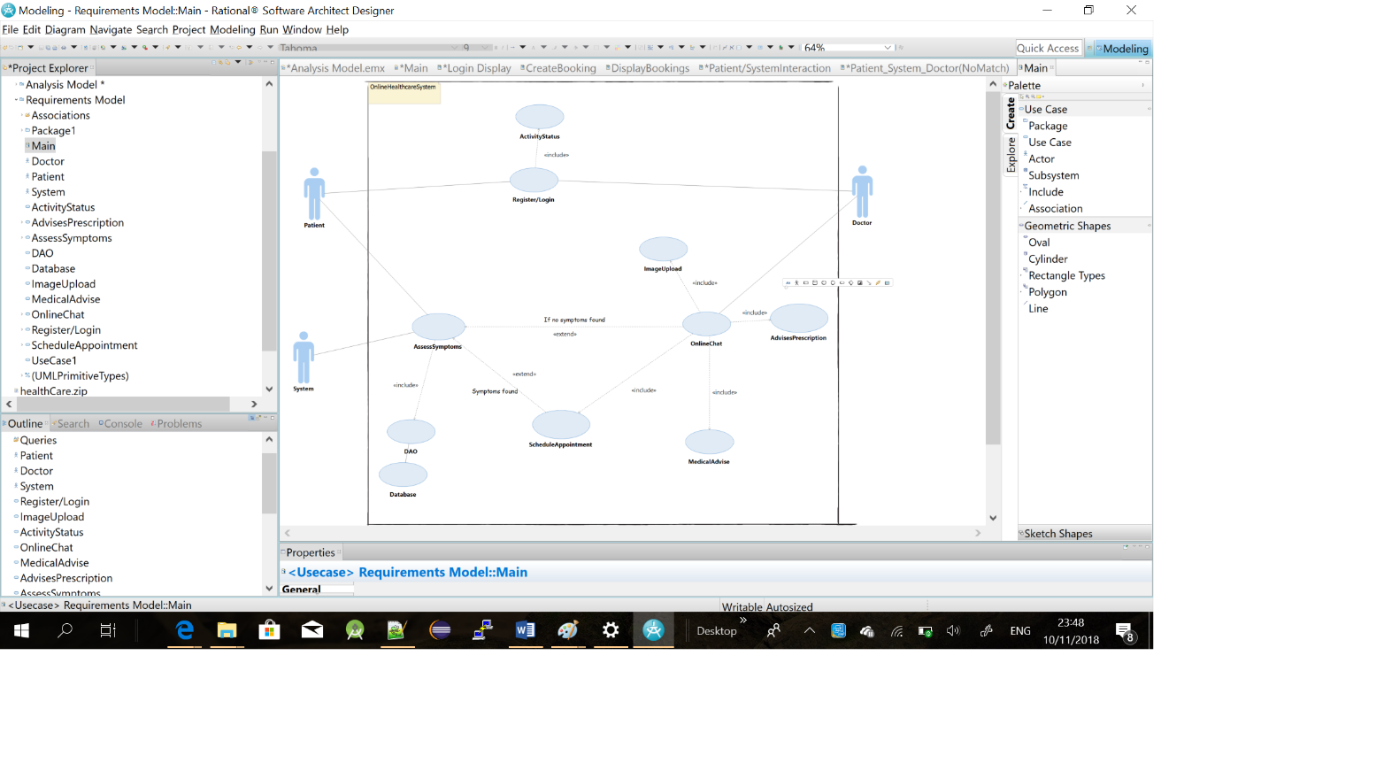

**Analysis Model:**

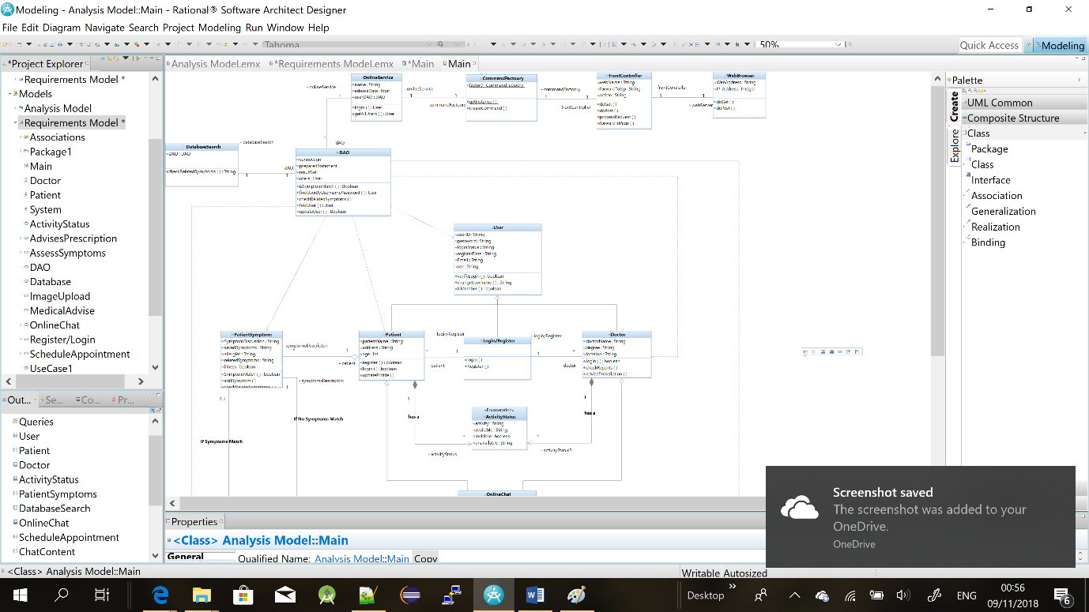

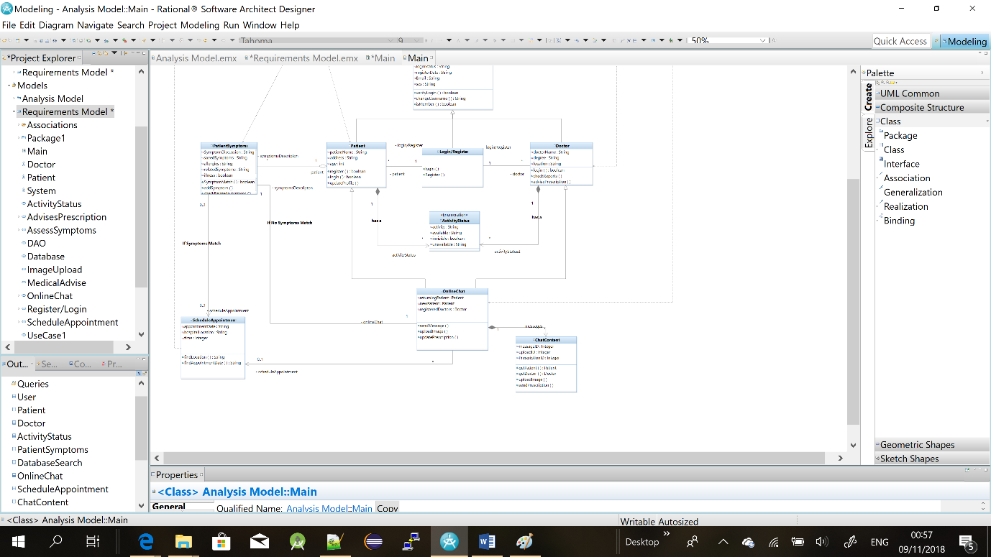

The analysis model consists of 15 classes with each containing their own attributes and methods. The model contains multiple different relationships such as bidirectionaol 1 to 1s, composition relationships, aggregation, inheritance, uni-directional relationships, 0.1 to * and simple realizations from the DAO to other classes. I used a few design patterns to implement my online web app, such as DAO pattern, Front Controller pattern, command factory pattern. Each one has its own reason for been implemented in my design. The DAO pattern allows me to update and grab information from my databases and classes. Creating userDAO’s so they can be updated, deleted, and so on. The front Controller pattern allows me to centralise point of access for handling client requests in the web app. It asks the command factory class for the appropriate command object. The controller has no knowledge of which command implementation it is invoking.

**Sequence Diagrams:**

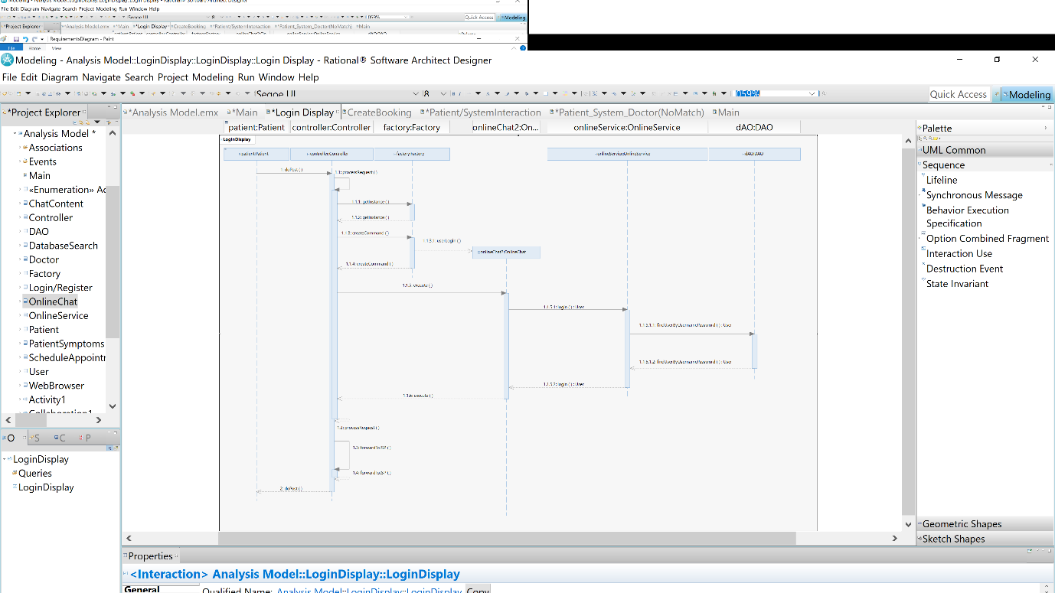

The sequence diagram above shows how the user login interaction is performed. The patient performs an interaction on the online service such as a login, the controller then process’ the request, creates an instance from the command factory, then creates a command where the user can then login to the system through the online chat. The chat checks the data base to see if the user is valid, if so logs in the user then the controller carries you on to the next page.

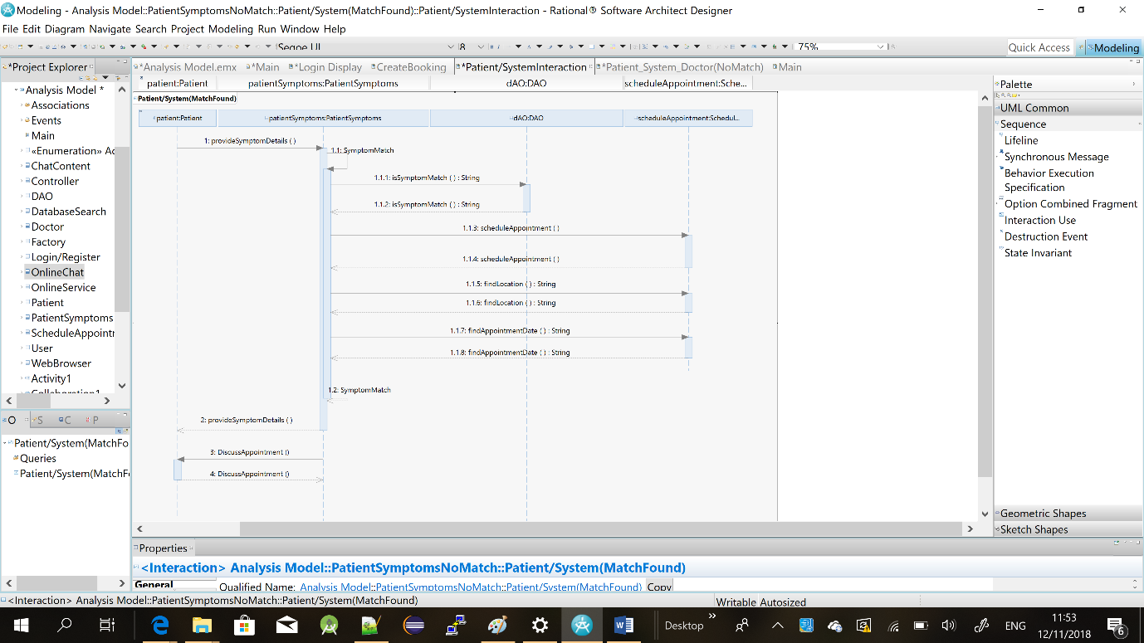

This sequence diagram reflects what happens in the system when there is a symptom match in the database from the patient logged in. When the user provides his symptoms to the patientSymptoms Class, the PatientSymptoms class will assess if the patient will be brought to an online chat with a doctor or will be scheduled an appointment instantly in respect to the symptoms discussed. When a match is found in the DAO, for a patient symptoms, the patient’s symptoms class will schedule an appointment in a hospital and the patient will be given the location and time is will take place at.

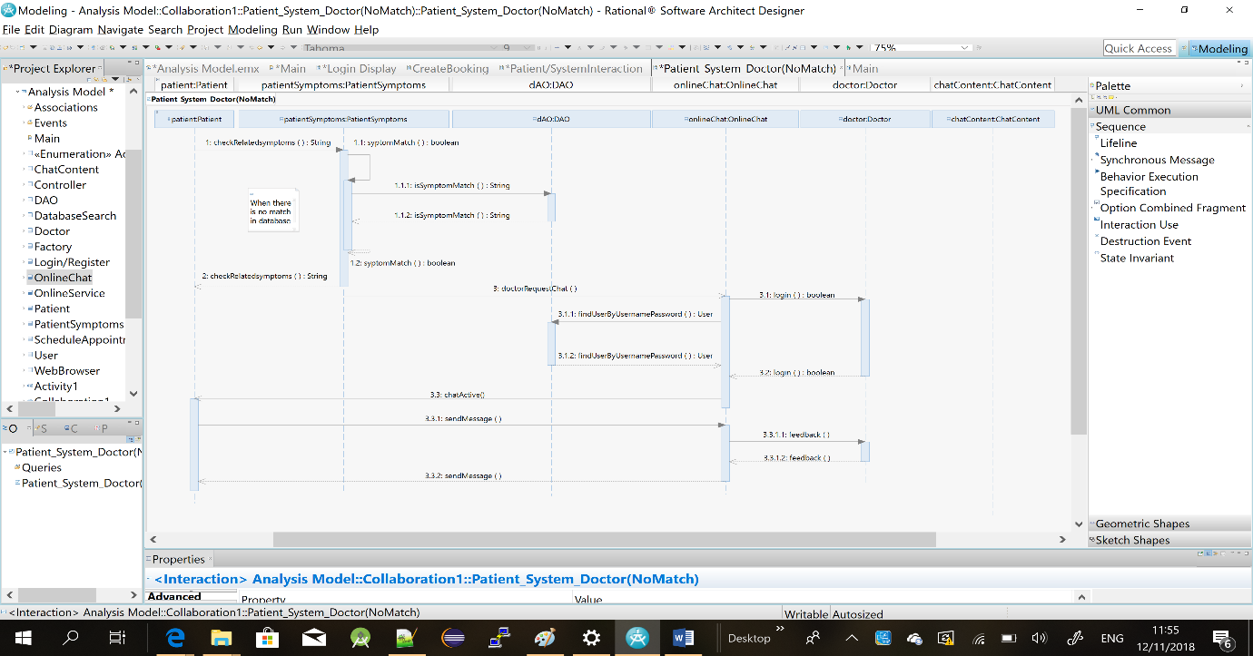

The above sequence diagram reflects what occurs when there is no match in the database for a user’s symptoms. In this situation the patient symptoms class will request an online chat with a doctor where a patient and doctor can message each other, upload images, prescribe medication…