CA 2

Web Design And Development Report

Part-1(Report)

### WebSite Idea : Game Website.

Summary

This Game Website will be a place where the client can buy all genre’s of different games online and have them delivered to their home, the Administrator of the site will be able to dictate what goes onto the site what need’s to be updated or removed.

User Requirements

The client/user will be able to

1. View Items on the website.

2. Add and Remove Items from there baskit.

3. Also they will be able to sign up and be able to login to their account on the website.

4. The end result will be user purchases items.

Admin Requirements

The Admin Will be able to

1. Add Items to the Webpage.

2. Update What Items are on the webpage.

3. Delete Items if needs be.

System Requirements

The System Requirements

1. Store Details about user.

2. Store Details about the items on the site.

3. Be able to display items on the website.

Physical Structure of Web Page.

#### Visual structure (3).jpg

### Webpage mutual Design

Colour Scheme

The Title of the Website will include Green & Orange, its background will be a dark purple to make the colours stand out these colours will also be used in the footer and some other pages within the website but also light tones of gray will be used as well.

Media

The Websites media will include mainly images with slide shows also which which may be used as clickable advertisement links to individual game pages, this website if possible will also include short clips of game trailers for each game on the website.

Main - Pages Layout

Model

The model of the page will be were the heading the navbar and the footer will be dynamically allocated to each page that is clicked upon.

The head of the page will use the .jumbotron Bootstrap div with the text Centered within it, While the container which will hold the rest of the page will be of type .container-fluid so it spans the entire view of the device to which it is opened on.

The navbar will be on the left hand side of the page and the content to the right these will both go within a singular bootstrap .row and navbar will have a class .col-sm size of 2 and the content will be allocated a column size of 10.

The footer will go below the content and navbar and will be inside a div with bootstrap class .col-sm within it will have its text aligned to the center.

HomePage

This be placed within the content div in the model as will all the rest of the pages, It will display a game image along with a brief description of the game to the right of the image each game will be a clickable link and each will span the entire length of the column each of these game links will be split into separate rows.

Just above the all of the rows of games there will be a drop down list which will allow the user to select the genre/platform of game they are looking for if they are unsure they will be able to just choose a option called all which will get all the games stored within the database.

Next to the drop down list there will be a search bar along with a cart icon which will allow the user once signed in to view the items currently in there cart.

Down the bottom of the page there will be a pagination to switch from one page to the next this will be how the user will scroll through the databases items and each time they go onto the next page it will generate a set number of game titles each time.

Game

This will be the page to which the user will travel when they click on one of the game links on the homepage this will then bring them to a page with image of game cover some extra details and a add to cart button.

Just below the image there will be a option to add game to the basket

This will be a clickable button on the page and when clicked will add the game chosen to your accounts basket if you are not signed in the website will redirect you to the sign in page.

Below this there will be given further insight into what the games about whether it's multiplayer or not etc.

Part-2(Report)

This part of the Continuous Assessment will be focusing on the background database and overall Functionality of the Website.

Functions Involved & Who they Apply to

1. Sign Up & Sign In - User.

Note : This means That once account is created user will then need to sign in to then add things to his cart, if he attempts to add them before he/she is signed in he/she should be notified that he/she must sign in.

1. Admin .

Note : This is not yet fully figured out but by the looks of it the Admin will

either have to sign in to Edit/Updates tables or it will be separate part of play frame not entirely sure.

1. Add Items to Cart - User.

Note : The User’s Cart Table will keep track of items the entire price and so on yes User will add items to his/her cart but from then on his/her item’s will be handled by the cart table for instance the association

1. View Cart - User.

Note : The User will be able to view the item’s in his cart but also will be able to view the total price of all items in the cart.

1. Remove From Cart - User.

Note : The User will be able to Remove the items from his/her cart.

1. Purchase Items - User.

Note : User once done his/her browsing of there items on the website will be capable of purchasing them from the cart view.

1. Add Items - Admin.
2. Remove Items - Admin.

Note: Items on the Website will be added and removed by admin as need be but some item’s will be in database by default as well as Admins.

Database Layout (Changes)

This not been edited to properly show the structure of the database as it turned out in the end, what had been removed was the cart we replaced that with a basic purchase item which once purchased would return them to the database.

Also the Games table also had an one to many with a newly added table Genre this was just as in the labs there was category and it seemed to handle the querying the database for just ‘RPG’s’ or ‘FPS’ alot better than the way that had been first thought out.

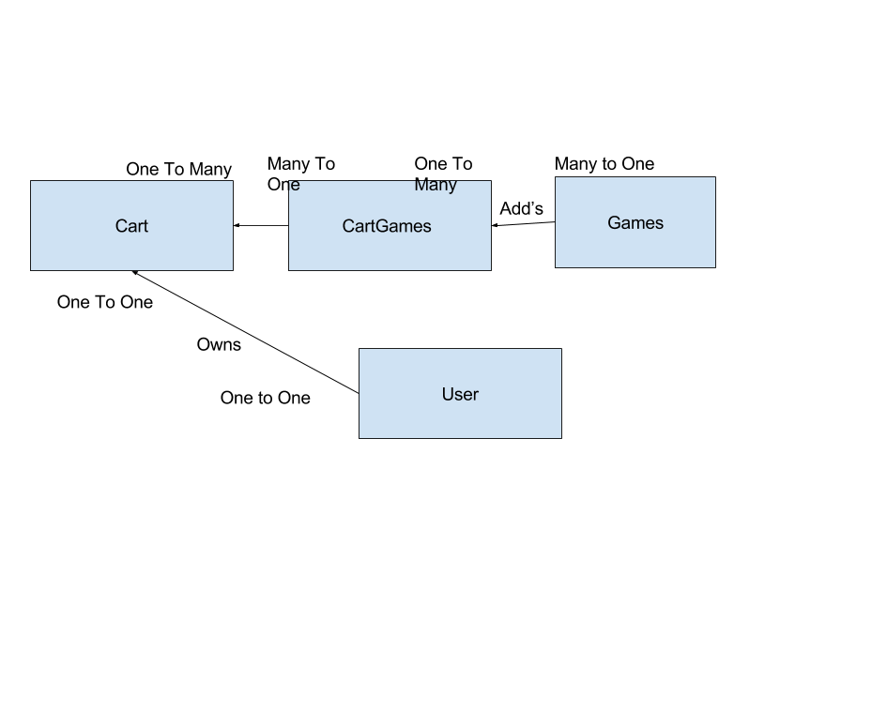

Issues

Some issues that we had run into was persisting the data from the forms to the database for both me and chris it had proved to be annoying.

Some other snags that we came across were with the User Login just ensuring that everything was properly secured and once it was bug checked ran just fine for us.

Search bar I had found difficult but quick fix once i googled how to pass parameters back to the Index controller to check for existing titles with the name that had been entered.

We wanted to put Platform into a separate table also but it would have a many to many relationship with games and i could not figure out a way around that so I kept it inside the game table and worked around it in the end that turned out just fine and the last thing that caught me out was image processing it was the assets routes i found the problem in the end just some minor spelling mistakes but for a second just wanted to delete it and instead pass a string to the href that the admin would enter to get the image from the web instead.

Tables - Explained

User

This Table will consist of User Name , User Password And Other Relevant information, main things to note about this table is that it will store both Admin’s And Users possibly this is not for definite and may be change if needs be as Admin’s and User separation has not been defined well up until now.

Just to note that the discriminating value between Admin and User will be User Type this will help to keep things nice and easy to differentiate.

Cart

This table will store data such as Cart id ,Total Price etc… Only Foreign Keys will be User Id.

If you are wondering why user is not directly connected to The Items table in visual db or in script this is because user does not need any connection only a connection to the Cart to which he owns this is because Users to not directly own items 1 until they are in the cart and not so much even then and 2 because As long as the users connected to cart the cart will handle what items are added bought and belong to that user.

Games

This table will consist of Game id, Title,Genre etc… this has a many to Many RelationShip with Cart So as Such an Associative table had to be created to make up for this issue,

The Associative Table name is Cart Games And It Consists of two Foreign Keys Cart id and Game id which make one composite primary key.

Contributors

Christopher McConnell

(Xnumber) - X00128141

Ryan Molyneux

(Xnumber) - X00131076

Aran Smith

(Xnumber)- X00118718

Roles

**Page Layout & Design -** Ryan,Christopher,Aran.

##### 

##### Individual Work-Part 1.

Model - Ryan,Aran.

About Us & Contact Us - Christopher.

Sign In Or Sign Up & Game - Ryan.

Home & Basket - Aran.

Documentation Part 1 - Chris & Ryan.

Individual Work-Part 2.

Database Script & Documentation Part 2 & Index,

Game,Admin Mode,view Games,view Messages (html)

&

Index(Search,Genre Choice etc..),Game,view Games,add Games,update Games,Delete Games,view Messages (functionality)- Ryan.

Contact Us & Purchase Functionality - Chris.

Sign in functionality (both users and admin) - Aran.