Flowchart Utility

A Portfolio Project by Ryan Moody

Contents

Abstract 1
Design 1
Modelling the Flowchart with a DTD 1
Flowchart Validity 1
Implementation 1
GUI Design 1
Demonstration 1
Testing 1
Flowchart Validation 1
User Interface 1
Applications 1
Training 1
Appendix A: Source Code 1
Program.cs 1
FlowchartUtility.cs 1
FlowchartUtility.Designer.cs 1
Flowchart.cs 1
Node.cs 1
Decision.cs 1
Appendix B: Example Flowcharts 1
ERROR - Does not satisfy DTD.xml 1
ERROR - No start node.xml 1
ERROR - Referenced node does not exist.xml 1
ERROR - Unreachable node.xml 1
ERROR - Self referencing node.xml 1
ERROR - Duplicate node IDs.xml 1
VALID - Adventure.xml 1
VALID - TV licensing call centre instructions.xml 1

Abstract

During the 1980s and 1990s, “Choose Your Own Adventure” (CYOA) books were very popular. Unlike traditional books which are linearly read from start to finish, CYOA books allow you to decide how the story progresses by reading pages in a non-consecutive order. An example of a page from a CYOA book is shown below:

You are lost in a jungle, it is starting to get dark, and you need to find shelter. You see a clearing in the forest, a nearby stream and a tall, old tree.

If you decide to:
- Enter the forest clearing, turn to page 12
- Follow the stream, turn to page 85
- Climb the tree, turn to page 27

This project aims to create a GUI that can be used to read a CYOA book. This will involve:
- Designing a model for a CYOA book which can be easily processed by a GUI.
- Implementing the GUI which allows the user to read these models of CYOA books.
- Confirming that the GUI functions as required through test cases.
- Exploring the flexibility of the GUI and how it could be applied to real scenarios.

Design

Modelling the Flowchart with a DTD
First, it needs to be decided how a CYOA book should be modelled so that a GUI can easily interpret such a model. A CYOA book can be thought of as a flowchart, with the pages of the book being represented by the flowchart’s nodes, and the available decisions on a page being represented by the directed arrows that connects the flowchart’s nodes together.

The data and structure that comprise the flowchart could easily be modelled using XML. Having made this design choice, this then gives rise to the following DTD:

<!ELEMENT flowchart (node*)> (The book)
<!ELEMENT node (decision*)> (The pages of the book)
<!ELEMENT decision EMPTY> (The decisions on the pages)

<!ATTLIST node ID CDATA #REQUIRED> (Page number)
<!ATTLIST node information CDATA #REQUIRED> (Page narrative)

<!ATTLIST decision IDreference CDATA #REQUIRED> (Decision’s “Turn to” page number)
<!ATTLIST decision description CDATA #REQUIRED> (Decision’s description)

Flowchart Validity
The DTD on its own is not enough to determine the validity of a flowchart. In addition to asserting that a flowchart conforms to the DTD, the implementation must also check the following to prevent erroneous behaviour:

- The flowchart has a start node
- All nodes referred to by the flowchart’s decisions exist
- The flowchart’s decisions allow all nodes to be reached from the start node
- The flowchart’s decisions do not cause any self references
- All nodes have unique IDs

The table on the next page depicts a number of invalid flowcharts and the error messages that the implementation should display for each individual case. Note that for the remainder of this document, the diagram below means that a node with ID “X” has a decision that refers to a node with ID “Y”:
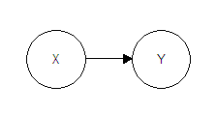

Flowchart Structure | Expected Error Message
Incorrectly  structured flowchart | 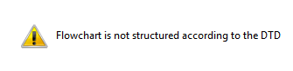
Empty flowchart | 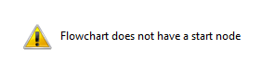
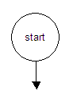 | 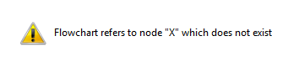
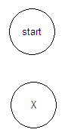 | 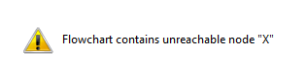
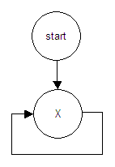 | 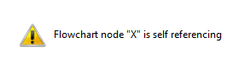
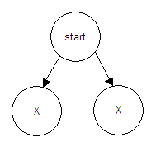 | 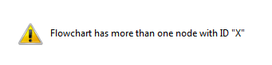

Implementation

GUI Design
As the GUI would need to make use of an XML parser, I decided the implementation should be written using C# (the source was compiled using Microsoft Visual Studio 2005). A screenshot showing the appearance of the GUI when it is first started is given below:

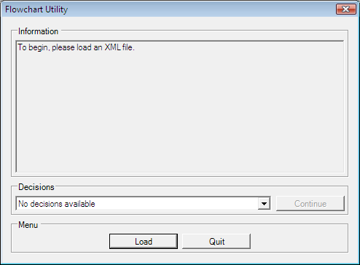

- The Load button loads a flowchart (only if it is valid)
- The Information text box displays the node’s narrative
- The Decisions combo box lists the available decisions for the current node
- The Continue button progresses the flowchart based on the decision selected
- The Quit button exits the flowchart utility

Demonstration
To demonstrate the usage of the flowchart utility, a flowchart representing a small CYOA book has been written (“VALID - Adventure.xml” which can be found on the accompanying DVD). A diagrammatic representation of this valid flowchart and the appearance of the GUI after it has loaded this flowchart can be found on the following page.

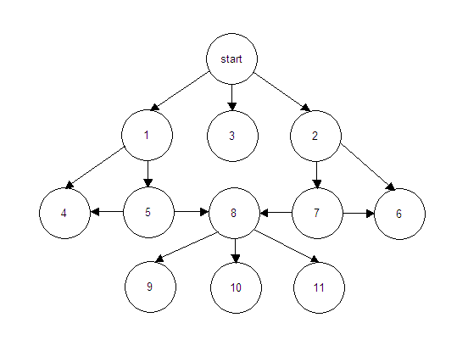
A diagram of a valid flowchart representing a CYOA book

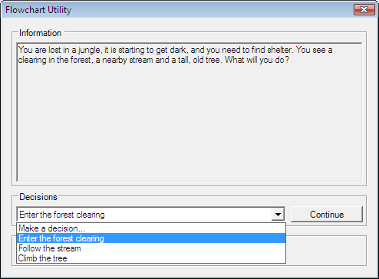
Screenshot of the same flowchart being read by the Flowchart Utility

Testing

Flowchart Validation
Test ID | Description | Result
A1 | Loading a flowchart that is not structured according to the DTD causes the error message “Flowchart is not structured according to the DTD” to be displayed. | PASS
A2 | Loading a flowchart that does not have a start node causes the error message “Flowchart does not have a start node” to be displayed. | PASS
A3 | Loading a flowchart that contains a decision which refers to non-existent node “X” causes the error message “Flowchart refers to node “X” which does not exist” to be displayed. | PASS
A4 | Loading a flowchart that has an unreachable node “X” causes the error message “Flowchart contains unreachable node “X”” to be displayed. | PASS
A5 | Loading a flowchart that has a self referencing node “X” causes the error message “Flowchart node “X” is self referencing” to be displayed. | PASS
A6 | Loading a flowchart that has duplicate node ID “X” causes the error message “Flowchart has more than one node with ID “X”” to be displayed. | PASS
A7 | Loading a flowchart from a non-existent file “X” causes the error message “”X” File not found. Check the file name and try again.” to be displayed. | PASS

User Interface
Test ID | Description | Result
B1 | In the GUI’s initial state, the Information text box contains the text “To begin, please load an XML file.” and the Decisions combo box only contains the option “No decisions available”. | PASS
B2 | Clicking on the Load button brings up a file selection dialog, filtered to only list flowchart files (*.xml) | PASS
B3 | If a valid flowchart is loaded, then no error message is displayed, the file selection dialog is closed and the GUI’s state changes to represent the data in the flowchart’s start node. | PASS
B4 | If an invalid flowchart is loaded, then an error message is displayed (as per tests A1 – A6), the file selection dialog is closed and the GUI is reset to the initial state. | PASS
B5 | If a flowchart from a non-existent file is loaded, then an error message is displayed (as per test A7), the file selection dialog remains open and the GUI remains in its current state. | PASS
B6 | Every node of a flowchart contains “Make a decision...” at the top of the Decisions combo box. The combo box defaults to this value after a valid flowchart is loaded and after the Continue button is clicked. | PASS
B7 | Flowchart nodes that have no decisions defined in the XML file display a Decisions combo box that only contains the values “Make a decision...” and “Restart”. | PASS
B8 | The Continue button is enabled if and only if the selected value in the Decisions combo box is neither “No decisions available” nor “Make a decision...” | PASS
B9 | When the Continue button is clicked, the GUI’s state changes to represent the data of the node referred to by the selected decision. | PASS
B10 | Clicking on the X or the Quit button closes the utility. | PASS

Applications

It has been demonstrated that a flowchart can be used to model a CYOA book. A flowchart however, can of course be used to model many other real-world scenarios.

Training
Consider the flowchart depicted below, representing simplified training instructions on how a TV Licensing call centre operator should answer customer calls:

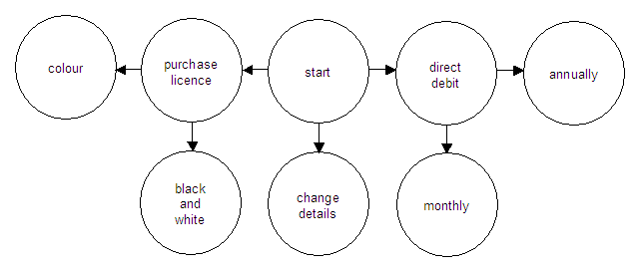

At the start of the call, the customer tells the operator if they want to:

- Purchase a TV licence
- Change their account details or
- Set up a direct debit

In the first case, the operator is instructed to ask the customer if they want a colour or black and white TV licence, then process the purchase accordingly.

In the second case, the operator is simply instructed to record the customer’s new details.

In the third case, the operator is instructed to ask the customer if they want their direct debit to make payments on a monthly or yearly basis, then set up the direct debit accordingly.

Thus, due to the flexibility of the flowchart model, as well as quizzes, adventures and games, the GUI can be used for non-trivial applications, especially training tasks where a set procedure needs to be followed.

Appendix A: Source Code

Program.cs

using System.Windows.Forms;
using System;

namespace FlowchartUtility
{
static class Program
{
[STAThread]
static void Main()
{
// Starting point of the Flowchart Utility execution
Application.Run(new FlowchartUtility());
}
}
}

FlowchartUtility.cs

using System.Windows.Forms;

namespace FlowchartUtility
{
public partial class FlowchartUtility : Form
{
public FlowchartUtility()
{
// Initialises the flowchart utility
InitializeComponent();
}
}
}

FlowchartUtility.Designer.cs

using System;
using System.Drawing;
using System.Windows.Forms;
using System.Xml;

namespace FlowchartUtility
{
partial class FlowchartUtility
{
// Singleton flowchart instance

private Flowchart flowchart = Flowchart.getFlowchart();

// GUI controls

private TextBox TB_Information = new TextBox();
private ComboBox CB_Decisions = new ComboBox();
private Button B_Continue = new Button();
private Button B_Load = new Button();
private Button B_Quit = new Button();
private GroupBox GB_Information = new GroupBox();
private GroupBox GB_Decisions = new GroupBox();
private GroupBox GB_Menu = new GroupBox();

private void InitializeComponent()
{
// Client window initialisation

Text = "Flowchart Utility";
ClientSize = new Size(488, 338);
FormBorderStyle = FormBorderStyle.FixedDialog;
MaximizeBox = false;
MinimizeBox = false;

// GUI controls initialisation

TB_Information.Location = new Point(6, 19);
TB_Information.Multiline = true;
TB_Information.ReadOnly = true;
TB_Information.Size = new Size(452, 183);

CB_Decisions.DropDownStyle = ComboBoxStyle.DropDownList;
CB_Decisions.Location = new Point(6, 19);
CB_Decisions.Size = new Size(352, 21);

B_Continue.Location = new Point(364, 19);
B_Continue.Size = new Size(94, 21);
B_Continue.Text = "Continue";

B_Load.Location = new Point(135, 19);
B_Load.Size = new Size(94, 21);
B_Load.Text = "Load";

B_Quit.Location = new Point(235, 19);
B_Quit.Size = new Size(94, 21);
B_Quit.Text = "Quit";

GB_Information.Controls.Add(TB_Information);
GB_Information.Location = new Point(12, 13);
GB_Information.Size = new Size(464, 208);
GB_Information.Text = "Information";

GB_Decisions.Controls.Add(CB_Decisions);
GB_Decisions.Controls.Add(B_Continue);
GB_Decisions.Location = new Point(12, 227);
GB_Decisions.Size = new Size(464, 46);
GB_Decisions.Text = "Decisions";

GB_Menu.Controls.Add(B_Load);
GB_Menu.Controls.Add(B_Quit);
GB_Menu.Location = new Point(12, 279);
GB_Menu.Size = new Size(464, 46);
GB_Menu.Text = "Menu";

InitialiseInformationAndDecisions();

// Add the GUI controls to the client window

Controls.Add(GB_Information);
Controls.Add(GB_Decisions);
Controls.Add(GB_Menu);

// The selected control should default to the Load button

B_Load.Select();

// Event handlers

CB_Decisions.SelectedIndexChanged += new EventHandler(SelectedDecision);
B_Continue.Click += new EventHandler(ClickedContinue);
B_Load.Click += new EventHandler(ClickedLoad);
B_Quit.Click += new EventHandler(ClickedQuit);
}

private void DisplayErrorMessage(string strError)
{
// Displays the given error message

InitialiseInformationAndDecisions();
MessageBox.Show(strError, "Error", MessageBoxButtons.OK,
MessageBoxIcon.Exclamation);
}

private void InitialiseInformationAndDecisions()
{
// Displays the initial information and decisions

TB_Information.Text = "To begin, please load an XML file.";
CB_Decisions.Items.Clear();
CB_Decisions.Items.Add("No decisions available");
CB_Decisions.SelectedIndex = 0;
B_Continue.Enabled = false;
}

private void UpdateInformationAndDecisions(string strID)
{
// Displays the information and decisions for the node with the given ID

Node node = flowchart.findNode(strID);
TB_Information.Text = node.getInformation();
CB_Decisions.Items.Clear();
CB_Decisions.Items.Add("Make a decision...");
CB_Decisions.Items.AddRange(node.getDecisions().ToArray());
CB_Decisions.SelectedIndex = 0;
}

private void SelectedDecision(object o, EventArgs args)
{
// Enables the Continue button when a decision is selected

B_Continue.Enabled = (CB_Decisions.SelectedIndex != 0);
}

private void ClickedContinue(object o, EventArgs args)
{
// Continues to the next node in the flowchart based on the decision selected

Decision decision = (Decision) CB_Decisions.SelectedItem;
UpdateInformationAndDecisions(decision.getIDreference());
}

private void ClickedLoad(object o, EventArgs args)
{
// Asks the user which XML flowchart file they would like to load

OpenFileDialog dialog = new OpenFileDialog();
dialog.Filter = "Flowchart Files (*.xml)|*.xml";

if (dialog.ShowDialog() == DialogResult.OK)
{
try
{
// Attempt to load the flowchart the user selected

flowchart.Load(dialog.FileName);
UpdateInformationAndDecisions("start");
}
catch (XmlException)
{
// If the flowchart does not satisfy the DTD, display an error message

DisplayErrorMessage("Flowchart is not structured according to the DTD");
}
catch (Exception error)
{
// If the flowchart is invalid, display an error message

DisplayErrorMessage(error.Message);
}
}
}

private void ClickedQuit(object o, EventArgs args)
{
// Exit the utility

Dispose();
}
}
}

Flowchart.cs

using System;
using System.Xml;
using System.Xml.Schema;
using System.Collections;

class Flowchart
{
// Member variables

private static Flowchart m_Flowchart;
private static ArrayList m_Nodes;

// Singleton Constructor

public static Flowchart getFlowchart()
{
if (m_Flowchart == null)
{
m_Flowchart = new Flowchart();
m_Nodes = new ArrayList();
}

return m_Flowchart;
}

public Node findNode(string strID)
{
// Finds and returns the node in the flowchart with the given ID

foreach (Node node in m_Nodes)
{
if (node.getID() == strID)
{
// Found node
return node;
}
}

// Node not found
return null;
}

private void findReachableNodes(Node node)
{
// Recursively find all nodes that can be reached via the given node's decisions

foreach (Decision decision in node.getDecisions())
{
// Get the node reached by a decision
Node reachedNode = findNode(decision.getIDreference());

// Only consider nodes that have not been previously
// reached to prevent infinite recursion
if (!reachedNode.isReachedFromStartNode())
{
// State that this node can be reached from the start node
reachedNode.wasReachedFromStartNode();

// Recursively find the nodes that this node reaches
findReachableNodes(reachedNode);
}
}
}

public void Load(string strFile)
{
// Loads an XML flowchart file

checkFlowchartSatisfiesDTD(strFile);
StoreFlowchart(strFile);
checkHasStartNode();
checkReferencedNodesExist();
checkAllNodesReachableFromStartNode();
}

private void StoreFlowchart(string strFile)
{
// Stores a flowchart internally. This means that the XML document
// containing the flowchart only needs to be accessed and validated once.

// Remove existing flowchart nodes
m_Nodes.Clear();

// Load the XML representation of the flowchart
XmlDocument document = new XmlDocument();
document.Load(strFile);
XmlNode flowchart = document.DocumentElement;

foreach (XmlNode node in flowchart.ChildNodes)
{
// Get node data
string strID = node.Attributes["ID"].Value;
checkNotDuplicateID(strID);
string strInformation = node.Attributes["information"].Value;

// Create a node from this data
Node newNode = new Node(strID, strInformation);

foreach (XmlNode decision in node.ChildNodes)
{
// Get decision data
string strIDreference = decision.Attributes["IDreference"].Value;
checkNotSelfReferencingID(strID, strIDreference);
string strDescription = decision.Attributes["description"].Value;

// Create a decision from this data
Decision newDecision = new Decision(strIDreference, strDescription);

// Add the decision to the node
newNode.addDecision(newDecision);
}

// If a node represents an end to the flowchart,
// then allow the user to restart the flowchart
if (node.ChildNodes.Count == 0)
{
newNode.addDecision(new Decision("start", "Restart"));
}

// Add the node to the flowchart
m_Nodes.Add(newNode);
}
}

private void checkNotDuplicateID(string strID)
{
// Throws an exception if a flowchart has duplicate node IDs

if (findNode(strID) != null)
{
throw new Exception("Flowchart has more than one node with ID \"" + strID + "\"");
}
}

private void checkNotSelfReferencingID(string strID, string strIDreference)
{
// Throws an exception if a flowchart has any self referencing nodes

if (strID == strIDreference)
{
throw new Exception("Flowchart node \"" + strID + "\" is self referencing");
}
}

private void checkHasStartNode()
{
// Throws an exception if a flowchart does not have a start node

if (findNode("start") == null)
{
throw new Exception("Flowchart does not have a start node");
}
}

private void checkAllNodesReachableFromStartNode()
{
// Finds all nodes that are reachable from the start node
findReachableNodes(findNode("start"));

foreach (Node node in m_Nodes)
{
// Throws an exception if a flowchart has any nodes
// that are not reachable from the start node

if (!node.isReachedFromStartNode())
{
throw new Exception("Flowchart contains unreachable node \""
+ node.getID() + "\"");
}
}
}

private void checkReferencedNodesExist()
{
// Checks the existence of all nodes
// referred to by all of the flowchart's decisions

foreach (Node node in m_Nodes)
{
foreach (Decision decision in node.getDecisions())
{
// Get the node referred to by a decision

string strID = decision.getIDreference();

// Throws an exception if the referred node does not exist

if (findNode(strID) == null)
{
throw new Exception("Flowchart refers to node \"" + strID +
"\" which does not exist");
}
}
}
}

private void checkFlowchartSatisfiesDTD(string strFile)
{
// Checks a flowchart's structure satisfies the flowchart DTD

// Creates an XML reader with DTD validation settings
XmlReaderSettings settings = new XmlReaderSettings();
settings.ProhibitDtd = false;
settings.ValidationType = ValidationType.DTD;
settings.ValidationEventHandler += new ValidationEventHandler(DTDError);
XmlReader reader = XmlReader.Create(strFile, settings);

// Read and validate the entire XML document
while (reader.Read()) ;

// The flowchart satisfies the DTD - close the XML reader
reader.Close();
}

private void DTDError(object o, ValidationEventArgs args)
{
// Throws an XML exception if a flowchart does not satisfy the DTD

throw new XmlException();
}
}

Node.cs

using System.Collections;

class Node
{
// Member variables

private string m_strID;
private string m_strInformation;
private bool m_bReachedFromStartNode;
private ArrayList m_Decisions;

// Constructor

public Node(string strID, string strInformation)
{
m_strID = strID;
m_strInformation = strInformation;
m_bReachedFromStartNode = (strID == "start");
m_Decisions = new ArrayList();
}

// Access procedures

public string getID()
{
return m_strID;
}

public string getInformation()
{
return m_strInformation;
}

public bool isReachedFromStartNode()
{
return m_bReachedFromStartNode;
}

public ArrayList getDecisions()
{
return m_Decisions;
}

// Specifies that this node can be reached from the start node

public void wasReachedFromStartNode()
{
m_bReachedFromStartNode = true;
}

// Adds a decision to the node's list of available decisions

public void addDecision(Decision decision)
{
m_Decisions.Add(decision);
}
}

Decision.cs

class Decision
{
// Member variables

private string m_strIDreference;
private string m_strDescription;

// Constructor

public Decision(string strIDreference, string strDescription)
{
m_strIDreference = strIDreference;
m_strDescription = strDescription;
}

// Access procedure

public string getIDreference()
{
return m_strIDreference;
}

// ToString is overriden so that the decisions
// in the combo box are displayed correctly

public override string ToString()
{
return m_strDescription;
}
}

Appendix B: Example Flowcharts

ERROR - Does not satisfy DTD.xml

This does not satisfy the flowchart DTD.

ERROR - No start node.xml

<?xml version="1.0"?>
<!DOCTYPE flowchart SYSTEM "flowchart.dtd">

<flowchart>
</flowchart>

ERROR - Referenced node does not exist.xml

<?xml version="1.0"?>
<!DOCTYPE flowchart SYSTEM "flowchart.dtd">

<flowchart>
<node ID="start" information="">
<decision IDreference="X" description="" />
</node>
</flowchart>

ERROR - Unreachable node.xml

<?xml version="1.0"?>
<!DOCTYPE flowchart SYSTEM "flowchart.dtd">

<flowchart>
<node ID="start" information="" />
<node ID="X" information="" />
</flowchart>

ERROR - Self referencing node.xml

<?xml version="1.0"?>
<!DOCTYPE flowchart SYSTEM "flowchart.dtd">

<flowchart>
<node ID="start" information="">
<decision IDreference="X" description="" />
</node>
<node ID="X" information="">
<decision IDreference="X" description="" />
</node>
</flowchart>

ERROR - Duplicate node IDs.xml

<?xml version="1.0"?>
<!DOCTYPE flowchart SYSTEM "flowchart.dtd">

<flowchart>
<node ID="start" information="">
<decision IDreference="X" description="" />
</node>
<node ID="X" information="" />
<node ID="X" information="" />
</flowchart>

VALID - Adventure.xml

This file can be found on the accompanying DVD under “Example Flowcharts”

VALID - TV licensing call centre instructions.xml

<?xml version="1.0"?>
<!DOCTYPE flowchart SYSTEM "flowchart.dtd">

<flowchart>
<node ID="start" information="Start of TV licensing call centre instructions: What does the customer want to do?">
<decision IDreference="purchase licence" description="Purchase a licence" />
<decision IDreference="direct debit" description="Setup a Direct Debit" />
<decision IDreference="change details" description="Change their account details" />
</node>
<node ID="purchase licence" information="What type of licence do they wish to purchase?">
<decision IDreference="colour" description="Colour" />
<decision IDreference="black and white" description="Black and white" />
</node>
<node ID="colour" information="Process payment for a colour TV licence" />
<node ID="black and white" information="Process payment for a black and white TV licence" />
<node ID="direct debit" information="How often would the customer like payments to be debited?">
<decision IDreference="monthly" description="Monthly" />
<decision IDreference="annually" description="Annually" />
</node>
<node ID="monthly" information="Setup a monthly Direct Debit for the customer" />
<node ID="annually" information="Setup an annual Direct Debit for the customer" />
<node ID="change details" information="Update the customer's account with their new account details" />
</flowchart>

It is possible for a node to have no decisions available (as a flowchart comes to an end). In this case, the decision to restart the flowchart becomes available.
This button is only enabled once the user has decided how to progress the flowchart.

