Name: Ryan Morey Student ID: R00218530 Course Name: Computer Systems Module: Virtualization Technologies

Virtualization Assignment

Table of Contents

Introduction 1

Question 1 2

i) 2

ii) 3

iii) 3

Question 2 4

Question 3 4

Question 4 5

i) 5

ii) 5

iii) 5

iv) 5

Question 5 5

Bibliography 7

# Introduction

In this assignment I have been asked to come up with a plan to migrate an existing physical server infrastructure to a virtualized infrastructure. I must design the virtual infrastructure well so that the workload, cost, and manpower needed to manage the servers is reduced. I will go through hardware requirements such as amount of hypervisors, CPU, RAM, and storage, cost benefits related to power consumption, choice of hypervisor, and end with showing a diagram of my proposed plan.

# Question 1

## i)

This task asks me for the number of Hypervisors needed to run without any spare capacity. A hypervisor such as Hyper-V would be way too much for the scale of this project. So, I’m going to choose vSphere ESXi as my hypervisor for this project. The minimum requirement for this hypervisor is 2 CPU cores and at least 8GB of RAM. It also requires at least 10GB of storage [1]. A vCPU will be assigned to each VM for it run.   
  
First, I calculated the non-cluster servers’ requirements:  
VMs (Servers):  
76 = Amount of non-clustered servers.  
15% is the CPU load that these servers are currently using.  
76 * 15% rounded up is 12.  
12 is the amount of VMs that the physical servers will be consolidated to and how much CPU cores is needed to run them.  
  
Then I calculated the clustered servers’ requirements:  
VMs (Servers):  
24 = Amount of non-clustered servers.  
12% is the CPU load that these servers are currently using.  
24 * 12% * 2(for 2x peak loads) rounded up is 6.   
6 is the amount of VMs these servers must be consolidated to and how much CPU cores is needed to run them.  
  
My equation for figuring out how many hypervisors will be needed for this is Total CPU core / 2 CPU cores.  
12+6 = 18, total CPU cores.  
18/2 = 9 Hypervisors, each with 2 CPU cores.   
  
3 Hypervisors will house the once clustered physical servers.  
The other 6 will house the once non-clustered physical servers.

## ii)

To calculate it so that we have 40% extra spare capacity, we will need to do the following.

Non-cluster servers’ requirements:  
VMs (Servers):  
76 = Amount of non-clustered servers.  
15% is the CPU load that these servers are currently using.  
76 * (15%+6%) rounded up is 16. (6% is 40% of 15%)  
16 is the amount of VMs that the physical servers will be consolidated to and how much CPU cores is needed to run them.

Then I calculated the clustered servers’ requirements:  
VMs (Servers):  
24 = Amount of non-clustered servers.  
12% is the CPU load that these servers are currently using.  
24 * (12%+4.8%) * 2 (for 2x peak loads) rounded up is 9.   
9 is the amount of VMs these servers must be consolidated to and how much CPU cores is needed to run them.

My equation for figuring out how many hypervisors will be needed for this is Total CPU core / 2 CPU cores.  
16+9 = 25, total CPU cores.  
25/2 = 13 Hypervisors, each with 2 CPU cores.  
5 Hypervisors would be used for the non-clustered.   
8 hypervisors would be used for the clustered.  
(1 of these would house only 1 VM as you cannot have half a hypervisor)

## iii)

High availability in vSphere ESXi is easy. It has a feature (HA) [2] that pools hosts (hypervisors) into a cluster and if it detects a failure of a host, it will failover the VM from the failed host to a new one in the cluster. We can add all the hosts to this HA feature and the 40% extra capacity in each host will allow a failover to happen in the case of a failure without any hardware issues. One more host is needed for this to work, a master host, that checks every other host VMs for a failure. Therefore, adding the 40% extra capacity model, we can determine that 13 hypervisors are needed. This would keep the number of hypervisors at 13. A master host is randomly chosen to monitor hypervisors and their status. In the case of a master host failure, a new master host will be chosen.

# Question 2

This task asks me to calculate the amount of RAM needed for all the servers. I will be calculating the amount of RAM needed so that we also have 40% spare capacity. This will make failovers and the adding of extra machines less of a threat to the hypervisors resources.

Non-Clustered Server RAM:  
8GB of ram is currently given to each server.  
10% is the utilization of this RAM.  
76 * 8 * 0.1 = 60.8GB, rounded to 64GB.

64/16 is 4GB per server.   
Each hypervisor has 2 VMs, so 8GB per hypervisor.  
To have 40% spare capacity, we multiply 8GB * 1.4 which is 11.2GB rounded to 12GB per hypervisor.  
12 * 5 = 60GB rounded to 64GB overall for these 8 non clustered servers.  
  
Clustered Server RAM:  
24 = Amount of non-clustered servers.  
8GB of ram is currently given to each server.  
15% is the utilization of this RAM.  
24 * 8 * 0.15 = 28.8GB   
For 2x higher peak load support: 28.8* 2 = 57.6 rounded to 64GB  
  
64/9 is 7.11111111111GB rounded to 8GB per server.  
Each hypervisor hosts 2 VMs, so 16GB per hypervisor.  
To have 40% spare capacity, we multiply 16GB * 1.4 which is 22.4 rounded to 24GB.  
24x5 = 120GB RAM.  
  
Total: 184GB  
(These calculations are for the 40% spare capacity option)

# Question 3

We have gotten 100 servers down to 18 servers. This will save massively on the financial side as well as workload side. The money saved from this can be used in other places where it may be needed in result.  
  
Calculations:  
Overall, each server uses 1 kilowatt of power a year.   
24*365 is 8760 kilowatt hours.  
10c per kWh would mean that it’s $876 per server a year.  
876*100 = $87,600 with the physical layout.  
876*25 = $21,900 with the virtualization layout.  
87,600 – 21900 = $65,700 saved.

# Question 4

## i)

There are 100 servers overall. Each server needs a 30GB and 200GB drive each in their physical form.  
I converted this to the shared storage solution:  
(30 * 100) + (200 * 100) = 23,000GB  
This is about 23 1TB HDDs.

## ii)

RAID 1 will work very well with this infrastructure. It has superb high availability and high performance. It will protect against disk failure by replicating the data. It will either use a software to replicate the data over partitions on the drive or use a second physical disk and replicate the data there. This is called mirroring.

## iii)

RAID 1 requires 26 HDDs minimum so we will have to add 3 more 1TB HDDs to reach this requirement.

## iv)

The cost of this is $52,000. The 26 HDDs plus another 26 for RAID 1. Between both software RAID and hardware RAID, although hardware is more expensive; it is also a lot more reliable. A failed disk is easier to replace when using the physical method as well. This is the costliest option but it the most optimal option also. I believe it is satisfactory to be using the most expensive option as the benefits are much higher and make the whole infrastructure much safer. It nice to also note that since we have saved $65,700 on overall power usage, we will still not be losing money with this entire setup. We will still have saved over $13,700.

# Question 5

There are 2 ways to make my diagram since I am using vSphere ESXi. The first way to connect the ESXi hypervisors to a VMware vCenter Server that manages all the ESXi’s and allows remote connection via a VMware vSphere Client. The second way is to instead simply just connect all the ESXi’s to a main switch or multiple switches if needed/wanted. I have included both diagrams as the only difference is that the first way will allow remote connection and the second will not. The first way also takes more time to setup. This is purely preferential as to what the company may want to do.   
(I have included these images separately just in case they come out in bad quality in the document)

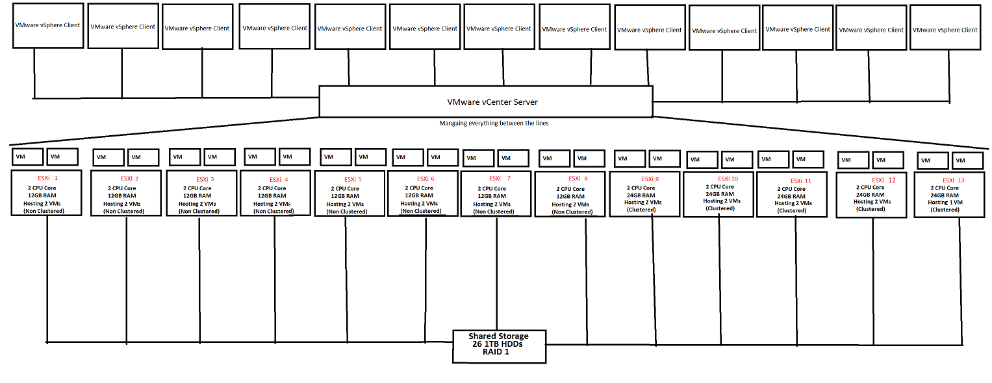1st Diagram [3]:

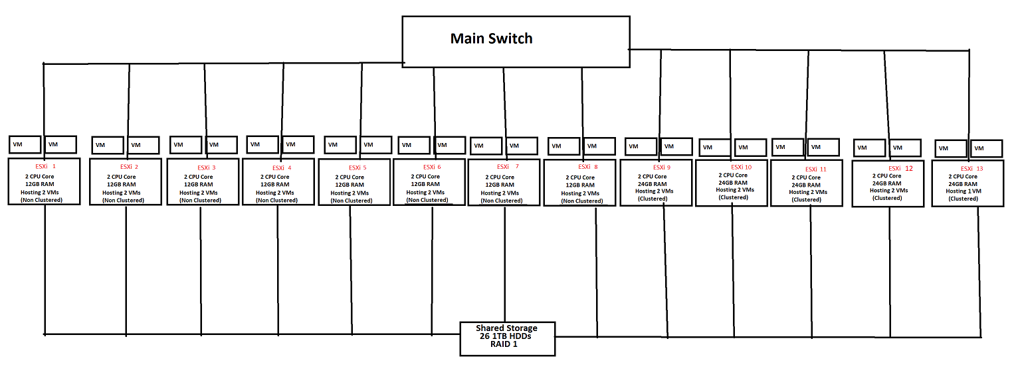2nd Diagram:

# Bibliography

|  |  |
| --- | --- |
| [1] | VMware, "ESXi Hardware Requirements," [Online]. Available: https://docs.vmware.com/en/VMware-vSphere/7.0/com.vmware.esxi.install.doc/GUID-DEB8086A-306B-4239-BF76-E354679202FC.html. |
| [2] | VMware, "How vSphere HA Works," [Online]. Available: https://docs.vmware.com/en/VMware-vSphere/7.0/com.vmware.vsphere.avail.doc/GUID-33A65FF7-DA22-4DC5-8B18-5A7F97CCA536.html. |
| [3] | VMware, "vSphere Documentation," [Online]. Available: https://docs.vmware.com/en/VMware-vSphere/index.html. |