Ryan’s Title

Ryan Munnikhuis3,✉

24 August, 2021

Text of abstract

1 University of One Place  
2 University of Another Place  
3 UCSB

✉ Correspondence: [Ryan Munnikhuis <[Rmunnikhuis@bren.ucsb.edu](mailto:Rmunnikhuis@bren.ucsb.edu)>](mailto:Rmunnikhuis@bren.ucsb.edu)

Keywords: keyword 1; keyword 2; keyword 3

Highlights: These are the highlights.

# 1 Introduction

Here is a citation (Marwick, 2017)

# 2 Background

# 3 Methods

# 4 Results

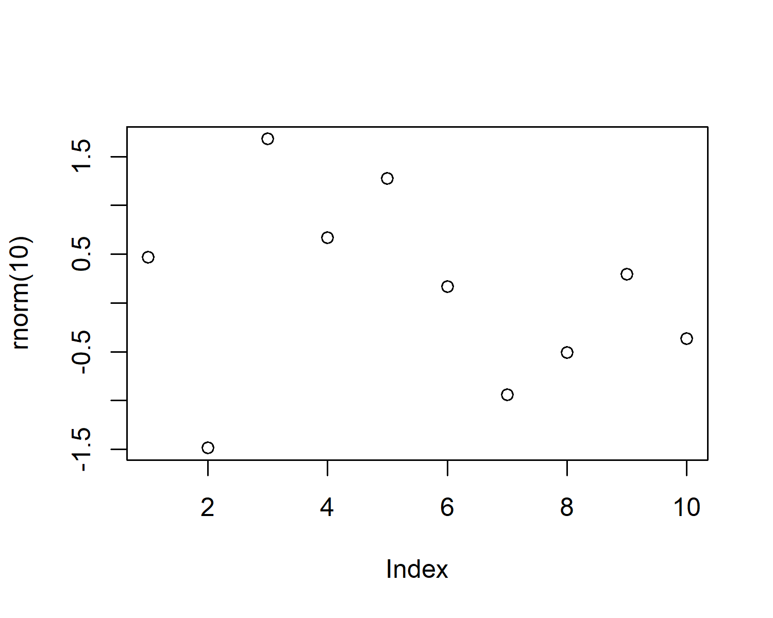

Figure 4.1: A plot of random numbers

Figure 4.1 shows how we can have a caption and cross-reference for a plot

Here is an example of inline code 3.14 in the middle of a sentence.

# 5 Discussion

# 6 Conclusion

# 7 Acknowledgements

# 8 References

Marwick, B., 2017. Computational reproducibility in archaeological research: Basic principles and a case study of their implementation. Journal of Archaeological Method and Theory 24, 424–450. <https://doi.org/10.1007/s10816-015-9272-9>

### 8.0.1 Colophon

This report was generated on 2021-08-24 11:32:09 using the following computational environment and dependencies:

#> - Session info ---------------------------------------------------------------  
#> setting value   
#> version R version 4.1.0 (2021-05-18)  
#> os Windows 10 x64   
#> system x86_64, mingw32   
#> ui RTerm   
#> language (EN)   
#> collate English_United States.1252   
#> ctype English_United States.1252   
#> tz America/Los_Angeles   
#> date 2021-08-24   
#>   
#> - Packages -------------------------------------------------------------------  
#> package * version date lib source   
#> bookdown 0.23 2021-08-13 [1] CRAN (R 4.1.1)  
#> cachem 1.0.6 2021-08-19 [1] CRAN (R 4.1.0)  
#> callr 3.7.0 2021-04-20 [1] CRAN (R 4.1.0)  
#> cli 3.0.1 2021-07-17 [1] CRAN (R 4.1.0)  
#> crayon 1.4.1 2021-02-08 [1] CRAN (R 4.1.0)  
#> desc 1.3.0 2021-03-05 [1] CRAN (R 4.1.0)  
#> devtools 2.4.2 2021-06-07 [1] CRAN (R 4.1.0)  
#> digest 0.6.27 2020-10-24 [1] CRAN (R 4.1.0)  
#> ellipsis 0.3.2 2021-04-29 [1] CRAN (R 4.1.0)  
#> evaluate 0.14 2019-05-28 [1] CRAN (R 4.1.0)  
#> fastmap 1.1.0 2021-01-25 [1] CRAN (R 4.1.0)  
#> fs 1.5.0 2020-07-31 [1] CRAN (R 4.1.0)  
#> glue 1.4.2 2020-08-27 [1] CRAN (R 4.1.0)  
#> highr 0.9 2021-04-16 [1] CRAN (R 4.1.0)  
#> htmltools 0.5.1.1 2021-01-22 [1] CRAN (R 4.1.0)  
#> knitr 1.33 2021-04-24 [1] CRAN (R 4.1.0)  
#> lifecycle 1.0.0 2021-02-15 [1] CRAN (R 4.1.0)  
#> magrittr 2.0.1 2020-11-17 [1] CRAN (R 4.1.0)  
#> memoise 2.0.0 2021-01-26 [1] CRAN (R 4.1.0)  
#> pkgbuild 1.2.0 2020-12-15 [1] CRAN (R 4.1.0)  
#> pkgload 1.2.1 2021-04-06 [1] CRAN (R 4.1.0)  
#> prettyunits 1.1.1 2020-01-24 [1] CRAN (R 4.1.0)  
#> processx 3.5.2 2021-04-30 [1] CRAN (R 4.1.0)  
#> ps 1.6.0 2021-02-28 [1] CRAN (R 4.1.0)  
#> purrr 0.3.4 2020-04-17 [1] CRAN (R 4.1.0)  
#> R6 2.5.1 2021-08-19 [1] CRAN (R 4.1.0)  
#> remotes 2.4.0 2021-06-02 [1] CRAN (R 4.1.0)  
#> rlang 0.4.11 2021-04-30 [1] CRAN (R 4.1.0)  
#> rmarkdown 2.10 2021-08-06 [1] CRAN (R 4.1.0)  
#> rprojroot 2.0.2 2020-11-15 [1] CRAN (R 4.1.0)  
#> rstudioapi 0.13 2020-11-12 [1] CRAN (R 4.1.0)  
#> sessioninfo 1.1.1 2018-11-05 [1] CRAN (R 4.1.0)  
#> stringi 1.7.3 2021-07-16 [1] CRAN (R 4.1.0)  
#> stringr 1.4.0 2019-02-10 [1] CRAN (R 4.1.0)  
#> testthat 3.0.4 2021-07-01 [1] CRAN (R 4.1.0)  
#> usethis 2.0.1 2021-02-10 [1] CRAN (R 4.1.0)  
#> withr 2.4.2 2021-04-18 [1] CRAN (R 4.1.0)  
#> xfun 0.24 2021-06-15 [1] CRAN (R 4.1.0)  
#> yaml 2.2.1 2020-02-01 [1] CRAN (R 4.1.0)  
#>   
#> [1] C:/Users/rmunn/Documents/R/win-library/4.1  
#> [2] C:/Program Files/R/R-4.1.0/library

The current Git commit details are:

#> Local: master C:/Users/rmunn/Documents/mypaper  
#> Head: [aad4e6b] 2021-08-24: Initial commit