May 7th, 2015

Computer Science 2

Professor Aaron Gordon

Secretary Project Results Report

By Ryan Newsom, Kristoffer West, and Aaron Parker

For the assignment 7 group project, our objective was to create a program that simulate an office secretary who was to take walk in customers and door customers, and provide an answer to them that took a random amount of time. Of these customers, the ones who walked in to ask a question would always be placed in the end of the “line” or priority queue, and the customers who called always had the highest priority and interrupted whoever was currently asking a question, even interrupting other phone customers.

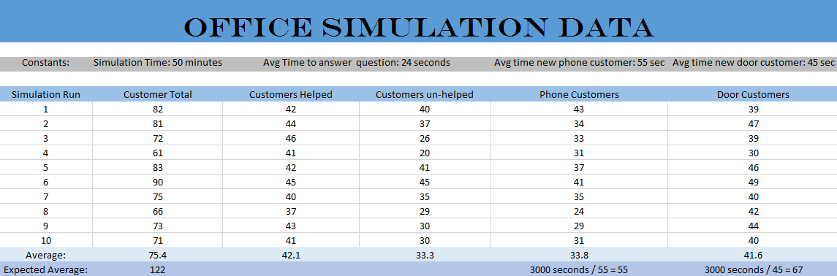 As specified, this report is based off the specified simulation time of 50 seconds, a mean customer door entry time of every 45 seconds, a mean customer phone call time of every 55 seconds, and a mean customer question time of 24 seconds. We ran 10 tests using those times, and took an average of those numbers. The results are in the chart below:

The overall average customers we handled in the simulation was 75.4, with 33.8 being phone customers and 41.6 being door customers. That makes sense with the numbers we used, as the mean phone customer call time was higher than the door customer entry time. As far as the amount of customers we helped vs un-helped, a little over half the total amount of customers had their question answered, while the rest remained in the line.

Is the total amount of customers correct mathematically? While I feel our data was very close to the expected numbers, it was slightly off. The expected number of customers was 122, and we got that number by dividing 3000 seconds by 55 seconds to get 55 phone customers, and 3000 seconds by 45 seconds to get 67 door customers. So that total of 122 is a bit off from our programs calculated 76 customers. However, I feel that looking at the ratios of our phone customer amount vs door customer amount, and customers helped vs customers un-helped shows that our data is fairly accurate overall.