Ryan O’Connor

Computer Science Project

Dr. Cynthia Howard

February 23, 2015

User Interface Design

Displayed below on the left is the navigation bar. The Home button displays all of a users aggregated content in one feed, then the “Feeds” dropdown displays all of the feeds that the user has created. An “Add Feed” option is available which will take you to the in-app browser.

Displayed on the right is the list view of a feed, whether that be “All feeds” or one chosen by specific. At the top left is the navigation button which slides in the navigation bar from the left when pressed.

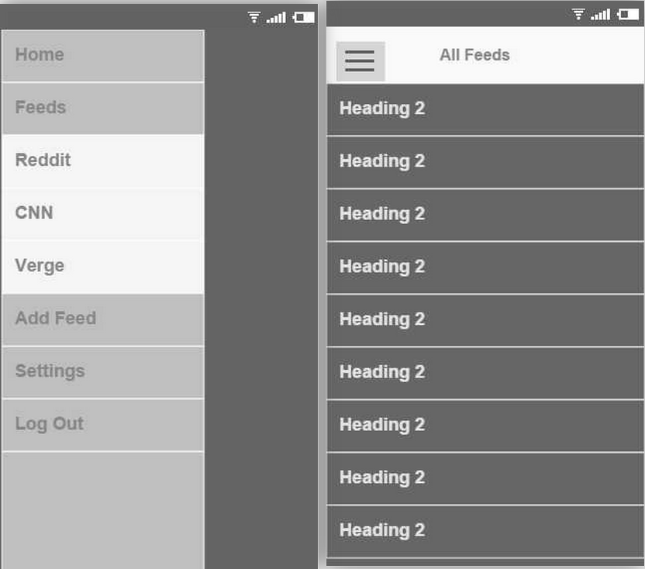

Displayed on the left is how the in-app browser will appear when first opened. The users keyboard will display and the field will be for entering a URL.

Displayed on the right is a crude rendition of what the highlighting controls will look like when a user selects the content they are interested in receiving updates on. This will not be anything near a full-featured browser, so it will likely just display an address bar and potentially a back button.

